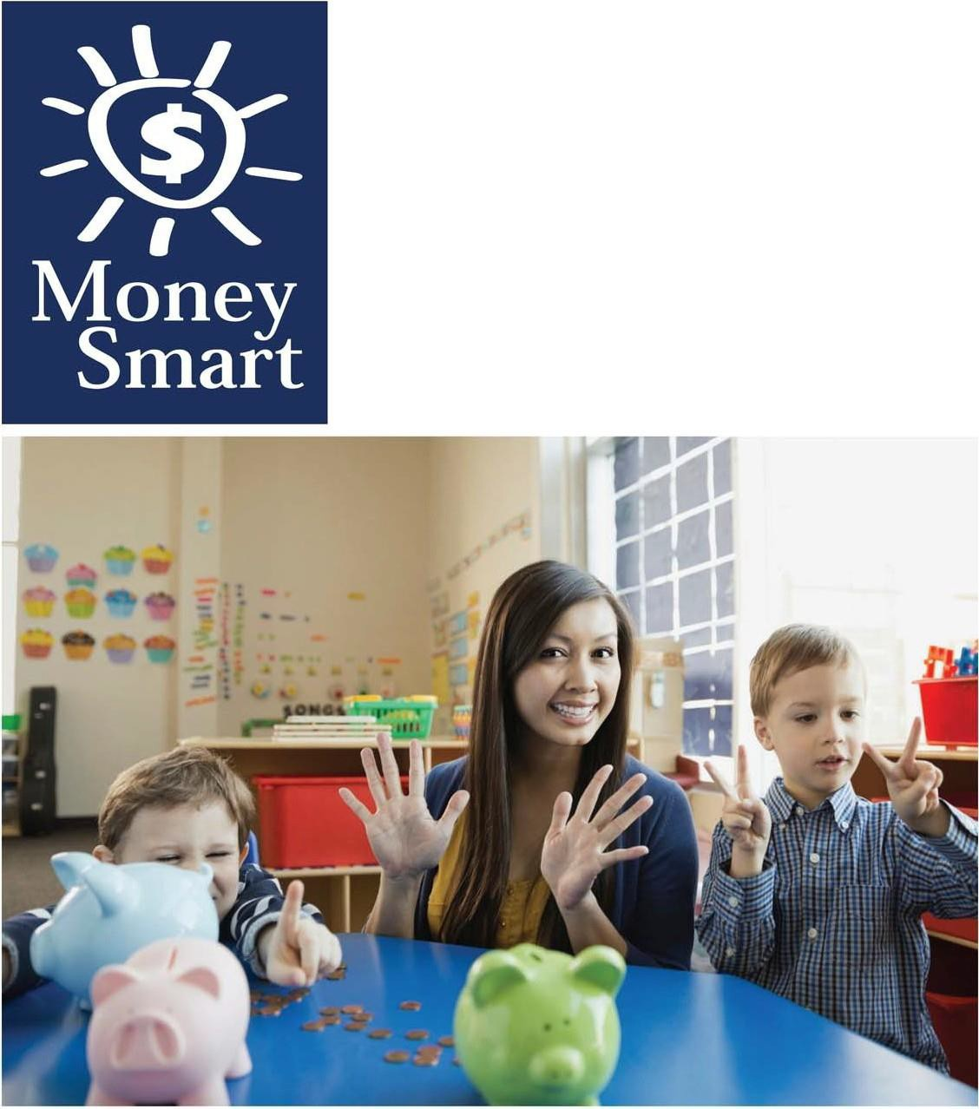
for Grades Pre-K-2

Educator Guide

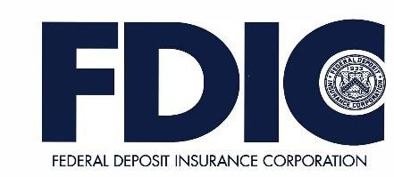

Caution:

Coins are a leading cause of choking-related injury and death for young children, particularly for those aged 3 and under.

FDIC Disclaimer:

The books and online resources referenced in the Educator Guide and Parent/Caregiver Guide are examples/options that may be used to support the subject being taught and should not be considered as an endorsement by the Federal Deposit Insurance Corporation (FDIC). Reference to any specific commercial product, process, or service by trade name, trademark, manufacture, or otherwise does not constitute an endorsement, a recommendation, or a favoring by the FDIC or the United States government.
The FDIC Money Smart curriculum references books and provides links to other websites for convenience and informational purposes only. Users should be aware that when they select a link on the FDIC's website to an external website, they are leaving the FDIC's site. Linked sites are not under the control of the FDIC, and the FDIC is not responsible for the contents of any linked site or any link contained in a linked site, or any changes or updates to such sites. The FDIC is not responsible for any transmission received from a linked site. The inclusion of a link does not imply endorsement by the FDIC of the site, its content, advertisers or sponsors. External sites may contain information that is copyrighted with restrictions on reuse. Permission to use copyrighted materials must be obtained from the original source and cannot be obtained from the FDIC.

TABLE OF CONTENTS
Welcome To Money Smart 4
Getting Started 5
Lessons At-a-Glance 9
Lesson 1: Counting Coins (Understanding Currency) 10
- Student Handout 1: My “History of Money” Mini-book 16
- Student Handout 2: Play Money 18
Answer Key 19
Glossary 20

WELCOME TO MONEY SMART

Welcome to Money Smart, an exciting interactive exploration of the concepts of money. This standards-aligned, cross-curricular program is designed to promote financial understanding in children ages 4 through 8. You can use Money Smart to add engaging and enriching activities to Math, English Language Arts, and Social Studies lessons while also helping your students build the foundation to become financially responsible adults.

In Money Smart you will find:
- Six Lessons with hands-on, cross-curricular activities that engage preschool through second- grade students in discussing and exploring key financial concepts
- Teacher Presentation Slides, which provide helpful visuals, as well as fill-in charts to support the activities in each lesson
- Student Handouts that let students explore the topics covered in each lesson and apply their new knowledge
- A Parent/Caregiver Guide with information about topics and terms being covered in class, conversation starters, online and literary resources, along with activities to try at home and around town

Developing positive financial habits equips students with 21st-century skills and tools that last a lifetime. We hope you and your students enjoy learning about money and its many uses.

We are eager to hear from you about how you use this curriculum. We would like to know what works well and what could be improved to make Money Smart even better. If you have any questions, we would like to help. Please contact us with your comments and questions via e-mail at communityaffairs@fdic.gov.

GETTING STARTED
Money Smart provides a comprehensive, developmentally appropriate program for young students to build an understanding of key financial concepts.
There are many features that help make the Money Smart curriculum engaging, motivating, and easy to use. Each lesson includes learning objectives, essential questions, supplies needed, and preparation required, as well as the following features and components to support easy integration of Money Smart activities into your instructional day.

STANDARDS
Each lesson promotes real-world connections through student-centered learning experiences and aligns to the following education standards and learning outcomes, including Common Core State Standards in mathematics and English Language Arts. The Education Standards Chart identifies which standards are met in each lesson.
- Financial Literacy Jump$tartStandards
- English Language Arts Common Core Standards
- Mathematics Common Core Standards
- National Early Childhood Learning Outcomes (NAEYC, NAECS/SDE, USDOE)
- Partnership for 21st-Century Skills

GRADE LEVEL MODIFICATIONS
Please note the grade level modifications identified throughout lessons to differentiate learning experiences for Pre-K–K and first- through second-grade students. Modifications provide developmentally appropriate activity recommendations and extension opportunities.

PRESENTATION TIME
Each lesson plan includes an estimated time required to teach the lesson. Actual time required will vary from classroom to classroom. The estimation includes instructional time spent on the Warm Up, Guided Exploration, and Wrap Up. Activities may also be taught as several short lessons over a period of days or weeks. Extended Exploration activities are included to extend financial literacy learning opportunities throughout the year and provide easy ways to integrate the topics into various content areas.

ASSESSMENTS
A variety of assessments are integrated throughout each of the six lessons. Assessments are designed to build value, meaning, and context around a topic, while providing teachers with opportunities to evaluate prior student knowledge, and collect evidence of new understandings of lesson concepts and skills. Pre- (formative) and post- (summative) assessments are noted on the first page of each lesson. Assessments include discussions, reflections, questions and answers, reading, writing, and problem-solving exercises. Student handouts are an especially useful form of written assessment.

MONEY SMART FOR GRADES PRE-K–2: EDUCATOR GUIDE 5

LESSON STRUCTURE
Each lesson is designed to include the following:
- Warm Up introduces students to the topic and sparks inquiry.
- Guided Exploration integrates cross-curricular and developmentally appropriate learning activities and assessments while focusing on the key financial literacy learning objectives of the lesson.
- Wrap Up provides a reflection question or activity to review lesson concepts and allow students to demonstrate their understanding.
- Money Smart Tips are provided throughout lessons to offer additional guidance, interesting and relevant financial facts, and additional ideas to help make Money Smart a success in your classroom.
- Extended Exploration activities provide teachers with additional opportunities to extend financial literacy concepts throughout the school year within core and creative content areas including English Language Arts, Math, Social Studies, Technology, and Art. All activities support dynamic classroom groupings throughout the day and can be completed independently, in groups, during “center time,” or in station rotations. Useful resources (such as books, web links, games, or videos) are also included to promote even more student engagement. The books and online resources suggested in this guide are just a few of the many available resources that explore these topics, and are not endorsed by FDIC.
- Student Handouts and Teacher Presentation Slides provide dynamic instructional support. Student handouts create an opportunity for students to apply their knowledge and for teachers to assess their understanding. Teacher presentation slides offer visuals and interactive activities corresponding with each lesson, and can be projected for whole-group activities, or copied for small-group use.
- The Answer Key, Glossary, and the Standards Chart house all of the information needed to check for understanding, define key terms, and check which activities meet specific national education standards. Vocabulary words are bolded in each lesson as they are introduced. The vocabulary words can be used to create flash cards or a classroom Word Bank list. Students can also make their own Word Banks and refer to the lists as needed.

MONEY SMART AT HOME
The Money Smart curriculum includes a helpful Parent/Caregiver Guide that corresponds to the classroom resources. Families of young children may also use it independently of the curriculum. It contains resources, activities, games, and conversation starters on financial literacy topics covered in each lesson. Use the following ideas to encourage parents to use the guide at home:
- Introduce parents to the Money Smart program and share the Parent/Caregiver Guide at the start of the school year.
- Discuss the Money Smart program during parent/teacher conferences, or in monthly parent newsletters home, and emphasize the importance of building healthy financial habits from an early age.

- Hold a Money Smart family night. Play games and have students present short skits about financial concepts they have learned.
- Send student handouts from each lesson home in each child’s homework folder for parents to review and sign.

SMART BUCKS
Additional incentives can be used to promote positive financial behaviors and study habits throughout the Money Smart curriculum and school year. Introduce Smart Bucks to recognize students’ positive financial and classroom behaviors.
Smart Bucks can be earned for the following behaviors:
- Accomplishment of a goal(s)
- Completion of homework
- Exceptional classroom conduct
- Classroom monitoring and keeping the classroom clean and neat
- Participating in discussions or responding to questions
- Excellent group collaboration or individual work
- Completing daily work
- Respectful behavior
As students accumulate Smart Bucks, they may “cash” them in, or “spend” them on prizes, toys, or special activities (extra computer time, free reading time, or game board time, for example) at the end of the week, month, or whenever you normally provide rewards.
Smart Bucks may be tracked using a chart (displaying desired behaviors and goals), stored in a classroom “treasury” box, or in a cash register (if a class “store” is set up), and handed out to students using play money. Provide price tags or stickers on items or activities to be “sold”. The presentation for cashing in Smart Bucks can be as simple or elaborate as you choose.
Aside from being a fun way to reward positive behaviors, Smart Bucks can help foster an application of the financial literacy concepts covered in Money Smart lessons.
With Smart Bucks, students can learn:
- How to identify bills (particularly how much money a given bill is worth)
- Various ways to make certain dollar amounts (for example, two 5s equal a 10-dollar bill, and so on)
- How to practice their counting skills in order to total up a combination of bills earned (you may suggest that students must be able to count their own money to cash in for a prize as an additional incentive)
- The concept of making change
- The value of saving as they choose to save instead of spend, or set a goal to save for a more desired choice

Use Smart Bucks during Money Smart lessons or continue throughout the year.

FINANCIAL LITERACY ALL YEAR LONG
Highlight financial literacy at your school all year long, especially in April, during National Financial Literacy and School Library Month.
- Create bulletin boards or posters with students about financial literacy themes learned in

Money Smart.
- Play games that focus on numeracy skills and financial concepts (such as Monopoly).
- Send home newsletters each week to parents about money skills and financial concepts covered in class.
- Feature children’s literature selections that cover financial literacy concepts in the library or during classroom reading time.

The more students are exposed to financial literacy, and the more opportunity they have to practice applying their new knowledge and understanding of concepts, at school and at home, the more prepared they will be to live Money Smart lives.

LESSONS AT-A-GLANCE
Lesson Title
Topic
Learning Objectives
Time Required
1
Counting Coins
Understanding
Currency
- Describe the purpose of money
- Examine and discuss the history of money
- Explain ways money can be used
- Identify, sort, and count coins and bills
65 min

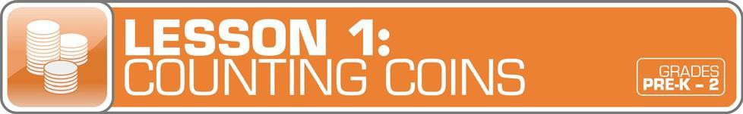
Answer Key 19
Glossary with key vocabulary 20

LESSON OVERVIEW

Guide students in building the basics of understanding currency while having fun with coins. Through the exploration of children’s literature, story problems, and hands-on activities, including identifying, sorting, and counting coins, students begin to develop connections between the literal product of coins and bills and the abstract concepts of using money to make purchases. Extend the exploration of currency throughout the year with a variety of cross-curricular independent and small group activities.
TOPIC: Understanding Currency

TIME REQUIRED: 65 minutes
(excluding Extended Exploration activities)

LEARNING OBJECTIVES:
Students will be able to.
- Describe the purpose of money
- Examine and discuss the history of money
- Explain ways money can be used
- Identify, sort, and count coins and bills

SUPPLIES:
- Replicas of various coins (pennies, nickels, dimes, quarters). Coin templates are available from the U.S. Mint at http://www.usmint.gov/kids/teachers/ coin curricula/
- One penny
- Chart paper, markers
- Art supplies (crayons, color pencils, scissors, tape, glue)
- Projector (for teacher presentation slides)
- Access to the Internet (optional)
- Suggested books (optional):
  - One Cent, Two Cents, Old Cent, New Cent: All About Money by Bonnie Worth
  - The Penny Pot by Stuart J. Murphy
  - The Coin Counting Book by Rozanne Lanczak Williams
  - If You Made a Million by David M. Schwartz
PREPARATION:
- Make copies of student handouts
- Set up projector with presentation slides

STUDENT HANDOUTS:

My “History of Money” Mini-Book
- Play Money

TEACHER PRESENTATION SLIDES:

Timeline: The History of Money
- Mixed Coins
- Story Problems: Counting Coins

ESSENTIAL QUESTIONS:
- What is money?
- What does money look like?
- How long has money been used?
- How does money look different today than in the past?
- Where can I use money?
- Where does money come from?
- How is money different in other places?

ASSESSMENT ACTIVITIES:
PRE-ASSESSMENT:
- Talking About Money activity
- The History of Money activity

POST-ASSESSMENT:

My “History of Money” Mini-Book
handout
- Play Money handout

Story Problems: Counting Coins slide
- Class Reflection activity

INSTRUCTION STEPS

Teacher Tips:
- Look for grade level modifications throughout this lesson for ways to adapt activities for your students.
- Spend extra time introducing your students to different coins and bills and the concept of different values.
- Understanding and differentiating currency takes time. Repeat these activities often.
- Use this lesson as a supplement to build on some of the other financial literacy topics and lessons.

WARM UP
TALKING ABOUT MONEY [5 MINUTES]
Begin by exploring what students know about money. Ask students: What is money? After inviting students to share their ideas, explain that money something we use to buy things (such as food, books, toys, cars) or services (such as haircuts, doctor visits, car washes).
Show the students a penny and ask them to imagine where that penny might have been before it came into the class.
Create a brainstorm list documenting students’ ideas, such as in someone’s pocket, a cash register, a wishing well, or on the sidewalk. Ask: How long do you think money has been used? Do you think the way it looks has changed?

MONEY SMART TIP!

Many young learners correlate the value of a coin to its size. Identifying coins
by look, size, name, and value provides students with the opportunity to develop connections between objects and represented numbers and value.

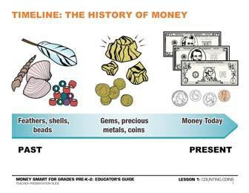THE HISTORY OF MONEY [10 MINUTES]
Display the first teacher presentation Timeline: The History of Money slide, which illustrates how currency has changed over time. Ask students: What do you notice about the pictures
of money? How is money different now than it was before? How is it the same?
Explain that money has changed over time. Money used to be all different sizes, shapes, and items. People used to use things like feathers, shells, beads, leather, gems, and other precious metals
to pay for things they wanted to buy. Today, everyone uses the same kind of money. If you get a dollar from a friend or from the store it will look the same. The money we use in the U.S. is going to look a little different from the money used in another country.

Grade Level Modifications:
Pre-K–K: Sort real-world items from the History of Money slide by similarities and differences (shells, beads, coins, play money). Students may discuss reasoning for sorting, such as all items of the same color or material. This topic can also extend to comparing how things in the classroom or community change over time.
Grades 1–2: Create a student timeline for history of money using items depicted in the slide.

Next, display the Mixed Coins slide for students to observe and identify details about the modern coins pictured. Ask them to describe the differences in size and imagery on coins.

Grade Level Modifications:
Pre-K–K: Identify and name the coins pictured on the slide as a class (pennies, nickels, dimes, and so on). Students can also use bags of change and hold up a match to the coin pointed to.
Grades 1–2: Select and circle or highlight two or more coins pictured and have students calculate the value.

GUIDED EXPLORATION
DISCOVERING THE PURPOSE OF MONEY [15 MINUTES]
After learning about money and looking at examples of what money used to look like on the Timeline: The History of Money slide, share with students that they will have the chance to create their own book about money. Introduce the My “History of Money” Mini-Book handout and provide each student with his or her own copy. Read the mini-book pages aloud and model how to complete each page and assemble the book.

Grade Level Modification:
Pre-K–K: Assist children by cutting out the pages of their books beforehand and then assembling their books for them. They may draw or paste magazine pictures on pages instead of writing. They may also narrate their story for the teacher or classroom volunteer to record in their book.
Optional: Read the book One Cent, Two Cents, Old Cent, New Cent: All About Money by Bonnie Worth. While reading the story, ask students to share what The Cat in the Hat discovers about money. Students can also compare illustrations to what they discovered on the Timeline: The History of Money slide.
Ask:
- What does it look like in different places?
- What was used as money in the past?
- How does it look different today?

USING COINS AND BILLS [20 MINUTES]
As a class, play a whole-group game “I Am Going on a Shopping Trip” to spark a connection between coins and bills and their value. Each student may take a turn sharing “I am going on a shopping trip and I am going to buy .”

Grade Level Modifications:
Pre-K–K: Record each student’s answer on chart paper, modeling writing.
Grades 1–2: Share each previous student’s answer, adding a memory element to the game.

After congratulating the class on all the wonderful ideas shared, provide each student with a Play Money handout. Provide art supplies so that they can design their own bills. Handouts can be sent home and completed as homework. When finished, they may cut out their bill and coins to go on pretend shopping trips at home. Explain that saving can also be a way to use some of their money.

Grade Level Modification:

Pre-K–K: Have students practice cutting skills as they maneuver scissors around the coins and their designed bill. They may describe the coins and bill as they cut, comparing the images to how real coins and bills look and feel.

COUNTING COINS [10 MINUTES]
Students may use small bags of real or play change for whole-class problem solving such as imaginary shopping and making small purchases. This activity can be explored repeatedly over the course of the year, giving students the chance to develop comfort and confidence identifying cents and dollars. Play coins should be larger than 2 inches in diameter to reduce the risk of choking.

Grade Level Modifications:
Pre-K–K: Practice sorting coins by size and color. Ask students to show you a penny, a nickel, a dime, a quarter. Ask students to count how many pennies they have and share with a partner.
Grades 1–2: Practice sorting by value. Imagine going shopping for an item and ask students to create that amount or make change for a purchase. For example: You had 50 cents and spent
30 cents. How much do you have? Represent different numbers using coins or bills. For example, today is the 16th: use cents and bills to represent the number 16.

WRAP UP
CLASS REFLECTION [5 MINUTES]
Ask students: What do you now know about money? Invite them to share their responses. Check for understanding and possibly introduce extended exploration centers for exploring the topic further.

EXTENDED EXPLORATION
Note: Use the following activities to extend the lesson topic throughout the year. Activities can be completed as a class, in small groups, or during center time. Duration of activities will vary.

LITERACY CENTER

Possible Book Club or Classroom Library Selections:
Note: Read books with your class that focus on the lesson’s financial literacy topic. Below are suggestions, but you may find other selections in your library that can be used to generate a similar discussion. For pre-literate students, read books aloud.
  - The Penny Pot by Stuart J. Murphy: In this book, join a group of children at the school fair. Can Jessie save enough pennies to have her face painted?
    - Discussion Questions: Why didn’t Jessie have enough money to get her face painted? How did she solve her problem?
  - The Coin Counting Book by Rozanne Lanczak Williams: Explore the world of coins and bills through catchy rhymes and detailed photographs. Move from identifying pennies to making a dollar.
    - Discussion Questions: What coins does it take to make a dollar?
  - If You Made a Million by David M. Schwartz: Have you ever wanted a million dollars? Discover ways to make and spend a lot of money with Marvelosissimo the Mathematical Magician and his friends.
    - Discussion Questions: What would you do with a million dollars?

Speaking, Listening & Writing Prompts:
Explore the following prompts through a themed show-and-tell, circle time discussions, partner pair-share discussions, or writing.

Grade Level Modifications:
Pre-K–K: Provide students with a visual or real-world object to support exploration of the prompt. Pre-literate students may discuss pictures and objects while having their stories recorded through modeled or guided writing as a small group or with the class.
- What would you use money to get?
Grades 1–2: Students may explore the following writing prompts by journaling or as independent writing assignments.
- If you had $5, how would you spend it?

MATH CENTER
- Math Station: Using the materials below, students can explore the following math station activities independently or as part of a small group. These could be used during classroom centers or as a choice for students who finish assignments early.

Grade Level Modifications:
Pre-K–K: Materials: Pennies, dice, or a number cube. Instructions: Have students roll the number cube and count coins to match the number.

Grades 1–2: Materials: Coins, dice, or a number cube, paper and pencil. Instructions: Have students roll the number cube and write down the number. They may then represent the number using coins of the appropriate value. For increased difficulty, they may roll the number cube twice and create two-digit numbers.
- Story Problems: Display the Story Problems: Counting Coins slides. Problems can be printed or projected then explored and solved as a whole class, a small collaborative group, or individually. The first problem listed, Challenge 1, is more appropriate for young students. Challenge 2 will provide more difficulty.

Grade Level Modifications:
Pre-K–K: Solve step-by-step problems developing students’ critical thinking and deductive reasoning during circle time or as a small group. Each challenge involves using or creating a visual with students and discussing small steps to solve a problem.
Grades 1–2: Using the provided challenges as inspiration, create personal story problems and exchange them with classmates to solve.

TECHNOLOGY CENTER
- Games and Online Activities: Exploring money through online games or educational apps is a powerful way to extend classroom learning.

  - Pig’s Money Counter: Identify, count, and sort money with Peter the Pig.

http://www.practicalmoneyskills.com/games/peterpigs/

  - Money Factory: Students see how money is created at the Bureau of Engraving and Printing. http://kids.usa.gov/watch-videos/money/money-factory/index.shtml
  - History of Money: Students choose the correct form of currency as they travel through different historical periods. http://duckiedeck.com/play/history-of-money

SOCIAL STUDIES CENTER
- To celebrate the 100th day of school, students can collaborate to represent the number 100 with as many variations of coins as possible.
- Presidents’ Day can be celebrated by discussing which coins or bills feature which presidents.

ARTS & DRAMATIC PLAY CENTER
- Dramatic Play: Explore using money through a variety of classroom dramatic play areas, including a flower shop, grocery store, or bank.
- Sensory Activities: Make coin impressions with clay or dough. Older students can identify the value, and then remold clay and create new impressions.
- Art Project: Create coin rubbings by laying a piece of white paper over the top of several coins and rubbing a crayon on the top of the sheet.

MY “HISTORY OF MONEY” Mini-Book

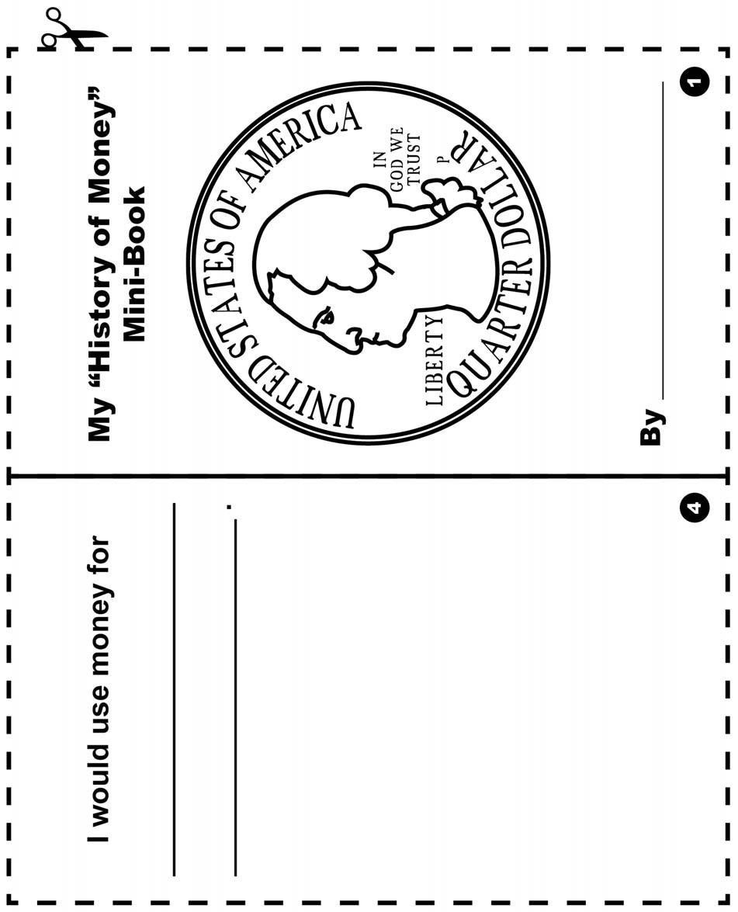
Color and cut out the pages along the dotted lines, then fold them to make your mini-book. Write or draw pictures of your answers on each page.

MY “HISTORY OF MONEY” Mini-Book (continued)

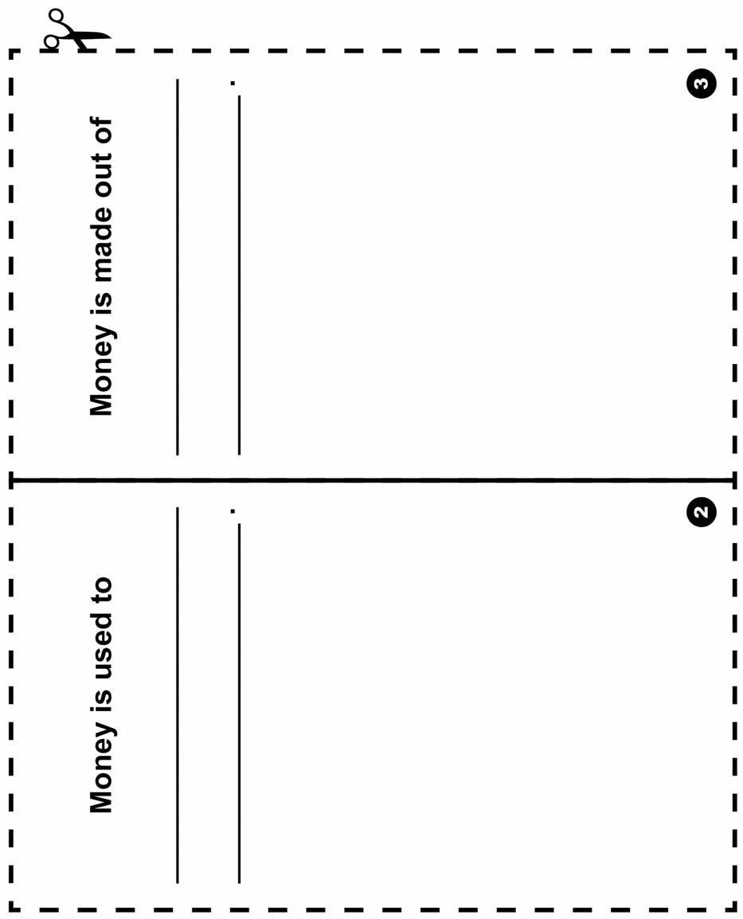

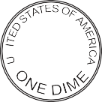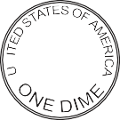
E PLU RIB USUNUM
E PLU RIB USUNUM
N
N
W
W

PLAY MONEY

Name:
Design your own bill. Money usually has a person on it. Who will you add to your bill? Don’t forget to add numbers. Color in then cut out the play money.
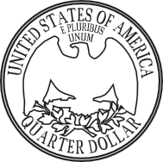
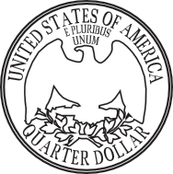
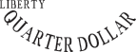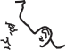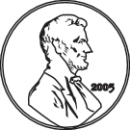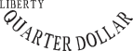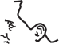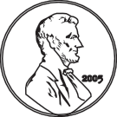
IN GOD
WE TRUST
S
2013
LIBERTY
D
IN GOD
WE TRUST
S
2013
LIBERTY
D

M O N T I C E L L O
C
E
EPLURIBUS UNUM

M O N T I C E L L O
C
E
EPLURIBUS UNUM

MY “HISTORY OF MONEY” Mini-Book (continued)

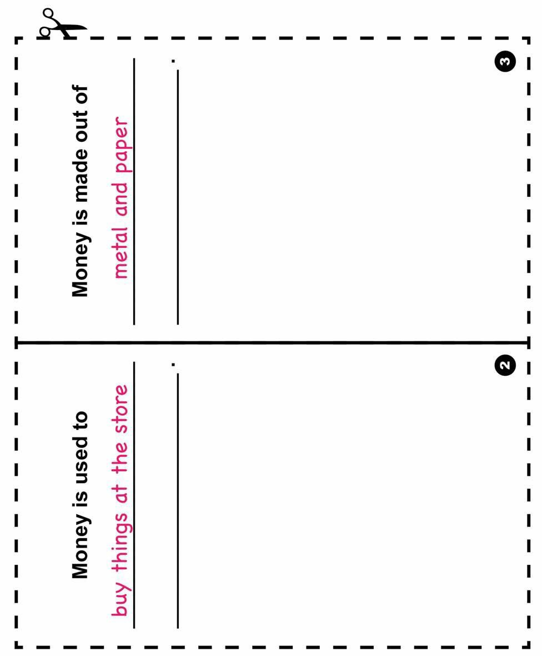

GLOSSARY

Bank: A financial institution and business that accepts deposits and makes loans.

Borrow: To receive something on loan with the understanding that you will return it.

Currency: A form of money that is generally accepted to measure value (banknotes, bills, coins, and so on).

Earn: To receive money in exchange for goods or services

Federal Deposit Insurance Corporation (FDIC): Preserves and promotes public confidence in the U.S. financial system by insuring deposits in banks and thrift institutions for at least $250,000. An independent agency of the federal government, the FDIC was created in 1933.

Goal: Something, such as an outcome, you wish to achieve or accomplish in a specific amount of time.

Income: Money that you receive from jobs, gifts, allowances, interest, dividends, and other sources.

Job: A specific duty, task, or activity someone completes using his or her time, skills, and energy to earn money.

Lend: The act of giving something to someone with the understanding that they will give it back to you.

Money: Money is an object you can use to purchase goods and services. Money looks different in different places around the world.

Need: Something you must have to survive, such as clothes, shelter, or food.

Save: Setting something, like money, aside to use in the future.

Spend: The act of using money to buy goods or services.

Want: Something that you would like to have but that you could live without.

