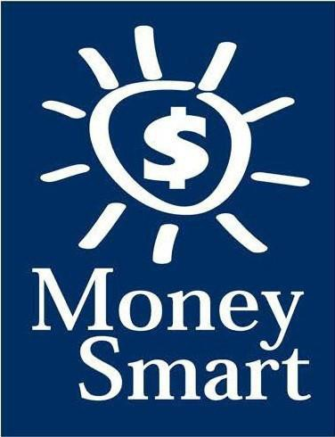
for Grades 3-5
Educator Guide

FDIC Disclaimer:
The books and online resources referenced in the Educator Guide and Parent/Caregiver Guide are examples/options that may be used to support the subject being taught and should not be considered as an endorsement by the Federal Deposit Insurance Corporation (FDIC). Reference to any specific commercial product, process, or service by trade name, trademark, manufacture, or otherwise does not constitute an endorsement, a recommendation, or a favoring by the FDIC or the United States government.
The FDIC Money Smart curriculum references books and provides links to other websites for convenience and informational purposes only. Users should be aware that when they select a link on the FDIC’s website to an external website, they are leaving the FDIC’s site. Linked sites are not under the control of the FDIC, and the FDIC is not responsible for the contents of any linked site or any link contained in a linked site, or any changes or updates to such sites. The FDIC is not responsible for any transmission received from a linked site. The inclusion of a link does not imply endorsement by the FDIC of the site, its content, advertisers, or sponsors. External sites may contain information that is copyrighted with restrictions on reuse. Permission to use copyrighted materials must be obtained from the original source and cannot be obtained from the FDIC.

TABLE OF CONTENTS
Welcome To Money Smart 4
Getting Started 5
Lessons At-a-Glance 8
Lesson 1: Money Matters (Buying Decisions) 9
Answer Key 14
Glossary 17

WELCOME TO MONEY SMART

Welcome to Money Smart, an exciting interactive exploration of the concepts of money. This standards-aligned, cross-curricular program is designed to promote financial understanding in children ages 8 through 11. You can use Money Smart to add engaging and enriching activities to Math, English Language Arts, and Social Studies lessons while also helping your students build the foundation to become financially responsible adults.
In Money Smart you will find:
- Eight Lessons with hands-on, cross-curricular activities that engage third- through fifth-grade students in discussing and exploring key financial concepts
- Teacher Presentation Slides, which provide helpful visuals, as well as fill-in charts to support the activities in each lesson
- A Student Guide with handouts that let students explore the topics covered in each lesson and apply their new knowledge
- A Parent/Caregiver Guide with information about topics and terms being covered in class, conversation starters, online and literary sources, along with activities to try at home and around town
Developing positive financial habits equips students with 21st-century skills and tools that last a lifetime. We hope you and your students enjoy learning about money and its many uses.
We are eager to hear from you about how you use this curriculum. We would like to know what works well and what could be improved to make Money Smart even better. If you have any questions, we would like to help. Please contact us with your comments and questions via e-mail at communityaffairs@fdic.gov.

GETTING STARTED

Money Smart provides a comprehensive, developmentally appropriate program for upper elementary students to build an understanding of key financial concepts.
There are many features that help make the Money Smart curriculum engaging, motivating, and easy to use. Each lesson includes learning objectives, essential questions, supplies needed, and preparation required, as well as the following features and components to support easy integration of Money Smart activities into your instructional day.

STANDARDS
Each lesson promotes real-world connections through student-centered learning experiences and aligns to the following education standards and learning outcomes, including Common Core State Standards in mathematics and English Language Arts. The Education Standards Chart on pages 48- 57 identifies which standards are met in each lesson.
- Financial Literacy Jump Start Standards
- English Language Arts Common Core State Standards
- Mathematics Common Core State Standards
- National Standards for Financial Literacy by the Council for Economic Education
- Partnership for 21st-Century Skills

GRADE-LEVEL MODIFICATIONS
Please note the modifications identified throughout lessons to differentiate learning experiences for beginner and advanced students. Modifications provide developmentally appropriate activity recommendations and extension opportunities.

PRESENTATION TIME
Each lesson plan includes an estimated time needed to teach the lesson. Actual time required will vary from classroom to classroom. The estimation includes instructional time spent on the Warm Up, Guided Exploration, and Wrap Up. Activities may also be taught as several short lessons over a period of days or weeks. Extended Exploration activities are included to extend financial literacy learning opportunities throughout the year and provide easy ways to integrate the topics into various content areas.

ASSESSMENTS
A variety of assessments are integrated throughout each of the eight lessons. Assessments are designed to build value, meaning, and context around a topic, while providing teachers with opportunities to evaluate prior student knowledge, and collect evidence of their new understandings of lesson concepts and skills. Pre- (formative) and post- (summative) assessments are noted on the first page of each lesson. Assessments include discussions, reflections, questions and answers, reading, writing, and problem-solving exercises. Student handouts are an especially useful form of written assessment.

LESSON STRUCTURE
Each lesson is designed to include the following:
- Warm Up introduces students to the topic and sparks inquiry.
- Guided Exploration integrates cross-curricular and developmentally appropriate learning activities and assessments while focusing on the key financial literacy learning objectives of the lesson.
- Wrap Up provides a reflection question or activity to review lesson concepts and allow students to demonstrate their understanding.
- Money Smart Tips are provided throughout lessons to offer additional guidance, interesting and relevant financial facts, and additional ideas to help make Money Smart a success in your classroom.
- Extended Exploration provides teachers with additional opportunities to extend financial literacy concepts throughout the school year within core and creative content areas including English Language Arts, Math. Activities can be completed as a class, in small groups, or by students individually. Useful resources (such as books, web links, games, or videos) are also included to promote even more student engagement. The books and online resources suggested in this guide are just a few of the many available resources that explore these topics, and are not endorsed by the FDIC.
- Student Handouts (found in the Student Guide) and Teacher Presentation Slides provide dynamic instructional support. Student handouts create an opportunity for students to apply their knowledge and for teachers to assess their understanding. Teacher presentation materials offer visuals and interactive activities corresponding with each lesson, and can be projected for whole-group activities, or copied for small-group use.
- The Answer Key, Glossary, and Standards Chart house all of the information needed to check for understanding, define key terms, and check which activities meet specific education standards. Vocabulary words are bolded in each lesson as they are introduced. The vocabulary words can be used to create flash cards or a classroom Word Bank list. Students can also make their own Word Banks and refer to the lists as needed.

MONEY SMART AT HOME
The Money Smart curriculum includes a helpful Parent/Caregiver Guide that corresponds to the classroom resources. Families of young children may also use it independently of the curriculum. It contains resources, activities, games, and conversation starters on financial literacy topics covered in each lesson. Use the following ideas to encourage parents to use the guide at home:
- Introduce parents to the Money Smart program and share the Parent/Caregiver Guide at the start of the school year.
- Discuss the Money Smart program during parent/teacher conferences, or in monthly parent newsletters home, and emphasize the importance of building healthy financial habits from an early age.
- Hold a Money Smart family night. Play games and have students present short skits about financial concepts they have learned.
- Send student handouts from each lesson home in each child’s homework folder for parents to review and sign.

SMART BUCKS
Additional incentives can be used to promote positive financial behaviors and study habits throughout the Money Smart curriculum and school year. Introduce Smart Bucks to recognize students’ positive financial and classroom behaviors.
Smart Bucks can be earned for the following behaviors:
- Accomplishment of a goal(s)
- Completion of homework
- Exceptional classroom conduct
- Keeping the classroom clean and neat
- Participating in discussions or respondingto questions
- Excellent group collaboration or individualwork
- Completing daily work
- Respectful behavior
As students accumulate Smart Bucks, they may spend them on prizes, toys, or special activities (for example: extra computer time, free reading time, game board time) at the end of the week or month, or whenever you normally provide rewards.
Smart Bucks may be tracked using a chart (displaying desired behaviors and goals), stored in a classroom “treasury” box, or in a cash register (if a class “store” is set up), and handed out to students using play money. Provide price tags or stickers on items or activities to be “sold.” The presentation for cashing in Smart Bucks can be as simple or elaborate as you choose.
Aside from being a fun way to reward positive behaviors, Smart Bucks can help foster an application of the financial literacy concepts covered in Money Smart lessons.
With Smart Bucks, students can practice:
- Math skills when adding the total of “Smart Bucks” earned
- The concept of making change without using a calculator
- The value of saving as they choose to save instead of spend, or set a goal to save for a more desired choice
Use Smart Bucks during Money Smart lessons or continue throughout the year.

FINANCIAL LITERACY ALL YEAR LONG
Highlight financial literacy at your school all year long, especially in April, during National Financial Literacy and School Library Month.
- Create bulletin boards or posters with students about financial literacy themes learned in
Money Smart.
- Play games that focus on numeracy skills and financial concepts (such as Monopoly).
- Feature children’s literature selections that cover financial literacy concepts in the library or during classroom reading time. See the Parent/Caregiver Guide for more literature suggestions.
The more students are exposed to financial literacy, and the more opportunity they have to practice applying their new knowledge and understanding of concepts, at school and at home, the more prepared they will be to live Money Smart lives.

LESSONS AT-A-GLANCE

Lesson Title | Topic | Learning | Time
 |  | Objectives | Required

1 Money Matters

Buying Decisions
•Explain the difference between needs and wants, and identify examples of each
•Compare and prioritize needs and wants
•Evaluate different choices when making a purchase
•Discuss impulse buying
•Discuss and explain opportunity cost
60 min

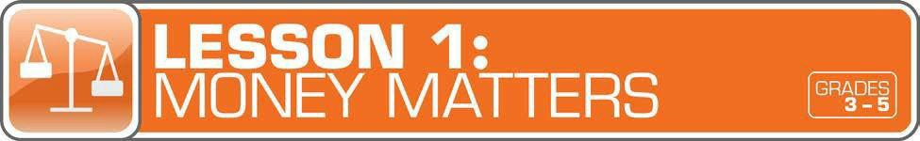

LESSON OVERVIEW
In this introductory lesson, students will evaluate buying decisions by practicing problem-solving and critical-thinking skills to understand how resources are limited. Students will learn that spending money for one purpose means that money cannot be spent for another purpose (opportunity cost) and that spending priorities can be developed by differentiating between needs and wants.
TOPIC: Buying Decisions

TIME REQUIRED: 60 minutes
(excluding Extended Exploration activities)

LEARNING OBJECTIVES:
Students will be able to…
- Explain the difference between needs and wants, and identify examples of each
- Compare and prioritize needs and wants
- Evaluate different choices when making a purchase
- Discuss impulsebuying
- Discuss and explain opportunity cost

SUPPLIES:
- A variety of “needs” and “wants” items (such as an apple, a pair of socks, apack of gum, a bracelet, a stuffed animal, a roll of toilet paper, a milk carton, a toy car, a bar of soap)
- Whiteboard or chart paper, markers
- Projector (for teacher presentation slides)
- Access to the Internet (optional)
- Suggested books(optional)
  - Tops and Bottoms by Janet Stevens
  - Erandi’s Braids byAntonio HernandezMadrigal

PREPARATION:
- Make copies of student handouts
- Set up projector with presentation slides
Answer Key 14
Glossary with key vocabulary 17
Standards met by lesson 48
STUDENT HANDOUTS:
(found in Student Guide)
- Sort It Out
- What Should I Buy?
- Trade-Offs
- Money Smart Book

TEACHER PRESENTATION SLIDES:
- What Are Needs andWants?
- Story Problems: OpportunityCost (Challenges 1, 2, 3)

ESSENTIAL QUESTIONS:
- What is the difference between a need and a want?
- How can one person’s need be another person’s want?
- How can comparing choices help you decide what to buy?
- What is an opportunity cost?

ASSESSMENT ACTIVITIES:
PRE-ASSESSMENT:
- Sort It Out handout
- What Should I Buy? handout
POST-ASSESSMENT:
- Story Problems: Opportunity Cost
slides (Challenge 1, 2, or 3)
- Money Smart Book handout

INSTRUCTION STEPS
WARM UP
NEEDS AND WANTS [15 MINUTES]
Begin the lesson by showing students eight or nine items, such as an apple, a pair of shoes, a pack of gum, a bracelet, a stuffed animal, a roll of toilet paper, a milk carton, a toy car, and a bar of soap. Put the items on a table in the front of the class.
Have students work together to sort items into two categories using the Sort It Out handout. Ask students to share their categories and explain their reasoning.
Ask students: What is the difference between a need and a want? (A need is something you cannot live without, for example: food, water, shelter. A want is something you would like, but can live without, for example: toys, candy, stickers, the latest fashions, and soon.)
If students have not already divided the items into needs and wants, have a class discussion to lead students to do so. Have them write their answers on the Sort It Out handout? Then ask them to share and discuss their reasoning.

Grade-Level Modifications:
Beginner: Divide the items into needs and wants as a whole-class activity.
Advanced: Have students sort the items individually or in small groups, and review as a class.

MONEY SMART TIP!
Discuss needs in terms of school. Ask: What are some things you need to help you learn?

GUIDED EXPLORATION

EXPLORING AND EVALUATING BUYING DECISION CHOICES [15 MINUTES]
As a class, brainstorm a list of needs (food, clothing, shelter, medical care, medicine, transportation, services — phone, haircut, water, electricity) and wants (toys, candy, the latest fashions, game apps, jewelry, movie tickets, music). List items on a whiteboard or chart paper. Explain that needs are top priorities because they are things you cannot live without. Since people can’t have everything they want, they need to decide which wants are most important. Then have students prioritize the list of wants by ranking them in order of importance. Discuss as a whole class.

Grade-Level Modifications:
Beginner: Have students work in small groups to prioritize the list of wants.
Advanced: Ask students to work independently to prioritize the list of wants and write a sentence next to each item to explain its ranking.

Ask students: How can one person’s need be another person’s want? (One person might need something, while someone else already has it and wants another. For example: you might need shoes when your only pair is getting too small, versus someone who might want another pair of shoes when he or she already has several pairs.) Have students share several examples.
Share with student’s important questions to ask when making a buying decision: Do I need it? How long will the item be useful? Am I buying it because my friend bought it? Am I buying itto impress others?
Distribute the What Should I Buy? handout to practice problem-solving and critical-thinking skills by evaluating buying decisions and differentiating between needs and wants.
Next, discuss and define the term “impulse buying” (a sudden decision to buy something that you didn’t plan to buy). Ask: Why might it be helpful to plan what to buy instead of making a sudden decision to buy something? (You can think about the cost and decide whether you really need it.)
Ask: What choices do people have when deciding what to buy? (For example: people can choose between different brands, stores, prices, quality levels.) How can comparing choices help you decide what to buy? (Comparing choices can help you decide which item is more important to buy, has a lower price, and soon.)

UNDERSTANDING OPPORTUNITY COST [20MINUTES]
Explain that every choice we make has an opportunity cost (the “trade-off” of making one choice over another). For example: if you choose to play outside, you might be giving up the opportunity to read a book indoors. If you only have $3 and choose to buy a notebook with the money, you give up the opportunity to buy something else, such as stickers, a pack of gum, or pencils.
Optional: Read the book Tops and Bottoms by Janet Stevens. This Caldecott Honor Book, a folktale about a lazy bear and a hardworking rabbit, demonstrates opportunity cost, as the bear must repeatedly choose between the “tops” or “bottoms” of crops, and always ends up with the inedible parts. (Students may also watch a video of the story being read for classroom instruction at https://www.youtube.com/watch?v=Qj7_IdQTZBc, which runs 6:51minutes.)
Then, have a class discussion of the book as it relates to opportunity cost.

Discussion Questions:
- What did Bear choose to do instead of to work? (He chose to sleep.)
- What choice did Hare give Bear the first two times? (Hare gave Bear the choice between the top half or the bottom half of the crops.)
- Did Bear make good choices? Explain. (No, Bear never asked Hare for more information and always got tricked.)
- What was the opportunity cost, or trade-off, of Bear choosing to sleep? (He gave up working and never received anyfood.)
- What did Bear learn from Hare’s trickery? (He learned to work hard by growing his own crops.)

Display the Story Problems: Opportunity Cost slides. Problems can be solved as a whole class, in small collaborative groups, or individually. (Note: Challenges increase in difficulty. The first challenge is more appropriate for young students, while the second and third may be more appropriate for older students.)

Grade-Level Modifications:
Beginner: After the class has discussed the answers, ask students whether they have ever had to choose between two activities on the same day. Have a few students share the choices and trade-off they made.
Advanced: Have students work in small groups to solve the problems and create pictures to illustrate each trade-off. Ask them to share their answers and pictures with the rest of the class.
Next, give students the Trade-Offs handout to have them write about a recent time they gave up one choice in order to buy or do something else by answering the following questions: What did you choose? What did you give up? Why? How did you decide what to choose? How did you feel about your decision?

WRAP UP
CLASS REFLECTION [10 MINUTES]
Ask students: Why is it important to know the difference between needs and wants? How do needs and wants affect my decisions? Using the Money Smart Book handout (explained below), ask students to write their first book entry about the difference between needs and wants. They will then draw a T-chart to organize and list their own needs and wants.

Grade-Level Modifications:
Beginner: Write the definitions of needs and wants on a whiteboard or chart paper. Ask students to copy the definitions and then create a T-chart to list their own needs and wants.
Advanced: Students may also write a definition of opportunity cost and include a personal example.
Money Smart Book: Students will create their own personal “Money Smart” book using the Money Smart Book handout (found in the Student Guide) as a template. They can add to it in each lesson, and maintain it throughout the unit to record what they have learned. The summary and final product will provide you with a measurable assessment. Students can also share the book with their parents as a discussion starter about what they have learned.
Tell students about Smart Bucks, if you have not yet already (see page 7 of this guide for more information). Give students Smart Bucks for excellent group collaboration, individual work, and/or participation in the lesson’s discussions.

EXTENDED EXPLORATION
Note: Use the following activities to extend the lesson topic throughout the year. Activities can be
completed as a class or in small groups. Duration of activities will vary.
- Have students work in small groups to create a “Needs and Wants” collage (or one of each) to hang in theclassroom.
- Read Erandi’s Braids by Antonio Hernandez Madrigal to discuss wants/needs and opportunity cost.
  - Summary: A girl named Erandi, from a poor Mexican village, has several choices to make as she picks a birthday gift and offers to sell her hair to help her family buy a new fishing net.
  - Discussion Questions:
▪ What choice did Erandi have to make for her birthday gift? (She had a choice between the dress and the doll.) Why did Erandi choose the dress? (Her mother didn’t have enough money for both. Erandi needed a new dress to wear to the fiesta.)
▪ What was the opportunity cost (or “trade-off”) of choosing the dress? (Erandi gave up the doll.) Was the doll a need or a want? (a want)
▪ Why do you think Erandi offered to sell her hair? (She knew hermother needed the money to buy a net.) Was the net a need or a want? (a need) How do you know? (The old net had holes and couldn’t be repaired. The family needed a net to catch fish to eat.)
▪ What was the opportunity cost of Erandi selling her hair? (She gave up her hair.) Was it worth it? (Yes, she received enough money for her mom to buy a new net and the doll.)
- As a follow-up to reading Erandi’s Braids, invite students to create a poster that shows the choices that Erandi made and the trade-off (opportunity cost) of each choice (the dress versus the doll; to cut her hair versus not cutting it).

Grade-Level Modification:
Advanced: Create a poster using a flowchart to show Erandi’s choices and the opportunity cost of each choice. Students can also include the choice that Erandi’s mother made (buying both the net and doll versus just the net) and the opportunity cost of her decision.

ANSWER KEY

for Student Handouts (found in Student Guide)

LESSON 1: MONEY MATTERS
Student Handout 1: Sort It Out. Answers will vary.

Student Handout 2: What Should I Buy?
Situation A: 1. want, 2. want, 3. need, 4. backpack, 5. Answers may include: Maya should spend her money on a new backpack. It is the most important because it is a need. Her old backpack is badly damaged.
Situation B: 1. want, 2. need, 3. want, 4. a pair of sneakers, 5. Answers may include: Travis should spend his money on a new pair of sneakers. It is the most important because it is a need. His old sneakers are getting too small.

Student Handout 3: Trade-Offs. Answers will vary.

Student Handout 4: Money Smart Book. Answers will vary.

LESSON 2: GET SET FOR GOALS
Student Handout 1: Short- and Long-Term Goals
Situation A: 1. Ella wants to challenge her brother to a basketball game. 2. Ella plans to join the basketball team when she gets to middle school. 3. She can keep practicing to improve her basketball skills.
Situation B: 1. Max wants to get a good grade on his French test next week. 2. Max wants to visit France when he is older. 3. Answers will vary, but may include: Max can keep studying and practicing French. Max can save money for a trip to France.

Student Handout 2: What Are Your Goals? Answers will vary.

Student Handout 3: Saving Together
1. Their savings goal is $150 to buy a tablet computer. 2. They want to reach their goal in one year.
3. It is a long-term goal. 4. They still need to save $120 ($150 – $20 = $130 – $10 = $120, or $150 – ($20 + $10)
= $120). 5. Each child will pay $75 ($150 ÷ 2 = $75). 6. Answers will vary.

Student Handout 4: My Savings Goals. Answers will vary.

LESSON 3: MAKE A PLAN
Student Handout 1: Jake’s Budget
Total monthly expenses: $1,620. Questions: 1. $180, 2. $1,800, 3. $910, 4. $510 ($410 + $100 = $510),
- $25 ($200 – $175 = $25), 6. Answers will vary, but may include clothes and entertainment (movies, bowling, sports games, concerts, etc.).

ANSWER KEY (continued)

Student Handout 2: Finish That Budget!
Monthly Income: Taking care of younger brother: $8, Getting the neighbor’s mail: $2, Total: $10; Monthly Expenses: Snacks and supplies: $9; Monthly Savings: $1. Questions: 1. 25 cents ($1 or 100 cents – 75 cents = 25 cents), 2. $12 ($1 per month, or $1 x 12 = $12), 2. Answers will vary, but may include: She can spend less on snacks and supplies, compare prices, get another job.

Student Handout 3: My Budget
Answers will vary, unless students use the suggested numbers of $15 monthly income and $8 monthly expenses. If so: Monthly Savings: $7. Questions: 1. $84 ($7 x 12 months = $84), 2. Answers will vary, but may include: I can spend less by comparing prices, buying fewer wants.

LESSON 4: SAVE YOUR MONEY
Student Handout 1: Calculate the Interest
  - C ($2), 2. B ($300 + $3 interest = $303), 3. A ($800, based on the chart, solutions may include: $8 x 100 or
$8 is the sum of $3 + $5, which corresponds to $300 + $500 = $800)

Student Handout 2: What Are the Risks?
Risks of Riding a Bicycle: Answers will vary, but may include: falling, getting hit by a car, a flat tire.
Ways to Avoid or Reduce the Risks: Answers will vary, but may include: wearing a helmet, riding in a safe area away from cars, carrying a bicycle pump.

Student Handout 3: Money Smart Book Comic Strip. Answers will

LESSON 5: WHICH WAY TO PAY?
Student Handout 1: Payment Options: True or False?
1. True, 2. True, 3. False (Credit cards and debit cards are made of plastic.), 4. True, 5. False (If you use a credit card, you receive a monthly bill.), 6. False (Credit cards do set limits to how much you can spend.),
7. True, 8. False (A debit is money removed from an account.), 9. True, 10. True

Student Handout 2: Payment Decisions
- She should pay using the credit card because she doesn’t have enough cash.
- He should pay with cash because the store only accepts cash.
- She should pay with her debit card because she doesn’t have enough cash.
- He should pay with his debit card because he has enough money in his checking account ($2,800). He shouldn’t use his credit card because he has a $3,000 credit card limit and has already charged
$800. ($3,000 – $800 = $2,200. That is $100 less than his car bill of $2,300.)

Student Handout 3: Test Your Payment Knowledge
1. A (checks and debit cards), 2. C (month), 3. C (using a credit card), 4. B (check), 5. B (Keep your personal information private.)

ANSWER KEY (continued)

LESSON 6: GET INVESTED
Student Handout 1: Complete the Story
My friend Ty is always talking about his long-term money goals. He plans to manage his money wisely. When he is older, he wants to invest money in several places. First, he says he’ll buy a CD from the bank so he can earn interest. He may also buy a bond from the government. Later, he is going to buy stocks so he can own shares of a company. If the company makes a big profit, he could make a lot of money! But if the company does not, he could lose his money. Ty told me that’s a chance he’ll have to take. One day he might even start his own company.

Student Handout 2: Risk and Return
1. A (Buy a CD or U.S. government bond.), 2. B (Do some more research about stocks. You may also lose your money.), 3. C (stocks and high-risk bonds)

LESSON 7: IT’S GREAT TO DONATE!
Student Handout 1: Story Problem: Giving
1. $100, 2. 32 magnets ($64 ÷ $2 per magnet = 32 magnets), 3. $40 profit ($64 – $24 =$40), 4. $60 ($100 – $40 = $60), 5. 30 magnets ($60 ÷ $2 per magnet = 30 magnets)

Student Handout 2: Giving Plan and Budget. Answers will vary.

LESSON 8: CAREER CHOICES
Student Handout 1: Different Jobs. Answers will vary.

Student Handout 2: Interest Survey. Answers will vary.

Student Handout 3: Salary and Education
- C (Master’s), 2. $54,200 ($116,700 – $62,500 = $54,200), 3. Answers may include: They all require a higher education degree and pay more than $60,000 a year.

GLOSSARY

Advertisement (Ad): A public notice or announcement that a company pays for to help promote and increase sales of a product or service.
Bank: A financial institution and business that accepts deposits and makes loans.

Borrow: To receive something on loan with the understanding that you will return it.

Budget: A plan that outlines what money you expect to earn or receive (your income) and how you will save it or spend it (your expenses) for a given period of time.
Career: The type of work a person pursues for the majority of their life that may involve formal education, special training, or be within a specific industry.
Cash: Money such as coins and bills.

Charity: The act of giving help or money to help people, animals, or communities in need; an organization that helps people, animals, or communities in need or supports social causes.
Check: A written order of payment that instructs a financial institution (such as a bank) to withdraw a specific amount of money from the check-writer’s account, and pay or deposit it to the person, or business, named on the check.
Credit: The ability to borrow money and pay it back later.

Debit: An amount of money taken out of a deposit account to pay for something.

Debt: Money that is owed.

Donation: Something (including money, food, clothes, and toys) that you give to help people, animals, or communities in need or to a charity.
Earn: To receive money in exchange for goods or services. Emergency Fund: Money set aside to pay for unexpected expenses. Entrepreneur: Someone who creates and runs a business.
Expense: The cost of goods and services; the amount of money that is spent.

Federal Deposit Insurance Corporation (FDIC): Preserves and promotes public confidence in the U.S. financial system by insuring deposits in banks and thrift institutions for at least $250,000. An independent agency of the federal government, the FDIC was created in1933.

Goal: Something you wish to achieve or accomplish in a specific amount of time.

Income: Money that you receive from jobs, allowances, interest, dividends, and other sources.

Interest: Money that a bank or other financial institution pays you for keeping money on deposit with them, or the amount of money you pay a bank as a fee when you borrow money.

GLOSSARY (continued)

Invest: To put money at risk with the goal of making a profit in the future.

Job: A specific duty, task, or activity someone completes using his or her time, skills, and energy to earn money.
Lend: The act of giving something to someone with the understanding that they will give it back to you.

Long-Term Goal: Something you want to achieve in the future, such as in one year, five years, ten years, or more.
Money Order: Similar to a check, but can be purchased at a bank or post office, and used to make a payment of a specified sum of money.
Need: Something you must have to survive, such as clothes, shelter, or food.

Opportunity Cost: The next best thing that you give up in order to do something else; a trade-off of a decision you make.
Profit: The money gained or left over after money spent (expense) is subtracted from money earned (income).

Return: Money made (profit) from an investment.

Risk: The possibility that something unplanned or unintended may happen (such as losing money).

Save: Setting something, like money, aside to use in the future.

Savings Account: A bank account that you can use to set aside money, and that pays you interest.

Savings Goal: The amount of money you plan to put aside for a specific purpose.

Short-Term Goal: Something you want to achieve soon, such as in two weeks or a few months.

Spend: The act of using money to buy goods or services.

Spending Limit: The most amount of money a person is allowed (or allows themselves) to spend.

Tax: Money that someone has to pay to help finance a government.

Want: Something that you would like to have but that you could live without.

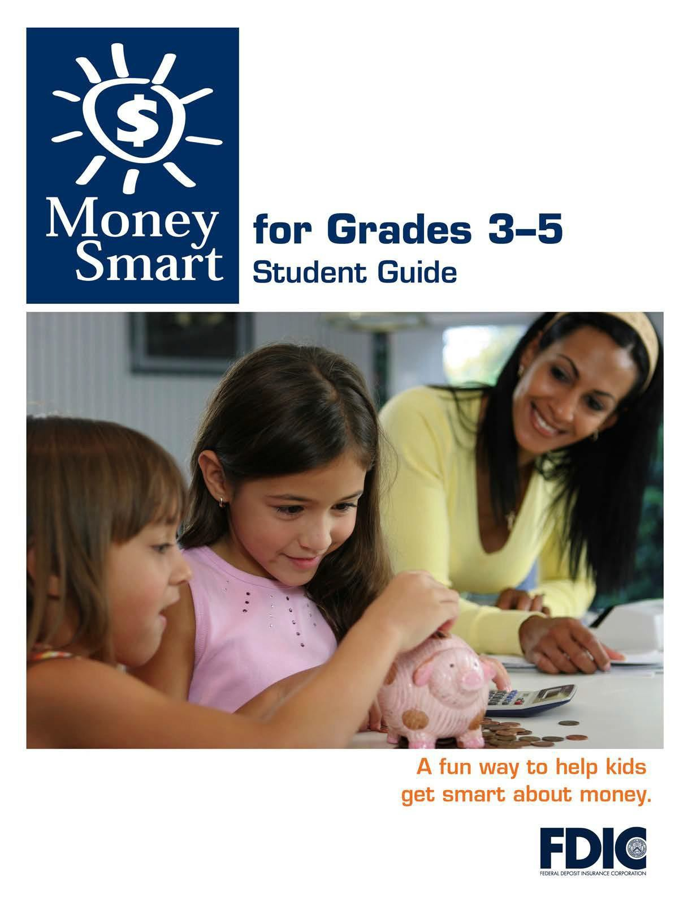

[1]

TABLE OF CONTENTS

Lesson 1: Money Matters (Buying Decisions) 3
  - Student Handout 1: Sort It Out
  - Student Handout 2: What Should I Buy?
  - Student Handout 3: Trade-Offs
  - Student Handout 4: Money Smart Book

MONEY SMART FOR GRADES 3–5: STUDENT GUIDE 2

SORT IT OUT

Name:

Directions: Take a group of items and sort them into two categories. Write the category name on the T-chart below. Write the items under each label.

For example:

Category: Yellow Category: Blue

sunflower lemon banana

blueberry blue jay jeans

Category: Category:

WHAT SHOULD I BUY?

Name:

A need is something that you cannot live without. A want is something you would like, but can live without.

Directions: Read each money situation below. Answer the questions to decide whether the items are needs or wants. Use that information to help make the best buying decision.

Situation A: Maya has $25 saved. Here are the things she would like to buy:

$15 – a magnet science kit. Maya loves science.

$8 – the latest book by her favorite author. She can’t wait to read it.

$20 – a new backpack for school. Her old backpack is badly damaged.

Is the science kit a need or a want?

Is the book a need or a want?

Is the backpack a need or a want?

Which item is the most important to buy?

How do you think Maya should spend her money? Please explain why.

WHAT SHOULD I BUY? (CONTINUED)

Situation B: Travis made $48 selling his old toys at a tag sale. Here are the things he would like to buy:

$22 – a new board game. Travis heard it was really fun.

$45 – a pair of sneakers. His old ones are getting too small.

$28 – a glow-in-the-dark construction set. A few of his friends have one.

Is the board game a need or a want?

Is the pair of sneakers a need or a want?

Is the construction set a need or a want?

Which item is the most important to buy?

How do you think Travis should spend his money? Please explain why.

MONEY SMART FOR GRADES 3–5: STUDENT GUIDE 5

TRADE-OFFS

Name:

Every decision you make has an opportunity cost. An opportunity cost

is the trade-off of making one choice over another? For example, if you choose to play outside, you might be giving up the opportunity to read a book indoors. If you only have $3 and choose to buy a notebook with the money, you give up the opportunity to buy something else, such as pencils or a pack of gum.

Directions: Think about a time you gave up one choice for another. Then fill in your answers to each statement or question below.

Describe a time you had to make one choice overanother.

What did you choose?

What opportunity did you give up?

Why did you make that choice?

How did you feel about your decision? Why?

MONEY SMART BOOK
Name:
Directions: What Money Smart lesson did you learn today? Write the lesson’s topic
and what you learned on the lines below. Then draw a picture about it in the “Draw About It” box.
Topic:
Draw About It
Write About It

