for Grades 3-5
Educator Guide

FDIC Disclaimer:
The books and online resources referenced in the Educator Guide and Parent/Caregiver Guide are examples/options that may be used to support the subject being taught and should not be considered as an endorsement by the Federal Deposit Insurance Corporation (FDIC). Reference to any specific commercial product, process, or service by trade name, trademark, manufacture, or otherwise does not constitute an endorsement, a recommendation, or a favoring by the FDIC or the United States government.
The FDIC Money Smart curriculum references books and provides links to other websites for convenience and informational purposes only. Users should be aware that when they select a link on the FDIC’s website to an external website, they are leaving the FDIC’s site. Linked sites are not under the control of the FDIC, and the FDIC is not responsible for the contents of any linked site or any link contained in a linked site, or any changes or updates to such sites. The FDIC is not responsible for any transmission received from a linked site. The inclusion of a link does not imply endorsement by the FDIC of the site, its content, advertisers, or sponsors. External sites may contain information that is copyrighted with restrictions on reuse. Permission to use copyrighted materials must be obtained from the original source and cannot be obtained from the FDIC.

TABLE OF CONTENTS
Welcome To Money Smart 4
Getting Started 5
Lessons At-a-Glance 8
Lesson 2: Get Set for Goals (Setting Goals) 9
Answer Key 13
Glossary 16

WELCOME TO MONEY SMART

Welcome to Money Smart, an exciting interactive exploration of the concepts of money. This standards-aligned, cross-curricular program is designed to promote financial understanding in children ages 8 through 11. You can use Money Smart to add engaging and enriching activities to Math, English Language Arts, and Social Studies lessons while also helping your students build the foundation to become financially responsible adults.
In Money Smart you will find:
- Eight Lessons with hands-on, cross-curricular activities that engage third- through fifth-grade students in discussing and exploring key financial concepts
- Teacher Presentation Slides, which provide helpful visuals, as well as fill-in charts tosupport the activities in each lesson
- A Student Guide with handouts that let students explore the topics covered in each lesson and apply their new knowledge
- A Parent/Caregiver Guide with information about topics and terms being covered inclass, conversation starters, online and literary sources, along with activities to try at home and around town
Developing positive financial habits equips students with 21st-century skills and tools that last a lifetime. We hope you and your students enjoy learning about money and its many uses.
We are eager to hear from you about how you use this curriculum. We would like to know what works well and what could be improved to make Money Smart even better. If you have any questions, we would like to help. Please contact us with your comments and questions via e-mail at communityaffairs@fdic.gov.

GETTING STARTED

Money Smart provides a comprehensive, developmentally appropriate program for upper elementary students to build an understanding of key financial concepts.
There are many features that help make the Money Smart curriculum engaging, motivating, and easy to use. Each lesson includes learning objectives, essential questions, supplies needed, and preparation required, as well as the following features and components to support easy integration of Money Smart activities into your instructional day.

STANDARDS
Each lesson promotes real-world connections through student-centered learning experiences and aligns to the following education standards and learning outcomes, including Common Core State Standards in mathematics and English Language Arts. The Education Standards Chart on pages 48- 57 identifies which standards are met in each lesson.
- Financial Literacy Jump$tartStandards
- English Language Arts Common Core State Standards
- Mathematics Common Core State Standards
- National Standards for Financial Literacy by the Council for Economic Education
- Partnership for 21st-Century Skills

GRADE-LEVEL MODIFICATIONS
Please note the modifications identified throughout lessons to differentiate learning experiences for beginner and advanced students. Modifications provide developmentally appropriate activity recommendations and extension opportunities.

PRESENTATION TIME
Each lesson plan includes an estimated time needed to teach the lesson. Actual time required will vary from classroom to classroom. The estimation includes instructional time spent on the Warm Up, Guided Exploration, and Wrap Up. Activities may also be taught as several short lessons over a period of days or weeks. Extended Exploration activities are included to extend financial literacy learning opportunities throughout the year and provide easy ways to integrate the topics into various content areas.

ASSESSMENTS
A variety of assessments are integrated throughout each of the eight lessons. Assessments are designed to build value, meaning, and context around a topic, while providing teachers with opportunities to evaluate prior student knowledge, and collect evidence of their new understandings of lesson concepts and skills. Pre- (formative) and post- (summative) assessments are noted on the first page of each lesson. Assessments include discussions, reflections, questions and answers, reading, writing, and problem-solving exercises. Student handouts are an especially useful form of written assessment.

LESSON STRUCTURE
Each lesson is designed to include the following:
- Warm Up introduces students to the topic and sparks inquiry.
- Guided Exploration integrates cross-curricular and developmentally appropriate learning activities and assessments while focusing on the keyfinancial literacy learning objectives of the lesson.
- Wrap Up provides a reflection question or activity to review lesson concepts andallow students to demonstrate theirunderstanding.
- Money Smart Tips are provided throughout lessons to offer additional guidance, interesting and relevant financial facts, and additional ideas to help make Money Smart a success in your classroom.
- Extended Exploration provides teachers with additional opportunities to extend financial literacy concepts throughout the school year within core and creative content areas including English Language Arts, Math. Activities can be completed as a class, in small groups, or by students individually. Useful resources (such as books, web links, games, or videos) arealso included to promote even more student engagement. The books and online resources suggested in this guide are just a few of the many available resources that explore these topics, and are not endorsed by the FDIC.
- Student Handouts (found in the Student Guide) and Teacher Presentation Slides provide dynamic instructional support. Student handouts create an opportunity for students to apply their knowledge and for teachers to assess their understanding. Teacher presentation materials offer visuals and interactive activities corresponding with each lesson, and can be projected for whole-group activities, or copied for small-group use.
- The Answer Key, Glossary, and Standards Chart house all of the information needed to check for understanding, define key terms, and check which activities meet specific education standards. Vocabulary words are bolded in each lesson as they are introduced. The vocabulary words can be used to create flash cards or a classroom Word Bank list. Students can also make their own Word Banks and refer to the lists as needed.

MONEY SMART AT HOME
The Money Smart curriculum includes a helpful Parent/Caregiver Guide that corresponds to the classroom resources. Families of young children may also use it independently of the curriculum. It contains resources, activities, games, and conversation starters on financial literacy topics covered in each lesson. Use the following ideas to encourage parents to use the guide at home:
- Introduce parents to the Money Smart program and share the Parent/Caregiver Guide atthe start of the school year.
- Discuss the Money Smart program during parent/teacher conferences, or in monthly parent newsletters home, and emphasize the importance of building healthy financial habits from an early age.
- Hold a Money Smart family night. Play games and have students present short skitsabout financial concepts they have learned.
- Send student handouts from each lesson home in each child’s homework folder for parentsto review and sign.

SMART BUCKS
Additional incentives can be used to promote positive financial behaviors and study habits throughout the Money Smart curriculum and school year. Introduce Smart Bucks to recognize students’ positive financial and classroom behaviors.
Smart Bucks can be earned for the following behaviors:
- Accomplishment of a goal(s)
- Completion of homework
- Exceptional classroom conduct
- Keeping the classroom clean and neat
- Participating in discussions or responding to questions
- Excellent group collaboration or individualwork
- Completing daily work
- Respectful behavior
As students accumulate Smart Bucks, they may spend them on prizes, toys, or special activities (for example: extra computer time, free reading time, game board time) at the end of the week or month, or whenever you normally provide rewards.
Smart Bucks may be tracked using a chart (displaying desired behaviors and goals), stored in a classroom “treasury” box, or in a cash register (if a class “store” is set up), and handed out to students using play money. Provide price tags or stickers on items or activities to be “sold.” The presentation for cashing in Smart Bucks can be as simple or elaborate as you choose.
Aside from being a fun way to reward positive behaviors, Smart Bucks can help foster an application of the financial literacy concepts covered in Money Smart lessons.
With Smart Bucks, students can practice:
- Math skills when adding the total of “Smart Bucks” earned
- The concept of making change without using acalculator
- The value of saving as they choose to save instead of spend, or set a goal to save for a more desired choice
Use Smart Bucks during Money Smart lessons or continue throughout the year.

FINANCIAL LITERACY ALL YEAR LONG
Highlight financial literacy at your school all year long, especially in April, during National Financial Literacy and School Library Month.
- Create bulletin boards or posters with students about financial literacy themes learnedin

Money Smart.
- Play games that focus on numeracy skills and financial concepts (such as Monopoly).
- Feature children’s literature selections that cover financial literacy concepts in the library or during classroom reading time. See the Parent/Caregiver Guide for more literaturesuggestions.
The more students are exposed to financial literacy, and the more opportunity they have to practice applying their new knowledge and understanding of concepts, at school and at home, the more prepared they will be to live Money Smart lives.

LESSONS AT-A-GLANCE
Lesson Title Topic
Learning Objectives
Time Required

2 Get Set
for Goals
Setting Goals
•Identify and develop ways to set short-
term and long-term goals for saving
•Explain the importance of setting goals for saving
•Identify things that might affect decisions to spend or save money
60 min

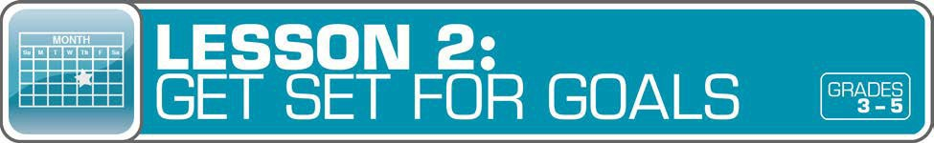
Answer Key 13
Glossary with key vocabulary 16

LESSON OVERVIEW
Learning to set goals helps students manage money. The lesson focuses on short- and long-term goals, as they relate to saving, with real-world examples. Students then set their own savings goals. In addition, they explore factors (such as advertising and peer pressure) that might influence their decisions to spend or save money.
TOPIC: Setting Goals

TIME REQUIRED: 60 minutes
(excluding Extended Exploration activities)

LEARNING OBJECTIVES:
Students will be able to…
- Identify and develop ways to set short- term and long-term goals for saving
- Explain the importance of setting goals for saving
- Identify things that might affectdecisions to spend or save money

SUPPLIES:
- Whiteboard or chart paper, markers
- Projector (for teacher presentationslides)
- Access to the Internet (optional)
- Magazines (optional; see the last
Extended Exploration activity)

PREPARATION:
- Make copies of student handouts
- Set up projector with presentation slides

STUDENT HANDOUTS:
(found in Student Guide)
- Short- and Long-Term Goals
- What Are Your Goals?
- Saving Together
- My Savings Goals
- Money Smart Book
(template from Lesson 1)
TEACHER PRESENTATION SLIDES:

Spend or Save?

Story Problems: Savings Goal (Challenges 1, 2)

How to Set Goals

ESSENTIAL QUESTIONS:
- What is a goal?
- What is the difference between
a short-term goal and a long-term goal?
- Why is it important to set goals?
- What is a savings goal?
- What is the purpose of advertising?
- How might advertising influence your decisions to spend or save money?

ASSESSMENT ACTIVITIES:
PRE-ASSESSMENT:
- Short- and Long-Term Goals handout
- Saving Together handout
POST-ASSESSMENT:
- My Savings Goals handout
- Money Smart Book handout

INSTRUCTION STEPS
WARM UP

DIFFERENTIATING BETWEEN SHORT- AND LONG-TERM GOALS [15 MINUTES]
Draw a T-chart on a whiteboard or chart paper with the words “short-term goals” and “long-term goals” and ask students: What is a goal? (A goal is something you plan to achieve.) What is the difference between a short-term goal and a long-term goal? (A short-term goal is something you want to achieve soon, such as in two weeks or a few months. A long-term goal is something you want to achieve in the future — in one year, five years, or when you’re an adult.)
Have students brainstorm some examples of short-term goals (for example: participating in class, doing well on a project, earning high grades, finishing a book, or jumping rope for two hours this week) and long-term goals (for example: reading 50 books by the end of the year, going to college, or getting the job you’ve always wanted). Write the examples on the T-chart.
Distribute the Short- and Long-Term Goals handout to demonstrate real-world examples. After students complete the activity, review as a whole class.
Explain to students that they will now have a chance to write some of their short- and long-term goals. Give students the What Are Your Goals? handout. To help students get started, prompt them to think about short- and long-term goals in school, at home, and in life. Although students will fill out their own goals, encourage them to work with a partner to help them brainstorm ideas. Ask students to share some of their goals.

Grade-Level Modifications:
Beginner: To simplify, have students focus on goals in the classroom or at school.
Advanced: Invite students to set more goals, and track their weekly or monthly progress to see what goals they have met.

GUIDED EXPLORATION
DEVELOPING WAYS TO SET GOALS FOR SAVINGS [30 MINUTES]
Display the Spend or Save? slide and ask students for a show of hands to the statement about their spending/saving habits.

MONEY SMART TIP!

Use classroom awards or Smart Bucks (see page 7)

as an example to discuss the concepts of spending and saving.

Using the slide, create a bar graph to see how many students are spenders, savers, or acombination of the two. Then ask students: What is a savings goal? (A savings goal is an amount of money you plan to put aside to buy something.) Lead students in a discussion about how short- and long-term goals might relate to savings. For example: saving to buy an ice cream or new notebook at the end of the week is a short-term goal. Saving enough money to buy a bicycle at the end of the year isa

long-term goal. Saving money to go to college is also a long-term goal. Explain that setting savings goals will help students manage their money.
Give students the Saving Together handout to demonstrate a real-world example of children setting a savings goal. After students complete the questions (including math problems), review as a class.
Then display the Story Problems: Savings Goal slides (Challenge 1 or 2) with two more real-life math word problems about savings goals.

Grade-Level Modifications:
Beginner: Ask students to draw pictures to help them solve the math problem(s) and to explain how they solved it.
Advanced: Have students show their math calculations and explain how they solved the problem(s). For Challenge 2, ask: How long will it take Sam to save enough money for the basketball if he made $4 a week (instead of $3) feeding cats? (four weeks)
Display the How to Set Goals slide to demonstrate some ways to set goals. Review and discuss. Then review the difference between a short-term and long-term savings goal by asking students: What is a short-term savings goal? (A short-term savings goal is an amount of money you plan to save in order to buy something soon, such as in two weeks or a few months.) What is a long-term savings goal? (A long-term savings goal is an amount of money you plan to save to buy something in the future, such as in one year, five years, ten years, or more.)
Tell students that they will be setting their own savings goals. (Note: You may want to have students focus on Smart Bucks, instead of actual money, using the prizes, toys, or special activities that you will provide for them to “purchase.”) Then give students the My Savings Goals handout to set their own savings goals. Invite students to share some of their personal goals.

MONEY SMART TIP!

Before students set their savings goals, give them the following tip:

Before you set a savings goal, ask yourself: Is what I want to buy worth the money?

Did I give myself enough time to save for it?

CONSIDERING INFLUENTIAL PURCHASING FACTORS [5 MINUTES]
Ask students: What are some things that might influence your decision to spend or save money? (Answers may include: the importance of what I need to buy, whether it is a need or a want, whether I can wait to buy it, how much money I have, peer pressure, advertising, my parents.)
Then ask students: Do you ever want something because other kids have it? If you haven’t already done so, define peer pressure (being influenced by others in the same age group). Ask: What is the purpose of advertising? (To persuade others to buy the product so the company who paid for the ad can make money.) How might advertising influence your decisions to spend or save money? (Advertising may influence you to want to spend money instead of saving it, or spend more money than you were planning to spend.)
Have students brainstorm places they can find advertising (in magazines, on billboards, in stores, on television, on the radio and websites, on the sides of buses and cars, and so on). Discuss advertising and peer pressure as influences on decisions to spend or save money.

WRAP UP
CLASS REFLECTION [10 MINUTES]
Initiate a class discussion by asking students: Why is it important to set goals? How will you feel when you reach your goals? Have students answer these discussion questions in their Money Smart Book (using a blank copy of the template in Student Guide from Lesson 1).

EXTENDED EXPLORATION
Note: Use the following activities to extend the lesson topic throughout the year. Activities can be completed as a class or in small groups. Duration of activities will vary.
- After students complete the What Are Your Goals? handout, have them think about steps required to get to those goals. Then ask students to create an actual plan for meeting their goals by listing the steps they will take.

Grade-Level Modification:
Beginner: Have students choose one goal to focus on, and then list the steps to meet it.
- Invite students to play an online game at http://game.admongo.gov, to learn about advertising and how companies use ads to try to influence how people spend their money. Students can also visit http://pbskids.org/dontbuyit to learn more about advertising tricks and media literacy. Then have them create posters about what they have learned about advertising. Display in the hallway to teach other students.
- Give students the opportunity to further explore advertising strategies by thinking abouthow and why brands sell and market to kids. Have students create their own magazine ads for made-up products using magazine examples for ideas. Before they begin, ask students to identify the target audience for their ads.

Grade-Level Modifications:
Beginner: Have students work with a partner to create their magazine ad.
Advanced: Ask students to point out ways their ad is trying to influence the buyer.

ANSWER KEY

for Student Handouts (found in Student Guide)

LESSON 1: MONEY MATTERS
Student Handout 1: Sort It Out. Answers will vary.

Student Handout 2: What Should I Buy?
Situation A: 1. want, 2. want, 3. need, 4. backpack, 5. Answers may include: Maya should spend her money on a new backpack. It is the most important because it is a need. Her old backpack is badly damaged.
Situation B: 1. want, 2. need, 3. want, 4. a pair of sneakers, 5. Answers may include: Travis should spend his money on a new pair of sneakers. It is the most important because it is a need. His old sneakers are getting too small.

Student Handout 3: Trade-Offs. Answers will vary.

Student Handout 4: Money Smart Book. Answers will vary.

LESSON 2: GET SET FOR GOALS
Student Handout 1: Short- and Long-Term Goals
Situation A: 1. Ella wants to challenge her brother to a basketball game. 2. Ella plans to join the basketball team when she gets to middle school. 3. She can keep practicing to improve her basketball skills.
Situation B: 1. Max wants to get a good grade on his French test next week. 2. Max wants to visit France when he is older. 3. Answers will vary, but may include: Max can keep studying and practicing French. Max can save money for a trip to France.

Student Handout 2: What Are Your Goals? Answers will vary.

Student Handout 3: Saving Together
1. Their savings goal is $150 to buy a tablet computer. 2. They want to reach their goal in one year.
3. It is a long-term goal. 4. They still need to save $120 ($150 – $20 = $130 – $10 = $120, or $150 – ($20 + $10)
= $120). 5. Each child will pay $75 ($150 ÷ 2 = $75). 6. Answers will vary.

Student Handout 4: My Savings Goals. Answers will vary.

LESSON 3: MAKE A PLAN
Student Handout 1: Jake’s Budget
Total monthly expenses: $1,620. Questions: 1. $180, 2. $1,800, 3. $910, 4. $510 ($410 + $100 = $510),
- $25 ($200 – $175 = $25), 6. Answers will vary, but may include clothes and entertainment (movies, bowling, sports games, concerts, etc.).

ANSWER KEY (continued)

Student Handout 2: Finish That Budget!
Monthly Income: Taking care of younger brother: $8, Getting the neighbor’s mail: $2, Total: $10; Monthly Expenses: Snacks and supplies: $9; Monthly Savings: $1. Questions: 1. 25 cents ($1 or 100 cents – 75 cents = 25 cents), 2. $12 ($1 per month, or $1 x 12 = $12), 2. Answers will vary, but may include: She can spend less on snacks and supplies, compare prices, get another job.

Student Handout 3: My Budget
Answers will vary, unless students use the suggested numbers of $15 monthly income and $8 monthly expenses. If so: Monthly Savings: $7. Questions: 1. $84 ($7 x 12 months = $84), 2. Answers will vary, but may include: I can spend less by comparing prices, buying fewer wants.

LESSON 4: SAVE YOUR MONEY
Student Handout 1: Calculate the Interest
  - C ($2), 2. B ($300 + $3 interest = $303), 3. A ($800, based on the chart, solutions may include: $8 x 100 or
$8 is the sum of $3 + $5, which corresponds to $300 + $500 = $800)

Student Handout 2: What Are the Risks?
Risks of Riding a Bicycle: Answers will vary, but may include: falling, getting hit by a car, a flat tire.
Ways to Avoid or Reduce the Risks: Answers will vary, but may include: wearing a helmet, riding in a safe area away from cars, carrying a bicycle pump.

Student Handout 3: Money Smart Book Comic Strip. Answers will vary.

LESSON 5: WHICH WAY TO PAY?
Student Handout 1: Payment Options: True or False?
1. True, 2. True, 3. False (Credit cards and debit cards are made of plastic.), 4. True, 5. False (If you use a credit card, you receive a monthly bill.), 6. False (Credit cards do set limits to how much you can spend.),
7. True, 8. False (A debit is money removed from an account.), 9. True, 10. True

Student Handout 2: Payment Decisions
- She should pay using the credit card because she doesn’t have enough cash.
- He should pay with cash because the store only accepts cash.
- She should pay with her debit card because she doesn’t have enough cash.
- He should pay with his debit card because he has enough money in his checking account($2,800).
He shouldn’t use his credit card because he has a $3,000 credit card limit and has already charged $800. ($3,000 – $800 = $2,200. That is $100 less than his car bill of $2,300.)

Student Handout 3: Test Your Payment Knowledge
1. A (checks and debit cards), 2. C (month), 3. C (using a credit card), 4. B (check), 5. B (Keep your personal information private.)

ANSWER KEY (continued)

LESSON 6: GET INVESTED
Student Handout 1: Complete the Story
My friend Ty is always talking about his long-term money goals. He plans to manage his money wisely. When he is older, he wants to invest money in several places. First, he says he’ll buy a CD from the bank so he can earn interest. He may also buy a bond from the government. Later, he is going to buy stocks so he can own shares of a company. If the company makes a big profit, he could make a lot of money! But if the company does not, he could lose his money. Ty told me that’s a chance he’ll have to take. One day he might even start his own company.

Student Handout 2: Risk and Return
1. A (Buy a CD or U.S. government bond.), 2. B (Do some more research about stocks. You may also lose your money.), 3. C (stocks and high-risk bonds)

LESSON 7: IT’S GREAT TO DONATE!
Student Handout 1: Story Problem: Giving
1. $100, 2. 32 magnets ($64 ÷ $2 per magnet = 32 magnets), 3. $40 profit ($64 – $24 = $40), 4. $60 ($100 – $40 = $60), 5. 30 magnets ($60 ÷ $2 per magnet = 30 magnets)

Student Handout 2: Giving Plan and Budget. Answers will vary.

LESSON 8: CAREER CHOICES
Student Handout 1: Different Jobs. Answers will vary.

Student Handout 2: Interest Survey. Answers will vary.

Student Handout 3: Salary and Education
- C (Master’s), 2. $54,200 ($116,700 – $62,500 = $54,200), 3. Answers may include: They all require a higher education degree and pay more than $60,000 ayear.

GLOSSARY

Advertisement (Ad): A public notice or announcement that a company pays for to help promote and increase sales of a product or service.

Bank: A financial institution and business that accepts deposits and makes loans.

Borrow: To receive something on loan with the understanding that you will return it.

Budget: A plan that outlines what money you expect to earn or receive (your income) and how you will save it or spend it (your expenses) for a given period of time.
Career: The type of work a person pursues for the majority of their life that may involve formal education, special training, or be within a specific industry.
Cash: Money such as coins and bills.

Charity: The act of giving help or money to help people, animals, or communities in need; an organization that helps people, animals, or communities in need or supports social causes.
Check: A written order of payment that instructs a financial institution (such as a bank) to withdraw a specific amount of money from the check-writer’s account, and pay or deposit it to the person, or business, named on the check.
Credit: The ability to borrow money and pay it back later.

Debit: An amount of money taken out of a deposit account to pay for something.

Debt: Money that is owed.

Donation: Something (including money, food, clothes, and toys) that you give to help people, animals, or communities in need or to a charity.
Earn: To receive money in exchange for goods or services. Emergency Fund: Money set aside to pay for unexpected expenses. Entrepreneur: Someone who creates and runs a business.
Expense: The cost of goods and services; the amount of money that is spent.

Federal Deposit Insurance Corporation (FDIC): Preserves and promotes public confidence in the U.S. financial system by insuring deposits in banks and thrift institutions for at least $250,000. An independent agency of the federal government, the FDIC was created in 1933.
Goal: Something you wish to achieve or accomplish in a specific amount of time.

Income: Money that you receive from jobs, allowances, interest, dividends, and other sources.

Interest: Money that a bank or other financial institution pays you for keeping money on deposit with them, or the amount of money you pay a bank as a fee when you borrow money.

GLOSSARY (continued)

Invest: To put money at risk with the goal of making a profit in the future.

Job: A specific duty, task, or activity someone completes using his or her time, skills, and energy to earn money.

Lend: The act of giving something to someone with the understanding that they will give it back to you.

Long-Term Goal: Something you want to achieve in the future, such as in one year, five years, ten years, or more.

Money Order: Similar to a check, but can be purchased at a bank or post office, and used to make a payment of a specified sum of money.
Need: Something you must have to survive, such as clothes, shelter, or food.

Opportunity Cost: The next best thing that you give up in order to do something else; a trade-off of a decision you make.
Profit: The money gained or left over after money spent (expense) is subtracted from money earned (income).

Return: Money made (profit) from an investment.

Risk: The possibility that something unplanned or unintended may happen (such as losing money).

Save: Setting something, like money, aside to use in the future.

Savings Account: A bank account that you can use to set aside money, and that pays you interest.

Savings Goal: The amount of money you plan to put aside for a specific purpose.

Short-Term Goal: Something you want to achieve soon, such as in two weeks or a few months.

Spend: The act of using money to buy goods or services.

Spending Limit: The most amount of money a person is allowed (or allows themselves) to spend.

Tax: Money that someone has to pay to help finance a government.

Want: Something that you would like to have but that you could live without.

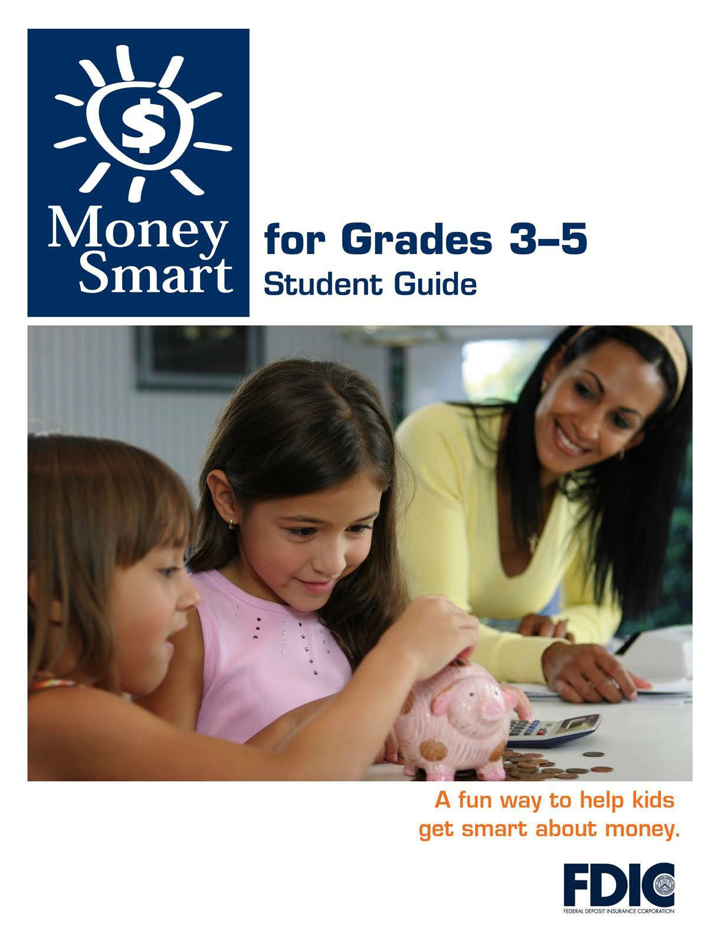

[1]

TABLE OF CONTENTS

Lesson 2: Get Set for Goals (Setting Goals) 3
  - Student Handout 1: Short- and Long-TermGoals
  - Student Handout 2: What Are Your Goals?
  - Student Handout 3: Saving Together
  - Student Handout 4: My Savings Goals

MONEY SMART FOR GRADES 3–5: STUDENT GUIDE 2

SHORT- AND LONG-TERM GOALS

Name:

A short-term goal is something you want to achieve soon, such as in two weeks or a few months. A long-term goal is something you want to achieve in the future—in one year, five years, or when you are an adult.

Directions: Read each situation below. Then answer the questions that follow.

Situation A: Ella, age 8, has been working on her basketball skills. She wants to challenge her older brother to a game next month. He is in middle school and plays on the basketball team. Ella is planning to try out for the basketball team when she gets to middle school.

What is Ella’s short-term goal?

What is Ella’s long-term goal?

How might Ella reach her goals?

Situation B: Max is learning to speak French so he can talk to his relatives in France. He wants to get a good grade on his French test next week. When Max is older, he wants to visit France to meet his relatives.

What is Max’s short-term goal?

What is Max’s long-term goal?

How might Max reach his goals?

MONEY SMART FOR GRADES 3–5: STUDENT GUIDE
3

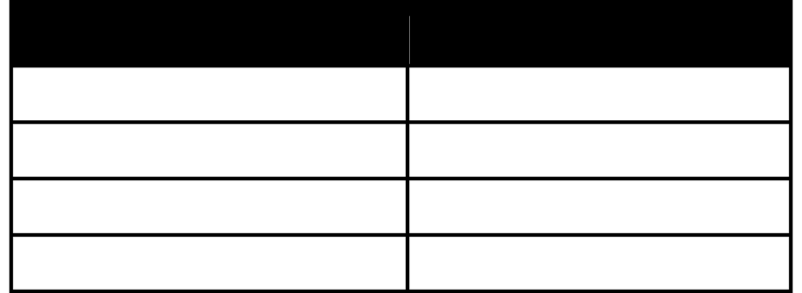
WHAT ARE YOUR GOALS?
Name:
A short-term goal is something you want to achieve soon, such as in two weeks
or a few months. A long-term goal is something you want to achieve in the future— in one year, five years, or when you’re an adult.
Directions: Write some of your short-term and long-term goals in the chart below. Then answer the questions that follow.
Short-Term Goal
Long-Term Goal

- What is your most important short-term goal?

  - When do you want to reach that goal?

  - How might you reach that goal?
- What is your most important long-term goal?

  - When do you want to reach that goal?

  - How might you reach that goal?
MONEY SMART FOR GRADES 3–5: STUDENT GUIDE
4

SAVING TOGETHER

Name:

A savings goal is the amount of money you plan to save in order to buy something. A short-term savings goal is an amount you are saving in order to buy something very soon, such as in two weeks or a few months. A long-term savings goal is an amount you are saving in order to buy something in the future, such as in one year, five years, or more.

Directions: Read the situation below and answer the questions that follow.

Jake and his sister, Anna, are saving their money for a tablet computer. The one they want costs $150. Jake has $20 so far and Anna has $10. They want to buy the computer in one year.

What savings goal have Jake and Anna set?

When do they want to reach their goal?

Is the goal a short-term or long-term one?

How much more money do they need to reach the goal? (Please show your math.)

If they split the cost in half, how much will each child pay? (Please show your math.)

What might they do to reach their savings goals?

MY SAVINGS GOALS

Name:

Directions: Complete the sentences below to help reach your savings goals.

My Short-Term Savings Goal

What is something you are saving for in the short term?

Is it a want or a need?

How much money does it cost (your savings goal)?

How much money do you plan to save each week to reach your savingsgoal?

How many weeks do you need to save to reach your savingsgoal?

My Long-Term Savings Goal

What is something you are saving for in the longterm?

Is it a want or a need?

How much money does it cost (your savings goal)?

How much money do you plan to save each week to reach your savings goal?

How many weeks do you need to save to reach your savingsgoal?

