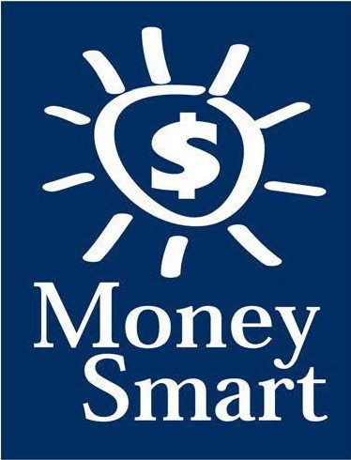
for Grades 3-5
Educator Guide

FDIC Disclaimer:
The books and online resources referenced in the Educator Guide and Parent/Caregiver Guide are examples/options that may be used to support the subject being taught and should not be considered as an endorsement by the Federal Deposit Insurance Corporation (FDIC). Reference to any specific commercial product, process, or service by trade name, trademark, manufacture, or otherwise does not constitute an endorsement, a recommendation, or a favoring by the FDIC or the United States government.
The FDIC Money Smart curriculum references books and provides links to other websites for convenience and informational purposes only. Users should be aware that when they select a link on the FDIC’s website to an external website, they are leaving the FDIC’s site. Linked sites are not under the control of the FDIC, and the FDIC is not responsible for the contents of any linked site or any link contained in a linked site, or any changes or updates to such sites. The FDIC is not responsible for any transmission received from a linked site. The inclusion of a link does not imply endorsement by the FDIC of the site, its content, advertisers, or sponsors. External sites may contain information that is copyrighted with restrictions on reuse. Permission to use copyrighted materials must be obtained from the original source and cannot be obtained from the FDIC.

TABLE OF CONTENTS
Welcome To Money Smart 4
Getting Started 5
Lessons At-a-Glance 8
Lesson 3: Make a Plan (Budgeting) 9
Answer Key 13
Glossary 16

WELCOME TO MONEY SMART

Welcome to Money Smart, an exciting interactive exploration of the concepts of money. This standards-aligned, cross-curricular program is designed to promote financial understanding in children ages 8 through 11. You can use Money Smart to add engaging and enriching activities to Math, English Language Arts, and Social Studies lessons while also helping your students build the foundation to become financially responsible adults.
In Money Smart you will find:
- Eight Lessons with hands-on, cross-curricular activities that engage third- through fifth-grade students in discussing and exploring key financial concepts
- Teacher Presentation Slides, which provide helpful visuals, as well as fill-in charts to support the activities in each lesson
- A Student Guide with handouts that let students explore the topics covered in each lesson and apply their new knowledge
- A Parent/Caregiver Guide with information about topics and terms being covered in class, conversation starters, online and literary sources, along with activities to try at home and around town
Developing positive financial habits equips students with 21st-century skills and tools that last a lifetime. We hope you and your students enjoy learning about money and its many uses.
We are eager to hear from you about how you use this curriculum. We would like to know what works well and what could be improved to make Money Smart even better. If you have any questions, we would like to help. Please contact us with your comments and questions via e-mail at communityaffairs@fdic.gov.

GETTING STARTED

Money Smart provides a comprehensive, developmentally appropriate program for upper elementary students to build an understanding of key financial concepts.
There are many features that help make the Money Smart curriculum engaging, motivating, and easy to use. Each lesson includes learning objectives, essential questions, supplies needed, and preparation required, as well as the following features and components to support easy integration of Money Smart activities into your instructional day.

STANDARDS
Each lesson promotes real-world connections through student-centered learning experiences and aligns to the following education standards and learning outcomes, including Common Core State Standards in mathematics and English Language Arts. The Education Standards Chart on pages 48- 57 identifies which standards are met in each lesson.
- Financial Literacy Jump$tart Standards
- English Language Arts Common Core State Standards
- Mathematics Common Core State Standards
- National Standards for Financial Literacy by the Council for Economic Education
- Partnership for 21st-Century Skills

GRADE-LEVEL MODIFICATIONS
Please note the modifications identified throughout lessons to differentiate learning experiences for beginner and advanced students. Modifications provide developmentally appropriate activity recommendations and extension opportunities.

PRESENTATION TIME
Each lesson plan includes an estimated time needed to teach the lesson. Actual time required will vary from classroom to classroom. The estimation includes instructional time spent on the Warm Up, Guided Exploration, and Wrap Up. Activities may also be taught as several short lessons over a period of days or weeks. Extended Exploration activities are included to extend financial literacy learning opportunities throughout the year and provide easy ways to integrate the topics into various content areas.

ASSESSMENTS
A variety of assessments are integrated throughout each of the eight lessons. Assessments are designed to build value, meaning, and context around a topic, while providing teachers with opportunities to evaluate prior student knowledge, and collect evidence of their new understandings of lesson concepts and skills. Pre- (formative) and post- (summative) assessments are noted on the first page of each lesson. Assessments include discussions, reflections, questions and answers, reading, writing, and problem-solving exercises. Student handouts are an especially useful form of written assessment.

LESSON STRUCTURE
Each lesson is designed to include the following:
- Warm Up introduces students to the topic and sparks inquiry.
- Guided Exploration integrates cross-curricular and developmentally appropriate learning activities and assessments while focusing on the keyfinancial literacy learning objectives of the lesson.
- Wrap Up provides a reflection question or activity to review lesson concepts and allow students to demonstrate their understanding.
- Money Smart Tips are provided throughout lessons to offer additional guidance, interesting and relevant financial facts, and additional ideas to help make Money Smart a success in your classroom.
- Extended Exploration provides teachers with additional opportunities to extend financial literacy concepts throughout the school year within core and creative content areas including English Language Arts, Math. Activities can be completed as a class, in small groups, or by students individually. Useful resources (such as books, web links, games, or videos) are also included to promote even more student engagement. The books and online resources suggested in this guide are just a few of the many available resources that explore these topics, and are not endorsed by the FDIC.
- Student Handouts (found in the Student Guide) and Teacher Presentation Slides provide dynamic instructional support. Student handouts create an opportunity for students to apply their knowledge and for teachers to assess their understanding. Teacher presentation materials offer visuals and interactive activities corresponding with each lesson, and can be projected for whole-group activities, or copied for small-group use.
- The Answer Key, Glossary, and Standards Chart house all of the information needed to check for understanding, define key terms, and check which activities meet specific education standards. Vocabulary words are bolded in each lesson as they are introduced. The vocabulary words can be used to create flash cards or a classroom Word Bank list. Students can also make their own Word Banks and refer to the lists as needed.

MONEY SMART AT HOME
The Money Smart curriculum includes a helpful Parent/Caregiver Guide that corresponds to the classroom resources. Families of young children may also use it independently of the curriculum. It contains resources, activities, games, and conversation starters on financial literacy topics covered in each lesson. Use the following ideas to encourage parents to use the guide at home:
- Introduce parents to the Money Smart program and share the Parent/Caregiver Guide atthe start of the school year.
- Discuss the Money Smart program during parent/teacher conferences, or in monthly parent newsletters home, and emphasize the importance of building healthy financial habits from an early age.
- Hold a Money Smart family night. Play games and have students present short skits about financial concepts they have learned.
- Send student handouts from each lesson home in each child’s homework folder for parents to review and sign.

SMART BUCKS
Additional incentives can be used to promote positive financial behaviors and study habits throughout the Money Smart curriculum and school year. Introduce Smart Bucks to recognize students’ positive financial and classroom behaviors.
Smart Bucks can be earned for the following behaviors:
- Accomplishment of a goal(s)
- Completion of homework
- Exceptional classroom conduct
- Keeping the classroom clean and neat
- Participating in discussions or responding to questions
- Excellent group collaboration or individual work
- Completing daily work
- Respectful behavior
As students accumulate Smart Bucks, they may spend them on prizes, toys, or special activities (for example: extra computer time, free reading time, game board time) at the end of the week or month, or whenever you normally provide rewards.
Smart Bucks may be tracked using a chart (displaying desired behaviors and goals), stored in a classroom “treasury” box, or in a cash register (if a class “store” is set up), and handed out to students using play money. Provide price tags or stickers on items or activities to be “sold.” The presentation for cashing in Smart Bucks can be as simple or elaborate as you choose.
Aside from being a fun way to reward positive behaviors, Smart Bucks can help foster an application of the financial literacy concepts covered in Money Smart lessons.
With Smart Bucks, students can practice:
- Math skills when adding the total of “Smart Bucks” earned
- The concept of making change without using a calculator
- The value of saving as they choose to save instead of spend, or set a goal to save for a more desired choice
Use Smart Bucks during Money Smart lessons or continue throughout the year.

FINANCIAL LITERACY ALL YEAR LONG
Highlight financial literacy at your school all year long, especially in April, during National Financial Literacy and School Library Month.
- Create bulletin boards or posters with students about financial literacy themes learned in

Money Smart.
- Play games that focus on numeracy skills and financial concepts (such as Monopoly).
- Feature children’s literature selections that cover financial literacy concepts in the library or during classroom reading time. See the Parent/Caregiver Guide for more literature suggestions.
The more students are exposed to financial literacy, and the more opportunity they have to practice applying their new knowledge and understanding of concepts, at school and at home, the more prepared they will be to live Money Smart lives.

LESSONS AT-A-GLANCE
Lesson Title Topic
Learning Objectives
Time Required

3 Make

a Plan
Budgeting •Explain the term “budget”
•Identify categories of a budget (income, expenses, savings)
•Create a budget
•Apply budgeting skills to real-world scenarios
•Understand the concept of “pay yourself first”
60 min

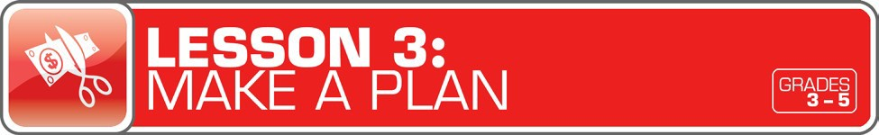

LESSON OVERVIEW

Learners put their financial skills to the test in this module as they travel through a simulation on creating a budget. The module will explore fundamental elements of creating a plan for how students spend their money and reach their savings goals. In addition, the module will provide real-world scenarios for students to apply budgeting principles.

TOPIC: Budgeting

TIME REQUIRED: 60 minutes
(excluding Extended Exploration activities)

LEARNING OBJECTIVES:
Students will be able to…
- Explain the term “budget”
- Identify categories of a budget (income, expenses, savings)
- Create a budget
- Apply budgeting skills to real-world scenarios
- Understand the concept of “pay yourself first”

SUPPLIES:
- Projector (for teacher presentation slides)
- Whiteboard or chart paper, markers
- Lined paper, pencils (for students)
- Access to the Internet (optional)
- Suggested books (optional)
o Lunch Money by Andrew Clements

PREPARATION:
- Make copies of student handouts
- Set up projector with presentation slides
Answer Key 13
Glossary with key vocabulary 16
STUDENT HANDOUTS:
(found in Student Guide)

Jake’s Budget

Finish That Budget!

My Budget

Money Smart Book
(template from Lesson 1)

TEACHER PRESENTATION SLIDES:

How Much Is $10,000?

Story Problems: Budget

Spending Limits

Pay Yourself First

ESSENTIAL QUESTIONS:
- What is a budget, and how is it useful?
- Why is it important to set spending limits?
- How can you stay within a budget (spending plan)?
- What does “pay yourself first” mean?

ASSESSMENT ACTIVITIES:
Pre-Assessment:
- Jake’s Budget handout
- Finish That Budget! handout
Post-Assessment:
- My Budget handout
- Money Smart Book handout

INSTRUCTION STEPS
WARM UP
DEFINING THE TERM “BUDGET” [25 MINUTES]
Ask students to imagine that they each have won $10,000. Display the How Much Is $10,000? slide to review examples that will provide students with an idea of how much $10,000 really is. Ask students to write a paragraph or two about what they would do with the money. Ask for volunteers to share their ideas.
Next, ask: What is a budget? (a spending plan) Why is it useful and how can it help? (It helps someone decide how much money can be spent and how to spend it.) Give students the Jake’s Budget handout (featuring a real-world scenario of a budget using an example of monthly expenses of food, rent, and other needs). Have students complete the handout and share their answers.
Now tell students to imagine that they are grown up and the $10,000 they won is their entire income for six months. Display the Story Problems: Budget slide and have students use the budget to solve the math questions. Provide students with paper and pencils to do the calculations. Review the problems and answers, then discuss.

Grade-Level Modifications:
Beginner: If students are having trouble with the math, complete the first problem as a whole class by displaying the number sentence required to solve the problem: $10,000 – $1,800 =
$8,200. Then have students solve the remaining problems with a partner. Ask them to show their work. If students need help with the math, you may want to guide them through all three problems. See the Answer Key for the number sentences.
Advanced: Have students work independently. They may also try to figure out how much would be left from their winnings after three months, four months, and so on.

MONEY SMART TIP!

Explain to students that, over time, little savings can add up to a lot!
If you set aside a little money for your savings every time you make money, you will soon see your savings grow. Ask: If you save a dollar every week, what would it grow into
after a month? (about $4) 6 months? ($26, or about $24) A year? ($52) 5 years? ($260)

GUIDED EXPLORATION

SETTING SPENDING LIMITS AND “PAYING YOURSELF FIRST” [10 MINUTES]
Explain that having a budget helps people set spending limits. Ask students: What is a limit? (A point beyond which a person or thing is not allowed to pass.) Ask: Why might it be useful to set spending limits? (Setting spending limits can stop a person from overspending and running out of money.) Display the Spending Limits slide and discuss the cartoon. Ask students what they think it means and why it might be risky to go beyond the spending limit.

Then display the Pay Yourself First slide to explore the concept of “paying yourself first.” (When you earn or receive money, make sure to save and set some of it aside for yourself before you spend it.) Ask: Why might it be a good idea to pay yourself first? (It will help you save some of your money.) Why is it important to save some of your money? (You will have money to use for things you need to buy in the future.) Remind students that a budget is a spending plan that can help them manage their money, save for emergencies, and meet their goals, and that they will learn to create a budget in the next activity.

EXPLORING BUDGETS (SPENDING PLANS) [15 MINUTES]
Ask students: What are different ways children can make money? (For example: gifts from friends and family, money for doing chores, selling lemonade or cookies, tag sales.) Write their ideas on a whiteboard or chart paper. Explain that money coming in is an income. Anyone with an income, including children, can use a budget to help manage his or her money.
Distribute the Finish That Budget! handout so students can complete a budget. Review answers together. Then give students the My Budget handout so they can create their own budget. Ask: How can you stay within a budget (spending plan)? (You can stay within a budget by writing it down, checking it regularly, and sticking to your plan. If your plan is too difficult to achieve, you can always change it.)

Grade-Level Modifications:
Beginner: Invite one student to read the Finish That Budget! handout directions aloud. Remind students that they need to fill in the budget before answering the questions and then review how to figure out the “Monthly Savings” (income minus expenses). If students are still having trouble with the handout, complete as a class. Then have them work on the My Budget handout in small groups or with a partner.
Advanced: After working on the Finish That Budget! handout, ask students: How much would Kayla have left in savings after one year if she only put 75 cents into her monthly savings? ($9)

WRAP UP
CLASS REFLECTION [10 MINUTES]
Ask: Why is it useful to create a budget? Why might schools, business, and governments need budgets? (Schools, governments, and companies all have budgets to plan for what they need.) Ask students: What needs might governments have to plan for? (For example: a new bus, road and bridge repairs, fire department, and saving for emergencies. If any money is left over, it can be used for “wants,” such as new benches or flowerbeds in towns.)
As a final reflection and assessment, have students write a “Money Smart” book entry using
a Money Smart Book handout (template in Student Guide from Lesson 1) about what a budget is and why it is useful.

Grade-Level Modification:
Advanced: Have students write about what they might use a budget for when they grow up.

EXTENDED EXPLORATION
Note: Use the following activities to extend the lesson topic throughout the year. Activities can be completed as a class or in small groups. Duration of activities will vary.
- Invite students to test their budgeting skills by playing Mad Money at

http://pbskids.org/itsmylife/games/mad_money_flash.html.
- Let students try their hand at the Dollar a Glass game at http://bizkids.com/games/dollar-a- glass to test their business skills as the owner of a lemonade stand.
- Read Lunch Money by Andrew Clements, a book about a Greg, a money-obsessed sixth- grader, who starts his own comics company, forms a business partnership with his rival, Maura, and learns all about business along the way. The book can be used as a springboard for a class business project for students to earn money to use for class needs and wants. The business project may include ideas such as a comic book business (as in the book) or a bake sale, art sale, and so on.

ANSWER KEY

for Student Handouts (found in Student Guide)

LESSON 1: MONEY MATTERS
Student Handout 1: Sort It Out. Answers will vary.

Student Handout 2: What Should I Buy?
Situation A: 1. want, 2. want, 3. need, 4. backpack, 5. Answers may include: Maya should spend her money on a new backpack. It is the most important because it is a need. Her old backpack is badly damaged.
Situation B: 1. want, 2. need, 3. want, 4. a pair of sneakers, 5. Answers may include: Travis should spend his money on a new pair of sneakers. It is the most important because it is a need. His old sneakers are getting too small.

Student Handout 3: Trade-Offs. Answers will vary.

Student Handout 4: Money Smart Book. Answers will vary.

LESSON 2: GET SET FOR GOALS
Student Handout 1: Short- and Long-Term Goals
Situation A: 1. Ella wants to challenge her brother to a basketball game. 2. Ella plans to join the basketball team when she gets to middle school. 3. She can keep practicing to improve her basketball skills.
Situation B: 1. Max wants to get a good grade on his French test next week. 2. Max wants to visit France when he is older. 3. Answers will vary, but may include: Max can keep studying and practicing French. Max can save money for a trip to France.

Student Handout 2: What Are Your Goals? Answers will vary.

Student Handout 3: Saving Together
1. Their savings goal is $150 to buy a tablet computer. 2. They want to reach their goal in one year.
3. It is a long-term goal. 4. They still need to save $120 ($150 – $20 = $130 – $10 = $120, or $150 – ($20 + $10)
= $120). 5. Each child will pay $75 ($150 ÷ 2 = $75). 6. Answers will vary.

Student Handout 4: My Savings Goals. Answers will vary.

LESSON 3: MAKE A PLAN
Student Handout 1: Jake’s Budget
Total monthly expenses: $1,620. Questions: 1. $180, 2. $1,800, 3. $910, 4. $510 ($410 + $100 = $510),
- $25 ($200 – $175 = $25), 6. Answers will vary, but may include clothes and entertainment (movies, bowling, sports games, concerts, etc.).

ANSWER KEY (continued)

Student Handout 2: Finish That Budget!
Monthly Income: Taking care of younger brother: $8, Getting the neighbor’s mail: $2, Total: $10; Monthly Expenses: Snacks and supplies: $9; Monthly Savings: $1. Questions: 1. 25 cents ($1 or 100 cents – 75 cents = 25 cents), 2. $12 ($1 per month, or $1 x 12 = $12), 2. Answers will vary, but may include: She can spend less on snacks and supplies, compare prices, get another job.

Student Handout 3: My Budget
Answers will vary, unless students use the suggested numbers of $15 monthly income and $8 monthly expenses. If so: Monthly Savings: $7. Questions: 1. $84 ($7 x 12 months = $84), 2. Answers will vary, but may include: I can spend less by comparing prices, buying fewer wants.

LESSON 4: SAVE YOUR MONEY
Student Handout 1: Calculate the Interest
  - C ($2), 2. B ($300 + $3 interest = $303), 3. A ($800, based on the chart, solutions may include: $8 x 100 or
$8 is the sum of $3 + $5, which corresponds to $300 + $500 = $800)

Student Handout 2: What Are the Risks?
Risks of Riding a Bicycle: Answers will vary, but may include: falling, getting hit by a car, a flat tire.
Ways to Avoid or Reduce the Risks: Answers will vary, but may include: wearing a helmet, riding in a safe area away from cars, carrying a bicycle pump.

Student Handout 3: Money Smart Book Comic Strip. Answers will vary.

LESSON 5: WHICH WAY TO PAY?
Student Handout 1: Payment Options: True or False?
1. True, 2. True, 3. False (Credit cards and debit cards are made of plastic.), 4. True, 5. False (If you use a credit card, you receive a monthly bill.), 6. False (Credit cards do set limits to how much you can spend.),
7. True, 8. False (A debit is money removed from an account.), 9. True, 10. True

Student Handout 2: Payment Decisions
- She should pay using the credit card because she doesn’t have enough cash.
- He should pay with cash because the store only accepts cash.
- She should pay with her debit card because she doesn’t have enough cash.
- He should pay with his debit card because he has enough money in his checking account ($2,800).
He shouldn’t use his credit card because he has a $3,000 credit card limit and has already charged $800. ($3,000 – $800 = $2,200. That is $100 less than his car bill of $2,300.)

Student Handout 3: Test Your Payment Knowledge
1. A (checks and debit cards), 2. C (month), 3. C (using a credit card), 4. B (check), 5. B (Keep your personal information private.)

ANSWER KEY (continued)

LESSON 6: GET INVESTED
Student Handout 1: Complete the Story
My friend Ty is always talking about his long-term money goals. He plans to manage his money wisely. When he is older, he wants to invest money in several places. First, he says he’ll buy a CD from the bank so he can earn interest. He may also buy a bond from the government. Later, he is going to buy stocks so he can own shares of a company. If the company makes a big profit, he could make a lot of money! But if the company does not, he could lose his money. Ty told me that’s a chance he’ll have to take. One day he might even start his own company.

Student Handout 2: Risk and Return
1. A (Buy a CD or U.S. government bond.), 2. B (Do some more research about stocks. You may also lose your money.), 3. C (stocks and high-risk bonds)

LESSON 7: IT’S GREAT TO DONATE!
Student Handout 1: Story Problem: Giving
1. $100, 2. 32 magnets ($64 ÷ $2 per magnet = 32 magnets), 3. $40 profit ($64 – $24 = $40), 4. $60 ($100 – $40 = $60), 5. 30 magnets ($60 ÷ $2 per magnet = 30 magnets)

Student Handout 2: Giving Plan and Budget. Answers will vary.

LESSON 8: CAREER CHOICES
Student Handout 1: Different Jobs. Answers will vary.

Student Handout 2: Interest Survey. Answers will vary.

Student Handout 3: Salary and Education
- C (Master’s), 2. $54,200 ($116,700 – $62,500 = $54,200), 3. Answers may include: They all require a higher education degree and pay more than $60,000 a year.

GLOSSARY

Advertisement (Ad): A public notice or announcement that a company pays for to help promote and increase sales of a product or service.
Bank: A financial institution and business that accepts deposits and makes loans.

Borrow: To receive something on loan with the understanding that you will return it.

Budget: A plan that outlines what money you expect to earn or receive (your income) and how you will save it or spend it (your expenses) for a given period of time.
Career: The type of work a person pursues for the majority of their life that may involve formal education, special training, or be within a specific industry.
Cash: Money such as coins and bills.

Charity: The act of giving help or money to help people, animals, or communities in need; an organization that helps people, animals, or communities in need or supports social causes.
Check: A written order of payment that instructs a financial institution (such as a bank) to withdraw a specific amount of money from the check-writer’s account, and pay or deposit it to the person, or business, named on the check.
Credit: The ability to borrow money and pay it back later.

Debit: An amount of money taken out of a deposit account to pay for something.

Debt: Money that is owed.

Donation: Something (including money, food, clothes, and toys) that you give to help people, animals, or communities in need or to a charity.
Earn: To receive money in exchange for goods or services. Emergency Fund: Money set aside to pay for unexpected expenses. Entrepreneur: Someone who creates and runs a business.
Expense: The cost of goods and services; the amount of money that is spent.

Federal Deposit Insurance Corporation (FDIC): Preserves and promotes public confidence in the U.S. financial system by insuring deposits in banks and thrift institutions for at least $250,000. An independent agency of the federal government, the FDIC was created in 1933.
Goal: Something you wish to achieve or accomplish in a specific amount of time.

Income: Money that you receive from jobs, allowances, interest, dividends, and other sources.

Interest: Money that a bank or other financial institution pays you for keeping money on deposit with them, or the amount of money you pay a bank as a fee when you borrow money.

GLOSSARY (continued)

Invest: To put money at risk with the goal of making a profit in the future.

Job: A specific duty, task, or activity someone completes using his or her time, skills, and energy to earn money.

Lend: The act of giving something to someone with the understanding that they will give it back to you.

Long-Term Goal: Something you want to achieve in the future, such as in one year, five years, ten years, or more.
Money Order: Similar to a check, but can be purchased at a bank or post office, and used to make a payment of a specified sum of money.
Need: Something you must have to survive, such as clothes, shelter, or food.

Opportunity Cost: The next best thing that you give up in order to do something else; a trade-off of a decision you make.
Profit: The money gained or left over after money spent (expense) is subtracted from money earned (income).

Return: Money made (profit) from an investment.

Risk: The possibility that something unplanned or unintended may happen (such as losing money).

Save: Setting something, like money, aside to use in the future.

Savings Account: A bank account that you can use to set aside money, and that pays you interest.

Savings Goal: The amount of money you plan to put aside for a specific purpose.

Short-Term Goal: Something you want to achieve soon, such as in two weeks or a few months.

Spend: The act of using money to buy goods or services.

Spending Limit: The most amount of money a person is allowed (or allows themselves) to spend.

Tax: Money that someone has to pay to help finance a government.

Want: Something that you would like to have but that you could live without.

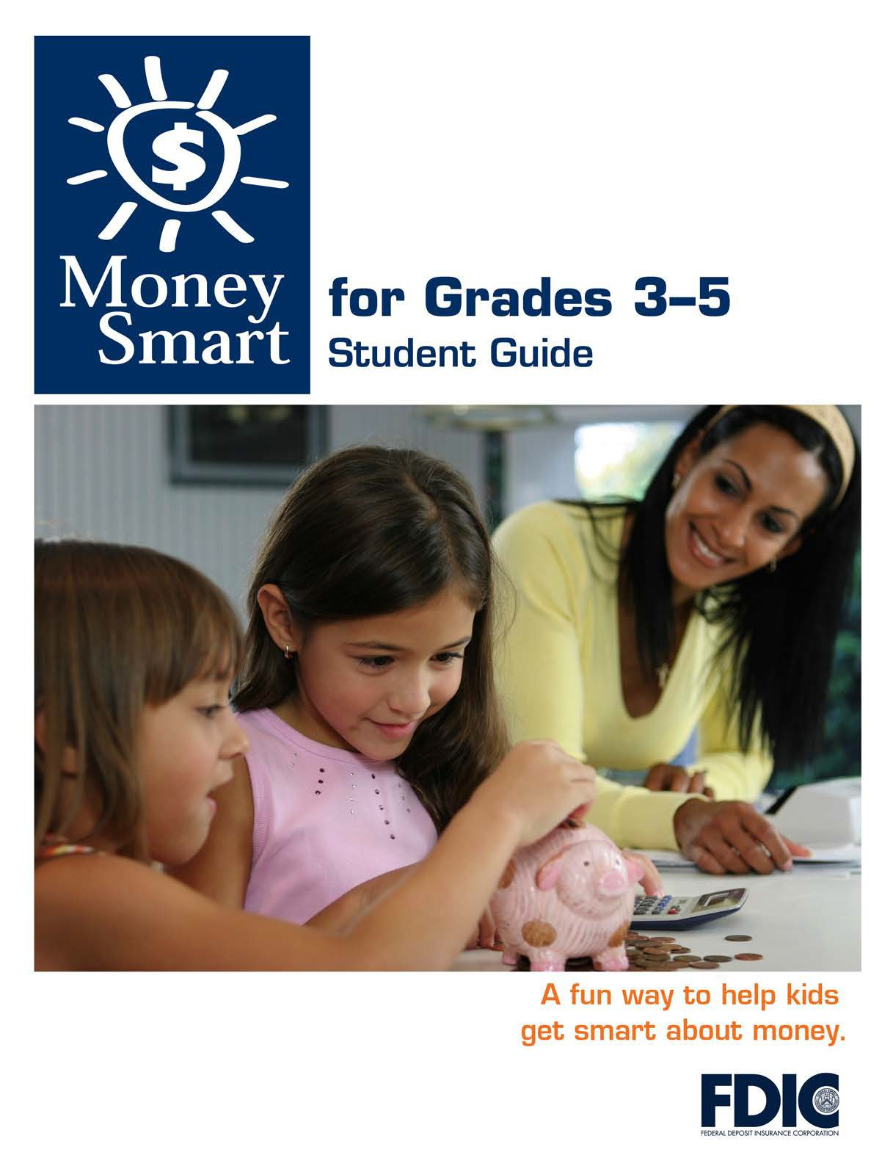

[1]

TABLE OF CONTENTS

Lesson 3: Make a Plan (Budgeting) 3
  - Student Handout 1: Jake’s Budget
  - Student Handout 2: Finish That Budget!
  - Student Handout 3: My Budget

MONEY SMART FOR GRADES 3–5: STUDENT GUIDE 2

JAKE’S BUDGET
Name:
A budget is a spending plan to help you manage your money. Part of making a
budget is to write down your income (the money you expect to make), your expenses (the money you expect to spend), and your savings (the money you expect to save).
Directions: Jake is a grown-up. Study Jake’s budget, add up the total expenses,

Monthly Income Monthly Expenses | $1,800
Rent | $910
Car payments | $410
Food | $200
Gasoline | $100
Total | $
Monthly Savings | $180
- How much money does Jake put into his savings each month?

- What is Jake’s monthly income?

- How much money does Jake spend on rent each month?
- How much money in all does Jake spend on his car payments and gasoline? (Please show your math.)
- How much money could Jake add to his monthly savings if he spent only $175 on
food? (Please show your math.)

- What other expenses might Jake need to add to his budget?
3
MONEY SMART FOR GRADES 3–5: STUDENT GUIDE

$
$
$

FINISH THAT BUDGET!

Name:

A budget is a spending plan to help you manage your money. Part of making a budget is to write down the money you expect to make (income), and the money you expect to spend (expenses). Some expenses repeat each month, such as rent and food.

Directions: Read about Kayla’s income and expenses. Then help complete the budget and answer the questions below.

Kayla is 11 years old. She earns $8 a month by taking care of her younger brother while her father cleans the house. The neighbors pay her $2 a month to collect the mail while they are away. Each month, Kayla spends $9 on snacks and school supplies. She also puts $1 a month into her savings.
$
$
$

KAYLA’S BUDGET
Monthly Income (Money She Expects to Make)
Taking care of younger brother Getting the neighbor’s mail Total
Monthly Expenses (Money She Expects to Spend)
Snacks and supplies
Total
Monthly Savings

- If Kayla puts only 75 cents into her monthly savings, how much money would she
have left over to spend each month? (Please show your math.)
- According to the budget, how much will Kayla have in savings after a year?
(Please show your math.)
3) How might Kayla save more money?
MONEY SMART FOR GRADES 3–5: Student Guide
4

MY BUDGET
Name:

A budget is a spending plan to help you manage your money. Part of making a budget is to write down the money you expect to make (income) and the money you expect to spend (expenses).

Directions: Create your own budget by writing down your income and expenses below. If you don’t have any income or expenses, use the following numbers:
Monthly income total: $15 Monthly expense total: $8

’S BUDGET

Monthly Income (Money I Expect to Make)

$

$

Total $

Monthly Expenses (Money I Expect to Spend)

$

$

$

Total $

Monthly Savings $

According to the budget, how much will you have saved in a year? (Please show your math.)

How might you save more money?

MONEY SMART FOR GRADES 3–5: STUDENT GUIDE
5

