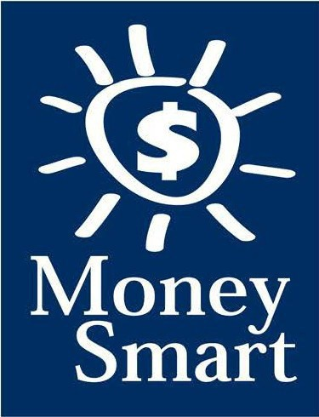
for Grades 3-5
Educator Guide
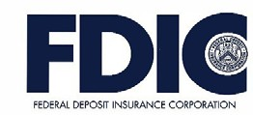

FDIC Disclaimer:
The books and online resources referenced in the Educator Guide and Parent/Caregiver Guide are examples/options that may be used to support the subject being taught and should not be considered as an endorsement by the Federal Deposit Insurance Corporation (FDIC). Reference to any specific commercial product, process, or service by trade name, trademark, manufacture, or otherwise does not constitute an endorsement, a recommendation, or a favoring by the FDIC or the United States government.
The FDIC Money Smart curriculum references books and provides links to other websites for convenience and informational purposes only. Users should be aware that when they select a link on the FDIC’s website to an external website, they are leaving the FDIC’s site. Linked sites are not under the control of the FDIC, and the FDIC is not responsible for the contents of any linked site or any link contained in a linked site, or any changes or updates to such sites. The FDIC is not responsible for any transmission received from a linked site. The inclusion of a link does not imply endorsement by the FDIC of the site, its content, advertisers, or sponsors. External sites may contain information that is copyrighted with restrictions on reuse. Permission to use copyrighted materials must be obtained from the original source and cannot be obtained from the FDIC.

TABLE OF CONTENTS
Welcome To Money Smart 4
Getting Started 5
Lessons At-a-Glance 8
Lesson 5: Which Way to Pay? (Payment Options) 9
Answer Key 13
Glossary 16

WELCOME TO MONEY SMART

Welcome to Money Smart, an exciting interactive exploration of the concepts of money. This standards-aligned, cross-curricular program is designed to promote financial understanding in children ages 8 through 11. You can use Money Smart to add engaging and enriching activities to Math, English Language Arts, and Social Studies lessons while also helping your students build the foundation to become financially responsible adults.
In Money Smart you will find:
- Eight Lessons with hands-on, cross-curricular activities that engage third- through fifth-grade students in discussing and exploring key financial concepts
- Teacher Presentation Slides, which provide helpful visuals, as well as fill-in charts to support the activities in each lesson
- A Student Guide with handouts that let students explore the topics covered in each lesson and apply their new knowledge
- A Parent/Caregiver Guide with information about topics and terms being covered in class, conversation starters, online and literary sources, along with activities to try at home and around town
Developing positive financial habits equips students with 21st-century skills and tools that last a lifetime. We hope you and your students enjoy learning about money and its many uses.
We are eager to hear from you about how you use this curriculum. We would like to know what works well and what could be improved to make Money Smart even better. If you have any questions, we would like to help. Please contact us with your comments and questions via e-mail at communityaffairs@fdic.gov.

GETTING STARTED

Money Smart provides a comprehensive, developmentally appropriate program for upper elementary students to build an understanding of key financial concepts.
There are many features that help make the Money Smart curriculum engaging, motivating, and easy to use. Each lesson includes learning objectives, essential questions, supplies needed, and preparation required, as well as the following features and components to support easy integration of Money Smart activities into your instructional day.

STANDARDS
Each lesson promotes real-world connections through student-centered learning experiences and aligns to the following education standards and learning outcomes, including Common Core State Standards in mathematics and English Language Arts. The Education Standards Chart on pages 48- 57 identifies which standards are met in each lesson.
- Financial Literacy Jump$tartStandards
- English Language Arts Common Core State Standards
- Mathematics Common Core State Standards
- National Standards for Financial Literacy by the Council for Economic Education
- Partnership for 21st-Century Skills

GRADE-LEVEL MODIFICATIONS
Please note the modifications identified throughout lessons to differentiate learning experiences for beginner and advanced students. Modifications provide developmentally appropriate activity recommendations and extension opportunities.

PRESENTATION TIME
Each lesson plan includes an estimated time needed to teach the lesson. Actual time required will vary from classroom to classroom. The estimation includes instructional time spent on the Warm Up, Guided Exploration, and Wrap Up. Activities may also be taught as several short lessons over a period of days or weeks. Extended Exploration activities are included to extend financial literacy learning opportunities throughout the year and provide easy ways to integrate the topics into various content areas.

ASSESSMENTS
A variety of assessments are integrated throughout each of the eight lessons. Assessments are designed to build value, meaning, and context around a topic, while providing teachers with opportunities to evaluate prior student knowledge, and collect evidence of their new understandings of lesson concepts and skills. Pre- (formative) and post- (summative) assessments are noted on the first page of each lesson. Assessments include discussions, reflections, questions and answers, reading, writing, and problem-solving exercises. Student handouts are an especially useful form of written assessment.

LESSON STRUCTURE
Each lesson is designed to include the following:
- Warm Up introduces students to the topic and sparks inquiry.
- Guided Exploration integrates cross-curricular and developmentally appropriate learning activities and assessments while focusing on the key financial literacy learning objectives of the lesson.
- Wrap Up provides a reflection question or activity to review lesson concepts and allow students to demonstrate theirunderstanding.
- Money Smart Tips are provided throughout lessons to offer additional guidance, interesting and relevant financial facts, and additional ideas to help make Money Smart a success in your classroom.
- Extended Exploration provides teachers with additional opportunities to extend financial literacy concepts throughout the school year within core and creative content areas including English Language Arts, Math. Activities can be completed as a class, in small groups, or by students individually. Useful resources (such as books, web links, games, or videos) are also included to promote even more student engagement. The books and online resources suggested in this guide are just a few of the many available resources that explore these topics, and are not endorsed by the FDIC.
- Student Handouts (found in the Student Guide) and Teacher Presentation Slides provide dynamic instructional support. Student handouts create an opportunity for students to apply their knowledge and for teachers to assess their understanding. Teacher presentation materials offer visuals and interactive activities corresponding with each lesson, and can be projected for whole-group activities, or copied for small-group use.
- The Answer Key, Glossary, and Standards Chart house all of the information needed to check for understanding, define key terms, and check which activities meet specific education standards. Vocabulary words are bolded in each lesson as they are introduced. The vocabulary words can be used to create flash cards or a classroom Word Bank list. Students can also make their own Word Banks and refer to the lists as needed.

MONEY SMART AT HOME
The Money Smart curriculum includes a helpful Parent/Caregiver Guide that corresponds to the classroom resources. Families of young children may also use it independently of the curriculum. It contains resources, activities, games, and conversation starters on financial literacy topics covered in each lesson. Use the following ideas to encourage parents to use the guide at home:
- Introduce parents to the Money Smart program and share the Parent/Caregiver Guide at the start of the school year.
- Discuss the Money Smart program during parent/teacher conferences, or in monthly parent newsletters home, and emphasize the importance of building healthy financial habits from an early age.
- Hold a Money Smart family night. Play games and have students present short skits about financial concepts they have learned.
- Send student handouts from each lesson home in each child’s homework folder for parents to review and sign.

SMART BUCKS
Additional incentives can be used to promote positive financial behaviors and study habits throughout the Money Smart curriculum and school year. Introduce Smart Bucks to recognize students’ positive financial and classroom behaviors.
Smart Bucks can be earned for the following behaviors:
- Accomplishment of a goal(s)
- Completion of homework
- Exceptional classroom conduct
- Keeping the classroom clean and neat
- Participating in discussions or responding to questions
- Excellent group collaboration or individualwork
- Completing daily work
- Respectful behavior
As students accumulate Smart Bucks, they may spend them on prizes, toys, or special activities (for example: extra computer time, free reading time, game board time) at the end of the week or month, or whenever you normally provide rewards.
Smart Bucks may be tracked using a chart (displaying desired behaviors and goals), stored in a classroom “treasury” box, or in a cash register (if a class “store” is set up), and handed out to students using play money. Provide price tags or stickers on items or activities to be “sold.” The presentation for cashing in Smart Bucks can be as simple or elaborate as you choose.
Aside from being a fun way to reward positive behaviors, Smart Bucks can help foster an application of the financial literacy concepts covered in Money Smart lessons.
With Smart Bucks, students can practice:
- Math skills when adding the total of “Smart Bucks” earned
- The concept of making change without using acalculator
- The value of saving as they choose to save instead of spend, or set a goal to save for a more desired choice
Use Smart Bucks during Money Smart lessons or continue throughout the year.

FINANCIAL LITERACY ALL YEAR LONG
Highlight financial literacy at your school all year long, especially in April, during National Financial Literacy and School Library Month.
- Create bulletin boards or posters with students about financial literacy themes learned in

Money Smart.
- Play games that focus on numeracy skills and financial concepts (such as Monopoly).
- Feature children’s literature selections that cover financial literacy concepts in the library or during classroom reading time. See the Parent/Caregiver Guide for more literature suggestions.
The more students are exposed to financial literacy, and the more opportunity they have to practice applying their new knowledge and understanding of concepts, at school and at home, the more prepared they will be to live Money Smart lives.

LESSONS AT-A-GLANCE
Lesson Title Topic
Learning Objectives
Time Required

5 Which Way to Pay?

Payment Options
•Explain the concept of credit and debit (including checks and money orders)
•Compare and contrast various payment methods (cash, credit, and debit)
•Apply knowledge of payment options to real-world scenarios
•Discuss the consequences of paying back credit past the due date
•Discuss identity theft and types of personal information that should not be shared
60 min

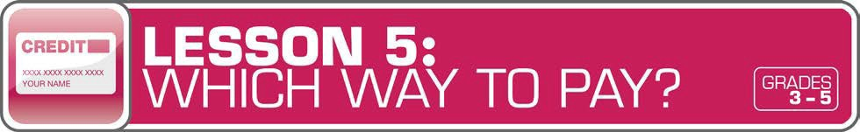

LESSON OVERVIEW
With students comfortably demonstrating the concept of cash through previous lessons, they will explore the concept of other payment options in this lesson. Hands-on activities will guide students through different forms of payment, such as cash, credit cards, debit cards, and checks. Students will apply their compounded knowledge by evaluating different real-world scenarios.
TOPIC: Payment Options

TIME REQUIRED: 60 minutes
(excluding Extended Exploration activities)

LEARNING OBJECTIVES:
Students will be able to…
- Explain the concept of credit and debit (including checks and money orders)
- Compare and contrast various payment methods (cash, credit, and debit)
- Apply knowledge of payment options to real-world scenarios
- Discuss the consequences of paying back credit past the due date
- Discuss identity theft and types of personal information that should not be shared

SUPPLIES:
- Projector (for teacher presentationslides)
- Whiteboard or chart paper, markers
- Access to the Internet (optional)

PREPARATION:
- Make copies of student handouts
- Set up projector with presentation slides
Answer Key 13
Glossary with key vocabulary 16
STUDENT HANDOUTS:
(found in Student Guide)

Payment Options: True or False?

Payment Decisions

Test Your Payment Knowledge
- Money Smart Book (template from Lesson 1)

TEACHER PRESENTATION SLIDES:

What Is Credit?

What Is Debit?

Story Problems: Payment Decisions

Private Information

ESSENTIAL QUESTIONS:
- What are credit and debit?
- What are checks?
- Why might someone choose to pay with cash, credit, or debit?
- What is debt?
- What information should not be shared with others to prevent identity theft?

ASSESSMENT ACTIVITIES:
Pre-Assessment:

Payment Options: True or False?
handout
- Payment Decisions handout
Post-Assessment:

Test Your Payment Knowledge handout
- Money Smart Book handout

INSTRUCTION STEPS
WARM UP
SHARING PRIOR KNOWLEDGE OF PAYMENT OPTIONS [15 MINUTES]
Start the lesson by asking students to think about ways people can pay for things. Ask: What do you use to pay for things? (Answers may include: money, cash, bills, or coins.) What do your parents use? (Answers may include: cash, credit cards, debit cards, checks, or money orders.) Draw a four-column chart on a whiteboard/chart paper with the title “Forms of Payment” and headings: cash, credit cards, debit cards, and checks. Ask students to share what they know about these four payment options, and record their answers on the chart.
Next, have students work in pairs to complete the Payment Options: True or False? handout, a short true/false quiz about credit, checks, debit, and cash, to test their knowledge of these payment options. Review answers together as a class.
Explain that a credit card is not just an endless supply of money. It is linked to a person’s account and must be paid back by a certain date every month. If it is not paid back in full by that date, that person has to pay interest (the cost of borrowing money; also the money earned from lending it). If someone has a credit card, that person also has a limit to how much “credit” he or she has available to use. The limit is based on how creditworthy that person is (how likely someone will be able to pay back a loan). Explain that creditworthy is similar to trustworthy. Ask students what trustworthy means (deserving of trust, dependable).
Add information students have learned to the “Forms of Payment” chart.

Grade-Level Modifications:
Beginner: If students don’t know an answer on the true/false quiz, ask them to take their best (educated) guess.
Advanced: Students can complete the quiz independently. Have them correct the statements that are false.

MONEY SMART TIP!

Invite students to keep track of their Smart Bucks (see page 7 for more information) in a journal. Have them write down each date they receive Smart Bucks (income), the amount, and how they earn it. They can also record each date they spend

their Smart Bucks (expenses), the amount, and what they spend it on.

GUIDED EXPLORATION
UNDERSTANDING CREDIT AND DEBIT [20 MINUTES]
Review the meaning of credit and discuss that it is not free money, but linked to an actual account.
Optional: Use the link http://handsonbanking.org/htdocs/en/k and click on “Credit & You” to show students an interactive cartoon video about credit and loans (six lessons, approximately 5 or 6 minutes). The class can also explore the virtual calculator and money math questions together.
Share the What Is Credit? and What Is Debit? slides with students, and discuss. To review and ensure understanding, have a discussion using the following guiding questions: What are credit and debit? (Credit is a loan. When you pay using credit, you are borrowing money with the agreement to pay it back by a later date. A debit is money taken out of a checking account as payment for an item or service.) What are checks? (A check is a written order of payment that instructs a financial institution, such as a bank, to withdraw a specific amount of money from the check-writer’s account, and pay or deposit it to the person, or business, named on the check.) In addition to what students learned from the slides, you might also want to ask: What is a money order? (It is similar to a check, but can be purchased at a bank or post office, and used to make a payment of a specific amount of money.)
Review the following: What is interest? (the cost of borrowing money) What is debt? (an amount of money owed) Explain that, if you use a credit card to make purchases and then cannot pay for them by your statement due date, you will likely pay interest. The interest owed is a debt. It can make a purchase more expensive than you had expected.
Next, ask students to share what they know about identity theft (a crime in which someone uses personal information from another person to steal his or her money). Share the Private Information slide, and explain that students should never buy anything online or share personal information with anyone without a parent’s permission. Review by removing the slide and asking: What information should not be shared with others to prevent identity theft? (Personal information should not be shared with others, especially when you are online. That information includes birth date, phone number, home address, school name and address, bank account number, a parent’s credit card number, and passwords. If you use a social networking site, only share your page with friends you know and trust.)

EXPLORING DIFFERENT PAYMENT SCENARIOS [15 MINUTES]
Begin the activity with a quick review of the terms and differences between the following payment methods: cash, checks, debit cards, and credit cards. Ask: Why might someone choose to pay with cash, credit, or debit? (Someone may choose to pay with cash if that person is carrying enough cash or a store only takes cash. A person may pay with credit or debit when he or she is not carrying enough cash or it is quicker and more convenient.)
Share the Story Problems: Payment Decisions slide and ask students to solve the problems as a whole class. Then have students try answering some more real-world scenarios on their own using the Payment Decisions handout. Review the payment decisions as a class.

Grade-Level Modifications:
Beginner: The last question may be tricky for beginners. You may want to give them some clues for solving it and/or have students work on the problem with a partner or as a whole- class activity.
Advanced: After students finish the handout, ask them to create one or two of their own examples.
Ask students to complete the Test Your Payment Knowledge handout as a post-lesson assessment to see how much they learned regarding payment options and identity theft.

WRAP UP
CLASS REFLECTION [10 MINUTES]
Lead a class discussion about the following questions: What is the difference between credit and debit? What information should not be shared with others to prevent identity theft? Ask students to write an entry in their Money Smart Books about the discussion questions.

EXTENDED EXPLORATION
Note: Use the following activities to extend the lesson topic throughout the year. Activities can be completed as a class or in small groups. Duration of activities will vary.
- Take students on a virtual field trip to the U.S. Bureau of Engraving and Printing to learn more about where cash is made at http://kids.usa.gov/watch-videos/money/money- factory/index.shtml.
- Invite students to read the online story “Giving Vicki Credit” at http://www.umsl.edu/~wpockets/Clubhouse/library.htm to learn more about credit. The website also offers an interactive quiz students can take to test their knowledge.
- Divide students into groups and have them make posters about identity theft and online safety, including the personal information that should be kept private and not shared with others. Hang them up in the classroom.

ANSWER KEY

for Student Handouts (found in Student Guide)

LESSON 1: MONEY MATTERS
Student Handout 1: Sort It Out. Answers will vary.

Student Handout 2: What Should I Buy?
Situation A: 1. want, 2. want, 3. need, 4. backpack, 5. Answers may include: Maya should spend her money on a new backpack. It is the most important because it is a need. Her old backpack is badly damaged.
Situation B: 1. want, 2. need, 3. want, 4. a pair of sneakers, 5. Answers may include: Travis should spend his money on a new pair of sneakers. It is the most important because it is a need. His old sneakers are getting too small.

Student Handout 3: Trade-Offs. Answers will vary.

Student Handout 4: Money Smart Book. Answers will vary.

LESSON 2: GET SET FOR GOALS
Student Handout 1: Short- and Long-Term Goals
Situation A: 1. Ella wants to challenge her brother to a basketball game. 2. Ella plans to join the basketball team when she gets to middle school. 3. She can keep practicing to improve her basketball skills.
Situation B: 1. Max wants to get a good grade on his French test next week. 2. Max wants to visit France when he is older. 3. Answers will vary, but may include: Max can keep studying and practicing French. Max can save money for a trip to France.

Student Handout 2: What Are Your Goals? Answers will vary.

Student Handout 3: Saving Together
1. Their savings goal is $150 to buy a tablet computer. 2. They want to reach their goal in one year.
3. It is a long-term goal. 4. They still need to save $120 ($150 – $20 = $130 – $10 = $120, or $150 – ($20 + $10)
= $120). 5. Each child will pay $75 ($150 ÷ 2 = $75). 6. Answers will vary.

Student Handout 4: My Savings Goals. Answers will vary.

LESSON 3: MAKE A PLAN
Student Handout 1: Jake’s Budget
Total monthly expenses: $1,620. Questions: 1. $180, 2. $1,800, 3. $910, 4. $510 ($410 + $100 = $510),
- $25 ($200 – $175 = $25), 6. Answers will vary, but may include clothes and entertainment (movies, bowling, sports games, concerts, etc.).

ANSWER KEY (continued)

Student Handout 2: Finish That Budget!
Monthly Income: Taking care of younger brother: $8, Getting the neighbor’s mail: $2, Total: $10; Monthly Expenses: Snacks and supplies: $9; Monthly Savings: $1. Questions: 1. 25 cents ($1 or 100 cents – 75 cents = 25 cents), 2. $12 ($1 per month, or $1 x 12 = $12), 2. Answers will vary, but may include: She can spend less on snacks and supplies, compare prices, get another job.

Student Handout 3: My Budget
Answers will vary, unless students use the suggested numbers of $15 monthly income and $8 monthly expenses. If so: Monthly Savings: $7. Questions: 1. $84 ($7 x 12 months = $84), 2. Answers will vary, but may include: I can spend less by comparing prices, buying fewer wants.

LESSON 4: SAVE YOUR MONEY
Student Handout 1: Calculate the Interest
  - C ($2), 2. B ($300 + $3 interest = $303), 3. A ($800, based on the chart, solutions may include: $8 x 100 or
$8 is the sum of $3 + $5, which corresponds to $300 + $500 = $800)

Student Handout 2: What Are the Risks?
Risks of Riding a Bicycle: Answers will vary, but may include: falling, getting hit by a car, a flat tire.
Ways to Avoid or Reduce the Risks: Answers will vary, but may include: wearing a helmet, riding in a safe area away from cars, carrying a bicycle pump.

Student Handout 3: Money Smart Book Comic Strip. Answers will vary.

LESSON 5: WHICH WAY TO PAY?
Student Handout 1: Payment Options: True or False?
1. True, 2. True, 3. False (Credit cards and debit cards are made of plastic.), 4. True, 5. False (If you use a credit card, you receive a monthly bill.), 6. False (Credit cards do set limits to how much you can spend.),
7. True, 8. False (A debit is money removed from an account.), 9. True, 10. True

Student Handout 2: Payment Decisions
- She should pay using the credit card because she doesn’t have enough cash.
- He should pay with cash because the store only accepts cash.
- She should pay with her debit card because she doesn’t have enough cash.
- He should pay with his debit card because he has enough money in his checking account($2,800).
He shouldn’t use his credit card because he has a $3,000 credit card limit and has already charged $800. ($3,000 – $800 = $2,200. That is $100 less than his car bill of $2,300.)

Student Handout 3: Test Your Payment Knowledge
1. A (checks and debit cards), 2. C (month), 3. C (using a credit card), 4. B (check), 5. B (Keep your personal information private.)

ANSWER KEY (continued)

LESSON 6: GET INVESTED
Student Handout 1: Complete the Story
My friend Ty is always talking about his long-term money goals. He plans to manage his money wisely. When he is older, he wants to invest money in several places. First, he says he’ll buy a CD from the bank so he can earn interest. He may also buy a bond from the government. Later, he is going to buy stocks so he can own shares of a company. If the company makes a big profit, he could make a lot of money! But if the company does not, he could lose his money. Ty told me that’s a chance he’ll have to take. One day he might even start his own company.

Student Handout 2: Risk and Return
1. A (Buy a CD or U.S. government bond.), 2. B (Do some more research about stocks. You may also lose your money.), 3. C (stocks and high-risk bonds)

LESSON 7: IT’S GREAT TO DONATE!
Student Handout 1: Story Problem: Giving
1. $100, 2. 32 magnets ($64 ÷ $2 per magnet = 32 magnets), 3. $40 profit ($64 – $24 = $40), 4. $60 ($100 – $40 = $60), 5. 30 magnets ($60 ÷ $2 per magnet = 30 magnets)

Student Handout 2: Giving Plan and Budget. Answers will vary.

LESSON 8: CAREER CHOICES
Student Handout 1: Different Jobs. Answers will vary.

Student Handout 2: Interest Survey. Answers will vary.

Student Handout 3: Salary and Education
- C (Master’s), 2. $54,200 ($116,700 – $62,500 = $54,200), 3. Answers may include: They all require a higher education degree and pay more than $60,000 ayear.

GLOSSARY

Advertisement (Ad): A public notice or announcement that a company pays for to help promote and increase sales of a product or service.

Bank: A financial institution and business that accepts deposits and makes loans.

Borrow: To receive something on loan with the understanding that you will return it.

Budget: A plan that outlines what money you expect to earn or receive (your income) and how you will save it or spend it (your expenses) for a given period of time.
Career: The type of work a person pursues for the majority of their life that may involve formal education, special training, or be within a specific industry.
Cash: Money such as coins and bills.

Charity: The act of giving help or money to help people, animals, or communities in need; an organization that helps people, animals, or communities in need or supports social causes.
Check: A written order of payment that instructs a financial institution (such as a bank) to withdraw a specific amount of money from the check-writer’s account, and pay or deposit it to the person, or business, named on the check.
Credit: The ability to borrow money and pay it back later.

Debit: An amount of money taken out of a deposit account to pay for something.

Debt: Money that is owed.

Donation: Something (including money, food, clothes, and toys) that you give to help people, animals, or communities in need or to a charity.
Earn: To receive money in exchange for goods or services. Emergency Fund: Money set aside to pay for unexpected expenses. Entrepreneur: Someone who creates and runs a business.
Expense: The cost of goods and services; the amount of money that is spent.

Federal Deposit Insurance Corporation (FDIC): Preserves and promotes public confidence in the U.S. financial system by insuring deposits in banks and thrift institutions for at least $250,000. An independent agency of the federal government, the FDIC was created in 1933.
Goal: Something you wish to achieve or accomplish in a specific amount of time.

Income: Money that you receive from jobs, allowances, interest, dividends, and other sources.

Interest: Money that a bank or other financial institution pays you for keeping money on deposit with them, or the amount of money you pay a bank as a fee when you borrow money.

GLOSSARY (continued)

Invest: To put money at risk with the goal of making a profit in the future.

Job: A specific duty, task, or activity someone completes using his or her time, skills, and energy to earn money.

Lend: The act of giving something to someone with the understanding that they will give it back to you.

Long-Term Goal: Something you want to achieve in the future, such as in one year, five years, ten years, or more.

Money Order: Similar to a check, but can be purchased at a bank or post office, and used to make a payment of a specified sum of money.
Need: Something you must have to survive, such as clothes, shelter, or food.

Opportunity Cost: The next best thing that you give up in order to do something else; a trade-off of a decision you make.
Profit: The money gained or left over after money spent (expense) is subtracted from money earned (income).

Return: Money made (profit) from an investment.

Risk: The possibility that something unplanned or unintended may happen (such as losing money).

Save: Setting something, like money, aside to use in the future.

Savings Account: A bank account that you can use to set aside money, and that pays you interest.

Savings Goal: The amount of money you plan to put aside for a specific purpose.

Short-Term Goal: Something you want to achieve soon, such as in two weeks or a few months.

Spend: The act of using money to buy goods or services.

Spending Limit: The most amount of money a person is allowed (or allows themselves) to spend.

Tax: Money that someone has to pay to help finance a government.

Want: Something that you would like to have but that you could live without.

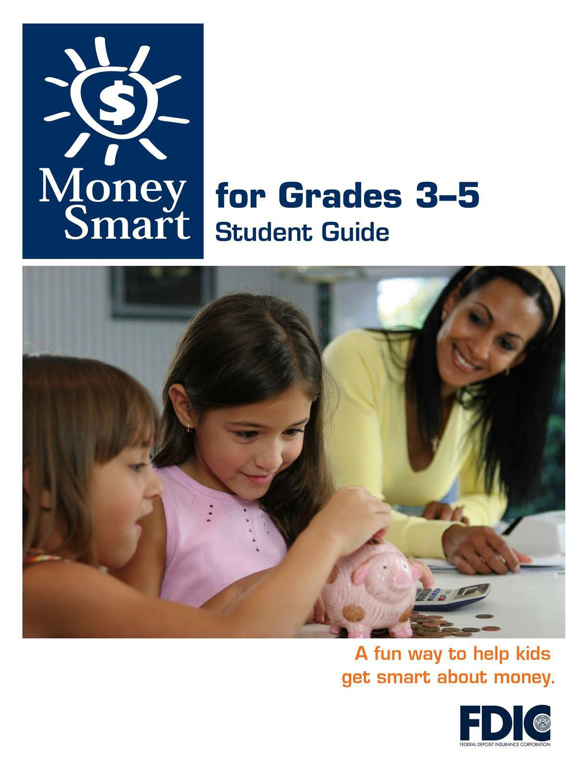

[1]

TABLE OF CONTENTS

Lesson 5: Which Way to Pay? (Payment Options) 3
  - Student Handout 1: Payment Options: True orFalse?
  - Student Handout 2: Payment Decisions
  - Student Handout 3: Test Your Payment Knowledge

MONEY SMART FOR GRADES 3–5: STUDENT GUIDE 2

PAYMENT OPTIONS: TRUE OR FALSE?

Name:

Directions: How much do you know about different payment options? Read each statement and circle whether it is true or false.

1) Cash, credit, and debit are payment options. | True | False
2) Some businesses only accept cash payments. | True | False
3) Credit cards and debit cards are made ofpaper. | True | False
4) When you pay with credit, you are borrowingmoney. | True | False
5) If you use a credit card, you receive a yearlybill. | True | False
6) Credit cards set no limits to how much you canspend. | True | False
7) A debit card is linked to a person’s checkingaccount. | True | False
8) A debit is money added to an account. | True | False
9) Checks come in a small book called acheckbook. | True | False
10) A check is piece of paper used for making a payment. | True | False
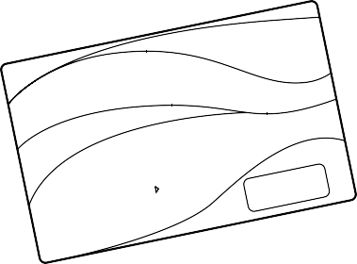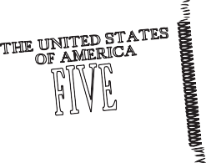

PAYMENT DECISIONS

Name:

People can make purchases using different payment options.

Directions: Read each scenario and answer the questions that follow.

Jose and his mother are buying food at the grocery store. The total is $65. Jose’s mom has a credit card and $40 cash in her wallet. How should she pay for the? food? Why?

Ryan is buying a $3 slice of pizza at a small restaurant. The sign in the store says “cash only.” Ryan has a credit card and $5 cash. Which payment option should he use? Why?

Sera is in college. She has a debit card and $24 cash in her wallet. She has $120 in her checking account. Sera needs a new pair of sneakers and finds a pair she

likes for $55. Which payment option should she use?Why?

Tim needs to pay for an expensive car repair. The total is $2,300. Tim has a credit card and a debit card in his wallet. He has $2,800 in his checking account. His credit card limit is $3,000 and he has already charged $800. Which payment

option should he use? Why? (Please show yourmath.)

TEST YOUR PAYMENT KNOWLEDGE

Name:

Directions: How much did you learn about payment options and identity theft? Circle the best answer to each statement or question below.

You need to buy new shoes. Which two ways can you pay if you want the money to come out of your checking account?

checks and debit cards

debit and credit cards

credit cards and checks

Since you have a credit card, you receive a statement every . The statement is a record of what you bought and the payment due.

day b) week c) month

People say you are trustworthy. You always pay back the money you borrow. Which payment option is the same as borrowingmoney?

paying by check b) using a debit card c) using a credit card

Sometimes, you choose to fill out a paper form to make a payment. Thatpaper form is called a .

debt b) check c) credit

You just learned about identity theft. What advice would you give to someone who asks how to prevent it?

Only pay for things with cash or checks.

Keep your personal informationprivate.

Never borrow money from a closefriend.

MONEY SMART FOR GRADES 3–5: STUDENT GUIDE 5

