for Grades 3-5
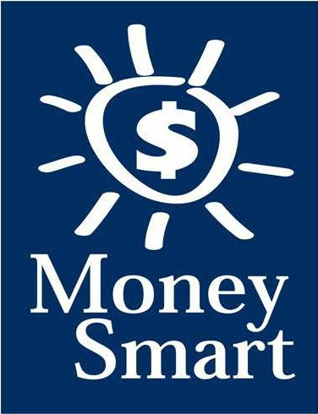

Educator Guide
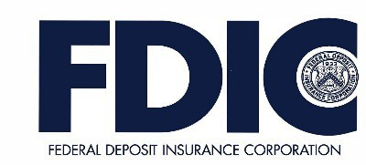

FDIC Disclaimer:
The books and online resources referenced in the Educator Guide and Parent/Caregiver Guide are examples/options that may be used to support the subject being taught and should not be considered as an endorsement by the Federal Deposit Insurance Corporation (FDIC). Reference to any specific commercial product, process, or service by trade name, trademark, manufacture, or otherwise does not constitute an endorsement, a recommendation, or a favoring by the FDIC or the United States government.
The FDIC Money Smart curriculum references books and provides links to other websites for convenience and informational purposes only. Users should be aware that when they select a link on the FDIC’s website to an external website, they are leaving the FDIC’s site. Linked sites are not under the control of the FDIC, and the FDIC is not responsible for the contents of any linked site or any link contained in a linked site, or any changes or updates to such sites. The FDIC is not responsible for any transmission received from a linked site. The inclusion of a link does not imply endorsement by the FDIC of the site, its content, advertisers, or sponsors. External sites may contain information that is copyrighted with restrictions on reuse. Permission to use copyrighted materials must be obtained from the original source and cannot be obtained from the FDIC.

TABLE OF CONTENTS

Welcome To Money Smart 4
Getting Started 5
Lessons At-a-Glance 8
Lesson 6: Get Invested (Introduction to Investing) ……………………………….9
Answer Key 12
Glossary 15

WELCOME TO MONEY SMART

Welcome to Money Smart, an exciting interactive exploration of the concepts of money. This standards-aligned, cross-curricular program is designed to promote financial understanding in children ages 8 through 11. You can use Money Smart to add engaging and enriching activities to Math, English Language Arts, and Social Studies lessons while also helping your students build the foundation to become financially responsible adults.
In Money Smart you will find:
- Eight Lessons with hands-on, cross-curricular activities that engage third- through fifth-grade students in discussing and exploring key financial concepts
- Teacher Presentation Slides, which provide helpful visuals, as well as fill-in charts to support the activities in each lesson
- A Student Guide with handouts that let students explore the topics covered in each lesson and apply their new knowledge
- A Parent/Caregiver Guide with information about topics and terms being covered in class, conversation starters, online and literary sources, along with activities to try at home and around town
Developing positive financial habits equips students with 21st-century skills and tools that last a lifetime. We hope you and your students enjoy learning about money and its many uses.
We are eager to hear from you about how you use this curriculum. We would like to know what works well and what could be improved to make Money Smart even better. If you have any questions, we would like to help. Please contact us with your comments and questions via e-mail at communityaffairs@fdic.gov.

GETTING STARTED

Money Smart provides a comprehensive, developmentally appropriate program for upper elementary students to build an understanding of key financial concepts.
There are many features that help make the Money Smart curriculum engaging, motivating, and easy to use. Each lesson includes learning objectives, essential questions, supplies needed, and preparation required, as well as the following features and components to support easy integration of Money Smart activities into your instructional day.

STANDARDS
Each lesson promotes real-world connections through student-centered learning experiences and aligns to the following education standards and learning outcomes, including Common Core State Standards in mathematics and English Language Arts. The Education Standards Chart on pages 48- 57 identifies which standards are met in each lesson.
- Financial Literacy Jump$tart Standards
- English Language Arts Common Core State Standards
- Mathematics Common Core State Standards
- National Standards for Financial Literacy by the Council for Economic Education
- Partnership for 21st-Century Skills

GRADE-LEVEL MODIFICATIONS
Please note the modifications identified throughout lessons to differentiate learning experiences for beginner and advanced students. Modifications provide developmentally appropriate activity recommendations and extension opportunities.

PRESENTATION TIME
Each lesson plan includes an estimated time needed to teach the lesson. Actual time required will vary from classroom to classroom. The estimation includes instructional time spent on the Warm Up, Guided Exploration, and Wrap Up. Activities may also be taught as several short lessons over a period of days or weeks. Extended Exploration activities are included to extend financial literacy learning opportunities throughout the year and provide easy ways to integrate the topics into various content areas.

ASSESSMENTS
A variety of assessments are integrated throughout each of the eight lessons. Assessments are designed to build value, meaning, and context around a topic, while providing teachers with opportunities to evaluate prior student knowledge, and collect evidence of their new understandings of lesson concepts and skills. Pre- (formative) and post- (summative) assessments are noted on the first page of each lesson. Assessments include discussions, reflections, questions and answers, reading, writing, and problem-solving exercises. Student handouts are an especially useful form of written assessment.

LESSON STRUCTURE
Each lesson is designed to include the following:
- Warm Up introduces students to the topic and sparks inquiry.
- Guided Exploration integrates cross-curricular and developmentally appropriate learning activities and assessments while focusing on the key financial literacy learning objectives of the lesson.
- Wrap Up provides a reflection question or activity to review lesson concepts and allow students to demonstrate their understanding.
- Money Smart Tips are provided throughout lessons to offer additional guidance, interesting and relevant financial facts, and additional ideas to help make Money Smart a success in your classroom.
- Extended Exploration provides teachers with additional opportunities to extend financial literacy concepts throughout the school year within core and creative content areas including English Language Arts, Math. Activities can be completed as a class, in small groups, or by students individually. Useful resources (such as books, web links, games, or videos) are also included to promote even more student engagement. The books and online resources suggested in this guide are just a few of the many available resources that explore these topics, and are not endorsed by the FDIC.
- Student Handouts (found in the Student Guide) and Teacher Presentation Slides provide dynamic instructional support. Student handouts create an opportunity for students to apply their knowledge and for teachers to assess their understanding. Teacher presentation materials offer visuals and interactive activities corresponding with each lesson, and can be projected for whole-group activities, or copied for small-group use.
- The Answer Key, Glossary, and Standards Chart house all of the information needed to check for understanding, define key terms, and check which activities meet specific education standards. Vocabulary words are bolded in each lesson as they are introduced. The vocabulary words can be used to create flash cards or a classroom Word Bank list. Students can also make their own Word Banks and refer to the lists as needed.

MONEY SMART AT HOME
The Money Smart curriculum includes a helpful Parent/Caregiver Guide that corresponds to the classroom resources. Families of young children may also use it independently of the curriculum. It contains resources, activities, games, and conversation starters on financial literacy topics covered in each lesson. Use the following ideas to encourage parents to use the guide at home:
- Introduce parents to the Money Smart program and share the Parent/Caregiver Guide at the start of the school year.
- Discuss the Money Smart program during parent/teacher conferences, or in monthly parent newsletters home, and emphasize the importance of building healthy financial habits from an early age.
- Hold a Money Smart family night. Play games and have students present short skits about financial concepts they have learned.
- Send student handouts from each lesson home in each child’s homework folder for parents to review and sign.

SMART BUCKS
Additional incentives can be used to promote positive financial behaviors and study habits throughout the Money Smart curriculum and school year. Introduce Smart Bucks to recognize students’ positive financial and classroom behaviors.
Smart Bucks can be earned for the following behaviors:
- Accomplishment of a goal(s)
- Completion of homework
- Exceptional classroom conduct
- Keeping the classroom clean and neat
- Participating in discussions or responding to questions
- Excellent group collaboration or individual work
- Completing daily work
- Respectful behavior
As students accumulate Smart Bucks, they may spend them on prizes, toys, or special activities (for example: extra computer time, free reading time, game board time) at the end of the week or month, or whenever you normally provide rewards.
Smart Bucks may be tracked using a chart (displaying desired behaviors and goals), stored in a classroom “treasury” box, or in a cash register (if a class “store” is set up), and handed out to students using play money. Provide price tags or stickers on items or activities to be “sold.” The presentation for cashing in Smart Bucks can be as simple or elaborate as you choose.
Aside from being a fun way to reward positive behaviors, Smart Bucks can help foster an application of the financial literacy concepts covered in Money Smart lessons.
With Smart Bucks, students can practice:
- Math skills when adding the total of “Smart Bucks” earned
- The concept of making change without using a calculator
- The value of saving as they choose to save instead of spend, or set a goal to save for a more desired choice
Use Smart Bucks during Money Smart lessons or continue throughout the year.

FINANCIAL LITERACY ALL YEAR LONG
Highlight financial literacy at your school all year long, especially in April, during National Financial Literacy and School Library Month.
- Create bulletin boards or posters with students about financial literacy themes learned in

Money Smart.
- Play games that focus on numeracy skills and financial concepts (such as Monopoly).
- Feature children’s literature selections that cover financial literacy concepts in the library or during classroom reading time. See the Parent/Caregiver Guide for more literature suggestions.
The more students are exposed to financial literacy, and the more opportunity they have to practice applying their new knowledge and understanding of concepts, at school and at home, the more prepared they will be to live Money Smart lives.

LESSONS AT-A-GLANCE

Lesson Title Topic
Learning Objectives
Time Required

6 Get
Invested
Introduction
to Investing
•Explore the basic concepts of investing,
including risk and return
•Compare and contrast several kinds of investments
•Analyze the savings outcome of several investment options
•Explain the value of long-term financial planning
60 min

LESSON OVERVIEW

Compounding students’ knowledge of saving and goal setting, this lesson builds interest by adding an introduction to investing. Students will begin to explore basic concepts about how goal setting is connected to investing and saving, and the concept of risk and return to help money grow over time. Students will explore the concept of saving to build wealth for the future, and will answer questions about real-life scenarios to recognize the value of long-term financial thinking.
TOPIC: Introduction to Investing

TIME REQUIRED: 60 minutes
(excluding Extended Exploration activities)

LEARNING OBJECTIVES:
Students will be able to…
- Explore the basic concepts of investing, including risk and return
- Compare and contrast several kinds of investments
- Analyze the savings outcome of several investment options
- Explain the value of long-term financial planning

SUPPLIES:
- Projector (for teacher presentation slides)
- Whiteboard or chart paper, markers
- Markers, Post-It notes (or paper and tape) for the game
- Access to the Internet (optional)

PREPARATION:
- Make copies of student handouts
- Set up projector with presentation slides
- Write one of each of the three investments (CDs, bonds, and stocks) on small pieces of paper so you have three sets, one for each student (that you will later tape to students’ foreheads)
Answer Key 12
Glossary with key vocabulary 15

STUDENT HANDOUTS:
(found in Student Guide)

Complete the Story
- Risk and Return
- Money Smart Book
(template from Lesson 1)

TEACHER PRESENTATION SLIDES:

Investing Your Money
- Investing: Risk and Return
- Story Problems: Investing
- What Is Inflation?

ESSENTIAL QUESTIONS:
- What is investing?
- Why is it important to have long-term money goals?
- What are the risks and returns of investing?

ASSESSMENT ACTIVITIES:
PRE-ASSESSMENT:
- Complete the Story handout

Story Problems: Investing slide
POST-ASSESSMENT:
- Risk and Return handout
- Money Smart Book handout

INSTRUCTION STEPS

WARM UP
INTRODUCING THE CONCEPT OF INVESTING [20 MINUTES]
Review what students learned about setting goals in Lesson 2 by asking them to share a few of their savings goals. Discuss the following inquiry-driving questions: Why is saving money important? (Saving allows you to have enough money to buy things in the future and to use for emergencies.) Why is it important to have long-term money goals? (Long-term money goals help you plan and save for the future.)
What is investing? (Investing is spending money with the goal that it will bring a profit, or more money, in the future.) How might investing help you achieve your long-term savings goals? (Investments can increase in value and provide income. Then I can set aside more money in savings.)
Next, students will play a game to spark their interest in investing. After you have prepared the investment papers (writing the names of three types of investment options — CDs, bonds, and stocks — on Post-It notes or individual pieces of paper), explain the rules of the game to students:
you stick the Post-It note on, or tape the piece of paper to, each student’s forehead so the name of an investment is visible to everyone, except to the student wearing it. Explain that the goal of the game is to get into groups with others that have the same kind of investment on their foreheads, but without any talking or pushing. (Hint for teachers: Students can help others find their groups, even though they don’t know their own investment option words.)
Discuss the activity, starting with the question: What was the hardest part of the activity? (Students might say the hardest part was not being allowed to talk or seeing how fast they could get into groups.) What do you think was the purpose of the activity? (to work as a team, to communicate without talking, to get us thinking about investments)

Grade-Level Modifications:
Beginner: Remind students that they can help each other get into groups without talking.
Advanced: Challenge students to see how fast they can get into their groups without talking. Time them to see how long it takes.

MONEY SMART TIP!

Explain to students that, when they are investing money, they need to be patient. Investments often take time to grow.

GUIDED EXPLORATION
EXPLORING INVESTMENT OPTIONS [10 MINUTES]
Ask students to share what they know about certificates of deposit (CDs), bonds, and stocks. Display the Investing Your Money slide to show the difference between the three investments. Provide students with the Complete the Story handout with a cloze passage about each kind of investment.

Grade-Level Modification:
Beginner: If students need help completing the handout, you may choose to keep the slide open as a reference.

UNDERSTANDING RISK AND RETURN [20 MINUTES]
As a refresher, ask students what they learned about risk from Lesson 4 and then ask: How might risk be part of investing? (Investing is risky because you could lose your money.)
Share the Risk and Return slides to illustrate the concepts of risk and return for CDs, bonds, and stocks. Then show the Story Problems: Investing slides to check for student understanding.
Afterward, have students complete the Risk and Return handout that covers these concepts using real-life scenarios. Review as a class. Ask: What are the risks and returns of investing? (Some investments are riskier than others. The risks are that you could lose your money. But you may also make money. The money you make from an investment is called the “return.”)

Grade-Level Modifications:
Beginner: Before students solve each problem on the Story Problems: Investing slides and Risk and Return handout, ask them to share what they remember from the Risk and Return slides. For example: after reading the first question on the Story Problems: Investing slide, review what “low risk” means.
Advanced: Ask students to explain the reasoning behind their answers.
Display the What Is Inflation? slide (with a graph showing the overall rise of the average price of a gallon of milk over time), and have students answer the questions.

WRAP UP
CLASS REFLECTION [10 MINUTES]
Ask students: How can investing help you reach your long-term money goals? Have students write an entry for their Money Smart Books to summarize what investment(s) they would recommend to their parents if they had to pick one or two of the options they learned about, and why.

EXTENDED EXPLORATION
Note: Use the following activities to extend the lesson topic throughout the year. Activities can be completed as a class or in small groups. Duration of activities will vary.
- This visual handout can help students learn more tips for saving money at http://kids.usa.gov/web_resources/themes/kidsgov/pdfs/Comic_Teens_FINAL.pdf. After reviewing, students can design their own cartoon poster, using more ideas for how they can save money.
- Invite students to play The Great Piggy Bank Adventure at http://piggybank.disney.go.com
to learn more about money and to test their knowledge.
- Get students thinking about investing by asking them to set a goal. Have students write a story about an investment they made that allowed them to achieve that goal. In addition, they can write about what challenges they might have had along the way.
- Older students can take the investor quiz for kids (from the U.S. Securities and Exchange Commission) at http://investor.gov/node/2351#.U-PQ8oBdWGN.

ANSWER KEY

for Student Handouts (found in Student Guide)

LESSON 1: MONEY MATTERS
Student Handout 1: Sort It Out. Answers will vary.

Student Handout 2: What Should I Buy?
Situation A: 1. want, 2. want, 3. need, 4. backpack, 5. Answers may include: Maya should spend her money on a new backpack. It is the most important because it is a need. Her old backpack is badly damaged.
Situation B: 1. want, 2. need, 3. want, 4. a pair of sneakers, 5. Answers may include: Travis should spend his money on a new pair of sneakers. It is the most important because it is a need. His old sneakers are getting too small.

Student Handout 3: Trade-Offs. Answers will vary.

Student Handout 4: Money Smart Book. Answers will vary.

LESSON 2: GET SET FOR GOALS
Student Handout 1: Short- and Long-Term Goals
Situation A: 1. Ella wants to challenge her brother to a basketball game. 2. Ella plans to join the basketball team when she gets to middle school. 3. She can keep practicing to improve her basketball skills.
Situation B: 1. Max wants to get a good grade on his French test next week. 2. Max wants to visit France when he is older. 3. Answers will vary, but may include: Max can keep studying and practicing French. Max can save money for a trip to France.

Student Handout 2: What Are Your Goals? Answers will vary.

Student Handout 3: Saving Together
1. Their savings goal is $150 to buy a tablet computer. 2. They want to reach their goal in one year.
3. It is a long-term goal. 4. They still need to save $120 ($150 – $20 = $130 – $10 = $120, or $150 – ($20 + $10)
= $120). 5. Each child will pay $75 ($150 ÷ 2 = $75). 6. Answers will vary.

Student Handout 4: My Savings Goals. Answers will vary.

LESSON 3: MAKE A PLAN
Student Handout 1: Jake’s Budget
Total monthly expenses: $1,620. Questions: 1. $180, 2. $1,800, 3. $910, 4. $510 ($410 + $100 = $510),
- $25 ($200 – $175 = $25), 6. Answers will vary, but may include clothes and entertainment (movies, bowling, sports games, concerts, etc.).

ANSWER KEY (continued)

Student Handout 2: Finish That Budget!
Monthly Income: Taking care of younger brother: $8, Getting the neighbor’s mail: $2, Total: $10; Monthly Expenses: Snacks and supplies: $9; Monthly Savings: $1. Questions: 1. 25 cents ($1 or 100 cents – 75 cents = 25 cents), 2. $12 ($1 per month, or $1 x 12 = $12), 2. Answers will vary, but may include: She can spend less on snacks and supplies, compare prices, get another job.

Student Handout 3: My Budget
Answers will vary, unless students use the suggested numbers of $15 monthly income and $8 monthly expenses. If so: Monthly Savings: $7. Questions: 1. $84 ($7 x 12 months = $84), 2. Answers will vary, but may include: I can spend less by comparing prices, buying fewer wants.

LESSON 4: SAVE YOUR MONEY
Student Handout 1: Calculate the Interest
  - C ($2), 2. B ($300 + $3 interest = $303), 3. A ($800, based on the chart, solutions may include: $8 x 100 or
$8 is the sum of $3 + $5, which corresponds to $300 + $500 = $800)

Student Handout 2: What Are the Risks?
Risks of Riding a Bicycle: Answers will vary, but may include: falling, getting hit by a car, a flat tire.
Ways to Avoid or Reduce the Risks: Answers will vary, but may include: wearing a helmet, riding in a safe area away from cars, carrying a bicycle pump.

Student Handout 3: Money Smart Book Comic Strip. Answers will vary.

LESSON 5: WHICH WAY TO PAY?
Student Handout 1: Payment Options: True or False?
1. True, 2. True, 3. False (Credit cards and debit cards are made of plastic.), 4. True, 5. False (If you use a credit card, you receive a monthly bill.), 6. False (Credit cards do set limits to how much you can spend.),
7. True, 8. False (A debit is money removed from an account.), 9. True, 10. True

Student Handout 2: Payment Decisions
- She should pay using the credit card because she doesn’t have enough cash.
- He should pay with cash because the store only accepts cash.
- She should pay with her debit card because she doesn’t have enough cash.
- He should pay with his debit card because he has enough money in his checking account ($2,800).
He shouldn’t use his credit card because he has a $3,000 credit card limit and has already charged $800. ($3,000 – $800 = $2,200. That is $100 less than his car bill of $2,300.)

Student Handout 3: Test Your Payment Knowledge
1. A (checks and debit cards), 2. C (month), 3. C (using a credit card), 4. B (check), 5. B (Keep your personal information private.)

ANSWER KEY (continued)

LESSON 6: GET INVESTED
Student Handout 1: Complete the Story
My friend Ty is always talking about his long-term money goals. He plans to manage his money wisely. When he is older, he wants to invest money in several places. First, he says he’ll buy a CD from the bank so he can earn interest. He may also buy a bond from the government. Later, he is going to buy stocks so he can own shares of a company. If the company makes a big profit, he could make a lot of money! But if the company does not, he could lose his money. Ty told me that’s a chance he’ll have to take. One day he might even start his own company.

Student Handout 2: Risk and Return
1. A (Buy a CD or U.S. government bond.), 2. B (Do some more research about stocks. You may also lose your money.), 3. C (stocks and high-risk bonds)

LESSON 7: IT’S GREAT TO DONATE!
Student Handout 1: Story Problem: Giving
1. $100, 2. 32 magnets ($64 ÷ $2 per magnet = 32 magnets), 3. $40 profit ($64 – $24 = $40), 4. $60 ($100 – $40 = $60), 5. 30 magnets ($60 ÷ $2 per magnet = 30 magnets)

Student Handout 2: Giving Plan and Budget. Answers will vary.

LESSON 8: CAREER CHOICES
Student Handout 1: Different Jobs. Answers will vary.

Student Handout 2: Interest Survey. Answers will vary.

Student Handout 3: Salary and Education
- C (Master’s), 2. $54,200 ($116,700 – $62,500 = $54,200), 3. Answers may include: They all require a higher education degree and pay more than $60,000 a year.

GLOSSARY

Advertisement (Ad): A public notice or announcement that a company pays for to help promote and increase sales of a product or service.

Bank: A financial institution and business that accepts deposits and makes loans.

Borrow: To receive something on loan with the understanding that you will return it.

Budget: A plan that outlines what money you expect to earn or receive (your income) and how you will save it or spend it (your expenses) for a given period of time.

Career: The type of work a person pursues for the majority of their life that may involve formal education, special training, or be within a specific industry.
Cash: Money such as coins and bills.

Charity: The act of giving help or money to help people, animals, or communities in need; an organization that helps people, animals, or communities in need or supports social causes.
Check: A written order of payment that instructs a financial institution (such as a bank) to withdraw a specific amount of money from the check-writer’s account, and pay or deposit it to the person, or business, named on the check.
Credit: The ability to borrow money and pay it back later.

Debit: An amount of money taken out of a deposit account to pay for something.

Debt: Money that is owed.

Donation: Something (including money, food, clothes, and toys) that you give to help people, animals, or communities in need or to a charity.

Earn: To receive money in exchange for goods or services. Emergency Fund: Money set aside to pay for unexpected expenses. Entrepreneur: Someone who creates and runs a business.
Expense: The cost of goods and services; the amount of money that is spent.

Federal Deposit Insurance Corporation (FDIC): Preserves and promotes public confidence in the U.S. financial system by insuring deposits in banks and thrift institutions for at least $250,000. An independent agency of the federal government, the FDIC was created in 1933.
Goal: Something you wish to achieve or accomplish in a specific amount of time.

Income: Money that you receive from jobs, allowances, interest, dividends, and other sources.

Interest: Money that a bank or other financial institution pays you for keeping money on deposit with them, or the amount of money you pay a bank as a fee when you borrow money.

GLOSSARY (continued)

Invest: To put money at risk with the goal of making a profit in the future.

Job: A specific duty, task, or activity someone completes using his or her time, skills, and energy to earn money.

Lend: The act of giving something to someone with the understanding that they will give it back to you.

Long-Term Goal: Something you want to achieve in the future, such as in one year, five years, ten years, or more.

Money Order: Similar to a check, but can be purchased at a bank or post office, and used to make a payment of a specified sum of money.
Need: Something you must have to survive, such as clothes, shelter, or food.

Opportunity Cost: The next best thing that you give up in order to do something else; a trade-off of a decision you make.
Profit: The money gained or left over after money spent (expense) is subtracted from money earned (income).

Return: Money made (profit) from an investment.

Risk: The possibility that something unplanned or unintended may happen (such as losing money).

Save: Setting something, like money, aside to use in the future.

Savings Account: A bank account that you can use to set aside money, and that pays you interest.

Savings Goal: The amount of money you plan to put aside for a specific purpose.

Short-Term Goal: Something you want to achieve soon, such as in two weeks or a few months.

Spend: The act of using money to buy goods or services.

Spending Limit: The most amount of money a person is allowed (or allows themselves) to spend.

Tax: Money that someone has to pay to help finance a government.

Want: Something that you would like to have but that you could live without.

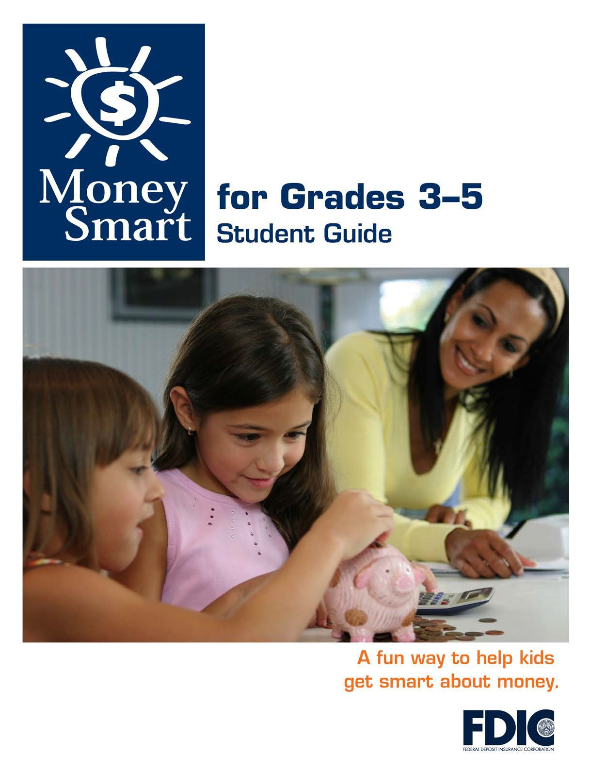

[1]

TABLE OF CONTENTS

Lesson 6: Get Invested (Introduction to Investing) 3
  - Student Handout 1: Complete the Story
  - Student Handout 2: Risk and Return

MONEY SMART FOR GRADES 3–5: STUDENT GUIDE 2

COMPLETE THE STORY

Name:

Directions: Read the passage and fill in each blank with the correct word from the word box.

Word Box
lose  profit | bond  company | stocks  interest | CD  wisely | goals  invest

My friend Ty is always talking about his long-term money

. He plans to manage his money .

When he is older, he wants to money in several

places. First, he says he’ll buy a from the bank

so he can earn . He may also buy a

from the government. Later, he is going to buy

so he can own shares of a company. If the company makes a big _ , he could make a lot of money! But if the
company does not, he could _ his money. Ty told

me that’s a risk he’ll have to take. One day he might even start his own .

RISK AND RETURN

Name:

The goal of investing is to buy something to make money in the future. Some investments are more risky than others.

Directions: Read the three scenarios below. Then fill in the circle for the best answer to each question about investing money.

- Keisha’s mother wants to invest money, but she does not want to risk losing it. She knows that taking a low risk means she might not make that much money. But she is OK with that. What should she do?
Buy a CD or U.S. government bond. Invest in stocks or any kind of bond. Put a large amount of money in stocks.

- Timo wants to buy shares of stock in a company. He thinks that, if he buys stocks, he will make lots of money. Then he plans to use the money to buy a car. What is the best advice to give him?
Make sure you invest a lot of money. Then you can get rich quickly. Do some more research about stocks. You may also lose your money. Sounds like a sure thing. You should start picking out your car today.

- Kim just made her first million. She plans to invest some of the money. She wants to get a high return and is not worried about taking a risk. What should she buy?
a one-year or five-year CD
U.S. government bonds stocks and high-risk bonds

