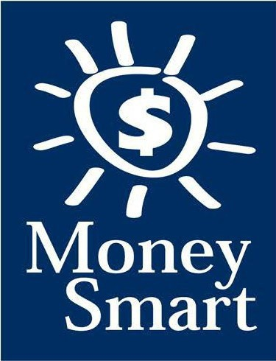
for Grades 3-5
Educator Guide

FDIC Disclaimer:
The books and online resources referenced in the Educator Guide and Parent/Caregiver Guide are examples/options that may be used to support the subject being taught and should not be considered as an endorsement by the Federal Deposit Insurance Corporation (FDIC). Reference to any specific commercial product, process, or service by trade name, trademark, manufacture, or otherwise does not constitute an endorsement, a recommendation, or a favoring by the FDIC or the United States government.
The FDIC Money Smart curriculum references books and provides links to other websites for convenience and informational purposes only. Users should be aware that when they select a link on the FDIC’s website to an external website, they are leaving the FDIC’s site. Linked sites are not under the control of the FDIC, and the FDIC is not responsible for the contents of any linked site or any link contained in a linked site, or any changes or updates to such sites. The FDIC is not responsible for any transmission received from a linked site. The inclusion of a link does not imply endorsement by the FDIC of the site, its content, advertisers, or sponsors. External sites may contain information that is copyrighted with restrictions on reuse. Permission to use copyrighted materials must be obtained from the original source and cannot be obtained from the FDIC.

TABLE OF CONTENTS
Welcome To Money Smart 4
Getting Started 5
Lessons At-a-Glance 8
Lesson 7: It’s Great to Donate! (Charitable Giving) 9
Answer Key 13
Glossary 16

WELCOME TO MONEY SMART

Welcome to Money Smart, an exciting interactive exploration of the concepts of money. This standards-aligned, cross-curricular program is designed to promote financial understanding in children ages 8 through 11. You can use Money Smart to add engaging and enriching activities to Math, English Language Arts, and Social Studies lessons while also helping your students build the foundation to become financially responsible adults.
In Money Smart you will find:
- Eight Lessons with hands-on, cross-curricular activities that engage third- through fifth-grade students in discussing and exploring key financial concepts
- Teacher Presentation Slides, which provide helpful visuals, as well as fill-in charts to support the activities in each lesson
- A Student Guide with handouts that let students explore the topics covered in each lesson and apply their new knowledge
- A Parent/Caregiver Guide with information about topics and terms being covered in class, conversation starters, online and literary sources, along with activities to try at home and around town
Developing positive financial habits equips students with 21st-century skills and tools that last a lifetime. We hope you and your students enjoy learning about money and its many uses.
We are eager to hear from you about how you use this curriculum. We would like to know what works well and what could be improved to make Money Smart even better. If you have any questions, we would like to help. Please contact us with your comments and questions via e-mail at communityaffairs@fdic.gov.

GETTING STARTED

Money Smart provides a comprehensive, developmentally appropriate program for upper elementary students to build an understanding of key financial concepts.
There are many features that help make the Money Smart curriculum engaging, motivating, and easy to use. Each lesson includes learning objectives, essential questions, supplies needed, and preparation required, as well as the following features and components to support easy integration of Money Smart activities into your instructional day.

STANDARDS
Each lesson promotes real-world connections through student-centered learning experiences and aligns to the following education standards and learning outcomes, including Common Core State Standards in mathematics and English Language Arts. The Education Standards Chart on pages 48- 57 identifies which standards are met in each lesson.
- Financial Literacy Jump$tartStandards
- English Language Arts Common Core State Standards
- Mathematics Common Core State Standards
- National Standards for Financial Literacy by the Council for Economic Education
- Partnership for 21st-Century Skills

GRADE-LEVEL MODIFICATIONS
Please note the modifications identified throughout lessons to differentiate learning experiences for beginner and advanced students. Modifications provide developmentally appropriate activity recommendations and extension opportunities.

PRESENTATION TIME
Each lesson plan includes an estimated time needed to teach the lesson. Actual time required will vary from classroom to classroom. The estimation includes instructional time spent on the Warm Up, Guided Exploration, and Wrap Up. Activities may also be taught as several short lessons over a period of days or weeks. Extended Exploration activities are included to extend financial literacy learning opportunities throughout the year and provide easy ways to integrate the topics into various content areas.

ASSESSMENTS
A variety of assessments are integrated throughout each of the eight lessons. Assessments are designed to build value, meaning, and context around a topic, while providing teachers with opportunities to evaluate prior student knowledge, and collect evidence of their new understandings of lesson concepts and skills. Pre- (formative) and post- (summative) assessments are noted on the first page of each lesson. Assessments include discussions, reflections, questions and answers, reading, writing, and problem-solving exercises. Student handouts are an especially useful form of written assessment.

LESSON STRUCTURE
Each lesson is designed to include the following:
- Warm Up introduces students to the topic and sparks inquiry.
- Guided Exploration integrates cross-curricular and developmentally appropriate learning activities and assessments while focusing on the key financial literacy learning objectives of the lesson.
- Wrap Up provides a reflection question or activity to review lesson concepts and allow students to demonstrate theirunderstanding.
- Money Smart Tips are provided throughout lessons to offer additional guidance, interesting and relevant financial facts, and additional ideas to help make Money Smart a success in your classroom.
- Extended Exploration provides teachers with additional opportunities to extend financial literacy concepts throughout the school year within core and creative content areas including English Language Arts, Math. Activities can be completed as a class, in small groups, or by students individually. Useful resources (such as books, web links, games, or videos) are also included to promote even more student engagement. The books and online resources suggested in this guide are just a few of the many available resources that explore these topics, and are not endorsed by the FDIC.
- Student Handouts (found in the Student Guide) and Teacher Presentation Slides provide dynamic instructional support. Student handouts create an opportunity for students to apply their knowledge and for teachers to assess their understanding. Teacher presentation materials offer visuals and interactive activities corresponding with each lesson, and can be projected for whole-group activities, or copied for small-group use.
- The Answer Key, Glossary, and Standards Chart house all of the information needed to check for understanding, define key terms, and check which activities meet specific education standards. Vocabulary words are bolded in each lesson as they are introduced. The vocabulary words can be used to create flash cards or a classroom Word Bank list. Students can also make their own Word Banks and refer to the lists as needed.

MONEY SMART AT HOME
The Money Smart curriculum includes a helpful Parent/Caregiver Guide that corresponds to the classroom resources. Families of young children may also use it independently of the curriculum. It contains resources, activities, games, and conversation starters on financial literacy topics covered in each lesson. Use the following ideas to encourage parents to use the guide at home:
- Introduce parents to the Money Smart program and share the Parent/Caregiver Guide at the start of the school year.
- Discuss the Money Smart program during parent/teacher conferences, or in monthly parent newsletters home, and emphasize the importance of building healthy financial habits from an early age.
- Hold a Money Smart family night. Play games and have students present short skits about financial concepts they have learned.
- Send student handouts from each lesson home in each child’s homework folder for parents to review and sign.

SMART BUCKS
Additional incentives can be used to promote positive financial behaviors and study habits throughout the Money Smart curriculum and school year. Introduce Smart Bucks to recognize students’ positive financial and classroom behaviors.
Smart Bucks can be earned for the following behaviors:
- Accomplishment of a goal(s)
- Completion of homework
- Exceptional classroom conduct
- Keeping the classroom clean and neat
- Participating in discussions or responding to questions
- Excellent group collaboration or individualwork
- Completing daily work
- Respectful behavior
As students accumulate Smart Bucks, they may spend them on prizes, toys, or special activities (for example: extra computer time, free reading time, game board time) at the end of the week or month, or whenever you normally provide rewards.
Smart Bucks may be tracked using a chart (displaying desired behaviors and goals), stored in a classroom “treasury” box, or in a cash register (if a class “store” is set up), and handed out to students using play money. Provide price tags or stickers on items or activities to be “sold.” The presentation for cashing in Smart Bucks can be as simple or elaborate as you choose.
Aside from being a fun way to reward positive behaviors, Smart Bucks can help foster an application of the financial literacy concepts covered in Money Smart lessons.
With Smart Bucks, students can practice:
- Math skills when adding the total of “Smart Bucks” earned
- The concept of making change without using acalculator
- The value of saving as they choose to save instead of spend, or set a goal to save for a more desired choice
Use Smart Bucks during Money Smart lessons or continue throughout the year.

FINANCIAL LITERACY ALL YEAR LONG
Highlight financial literacy at your school all year long, especially in April, during National Financial Literacy and School Library Month.
- Create bulletin boards or posters with students about financial literacy themes learned in

Money Smart.
- Play games that focus on numeracy skills and financial concepts (such as Monopoly).
- Feature children’s literature selections that cover financial literacy concepts in the library or during classroom reading time. See the Parent/Caregiver Guide for more literature suggestions.
The more students are exposed to financial literacy, and the more opportunity they have to practice applying their new knowledge and understanding of concepts, at school and at home, the more prepared they will be to live Money Smart lives.

LESSONS AT-A-GLANCE
Lesson Title Topic
Learning Objectives
Time Required

7 It’s Great to Donate!

Charitable Giving
•Explain the meaning of charitable giving, and its rewards
•Create a plan to raise money for a charitable cause
•Research various charitable causes
•Organize a charity drive
60 min

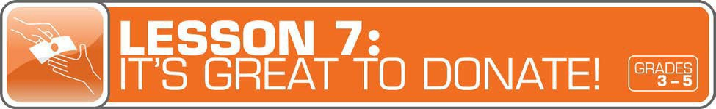

LESSON OVERVIEW
While students are beginning to formulate their knowledge of spending and saving, incorporate helping the less fortunate/those in need as part of a financial plan. Students will discover why they may choose to include charitable giving as part of a budget. They will also be reminded how time has an opportunity cost, so even if they don’t have money to donate, they can support charitable causes through volunteering.
TOPIC: Charitable Giving

TIME REQUIRED: 60 minutes
(excluding Extended Exploration activities)

LEARNING OBJECTIVES:
Students will be able to…
- Explain the meaning of charitable giving, and its rewards
- Create a plan to raise money for a charitable cause
- Research various charitable causes
- Organize a charity drive

SUPPLIES:
- Projector (for teacher presentationslides)
- Whiteboard or chart paper, markers
- Paper, pencils (for students)
- Access to the Internet (optional)
- Suggested books (optional)
o Sam and the Lucky Money by Karen Chinn

PREPARATION:
- Make copies of student handouts
- Set up projector with presentation slides
Answer Key 13
Glossary with key vocabulary 16
STUDENT HANDOUTS:
(found in Student Guide)

Story Problem: Giving

Giving Plan and Budget
- Money Smart Book (template from Lesson 1)

TEACHER PRESENTATION SLIDES:

What Is Profit?

Mr. Vega’s Class Giving Plan and Budget

Charity Vote

Fundraising Ideas

ESSENTIAL QUESTIONS:
- What does “charity” mean?
- Why is it important to help other people?
- How can you make giving a part of your budget?

ASSESSMENT ACTIVITIES:
PRE-ASSESSMENT:
- What Is Profit? slide
- Story Problem: Giving handout
POST-ASSESSMENT:
- Giving Plan and Budget handout
- Money Smart Book handout

INSTRUCTION STEPS
WARM UP
EXPLORING WHAT CHARITABLE GIVING MEANS [15 MINUTES]
Begin the lesson by asking students: What does charity mean? (It is the act of giving help or money to people, animals, or communities in need. A charity is an organization that helps people, animals, or communities in need or supports social causes.) How can giving to others in need help you? (Students might say it makes them feel good, like they are part of a community, makes them appreciate what they have, and so on.)
Optional: Read the book Sam and the Lucky Money by Karen Chinn. The story is about a boy who receives money (also known as “laisee”), for Chinese New Year and has to decide how to spend it. He eventually decides to give the money to a homeless man.
Have a class discussion about the main character and his act of charitable giving.

Discussion Questions:
- What things did Sam consider buying with his lucky money? (sweets, toys, a basketball)
- Why didn’t Sam buy the basketball? (He didn’t have enough money.)
- How did Sam decide to spend the money? (Sam gave it to the old man so he could buy socks.)
- How do you think the old man felt after Sam gave him the money? (happy, thankful) How might Sam have felt? (happy, upset to see the old man without shoes, and so on)
- What do you think the author meant by the last sentence of the book? “And as they headed home for more New Year’s celebration, Sam knew he was the lucky one.” (After seeing the old man, Sam knew that he had a lot to be thankful for.)
Ask students to think about a personal experience when they received a gift or help from someone. Invite students to share their stories. Then ask: How did receiving a gift or help from someone make you feel? (Answers will vary, but may include: happy, thankful, lucky, grateful.) Why is it important to help people? (Many people all over the world need help. Other people can make a difference in their lives by helping them. It is a kind thing to do that can make the world a better place.) The following activity will teach students more about how to plan for giving.

MONEY SMART TIP!

Review the concept of “pay yourself first” with students.

Explain that, when they receive money, the first thing theyshould do is save some of it. Then they can spend on things they need or want, and set a portion of money aside todonate.

GUIDED EXPLORATION
UNDERSTANDING HOW TO PLAN FOR GIVING [20 MINUTES]
Discuss: What do you think is meant by the expression the “gift of giving”? (the rewarding feeling you get from helping others) Ask: How can you make giving a part of your budget? (Plan for giving just like you would for saving and spending. Pay yourself first by saving money before spending it. Plan ahead for how much you would like to give, and set aside that money for charity.)
Students can learn to make charitable giving part of a budget. Display the What Is Profit? slide and give students paper and pencils to work on the math problem. Discuss the answers together as a class. Then have students work on the Story Problem: Giving handout to explore a real-life scenario about a class raising money for charity. After students answer the questions, review as a class.

Grade-Level Modification:
Beginner: Call on one or more students to read the word problem aloud on the Story Problem: Giving handout. As students follow along, have them use a pencil to underline or circle the most important pieces of information (giving goal is $100, $2 a magnet, sold $65 worth of magnets, and spent $24 on art supplies). Review the definitions for income and expenses from the What Is Profit slide. Ask students to identify the income ($65) and expenses ($24) before they begin the first question.

Display the Mr. Vega’s Class Giving Plan and Budget slide to show students how the giving plan and budget can be written. After discussing the questions at the end of the slide, explain that students will now talk about a class-giving project of their own.

EXPLORING FUNDRAISING OPPORTUNITIES [15 MINUTES]
List a few charities on a whiteboard or chart paper. Ask students what they know about each charity, and give them more information. Take a vote to see which charity students would like to help. Use the Charity Vote slide to record the results of the class vote. Then ask them to brainstorm ways they can raise money as a class by using the Fundraising Ideas slide to help spark some ideas.
Once students have decided on a charity and how they will raise money, have them complete a giving plan and budget as a whole class using the Giving Plan and Budget handout. Allow students to refer to the Mr. Vega’s Class Giving Plan and Budget slide to help them.

Grade-Level Modifications:
Beginner: Give the students a list of charities from which they can choose.
Advanced: Ask students to think about what causes are important to them (in their communities, nationally, globally). Then ask them to research the charities they would like to help before choosing one in a class vote.

MONEY SMART TIP!

Remind students that time has an opportunity cost, so even if they don’t have money to donate, they can support charitable causes through volunteering.

WRAP UP
CLASS REFLECTION [10 MINUTES]
Debrief students by starting a discussion. Ask: Why is it important to help other people? How can giving to others in need help you? Have students write a Money Smart Book entry to describe a time they helped someone and how it made them feel. Invite students to draw illustrations as well.

EXTENDED EXPLORATION
Note: Use the following activities to extend the lesson topic throughout the year. Activities can be completed as a class or in small groups. Duration of activities will vary.
- Have students raise money for the charity of their choice using their giving plan and budget. Then make a donation! Remind students to refer to the budget throughout the project to make sure they are on track. At the end of the project, ask them to review the budget to see whether they met their goal and are under budget (spent less money than they expected) or over budget (spent more than they expected).
Review and discuss. Ask: How did the budget help you achieve your goal? (Answers may include: It helped us manage our money.) What did you learn from doing the fundraiser? (Answers may include: We learned how to write a giving plan and budget, how to raise money for charity, that having a business takes a lot of planning.)
- After students make a charitable donation, have them write an essay about how it felt to give a donation and why it was important. Essays can be shared on the school website or community newsletter, or read at an assembly to motivate others to do the same.
- Have students work in small groups to create and share a presentation or puppet show for younger students about their charitable givingproject.

ANSWER KEY

for Student Handouts (found in Student Guide)

LESSON 1: MONEY MATTERS
Student Handout 1: Sort It Out. Answers will vary.

Student Handout 2: What Should I Buy?
Situation A: 1. want, 2. want, 3. need, 4. backpack, 5. Answers may include: Maya should spend her money on a new backpack. It is the most important because it is a need. Her old backpack is badly damaged.
Situation B: 1. want, 2. need, 3. want, 4. a pair of sneakers, 5. Answers may include: Travis should spend his money on a new pair of sneakers. It is the most important because it is a need. His old sneakers are getting too small.

Student Handout 3: Trade-Offs. Answers will vary.

Student Handout 4: Money Smart Book. Answers will vary.

LESSON 2: GET SET FOR GOALS
Student Handout 1: Short- and Long-Term Goals
Situation A: 1. Ella wants to challenge her brother to a basketball game. 2. Ella plans to join the basketball team when she gets to middle school. 3. She can keep practicing to improve her basketball skills.
Situation B: 1. Max wants to get a good grade on his French test next week. 2. Max wants to visit France when he is older. 3. Answers will vary, but may include: Max can keep studying and practicing French. Max can save money for a trip to France.

Student Handout 2: What Are Your Goals? Answers will vary.

Student Handout 3: Saving Together
1. Their savings goal is $150 to buy a tablet computer. 2. They want to reach their goal in one year.
3. It is a long-term goal. 4. They still need to save $120 ($150 – $20 = $130 – $10 = $120, or $150 – ($20 + $10)
= $120). 5. Each child will pay $75 ($150 ÷ 2 = $75). 6. Answers will vary.

Student Handout 4: My Savings Goals. Answers will vary.

LESSON 3: MAKE A PLAN
Student Handout 1: Jake’s Budget
Total monthly expenses: $1,620. Questions: 1. $180, 2. $1,800, 3. $910, 4. $510 ($410 + $100 = $510),
- $25 ($200 – $175 = $25), 6. Answers will vary, but may include clothes and entertainment (movies, bowling, sports games, concerts, etc.).

ANSWER KEY (continued)

Student Handout 2: Finish That Budget!
Monthly Income: Taking care of younger brother: $8, Getting the neighbor’s mail: $2, Total: $10; Monthly Expenses: Snacks and supplies: $9; Monthly Savings: $1. Questions: 1. 25 cents ($1 or 100 cents – 75 cents = 25 cents), 2. $12 ($1 per month, or $1 x 12 = $12), 2. Answers will vary, but may include: She can spend less on snacks and supplies, compare prices, get another job.

Student Handout 3: My Budget
Answers will vary, unless students use the suggested numbers of $15 monthly income and $8 monthly expenses. If so: Monthly Savings: $7. Questions: 1. $84 ($7 x 12 months = $84), 2. Answers will vary, but may include: I can spend less by comparing prices, buying fewer wants.

LESSON 4: SAVE YOUR MONEY
Student Handout 1: Calculate the Interest
  - C ($2), 2. B ($300 + $3 interest = $303), 3. A ($800, based on the chart, solutions may include: $8 x 100 or
$8 is the sum of $3 + $5, which corresponds to $300 + $500 = $800)

Student Handout 2: What Are the Risks?
Risks of Riding a Bicycle: Answers will vary, but may include: falling, getting hit by a car, a flat tire.
Ways to Avoid or Reduce the Risks: Answers will vary, but may include: wearing a helmet, riding in a safe area away from cars, carrying a bicycle pump.

Student Handout 3: Money Smart Book Comic Strip. Answers will vary.

LESSON 5: WHICH WAY TO PAY?
Student Handout 1: Payment Options: True or False?
1. True, 2. True, 3. False (Credit cards and debit cards are made of plastic.), 4. True, 5. False (If you use a credit card, you receive a monthly bill.), 6. False (Credit cards do set limits to how much you can spend.),
7. True, 8. False (A debit is money removed from an account.), 9. True, 10. True

Student Handout 2: Payment Decisions
- She should pay using the credit card because she doesn’t have enough cash.
- He should pay with cash because the store only accepts cash.
- She should pay with her debit card because she doesn’t have enough cash.
- He should pay with his debit card because he has enough money in his checking account ($2,800).
He shouldn’t use his credit card because he has a $3,000 credit card limit and has already charged $800. ($3,000 – $800 = $2,200. That is $100 less than his car bill of $2,300.)

Student Handout 3: Test Your Payment Knowledge
1. A (checks and debit cards), 2. C (month), 3. C (using a credit card), 4. B (check), 5. B (Keep your personal information private.)

ANSWER KEY (continued)

LESSON 6: GET INVESTED
Student Handout 1: Complete the Story
My friend Ty is always talking about his long-term money goals. He plans to manage his money wisely. When he is older, he wants to invest money in several places. First, he says he’ll buy a CD from the bank so he can earn interest. He may also buy a bond from the government. Later, he is going to buy stocks so he can own shares of a company. If the company makes a big profit, he could make a lot of money! But if the company does not, he could lose his money. Ty told me that’s a chance he’ll have to take. One day he might even start his own company.

Student Handout 2: Risk and Return
1. A (Buy a CD or U.S. government bond.), 2. B (Do some more research about stocks. You may also lose your money.), 3. C (stocks and high-risk bonds)

LESSON 7: IT’S GREAT TO DONATE!
Student Handout 1: Story Problem: Giving
1. $100, 2. 32 magnets ($64 ÷ $2 per magnet = 32 magnets), 3. $40 profit ($64 – $24 = $40), 4. $60 ($100 – $40 = $60), 5. 30 magnets ($60 ÷ $2 per magnet = 30 magnets)

Student Handout 2: Giving Plan and Budget. Answers will vary.

LESSON 8: CAREER CHOICES
Student Handout 1: Different Jobs. Answers will vary.

Student Handout 2: Interest Survey. Answers will vary.

Student Handout 3: Salary and Education
- C (Master’s), 2. $54,200 ($116,700 – $62,500 = $54,200), 3. Answers may include: They all require a higher education degree and pay more than $60,000 ayear.

GLOSSARY

Advertisement (Ad): A public notice or announcement that a company pays for to help promote and increase sales of a product or service.

Bank: A financial institution and business that accepts deposits and makes loans.

Borrow: To receive something on loan with the understanding that you will return it.

Budget: A plan that outlines what money you expect to earn or receive (your income) and how you will save it or spend it (your expenses) for a given period of time.
Career: The type of work a person pursues for the majority of their life that may involve formal education, special training, or be within a specific industry.
Cash: Money such as coins and bills.

Charity: The act of giving help or money to help people, animals, or communities in need; an organization that helps people, animals, or communities in need or supports social causes.
Check: A written order of payment that instructs a financial institution (such as a bank) to withdraw a specific amount of money from the check-writer’s account, and pay or deposit it to the person, or business, named on the check.
Credit: The ability to borrow money and pay it back later.

Debit: An amount of money taken out of a deposit account to pay for something.

Debt: Money that is owed.

Donation: Something (including money, food, clothes, and toys) that you give to help people, animals, or communities in need or to a charity.
Earn: To receive money in exchange for goods or services. Emergency Fund: Money set aside to pay for unexpected expenses. Entrepreneur: Someone who creates and runs a business.
Expense: The cost of goods and services; the amount of money that is spent.

Federal Deposit Insurance Corporation (FDIC): Preserves and promotes public confidence in the U.S. financial system by insuring deposits in banks and thrift institutions for at least $250,000. An independent agency of the federal government, the FDIC was created in 1933.
Goal: Something you wish to achieve or accomplish in a specific amount of time.

Income: Money that you receive from jobs, allowances, interest, dividends, and other sources.

Interest: Money that a bank or other financial institution pays you for keeping money on deposit with them, or the amount of money you pay a bank as a fee when you borrow money.

GLOSSARY (continued)

Invest: To put money at risk with the goal of making a profit in the future.

Job: A specific duty, task, or activity someone completes using his or her time, skills, and energy to earn money.

Lend: The act of giving something to someone with the understanding that they will give it back to you.

Long-Term Goal: Something you want to achieve in the future, such as in one year, five years, ten years, or more.

Money Order: Similar to a check, but can be purchased at a bank or post office, and used to make a payment of a specified sum of money.
Need: Something you must have to survive, such as clothes, shelter, or food.

Opportunity Cost: The next best thing that you give up in order to do something else; a trade-off of a decision you make.
Profit: The money gained or left over after money spent (expense) is subtracted from money earned (income).

Return: Money made (profit) from an investment.

Risk: The possibility that something unplanned or unintended may happen (such as losing money).

Save: Setting something, like money, aside to use in the future.

Savings Account: A bank account that you can use to set aside money, and that pays you interest.

Savings Goal: The amount of money you plan to put aside for a specific purpose.

Short-Term Goal: Something you want to achieve soon, such as in two weeks or a few months.

Spend: The act of using money to buy goods or services.

Spending Limit: The most amount of money a person is allowed (or allows themselves) to spend.

Tax: Money that someone has to pay to help finance a government.

Want: Something that you would like to have but that you could live without.

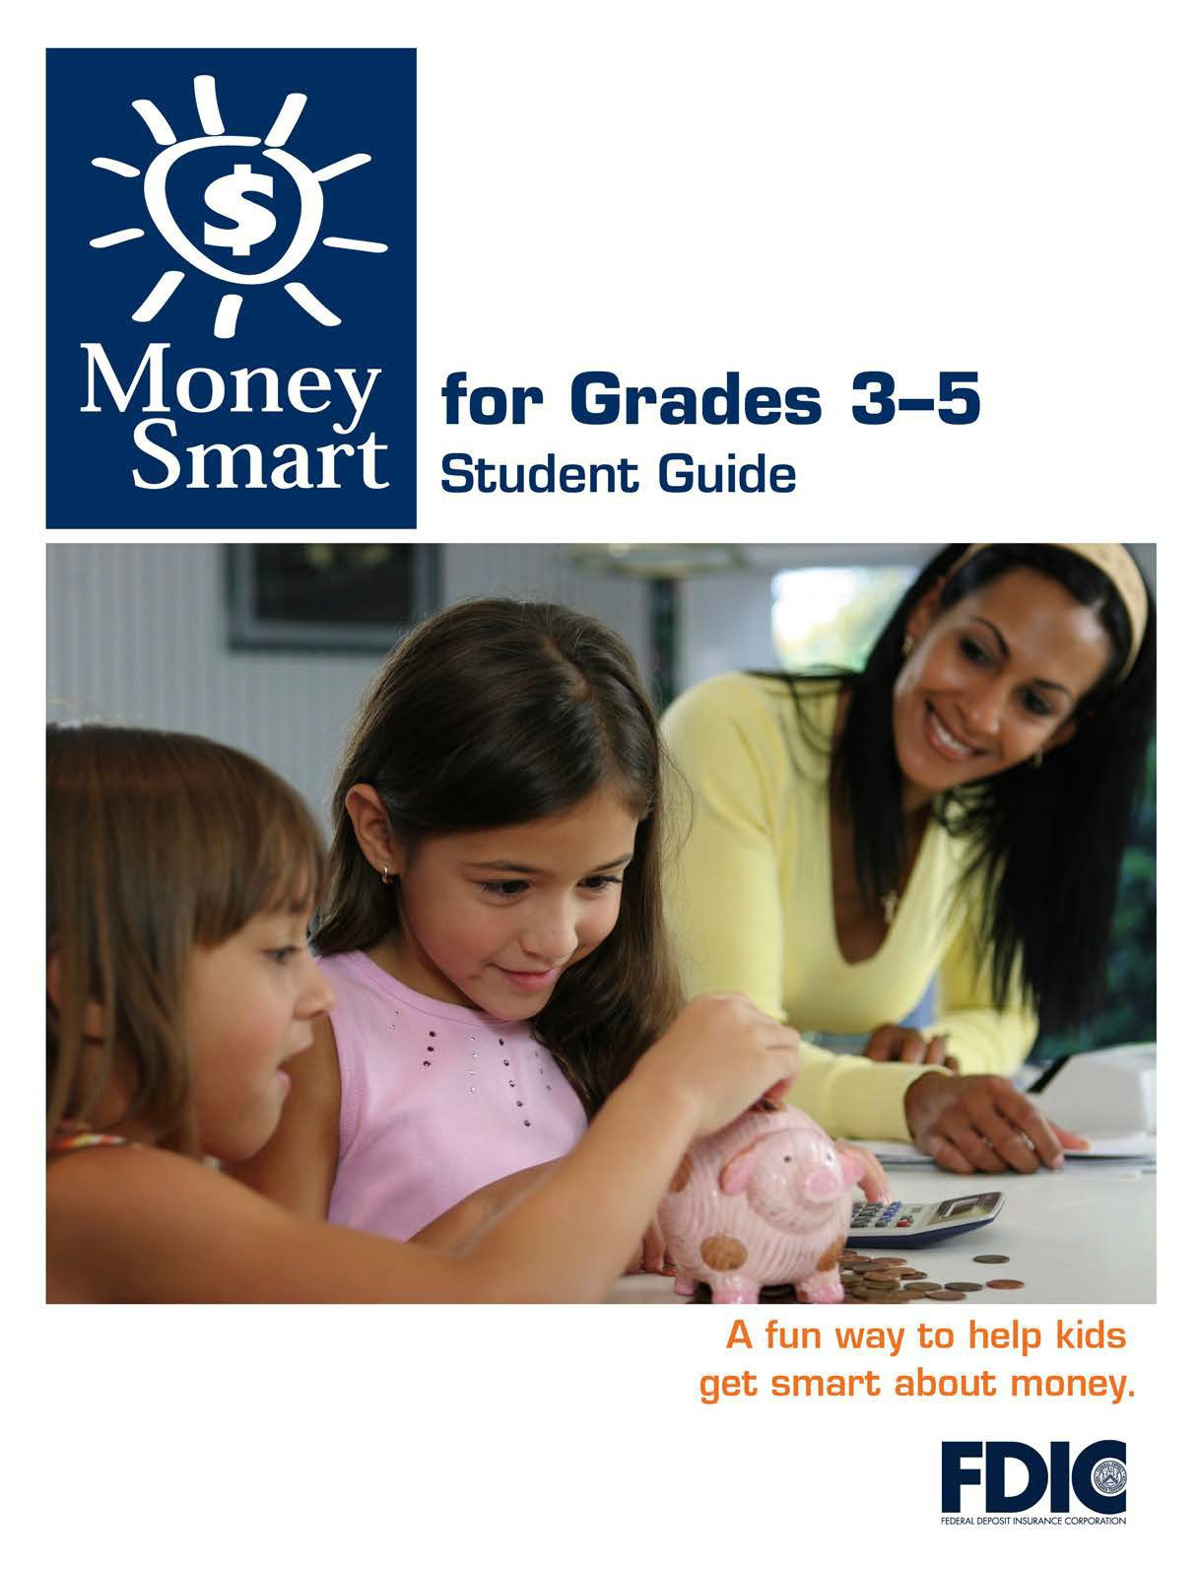

[1]

TABLE OF CONTENTS

Lesson 7: It’s Great to Donate! (Charitable Giving) 3
  - Student Handout 1: Story Problem: Giving
  - Student Handout 2: Giving Plan and Budget

MONEY SMART FOR GRADES 3–5: STUDENT GUIDE
2

STORY PROBLEM: GIVING

Name:

Directions: Read the scenario below. Then answer the questions that follow.

Mr. Vega’s class wants to donate money to a local animal shelter. Their giving goal is

$100. Students decide to make and sell animal magnets at $2 a magnet, to raise the money. So far, they have sold $64 worth of magnets. They spent $24 on art supplies to make the magnets. The good news is that they have enough supplies left for the rest of the project.

How much money does the class want toraise?

How many magnets has the class sold so far? Show your math:

What profit have they made so far? (Hint: A profit is the total income minus theexpenses.)

Show your math:

How much more money do they need to raise to meettheir goal? Show your math:

How many more magnets will they have to sell to reachtheir goal? Show your math:

GIVING PLAN AND BUDGET
Name:
A budget is a spending plan to help you manage your money. You can make giving
part of your budget.
Directions: Use the worksheet below to help put your giving plan into action. First,
decide how you will raise the money and how much you want to give. Then fill in the money you expect to make and your expenses (money you will spend).
Giving (Money We Expect to Give)
$
$
$
Total
$
Income (Money We Expect to Make)
$
$
$
Total
$
Expenses (Money We Expect to Spend)
$
$
$
Total
$

