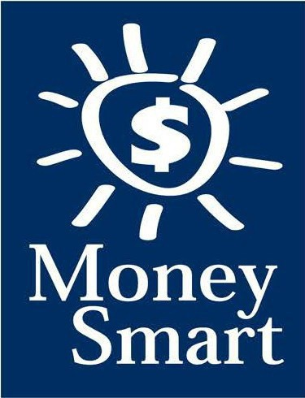
for Grades 3-5
Educator Guide

FDIC Disclaimer:
The books and online resources referenced in the Educator Guide and Parent/Caregiver Guide are examples/options that may be used to support the subject being taught and should not be considered as an endorsement by the Federal Deposit Insurance Corporation (FDIC). Reference to any specific commercial product, process, or service by trade name, trademark, manufacture, or otherwise does not constitute an endorsement, a recommendation, or a favoring by the FDIC or the United States government.
The FDIC Money Smart curriculum references books and provides links to other websites for convenience and informational purposes only. Users should be aware that when they select a link on the FDIC’s website to an external website, they are leaving the FDIC’s site. Linked sites are not under the control of the FDIC, and the FDIC is not responsible for the contents of any linked site or any link contained in a linked site, or any changes or updates to such sites. The FDIC is not responsible for any transmission received from a linked site. The inclusion of a link does not imply endorsement by the FDIC of the site, its content, advertisers, or sponsors. External sites may contain information that is copyrighted with restrictions on reuse. Permission to use copyrighted materials must be obtained from the original source and cannot be obtained from the FDIC.

TABLE OF CONTENTS
Welcome To Money Smart 4
Getting Started 5
Lessons At-a-Glance 8
Lesson 8: Career Choices (Exploring Careers and Income) 9
Answer Key 14
Glossary 17

WELCOME TO MONEY SMART

Welcome to Money Smart, an exciting interactive exploration of the concepts of money. This standards-aligned, cross-curricular program is designed to promote financial understanding in children ages 8 through 11. You can use Money Smart to add engaging and enriching activities to Math, English Language Arts, and Social Studies lessons while also helping your students build the foundation to become financially responsible adults.
In Money Smart you will find:
- Eight Lessons with hands-on, cross-curricular activities that engage third- through fifth-grade students in discussing and exploring key financial concepts
- Teacher Presentation Slides, which provide helpful visuals, as well as fill-in charts to support the activities in each lesson
- A Student Guide with handouts that let students explore the topics covered in each lesson and apply their new knowledge
- A Parent/Caregiver Guide with information about topics and terms being covered in class, conversation starters, online and literary sources, along with activities to try at home and around town
Developing positive financial habits equips students with 21st-century skills and tools that last a lifetime. We hope you and your students enjoy learning about money and its many uses.
We are eager to hear from you about how you use this curriculum. We would like to know what works well and what could be improved to make Money Smart even better. If you have any questions, we would like to help. Please contact us with your comments and questions via e-mail at communityaffairs@fdic.gov.

GETTING STARTED

Money Smart provides a comprehensive, developmentally appropriate program for upper elementary students to build an understanding of key financial concepts.
There are many features that help make the Money Smart curriculum engaging, motivating, and easy to use. Each lesson includes learning objectives, essential questions, supplies needed, and preparation required, as well as the following features and components to support easy integration of Money Smart activities into your instructional day.

STANDARDS
Each lesson promotes real-world connections through student-centered learning experiences and aligns to the following education standards and learning outcomes, including Common Core State Standards in mathematics and English Language Arts. The Education Standards Chart on pages 48- 57 identifies which standards are met in each lesson.
- Financial Literacy Jump$tartStandards
- English Language Arts Common Core State Standards
- Mathematics Common Core State Standards
- National Standards for Financial Literacy by the Council for Economic Education
- Partnership for 21st-Century Skills

GRADE-LEVEL MODIFICATIONS
Please note the modifications identified throughout lessons to differentiate learning experiences for beginner and advanced students. Modifications provide developmentally appropriate activity recommendations and extension opportunities.

PRESENTATION TIME
Each lesson plan includes an estimated time needed to teach the lesson. Actual time required will vary from classroom to classroom. The estimation includes instructional time spent on the Warm Up, Guided Exploration, and Wrap Up. Activities may also be taught as several short lessons over a period of days or weeks. Extended Exploration activities are included to extend financial literacy learning opportunities throughout the year and provide easy ways to integrate the topics into various content areas.

ASSESSMENTS
A variety of assessments are integrated throughout each of the eight lessons. Assessments are designed to build value, meaning, and context around a topic, while providing teachers with opportunities to evaluate prior student knowledge, and collect evidence of their new understandings of lesson concepts and skills. Pre- (formative) and post- (summative) assessments are noted on the first page of each lesson. Assessments include discussions, reflections, questions and answers, reading, writing, and problem-solving exercises. Student handouts are an especially useful form of written assessment.

LESSON STRUCTURE
Each lesson is designed to include the following:
- Warm Up introduces students to the topic and sparks inquiry.
- Guided Exploration integrates cross-curricular and developmentally appropriate learning activities and assessments while focusing on the key financial literacy learning objectives of the lesson.
- Wrap Up provides a reflection question or activity to review lesson concepts and allow students to demonstrate theirunderstanding.
- Money Smart Tips are provided throughout lessons to offer additional guidance, interesting and relevant financial facts, and additional ideas to help make Money Smart a success in your classroom.
- Extended Exploration provides teachers with additional opportunities to extend financial literacy concepts throughout the school year within core and creative content areas including English Language Arts, Math. Activities can be completed as a class, in small groups, or by students individually. Useful resources (such as books, web links, games, or videos) are also included to promote even more student engagement. The books and online resources suggested in this guide are just a few of the many available resources that explore these topics, and are not endorsed by the FDIC.
- Student Handouts (found in the Student Guide) and Teacher Presentation Slides provide dynamic instructional support. Student handouts create an opportunity for students to apply their knowledge and for teachers to assess their understanding. Teacher presentation materials offer visuals and interactive activities corresponding with each lesson, and can be projected for whole-group activities, or copied for small-group use.
- The Answer Key, Glossary, and Standards Chart house all of the information needed to check for understanding, define key terms, and check which activities meet specific education standards. Vocabulary words are bolded in each lesson as they are introduced. The vocabulary words can be used to create flash cards or a classroom Word Bank list. Students can also make their own Word Banks and refer to the lists as needed.

MONEY SMART AT HOME
The Money Smart curriculum includes a helpful Parent/Caregiver Guide that corresponds to the classroom resources. Families of young children may also use it independently of the curriculum. It contains resources, activities, games, and conversation starters on financial literacy topics covered in each lesson. Use the following ideas to encourage parents to use the guide at home:
- Introduce parents to the Money Smart program and share the Parent/Caregiver Guide at the start of the school year.
- Discuss the Money Smart program during parent/teacher conferences, or in monthly parent newsletters home, and emphasize the importance of building healthy financial habits from an early age.
- Hold a Money Smart family night. Play games and have students present short skits about financial concepts they have learned.
- Send student handouts from each lesson home in each child’s homework folder for parents to review and sign.

SMART BUCKS
Additional incentives can be used to promote positive financial behaviors and study habits throughout the Money Smart curriculum and school year. Introduce Smart Bucks to recognize students’ positive financial and classroom behaviors.
Smart Bucks can be earned for the following behaviors:
- Accomplishment of a goal(s)
- Completion of homework
- Exceptional classroom conduct
- Keeping the classroom clean and neat
- Participating in discussions or responding to questions
- Excellent group collaboration or individualwork
- Completing daily work
- Respectful behavior
As students accumulate Smart Bucks, they may spend them on prizes, toys, or special activities (for example: extra computer time, free reading time, game board time) at the end of the week or month, or whenever you normally provide rewards.
Smart Bucks may be tracked using a chart (displaying desired behaviors and goals), stored in a classroom “treasury” box, or in a cash register (if a class “store” is set up), and handed out to students using play money. Provide price tags or stickers on items or activities to be “sold.” The presentation for cashing in Smart Bucks can be as simple or elaborate as you choose.
Aside from being a fun way to reward positive behaviors, Smart Bucks can help foster an application of the financial literacy concepts covered in Money Smart lessons.
With Smart Bucks, students can practice:
- Math skills when adding the total of “Smart Bucks” earned
- The concept of making change without using acalculator
- The value of saving as they choose to save instead of spend, or set a goal to save for a more desired choice
Use Smart Bucks during Money Smart lessons or continue throughout the year.

FINANCIAL LITERACY ALL YEAR LONG
Highlight financial literacy at your school all year long, especially in April, during National Financial Literacy and School Library Month.
- Create bulletin boards or posters with students about financial literacy themes learned in

Money Smart.
- Play games that focus on numeracy skills and financial concepts (such as Monopoly).
- Feature children’s literature selections that cover financial literacy concepts in the library or during classroom reading time. See the Parent/Caregiver Guide for more literature suggestions.
The more students are exposed to financial literacy, and the more opportunity they have to practice applying their new knowledge and understanding of concepts, at school and at home, the more prepared they will be to live Money Smart lives.

LESSONS AT-A-GLANCE

Lesson Title Topic
Learning Objectives
Time Required
8 Career Choices
Exploring
Careers and Income
•Identify and explore different types
of jobs
•Evaluate personal interests related to careers
•Explain how money is earned and why it is taxed
•Explain what an entrepreneur is
60 min

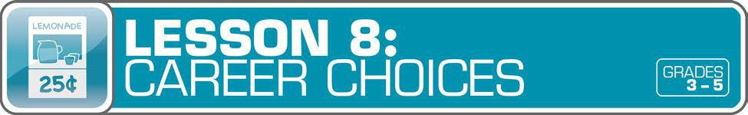
Answer Key 14
Glossary with key vocabulary 17

LESSON OVERVIEW
Using student-centered activities, this lesson will not only teach learners about different job sectors and reinforce how income is earned (either by working or through investments), but will also engage them in assessing their personal interests as they relate to potential careers. Students will learn how education is a proven strategy to improve their lifelong earnings potential. They will also extend their working knowledge of income by recognizing that earned income is taxed.
TOPIC: Exploring Careers and Income

TIME REQUIRED: 60 minutes
(excluding Extended Exploration activities)

LEARNING OBJECTIVES:
Students will be able to…
- Identify and explore different types of jobs
- Evaluate personal interests related to careers
- Explain how money is earned and why it is taxed
- Explain what an entrepreneur is

SUPPLIES:
- Projector (for teacher presentationslides)
- Whiteboard or chart paper, markers
- Paper, markers, tape, and a box or hat (for the game)
- Access to the Internet (optional)

PREPARATION:
- Make copies of student handouts
- Set up projector with presentation slides
- Pre-write different careers on individual pieces of paper, one for each student (that you will later tape to students’ foreheads) and put in a box or hat
STUDENT HANDOUTS:
(found in Student Guide)

Different Jobs

Interest Survey

Salary and Education

Money Smart Book
(template from Lesson 1)

TEACHER PRESENTATION SLIDES:

Interests and Jobs

Education Levels and Income

Bureau of Labor Statistics

How Is Income Tax Spent?

ESSENTIAL QUESTIONS:
- What is income, and how is it earned?
- What are different types of jobs that you can have?
- What is an entrepreneur?
- What is tax and why is income taxed?

ASSESSMENT ACTIVITIES:
Pre-Assessment:
- Class discussions

Education Levels and Income slide
Post-Assessment:
- Salary and Education handout
- Money Smart Book handout

INSTRUCTION STEPS
WARM UP
EXPLORING DIFFERENT JOB SECTORS [25 MINUTES]
Tap prior knowledge by asking students: What is a job? (A specific duty, task, or activity someone completes using his or her time, skills, and energy to earn money.) What are the different types of jobs that you can have? (You can choose between hundreds of different types of jobs in many fields, including science, technology, engineering, math, art, and music.) What is a career? (The type of work a person pursues for the majority of their life that may involve formal education, special training, or be within a specific industry, such as a career in medicine, advertising, or food services.)

Provide students with the Different Jobs handout, which includes a list of jobs and their definitions. Discuss the handout and explain that the class will play a game using the handout.
Ask students to sit in a circle and pick one paper from the box to tape to each student’s forehead (job title facing out). Explain the rules: Each player will be able to see the job titles of all players except his or her own. Using their student handouts as a guide, students will try to guess their own jobs by asking “yes” or “no” questions of the other players.
The student who begins will ask one question, such as: Do I work in a science job? If the answer is yes, the student can ask another question, such as: Do I work directly with patients? If the answer is yes, the student asks another question until either A) he or she guesses the job title correctly, or B) the answer to his or her question is no. If the answer is no, play passes to the next student until each student has had a chance to guess. To speed up the game, students can play in smaller groups after a practice round with the whole class.

Grade-Level Modifications:
Beginner: If students are having trouble guessing their jobs, you or the other students can give them clues instead of having them ask “yes” or “no” questions. For example: if a student is a geologist, you can say, “You like the outdoors.” If student guesses incorrectly, give another clue: “You are a scientist.” If student still hasn’t guessed, give an easier clue, such as “You study rocks.”
Advanced: In addition to asking “yes” or “no” questions, students may silently act out clues for the student guessing. After the game is over, have students try to group themselves into job sectors (for example: science, health, engineering, computers).
End the game with a discussion about the jobs. Ask: Have you heard of the job you received? Do you know anyone who has that job? What does that person do? Ask: What is an entrepreneur? (An entrepreneur is someone who creates and runs a business.) People who own a successful business can earn a profit, which is a source of income.

MONEY SMART TIP!

Explain to students: Going to college can be expensive because colleges charge students money to attend. Ask: Why might it be worth it to spend the money? (Paying for college is an investment in your future.) On average, people

with a college degree earn more money than people who do not attend college.

If you don’t go to college, other ways to get more education are through apprenticeships, internships, or training programs.

GUIDED EXPLORATION
EXAMINING PERSONAL INTERESTS AND SKILLS [10 MINUTES]
Provide students with the Interest Survey handout, and after completing it, display the Interests and Jobs slide to show them some possible jobs based on their interests. As an extension activity, have students research more about those jobs, along with others they may want to learn more about. See the links below for websites with career information. Ask: What type of work do you want to do when you grow up? How can you get prepared for the work that interests you? Would you want to start your own business? Please explain why or why not.

EXPLORING INCOME AND EDUCATION LEVELS [10 MINUTES]
Prompt students with the following questions: What is income? (money earned) How is it earned? (by either working for a period of time, owning a business, or through investments) Why might income levels differ? (Answers may include: Different people get paid different salaries depending on their field, education level, where they live, who they work for.) How might an increase in skills and education lead to increased income? (Higher-paying careers often require that people have more skills and a higher education.) Share the Education Levels and Income slide and discuss the cartoon.
Display the Bureau of Labor Statistics slide, which explains what the agency does and some different levels of education. After students review the slide, distribute the Salary and Education handout, which includes salary estimates and levels of required education for various jobs from the
  - Bureau of Labor Statistics. After students answer the questions, review and discuss.

Grade-Level Modifications:
Beginner: Leave the Bureau of Labor Statistics slide open while students are working on the
Salary and Education handout so they can refer to the levels of higher education.
Advanced: Students can research more careers by going to http://www.bls.gov/ooh. There, they can find careers listed by occupational groups, highest paying, fastest growing, and so on.

UNDERSTANDING THAT INCOME IS TAXED [5 MINUTES]
Lead a class discussion by asking: What is tax? (a government fee on things, including income, sales, and property) What kinds of things are taxed? (Students may give examples, such as clothes, school supplies, food at a restaurant, and toys.)
Explain that the government collects taxes on the income people earn. Ask: Why is income taxed? (The government uses the money to pay for things people need.) Then ask: How might the government use that money? (public education, libraries, road and bridge repairs, health care for seniors and people with low incomes, national defense spending, and so on) Share the How Is Income Tax Spent? slide with students and discuss.

WRAP UP
CLASS REFLECTION [10 MINUTES]
Ask students: Based on what you learned today, what jobs are you interested in, and why? What kinds of skills and education do you need to be able to do this job? Why is it important to think about a job or career early? Ask students to write in their Money Smart Book about one or two jobs that interest them, and to add illustrations.

EXTENDED EXPLORATION
Note: Use the following activities to extend the lesson topic throughout the year. Activities can be completed as a class or in small groups. Duration of activities will vary.
    - Games and Online Activities: Invite students to visit the following websites to further explore career options:
      - Career Exploration! Access information on dozens of careers in various industries to learn about specific skills and duties, education or training requirements, work environments, earning potential, and job outlook. http://www.bls.gov/k12/content/students/careers/career-exploration.htm
      - Career Aisle: Features career videos for students to explore.

http://knowitall.scetv.org/careeraisle/students/elementary/
      - Careers: Explore, Learn, Grow: Print out a fill-in-the-blank quiz for students to match careers with the right job descriptions. http://virginiacareerview.com/k5/careers/computer-career-games/3-5/careers- explore-learn-grow
      - Jobs: Information and videos about different careers from Kids.gov.

http://kids.usa.gov/jobs/index.shtml
      - Lesson Plans on Jobs: More classroom resources for teachers about careers.

http://kids.usa.gov/teachers/lesson-plans/jobs/index.shtml

    - Invite members (or parents) of the community to visit the classroom as guest speakers to tell students about their jobs and answer questions. Ask students to prepare interview questions in advance. Make sure to include speakers from a variety of careers, especially those in the STEM (science, technology, engineering, and math) fields. To do so, you may want to post ads at the local library, send out requests with the school newsletter, and ask people from local businesses to come and speak (for example: the dentist office, a gift shop owner, a landscaping company, a city employee, a school administrator, entrepreneurs).
    - Ask students to think about business ideas and write an essay using the following questions to help them get started: Do you know someone who has started his or her own business? If you started your own business, what would you do? Would you sell a product or a service? Would it be something people would need or want?
    - Make a social studies connection by asking students to research career options for people who lived in colonial days (or another historical time period), compare and contrast to today’s career options, and discuss why those career options have changed overtime.

ANSWER KEY

for Student Handouts (found in Student Guide)

LESSON 1: MONEY MATTERS
Student Handout 1: Sort It Out. Answers will vary.

Student Handout 2: What Should I Buy?
Situation A: 1. want, 2. want, 3. need, 4. backpack, 5. Answers may include: Maya should spend her money on a new backpack. It is the most important because it is a need. Her old backpack is badly damaged.
Situation B: 1. want, 2. need, 3. want, 4. a pair of sneakers, 5. Answers may include: Travis should spend his money on a new pair of sneakers. It is the most important because it is a need. His old sneakers are getting too small.

Student Handout 3: Trade-Offs. Answers will vary.

Student Handout 4: Money Smart Book. Answers will vary.

LESSON 2: GET SET FOR GOALS
Student Handout 1: Short- and Long-Term Goals
Situation A: 1. Ella wants to challenge her brother to a basketball game. 2. Ella plans to join the basketball team when she gets to middle school. 3. She can keep practicing to improve her basketball skills.
Situation B: 1. Max wants to get a good grade on his French test next week. 2. Max wants to visit France when he is older. 3. Answers will vary, but may include: Max can keep studying and practicing French. Max can save money for a trip to France.

Student Handout 2: What Are Your Goals? Answers will vary.

Student Handout 3: Saving Together
1. Their savings goal is $150 to buy a tablet computer. 2. They want to reach their goal in one year.
3. It is a long-term goal. 4. They still need to save $120 ($150 – $20 = $130 – $10 = $120, or $150 – ($20 + $10)
= $120). 5. Each child will pay $75 ($150 ÷ 2 = $75). 6. Answers will vary.

Student Handout 4: My Savings Goals. Answers will vary.

LESSON 3: MAKE A PLAN
Student Handout 1: Jake’s Budget
Total monthly expenses: $1,620. Questions: 1. $180, 2. $1,800, 3. $910, 4. $510 ($410 + $100 = $510),
- $25 ($200 – $175 = $25), 6. Answers will vary, but may include clothes and entertainment (movies, bowling, sports games, concerts, etc.).

ANSWER KEY (continued)

Student Handout 2: Finish That Budget!
Monthly Income: Taking care of younger brother: $8, Getting the neighbor’s mail: $2, Total: $10; Monthly Expenses: Snacks and supplies: $9; Monthly Savings: $1. Questions: 1. 25 cents ($1 or 100 cents – 75 cents = 25 cents), 2. $12 ($1 per month, or $1 x 12 = $12), 2. Answers will vary, but may include: She can spend less on snacks and supplies, compare prices, get another job.

Student Handout 3: My Budget
Answers will vary, unless students use the suggested numbers of $15 monthly income and $8 monthly expenses. If so: Monthly Savings: $7. Questions: 1. $84 ($7 x 12 months = $84), 2. Answers will vary, but may include: I can spend less by comparing prices, buying fewer wants.

LESSON 4: SAVE YOUR MONEY
Student Handout 1: Calculate the Interest
  - C ($2), 2. B ($300 + $3 interest = $303), 3. A ($800, based on the chart, solutions may include: $8 x 100 or
$8 is the sum of $3 + $5, which corresponds to $300 + $500 = $800)

Student Handout 2: What Are the Risks?
Risks of Riding a Bicycle: Answers will vary, but may include: falling, getting hit by a car, a flat tire.
Ways to Avoid or Reduce the Risks: Answers will vary, but may include: wearing a helmet, riding in a safe area away from cars, carrying a bicycle pump.

Student Handout 3: Money Smart Book Comic Strip. Answers will vary.

LESSON 5: WHICH WAY TO PAY?
Student Handout 1: Payment Options: True or False?
1. True, 2. True, 3. False (Credit cards and debit cards are made of plastic.), 4. True, 5. False (If you use a credit card, you receive a monthly bill.), 6. False (Credit cards do set limits to how much you can spend.),
7. True, 8. False (A debit is money removed from an account.), 9. True, 10. True

Student Handout 2: Payment Decisions
- She should pay using the credit card because she doesn’t have enough cash.
- He should pay with cash because the store only accepts cash.
- She should pay with her debit card because she doesn’t have enough cash.
- He should pay with his debit card because he has enough money in his checking account($2,800).
He shouldn’t use his credit card because he has a $3,000 credit card limit and has already charged $800. ($3,000 – $800 = $2,200. That is $100 less than his car bill of $2,300.)

Student Handout 3: Test Your Payment Knowledge
1. A (checks and debit cards), 2. C (month), 3. C (using a credit card), 4. B (check), 5. B (Keep your personal information private.)

ANSWER KEY (continued)

LESSON 6: GET INVESTED
Student Handout 1: Complete the Story
My friend Ty is always talking about his long-term money goals. He plans to manage his money wisely. When he is older, he wants to invest money in several places. First, he says he’ll buy a CD from the bank so he can earn interest. He may also buy a bond from the government. Later, he is going to buy stocks so he can own shares of a company. If the company makes a big profit, he could make a lot of money! But if the company does not, he could lose his money. Ty told me that’s a chance he’ll have to take. One day he might even start his own company.

Student Handout 2: Risk and Return
1. A (Buy a CD or U.S. government bond.), 2. B (Do some more research about stocks. You may also lose your money.), 3. C (stocks and high-risk bonds)

LESSON 7: IT’S GREAT TO DONATE!
Student Handout 1: Story Problem: Giving
1. $100, 2. 32 magnets ($64 ÷ $2 per magnet = 32 magnets), 3. $40 profit ($64 – $24 = $40), 4. $60 ($100 – $40 = $60), 5. 30 magnets ($60 ÷ $2 per magnet = 30 magnets)

Student Handout 2: Giving Plan and Budget. Answers will vary.

LESSON 8: CAREER CHOICES
Student Handout 1: Different Jobs. Answers will vary.

Student Handout 2: Interest Survey. Answers will vary.

Student Handout 3: Salary and Education
- C (Master’s), 2. $54,200 ($116,700 – $62,500 = $54,200), 3. Answers may include: They all require a higher education degree and pay more than $60,000 ayear.

GLOSSARY

Advertisement (Ad): A public notice or announcement that a company pays for to help promote and increase sales of a product or service.

Bank: A financial institution and business that accepts deposits and makes loans.

Borrow: To receive something on loan with the understanding that you will return it.

Budget: A plan that outlines what money you expect to earn or receive (your income) and how you will save it or spend it (your expenses) for a given period of time.
Career: The type of work a person pursues for the majority of their life that may involve formal education, special training, or be within a specific industry.
Cash: Money such as coins and bills.

Charity: The act of giving help or money to help people, animals, or communities in need; an organization that helps people, animals, or communities in need or supports social causes.
Check: A written order of payment that instructs a financial institution (such as a bank) to withdraw a specific amount of money from the check-writer’s account, and pay or deposit it to the person, or business, named on the check.
Credit: The ability to borrow money and pay it back later.

Debit: An amount of money taken out of a deposit account to pay for something.

Debt: Money that is owed.

Donation: Something (including money, food, clothes, and toys) that you give to help people, animals, or communities in need or to a charity.
Earn: To receive money in exchange for goods or services. Emergency Fund: Money set aside to pay for unexpected expenses. Entrepreneur: Someone who creates and runs a business.
Expense: The cost of goods and services; the amount of money that is spent.

Federal Deposit Insurance Corporation (FDIC): Preserves and promotes public confidence in the U.S. financial system by insuring deposits in banks and thrift institutions for at least $250,000. An independent agency of the federal government, the FDIC was created in 1933.
Goal: Something you wish to achieve or accomplish in a specific amount of time.

Income: Money that you receive from jobs, allowances, interest, dividends, and other sources.

Interest: Money that a bank or other financial institution pays you for keeping money on deposit with them, or the amount of money you pay a bank as a fee when you borrow money.

GLOSSARY (continued)

Invest: To put money at risk with the goal of making a profit in the future.

Job: A specific duty, task, or activity someone completes using his or her time, skills, and energy to earn money.

Lend: The act of giving something to someone with the understanding that they will give it back to you.

Long-Term Goal: Something you want to achieve in the future, such as in one year, five years, ten years, or more.

Money Order: Similar to a check, but can be purchased at a bank or post office, and used to make a payment of a specified sum of money.
Need: Something you must have to survive, such as clothes, shelter, or food.

Opportunity Cost: The next best thing that you give up in order to do something else; a trade-off of a decision you make.
Profit: The money gained or left over after money spent (expense) is subtracted from money earned (income).

Return: Money made (profit) from an investment.

Risk: The possibility that something unplanned or unintended may happen (such as losing money).

Save: Setting something, like money, aside to use in the future.

Savings Account: A bank account that you can use to set aside money, and that pays you interest.

Savings Goal: The amount of money you plan to put aside for a specific purpose.

Short-Term Goal: Something you want to achieve soon, such as in two weeks or a few months.

Spend: The act of using money to buy goods or services.

Spending Limit: The most amount of money a person is allowed (or allows themselves) to spend.

Tax: Money that someone has to pay to help finance a government.

Want: Something that you would like to have but that you could live without.

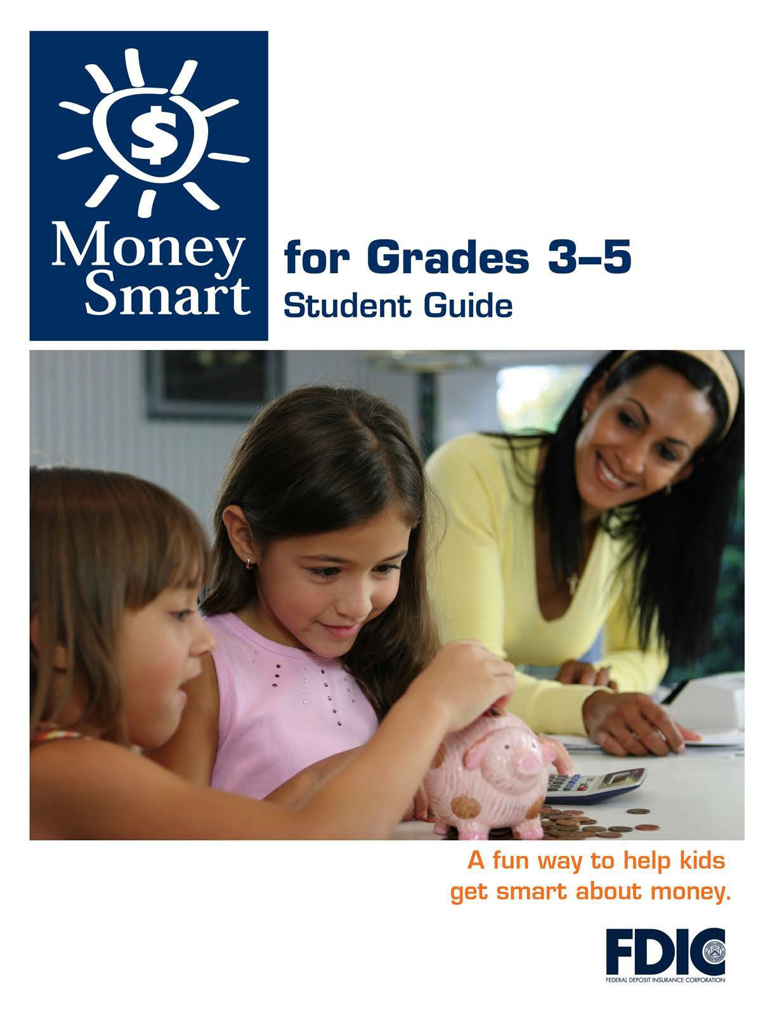

[1]

TABLE OF CONTENTS

Lesson 8: Career Choices (Exploring Careers and Income) 3
  - Student Handout 1: Different Jobs
  - Student Handout 2: Interest Survey
  - Student Handout 3: Salary andEducation

MONEY SMART FOR GRADES 3–5: STUDENT GUIDE 2

DIFFERENT JOBS

Name:

Directions: Below is a list of 12 different jobs and a description of each.

Read about each job. Check the box for each job that interests you. What other jobs can you name? List them below.

- Aerospace Engineer: designs aircraft, space vehicles, and satellites

Architect: designs buildings and oversees their construction

- Automotive Engineer: designs cars so they are safe and efficient

Biologist: studies living things in their naturalhabitats

- Environmental Scientist: conducts research to protect the environment

- Financial Analyst: makes recommendations about investments

Geologist: studies rocks and minerals to learn about Earth’shistory

Lawyer: helps people who need legaladvice

- Mechanical Engineer: designs, builds, and testsmachines

Pharmacist: prepares medications and dispenses them to patients

- Social Worker: helps people cope with problems in their lives

- Software Developer: develops computerprograms

- Web Developer: creates websites forcomputers









MONEY SMART FOR GRADES 3–5: STUDENT GUIDE
3

INTEREST SURVEY

Name:

Directions: Put a check in the box next to statements that describe you.

Then write down any other interests and skills (things you are good at) on the lines below. When you are done, use the information to research different career choices based on your interests.

I care about people and theirproblems.

I enjoy taking care of animals.

I like to design and build things.

I enjoy being outdoors and studyingnature.

I like to take things apart to figure out how theywork.

I am interested in taking care of theenvironment.

I enjoy using computers and learning newprograms.

I am good at math and like to solve problems.

I like figuring out the answers to complexproblems.

I am good at drawing, and interested inart.

What other interests and skills do you have that are not on the list?

MONEY SMART FOR GRADES 3–5: STUDENT GUIDE 4

SALARY AND EDUCATION
Name:
Directions: Read the information below about the salary and collegeeducation
levels for various jobs. Then answer the questions that follow.
Career
Average Salary
Level of Higher Education
Pharmacist
$116,700
Doctoral or professional degree
Mechanical Engineer
$80,600
Bachelor’s degree
Statistician
$75,600
Master’s degree
Architect
$73,100
Bachelor’s degree
Web Developer
$62,500
Associate’s degree
Source: U.S. Bureau of Labor Statistics
1) What kind of degree does a statisticianneed?
a) Associate’s
b) Bachelor’s
c) Master’s
2) On average, how much more does a pharmacist make than a web developer?
3) What do the jobs listed above have incommon?
MONEY SMART FOR GRADES 3–5: Student Guide
5

