for Grades 6-8

Educator Guide

FDIC Disclaimer:
The books and online resources referenced in the Educator Guide and Parent/Caregiver Guide are examples/options that may be used to support the subject being taught and should not be considered as an endorsement by the Federal Deposit Insurance Corporation (FDIC). Reference to any specific commercial product, process, or service by trade name, trademark, manufacture, or otherwise does not constitute an endorsement, a recommendation, or a favoring by the FDIC or the United States government.
The FDIC Money Smart curriculum references books and provides links to other websites for convenience and informational purposes only. Users should be aware that when they select a link on the FDIC’s website to an external website, they are leaving the FDIC’s site. Linked sites are not under the control of the FDIC, and the FDIC is not responsible for the contents of any linked site or any link contained in a linked site, or any changes or updates to such sites. The FDIC is not responsible for any transmission received from a linked site. The inclusion of a link does not imply endorsement by the FDIC of the site, its content, advertisers, or sponsors. External sites may contain information that is copyrighted with restrictions on reuse. Permission to use copyrighted materials must be obtained from the original source and cannot be obtained from the FDIC.

TABLE OF CONTENTS

Welcome to Money Smart 4
Getting Started 5
Lesson At-a-Glance 10
Lesson 8: Money Doesn’t Grow on Trees (Investing Options) 11
Answer Key 17
Glossary 18

WELCOME TO MONEY SMART
Welcome to Money Smart, an exciting interactive exploration of the concepts of money. This standards-aligned, cross-curricular program is designed to promote financial understanding for middle school students in grades 6 through 8. You can use Money Smart to add engaging and enriching activities to financial literacy and economics instruction. Extension activities support English Language Arts, Math, Social Studies and Economics, and Technology, while also helping your students build the foundation to become financially responsible adults.

In Money Smart you will find:
- Twelve Lessons with hands-on, cross-curricular activities that engage sixth- through eighth- grade students in discussing and exploring key financial concepts
- Teacher Presentation Slides, which provide helpful visuals, as well as challenge exercises and reflective prompts to support the activities in each lesson
- A Student Guide with handouts, worksheets, and resources that let students explore the topics covered in each lesson and apply their new knowledge
  - A Parent/Caregiver Guide with information about topics and terms being covered in class, conversation starters, online and literary sources, along with activities to try at home and around town

Developing positive financial habits equips students with 21st-century skills and tools that last a lifetime. We hope you and your students enjoy learning about money and its many uses.

We are eager to hear from you about how you use this curriculum. We would like to know what works well and what could be improved to make Money Smart even better. If you have any questions, we would like to help. Please contact us with your comments and questions via e-mail at communityaffairs@fdic.gov.

GETTING STARTED
Money Smart provides a comprehensive, developmentally appropriate program for middle school students to build an understanding of key financial concepts.
There are many features that help make the Money Smart curriculum engaging, motivating, and easy to use. Each lesson includes learning objectives, essential questions, supplies needed, and preparation required, as well as the following features and components to support easy integration of Money Smart activities into your instructional day.

STANDARDS
Each lesson promotes real-world connections through student-centered learning experiences and aligns to the following education standards and learning outcomes, including Common Core State Standards in mathematics and English Language Arts. The Education Standards Chart identifies which standards are met in each lesson.
- Financial Literacy JumpStart Standards
- English Language Arts Common Core State Standards
- Mathematics Common Core State Standards
- National Standards for Financial Literacy by the Council for Economic Education
- Partnership for 21st-Century Skills

GRADE-LEVEL MODIFICATIONS
Please note the modifications identified throughout lessons to differentiate learning experiences for beginner and advanced students. Modifications provide developmentally appropriate activity recommendations and extension opportunities.

PRESENTATION TIME
Each lesson plan includes an estimated time needed to teach the lesson. Actual time required will vary from classroom to classroom. The estimation includes instructional time spent on the Warm Up, Guided Exploration, Group Exploration, Independent Exploration, and Wrap Up. Activities may also be taught as several short lessons over a period of days or weeks. Extended Exploration activities are included to extend financial literacy learning opportunities throughout the year and provide easy ways to integrate the topics into various content areas.

ASSESSMENTS
A variety of assessments are integrated throughout each of the twelve lessons. Assessments are designed to build value, meaning, and context around a topic, while providing teachers with opportunities to evaluate prior student knowledge, and collect evidence their new understandings of lesson concepts and skills. Pre- (formative) and post- (summative) assessments are noted on the first page of each lesson. Assessments include discussions, reflections, questions and answers, reading, writing, and problem-solving exercises. Assessments are aligned to standards so that teachers may track students’ mastery of standards. Student handouts are an especially useful form of written assessment.

LESSON STRUCTURE
Each lesson is designed to include the following:
- Warm Up introduces students to the topic and sparks inquiry.
- Guided Exploration integrates cross-curricular and developmentally appropriate learning activities and assessments while focusing on the key financial literacy learning objectives of the lesson, with teacher guidance.
- Money Smart Tips are provided throughout lessons to offer additional guidance, interesting and relevant financial facts, and additional ideas to help make Money Smart a success in your classroom.
- Group Exploration allows students to work in small groups to explore concepts and solve problems together. Cooperative learning is considered a “best practice” in middle school instruction.
- Independent Exploration activities are designed to engage students in the process of learning through individual discovery, research, and interpretation. These activities are more independent than the Guided and Group Exploration activities and may also be used as homework assignments or independent study.
- Wrap Up provides a reflection question or activity to review lesson concepts and allow students to demonstrate their understanding.
- Extended Exploration provides teachers with additional opportunities to extend financial literacy concepts throughout the school year within core content areas including English Language Arts and Math. Activities can be completed as a class, in small groups, or by students individually. Useful resources (such as books, web links, games, or videos) are also included to promote even more student engagement. The books and online resources suggested in this guide are just a few of the many available resources that explore these topics, and are not endorsed by the FDIC.
- Student Handouts (found in the Student Guide), Group Handouts (found in this guide), and Teacher Presentation Slides provide dynamic instructional support. Student and group handouts create an opportunity for students to apply their knowledge and for teachers to assess their understanding. Teacher presentation slides offer visuals and interactive activities corresponding with lessons.
- The Answer Key, Glossary, and Standards Chart house all of the information needed to check for understanding, define key terms, and check which activities meet specific education standards. Vocabulary words are bolded in each lesson as they are introduced. It may be helpful to distribute copies of the entire glossary to students as a reference.

MONEY SMART AT HOME
The Money Smart curriculum includes a helpful Parent/Caregiver Guide that corresponds to the classroom materials. Families may also use it independently of the curriculum. It contains resources, activities, games, and conversation starters on financial literacy topics covered in each lesson. Use the following ideas to encourage parents to use the guide at home:
- Introduce parents to the Money Smart program and share the Parent/Caregiver Guide at the start of the school year.
- Discuss the Money Smart program during parent-teacher conferences or in monthly parent newsletters home, and emphasize the importance of building healthy financial habits from an early age.
- Hold a Money Smart family night. Play games and have students share short skits about financial concepts they have learned.
- Send student handouts from each lesson home in homework folders for parents to review and sign.

INTERDISCIPLINARY PROJECTS
Interdisciplinary project-based learning provides the connectedness that many middle school students need as they make the transition from single classroom instruction in elementary school to subject- specific classrooms at the secondary levels. This section provides a few ideas for connecting financial literacy across disciplines into single projects.

Financial Literacy Assembly or Community Awareness Campaign
Use arts-integration to allow students a creative outlet to demonstrate their learning from one, some, or all Money Smart lessons. Some options include:
  - Drama: Write and perform a play, a video advertisement, or a news broadcast. For example: students could combine their learning from Lesson 1: The Path to Success and Lesson 2: Bread and Butter to write a play about how to select a career field, how to get a job, and what happens once you get a job.
  - Visual Art: Study and develop public service announcement (PSA) posters for the school or the community. For example: students could use their learning from Lesson 10: Protecting Yourself to develop PSA posters on what identity theft looks like, how to avoid it, and what you should do if you suspect that you are a victim of it.
  - Music/Choir: Write and perform a song or rap. For example: students can demonstrate their learning from Lesson 12: Spend, Save, or Give? by writing a song that helps other students identify the various ways that they can spend, save, or give their money. The song can be played on the school PA system, posted on the school website or performed at an assembly.
  - Technology: Create PSAs using PowerPoint, Prezi, Microsoft Publisher, online cartoon creators like http://www.abcya.com/animate.htm or http://scratch.mit.edu/, or other design programs. For example: students could create an online cartoon to share with others that demonstrates their understanding of Lesson 7: How to Stash Your Cash.

Managing a Budget
Planning a field trip, an assembly, or a school party? Develop an interdisciplinary project to allow students to create and manage the budget. Some options include:
  - Social Studies: Assess the needs and wants of the event. Prioritize necessary items and then wanted items. Students can use their learning from Lesson 4: Being a Savvy Shopper to research to identify and evaluate costs.
  - Math: Develop a suggested budget based on assessing needs and wants for the event. If and when the budget is accepted, manage the spending to ensure that the event does not go over budget. Students can use their learning from Lesson 3: Designing Dreams and Lesson 5: Go with the Flow.
  - English: Write a persuasive letter to the school administration explaining the needs and wants of the event, analyzing the suggested budget, and requesting the funds to execute the event. Students can use their learning from Lesson 3: Designing Dreams and Lesson 5: Go with the Flow.

School Store
Whether your school has a school store, or it is something that the students might be interested in starting, consider developing a project to provide students with ownership, while allowing them to learn more about financial literacy. Some options include:
  - Social Studies: In coordination with other students and staff in the building, develop an inventory of needs and wants that can be supplied in the school store. Use research to identify and evaluate costs. Students can use their learning from Lesson 4: Being a Savvy Shopper.
  - Math: Develop a budget for purchasing bulk items. Consider options for and create sale prices for each item. Create a cash flow statement to determine the amount of product that must be sold in order to turn a profit. Students can use their learning from Lesson 3: Designing Dreams and Lesson 5: Go with the Flow.
  - Art/Design: Use advertising techniques to advertise and sell the school store products. Students can use their learning from Lesson 4: Being a Savvy Shopper.
  - English: Write a persuasive argument to open a school savings account to keep school store profits in a safe place and earn interest. Alternately, write a persuasive argument to invest the profits in an investment vehicle like stocks or bonds. Students can use their learning from Lesson 7: How to Stash Your Cash and Lesson 8: Money Doesn’t Grow on Trees.

Create and Use Financial Literacy Games
Playing games is a great way to engage students in learning. Even better, is to allow students to create their own games to play. Students can demonstrate their learning from one, some, or all Money Smart lessons. These games can be created and played in several subject areas including Social Studies, English, Math, and Art. Some options include:
  - The Path to Success: Create a game where you must make choices about your education, your career, the jobs you get and the associated income, the taxes you pay on your income, and the insurance purchases that you can make. Money Smart connections: Lesson 1: The Path to Success, Lesson 2: Bread and Butter, Lesson 11: Risky Business.

  - Charge It! Create a game where you can make choices about which credit card to apply for, make purchases with credit versus cash, and build credit. Money Smart connection: Lesson 9: Credit and Debt.
  - Money, Money, Money: Create a game where you can make choices about how to earn and spend money, factoring in cash flow, saving, and charitable giving. Money Smart connections: Lesson 5: Go with the Flow, Lesson 12: Spend, Save, or Give?

Solve a Community Problem
The intersection of problem-solving and real-life application is important for middle school students. What better way to combine the two than to solve a community-wide problem? Start by considering problems in your community. Problems could be split along content lines, for example:
  - Science: Does your community recycle? How “green” is your community? Investigate science career fields and discover how students might make a career of solving these community problems, using Lesson 1: The Path to Success.
  - Technology: Who has access to technology in your community? Inform your community about online threats after covering Lesson 10: Protecting Yourself.
  - Arts: Does any part of your community need beautifying? Determine a method to raise and spend money on community beautification using Lesson 5: Go with the Flow.
  - Foreign Language: Do non–English speaking members of your community
need access to resources? Consider developing a foreign-language PSA that ties to student learning from Lesson 4: Being a Savvy Shopper.
Encourage students to use the financial literacy topics learned in Money Smart lessons to identify a community problem and develop and maintain a budget for solving the problem.

FINANCIAL LITERACY ALL YEAR LONG
Highlight financial literacy at your school all year long, especially in April, during National Financial Literacy and School Library Month.
  - Create bulletin boards or posters with students about financial literacy themes learned in
Money Smart.
  - Develop interdisciplinary projects that incorporate financial literacy topics.
  - Create a class or school newsletter with students to distribute to the school community about money skills and financial concepts covered in class.
  - Integrate real-world applications of financial literacy into content area classes.
The more students are exposed to financial literacy, and the more opportunity they have to practice applying their new knowledge and understanding of concepts, at school and at home, the more prepared they will be to live Money Smart lives.

LESSON AT-A-GLANCE

Lesson Title
Topic
Learning Objectives
Time Required

8 | Money Doesn’t Grow on Trees | Investing  Options | Understand investment growth, losses, reward, and risk by developing and tracking a stock portfolio  - Demonstrate a general understanding of investment vehicles, like bonds, stocks, and mutual funds  - Create investment tips for an adult audience | 65 min  Session 1 (30 min)  - Investing in a Friend (10 min)  - Investment Vocabulary and Vehicles (20 min)  Session 2 (35 min)  - Investing in Stock Simulation (25 min)  - Investing Tips Letter (10 min)

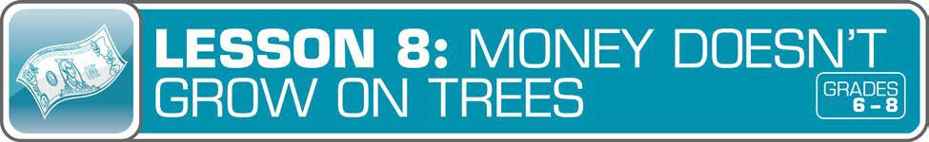
Answer Key 17
Glossary with key vocabulary 18

LESSON OVERVIEW
This lesson will explore the concepts of interest and investments helping learners make initial discoveries about how their money can grow overtime.
TOPIC: Investing Options

TIME REQUIRED: 65 minutes
(excluding Extended Exploration activities)

LEARNING OBJECTIVES:
Students will be able to…
- Understand investment growth, losses, reward, and risk by developing and tracking a stock portfolio
- Demonstrate a general understanding of investment vehicles, like bonds, stocks, and mutual funds
- Create investment tips for an adult audience

SUPPLIES:
- Loose-leaf paper for Investing Tips Letter
- Projector (for teacher presentation slides)
- Access to the Internet (optional)

PREPARATION:
- Make copies of student handouts
- Set up projector with presentation slides
- Set up individual or group computers with access to the Internet(optional)
STUDENT HANDOUTS:
(found in Student Guide)
- Stock Market Tracking
- Stock Market Week 1
- Stock Market Week 2

TEACHER PRESENTATION SLIDES:
- Investment Vehicles
- Case Study: Three Stocks

ESSENTIAL QUESTIONS:
- What are the benefits to investing money?
- Is investing money worthwhile?
- What investing strategies will create positive rate of return?

ASSESSMENT ACTIVITIES:
Pre-Assessment:
- Investing in a Friend activity
Post-Assessment:
- Stock Market Tracking activity
- Investing Tips Letter activity

INSTRUCTION STEPS

WARM UP
INVESTING IN A FRIEND [10 MINUTES]
The lesson begins with students considering a concrete and age-appropriate example of investing. Ask students to consider the following scenario:
  - A friend comes to you asking to invest $50 to start a business (for example: lemonade stand, lawn care service, DJ service). When you invest money, you “commit money to an endeavor with the expectation (but not guarantee) of additional profit.”
  - What are the benefits of helping your friend? What are the drawbacks? According to the definition, investing means that there is an “expectation of additional profit,” so how might you make additional profit if you invested $50 in your friend’s business?

MONEY SMART TIP!

The U.S. Securities and Exchange Commission (SEC) has provided a number of resources about investing. Review their helpful website for more information on financial plans, risk tolerance, and investment vehicles. http://www.sec.gov/investor/pubs/roadmap.htm

GUIDED EXPLORATION
INVESTMENT VOCABULARY AND VEHICLES [20 MINUTES]
As a whole group, discuss investment options and how investments are made. First, explain the general concepts and vocabulary of investing.
  - Investing is the process of “committing money to an endeavor with the expectation (but not guarantee) of additional profit.”
  - In this lesson, we’ll be narrowing our definition of investing to “purchasing securities such as stocks, bonds, and mutual funds with the goal of increasing wealth over time, but with the risk of loss.”
  - Discuss an example of a low-risk investment a young person might make, and the possible reward of that investment. For example: If an 18-year-old invests $5 a week at an 8% interest rate, the money will grow to $136,138 by the age of 65.
  - Define risk as “a measure of the likelihood of loss or the uncertainty of an investment’s rate of return.” Explain that investors have to consider whether they are financially comfortable with the risk that they might take when they invest. Additionally, different investment vehicles come with different levels of risk.

Next, display the Investment Vehicles slide and explain each. Investment vehicles are the methods that a person (or business) can use to invest money.
  - A stock is an investment that represents shares of ownership of the assets and earnings of a company. It is an investment made in a business. When you buy a stock, you become a partial owner of the company (like a fast-food company or a computer company) and you may get a say in certain decisions about how the company is run. The value of your investment goes up and down. Buying shares of stock in a company is a way to grow money quickly, or lose it quickly. There is no guarantee that your money is safe. If the company does really well, your stock in the company will increase and be worth more, but if the company does poorly or goes out of business, your stock will decrease and you could lose some or all of your investment. Therefore, stocks have more risk than savings bonds.
  - A mutual fund is an investment tool that pools the money of many shareholders and invests it in a large number of securities, such as stocks, bonds, and money market assets. When you invest in a mutual fund, you purchase a small piece of several stocks. For example: you may own a small piece of a sportswear company, a small piece of a technology company, and a small piece of a furniture company. Stock mutual funds are considered less risky than individual stocks because of the concept of diversification. Diversification is a strategy for reducing some types of risk by selecting a wide variety of investments. With stocks, it means spreading your money out to several different company stocks so that, if one company does poorly, you won’t lose too much money.

Grade-Level Modification:
Beginner: Build background knowledge by watching What’s Up With the Stock Market? Students will learn about the basics of the stock market, including vocabulary.
Check for understanding of the investment vehicles and associated vocabulary.
  - Which investment vehicles are you most interested in? Why?
  - Which investment vehicles might a financially successful adult most be interested in? Why?
  - Why is diversification important?
Encourage students to use vocabulary terms as they explain their answers.

INDIVIDUAL EXPLORATION
INVESTING IN STOCK SIMULATION [25 MINUTES]
Distribute the Stock Market Tracking handout and display the Case Study: Three Stocks slide. Explain to students that they will each be allowed to invest some money in a stock.

Grade-Level Modifications:
Beginner: The teacher can provide a set amount of money for investment for students, say $1,000. This provides students with a round number to more easily work their math.
Advanced: The teacher can allow students to set their own amounts of money for investment. For example: some students may decide to invest just $100, while others may choose to invest $5,000. This should provide rich conversation about how the principal affects the return on investment.

Allow students time to study the Case Study: Three Stocks slide before selecting a company to purchase stock. (Note: If students are doing real-time, online stock tracking, they should research their stocks and share prices online.) Ask students to fill out the company, stock symbol, and purchase information on their Stock Market Tracking handout after they have selected their company. Optional check for understanding questions:
  - Why did you choose your company?
  - Advanced: Why did you choose to invest that amount of money?
Demonstrate how to track stock information by reviewing the example on the Stock Market Tracking handout and distributing copies of the Stock Market Week 1 handout. To use the Stock Market Tracker, students should:
- Identify the stock symbol.
- Locate the stock symbol on the Stock Market Week 1 report.
- Identify the stock’s closing price for each day of the week.
- Calculate the percentage change from one day to the next. (Demonstrate this using the model on the Stock Market Tracker. The basic formula is: (Price Sold – Purchase Price) / (Purchase Price). For example: (105 – 100) / (100) = .05. Then, multiply by 100 to calculate the percentage: 5% change.

MONEY SMART TIP!
Do all of your students have Internet access? Instead of using the Stock Market Week 1

handout, track stocks in real time at http://finance.yahoo.com/stock-center/.

Allow students to use the Stock Market Week 1 handout to track their stock on the Stock Market Tracker. Optional check for understanding questions:
  - How is your stock doing after one week?
  - Why do you think the stock prices change in the way that they do?
  - How do you feel about the financial rewards and/or risk you’ve taken by purchasing stock?

MONEY SMART TIP!

There is often a lot of volatility and risk associated with investing in stocks. The volatility index
- values greater than 30 are usually associated with higher volatility because of investor fear or uncertainty, while values lower than 20 are associated with less investor fear and uncertainty. Learn more about the VIX tracked by the Chicago Board Options Exchange.
http://www.investopedia.com/terms/v/vix.asp

Distribute copies of the Stock Market Week 2 handout. Have students use their handouts to track their stock. Then, point out the business news that is on the Stock Market Week 2 handout. Discuss:
  - How did your stock do after two weeks?
  - How might business news influence shareholders or potential investors?

Finally, prompt students to finish the worksheet by tracking the stock’s overall changes. Then, wrap up with one or two questions about investing in stocks:
  - Which stocks had the biggest percentage change? What does that mean for investors?
  - Advanced: What impact did the amount of money you invested originally have on your gains or losses? Would you make the same decision about the money you invest in the future?
  - Do you think that you would invest in stock in the future? Why or why not?
  - What tips would you give someone who is thinking about investing?

WRAP UP
INVESTING TIPS LETTER [10 MINUTES]
Ask students to take out a sheet of loose-leaf paper, on which they will write a letter to a family member or guardian. In their letter, students should provide their family member or guardian with some tips on investing. Some helpful questions are: What goals might investors have? Why are investor goals important? Why is it a good idea to invest? What risks do you take when you invest money?
What are low-risk investment vehicles and what are high-risk investment vehicles? Why?

EXTENDED EXPLORATION
Note: Use the following ideas to extend financial literacy concepts throughout the school year within core content areas through English Language Arts, Math, Social Studies and Economics, and Technology activities, projects, and discussions. Duration of activities will vary.

ENGLISH LANGUAGE ARTS

Writing Prompts:
    - Is it worth the risk to invest? Explain your stance.
    - In your opinion, what’s the best investment vehicle? Why? Write a convincing argument to support your answer.

Additional Readings/Resources:
    - Investment Tips by the U.S. government: Helpful tips on what to do before investing, and available investment vehicles. http://www.usa.gov/topics/money/investing/tips.shtml
    - Save and Invest by the Financial Literacy and Education Commission: Information for students on saving and investing. http://www.mymoney.gov/save- invest/Pages/saveandinvest.aspx

    - What’s Up With the Stock Market? by BizKids: A video overview of how the stock market works, including important vocabulary. (Time of video: 4:07 minutes) https://www.youtube.com/watch?v=osvQSd6Opac

MATH

Activity/Project Ideas:
    - Track a stock long-term. Use the Stock Market Tracker and http://finance.yahoo.com/stock-center/ to observe the changes in stock prices over several months.

SOCIAL STUDIES AND ECONOMICS

Activity/Project Ideas:
    - Investigate the history of the Stock Market Crash of 1929. Compare and contrast the stock market of 1929 with the stock market of today to determine whether or not a major stock market crash could happen again. http://www.history.com/topics/1929-stock-market-crash
    - Investigate the history of the financial crisis of 2008. Explore the causes of the crisis, the impact on investing, and the regulations the government has made in its wake. http://www.britannica.com/EBchecked/topic/1484264/The-Financial-Crisis-of-2008- Year-In-Review-2008/280410/The-Crisis-Unfolds

TECHNOLOGY

Online Games/Tools:
    - Investment Calculators by the U.S. Securities and Exchange Commission: Several useful tools for calculating investment information. http://www.investor.gov/tools/calculators#.VDrmbtTF-Hs
    - The Stock Market Game by the Securities Industry and Financial Markets Association: An online stock market tracking game for students. http://www.stockmarketgame.org/

ANSWER KEY

for Student Handouts

LESSON 8: STOCK MARKET TRACKING
Answers will vary.

GLOSSARY
Annual Percentage Rate (APR): The cost of borrowing money on a yearly basis, expressed as a percentage rate.
Bank: A financial institution and business that accepts deposits, makes loans, and handles other financial transactions.
Budget: A plan that outlines what money you expect to earn or receive (your income) and how you will save it or spend it (your expenses) for a given period of time.
Career: The type of work a person pursues for the majority of their life that may involve formal education, special training, or be within a specific industry.
Cash Flow: Income and expenses over a given period of time.
Credit: The ability to borrow money and pay it back later.
Credit Card: A plastic card that can be used to obtain credit (such as to purchase goods and services).
Debit: An amount of money taken out of a deposit account to pay for something.
Debit Card: A plastic card that can be used to deposit or withdraw cash from a checking or other bank deposit account, such as at automated teller machines or at retail locations that accept cards.
Debt: Money that is owed.
Discretionary Expenses: Money that is not essential to spend; money spent on wants.
Diversification: The approach of spreading your money among various investments with the hope that if one investment loses money, the others will make up for those losses; also referred to by the phrase "don't put all your eggs in one basket".
Earned Income: Money you get from working, such as wages, commissions and tips.
Expense: The cost of goods and services; the amount of money that is spent.
Federal Deposit Insurance Corporation (FDIC): Preserves and promotes public confidence in the
  - financial system by insuring deposits in banks and thrift institutions for at least $250,000. An independent agency of the federal government, the FDIC was created in 1933.
Financial Institution: A bank or credit union.
Fixed Expense: An expense that does not change from month to month.
Goal: Something you wish to achieve or accomplish in a specific amount of time.
Identity Theft: When someone steals another person’s identity to commit fraud, such as by using his or her name or Social Security number to get something. Identity theft is a crime.
Income: Money that you receive from jobs, allowances, gifts, interest, dividends, and other sources.
Income Tax: Taxes on income, both earned (salaries, wages, tips, commissions) and unearned (interest, dividends). Income taxes can be levied on both individuals (personal income taxes) and businesses (business and corporate income taxes).
Insurance: A contractual relationship that exists when one party (the Insurer), for a fee (the

GLOSSARY (continued)
premium) agrees to reimburse another party (the Insured or third party on behalf of the Insured) for a specific loss.
Interest: Money that a bank or other financial institution pays you for keeping money on deposit with them, or the amount of money you pay a bank as a fee when you borrow money.
Invest: To put money at risk with the goal of making a profit in the future.
Investment Vehicles: The methods that a person (or business) can use to invest money.
Job: A specific duty, task, or activity someone completes using his or her time, skills, and energy to earn money.
Mutual Fund: An investment tool that pools the money of many investors and invests it in stocks, bonds, and money market assets, or other securities.
Need: Something you must have to survive, such as clothes, shelter, or food.

Opportunity Cost: The next best thing that you give up in order to do something else; a trade-off of a decision you make.
Payroll Deduction: Money that an employer withholds from earnings.
Phishing: When fraudsters impersonate a business or government agency to try to get you to give them personal information, such as through an email or text message. Can also be thought of as “fishing for confidential information”.
Profit: The money gained or left over after money spent (expense) is subtracted from money earned (income).
Return: Money made (profit) from an investment.

Risk: The possibility that something unplanned or unintended may happen (such as losing money). Uncertainty about outcomes that are not equally desirable. In finance, it refers to the degree of uncertainty about the rate of return and the potential harm that could arise when financial returns are not what the investor expected.
Risk Management: The process of calculating risk and choosing approaches to minimize or manage loss.
Save: Setting something, like money, aside to use in the future.

Savings Account: A bank account that you can use to set aside money, and that pays you interest.
Savings Bond: People lend money to the Government so it can pay its bills. Over time, the Government gives that money, plus a bit extra (interest), back to those people as payment for using the borrowed money.
Stock: An investment that represents a share of ownership in a company.
Tax: Money that has to be paid to a government to provide public goods and services.

Variable Expense: Money that a person spends or gives away that varies from month to month.
Want: Something that you would like to have but that you could live without, such as a TV or tickets to a baseball game.

for Grades 6-8

Student Guide

A fun way to help kids get smart about money.

STOCK MARKET TRACKING
Name: _
Company: Stock Symbol: _

Purchase Price: ________ # of Shares Purchased: ______ Total Cost: _
TRACKING EXAMPLE:
Purchase Price: $101.25

Date
3/9/2015
3/20/2015
Day
Monday Tuesday
Close Price
$101.25
$101.13
% Change
0%
–0.12%
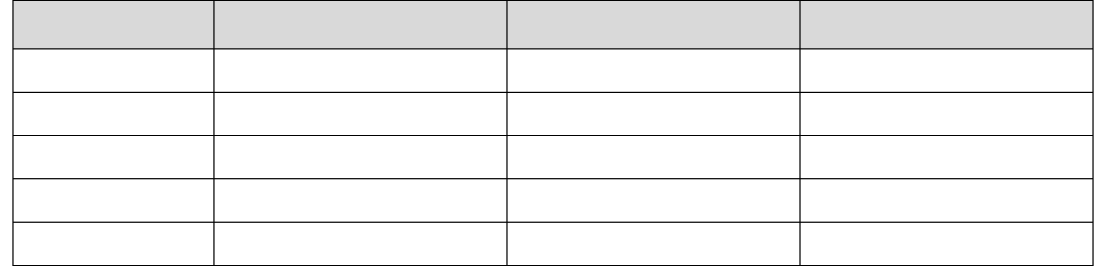
TRACKING WEEK 1:
Date
Day
Monday Tuesday Wednesday Thursday Friday
Close Price
% Change
After Week 1, if you were to sell your shares, would you make money or lose money?
Use the space below to calculate and explain your answer.
TRACKING WEEK 2:

Date
Day
Monday Tuesday Wednesday Thursday Friday
Close Price
% Change
After Week 2, if you were to sell your shares, would you make money or lose money? Use the space below to calculate and explain your answer.

STOCK MARKET TRACKING: WEEK 1

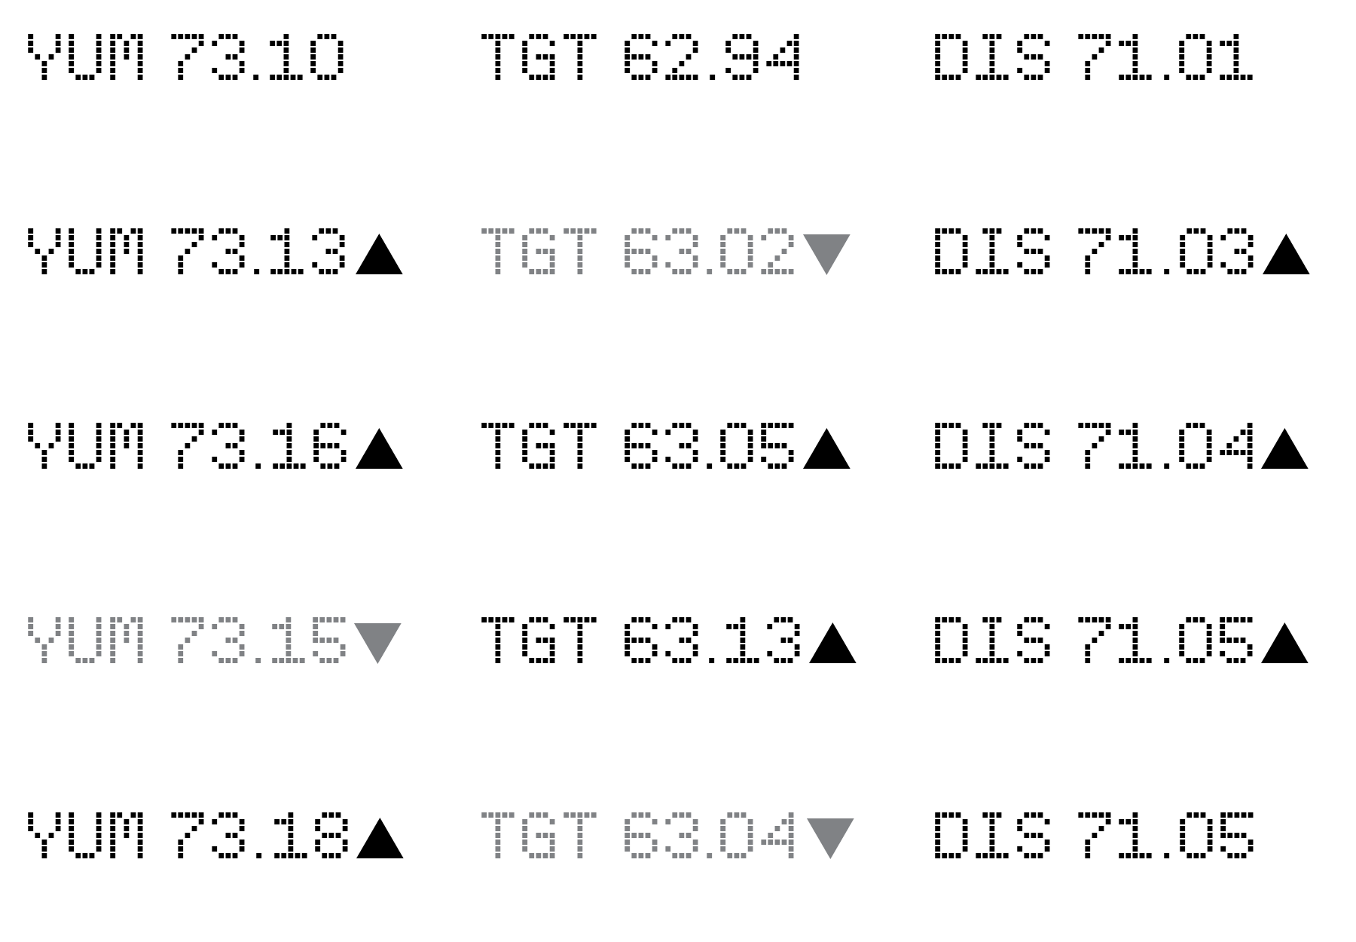
MONDAY
TUESDAY
WEDNESDAY
THURSDAY
FRIDAY

STOCK MARKET TRACKING: WEEK 2

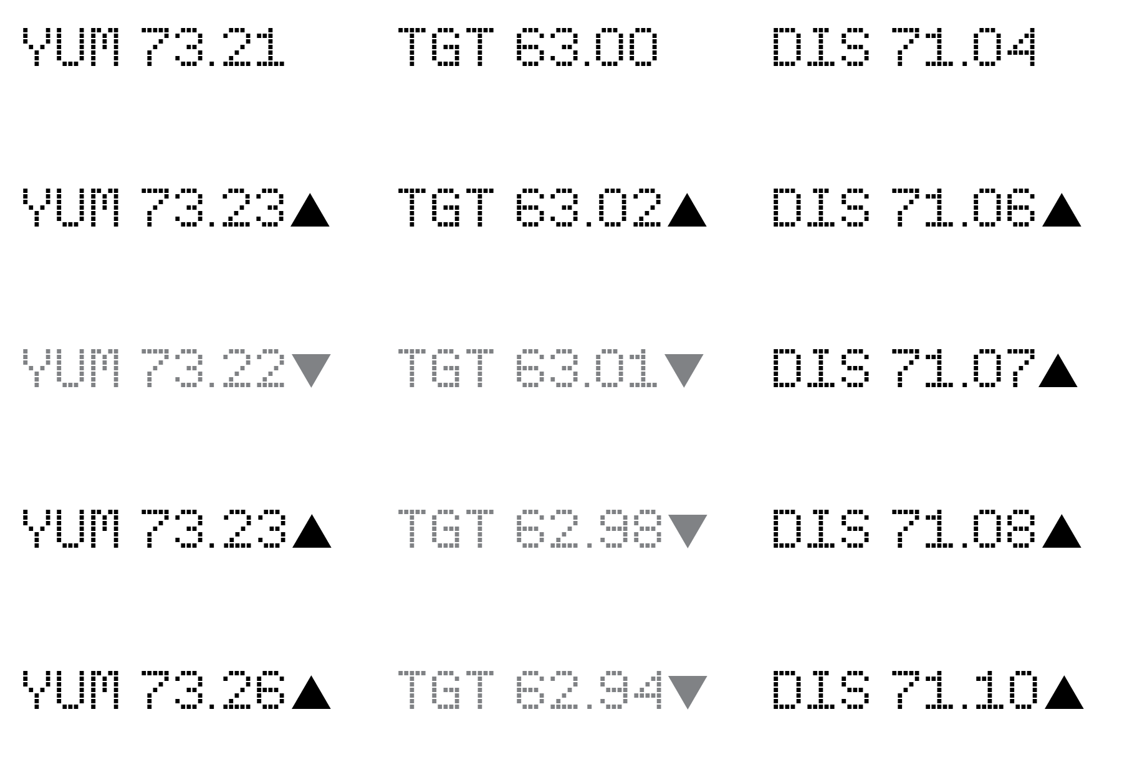
MONDAY
TUESDAY
WEDNESDAY
THURSDAY
FRIDAY

BUSINESS NEWS: WEEK IN REVIEW

Yum! Brands continues its rapid growth again this week following news about recent company growth. Target continues its up and down trend after struggling to make the financial gains the company predicted at the beginning of the year. Behind its most recent hit movie, Walt Disney is gaining slowly but surely.

