for Grades 9-12

Educator Guide

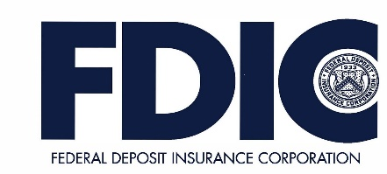

FDIC Disclaimer:
The books and online resources referenced in the Educator Guide and Parent/Caregiver Guide are examples/options that may be used to support the subject being taught and should not be considered as an endorsement by the Federal Deposit Insurance Corporation (FDIC). Reference to any specific commercial product, process, or service by trade name, trademark, manufacture, or otherwise does not constitute an endorsement, a recommendation, or a favoring by the FDIC or the United States government.
The FDIC Money Smart curriculum references books and provides links to other websites for convenience and informational purposes only. Users should be aware that when they select a link on the FDIC’s website to an external website, they are leaving the FDIC’s site. Linked sites are not under the control of the FDIC, and the FDIC is not responsible for the contents of any linked site or any link contained in a linked site, or any changes or updates to such sites. The FDIC is not responsible for any transmission received from a linked site. The inclusion of a link does not imply endorsement by the FDIC of the site, its content, advertisers, or sponsors. External sites may contain information that is copyrighted with restrictions on reuse. Permission to use copyrighted materials must be obtained from the original source and cannot be obtained from the FDIC.

TABLE OF CONTENTS
Welcome to Money Smart 4
Getting Started 5
Lesson 5: Bank Your Bucks (Choosing a Banking Partner) 8
Answer Key 13
Glossary 15

Welcome to Money Smart, an exciting interactive exploration of the concepts of money. This standards-aligned, cross-curricular program is designed to promote personal financial education in grades 9 through 12 students and young adults aged 18 to 20. You can use Money Smart to add engaging and enriching activities to financial literacy and economics instruction. Extension activities support English Language Arts, Math, Social Studies and Economics, and Technology, while also helping your students build the foundation to become financially responsible adults.
In Money Smart you will find:
- Twenty-Two Lessons with hands-on, cross-curricular activities that engage ninth- through twelfth-grade students and young adults aged 18 to 20 in discussing and exploring key financial concepts
- Teacher Presentation Slides, which provide helpful visuals, as well as challenge exercises and reflective prompts to support the activities in each lesson
- A Student Guide with handouts, worksheets, and resources that let students explore the topics covered in each lesson and apply their new knowledge
- A Parent/Caregiver Guide with information about topics being covered in class, conversation starters, online and literary sources, along with conversation starters and family activities to try together

Developing positive financial habits equips students with 21st-century skills and tools that last a lifetime. We hope you and your students enjoy learning about money and its many uses.
We are eager to hear from you about how you use this curriculum. We would like to know what works well and what could be improved to make Money Smart even better. If you have any questions, we would like to help. Please contact us with your comments and questions via e-mail at communityaffairs@fdic.gov.

Money Smart provides a comprehensive, developmentally appropriate program for teens and young adults to build an understanding of key financial concepts.
There are many features that help make the Money Smart curriculum engaging, motivating, and easy to use. Each lesson includes learning objectives, essential questions, supplies needed, and preparation required, as well as the following features and components to support easy integration of Money Smart activities into your instructional day.

STANDARDS
Each lesson promotes real-world connections through student-centered learning experiences and aligns to the following education standards, including Common Core State Standards in mathematics and English Language Arts. The Education Standards Chart identifies which standards are met in each lesson.
- Financial Literacy Jump$tart Standards
- English Language Arts Common Core State Standards
- Mathematics Common Core State Standards
- National Standards in Economics by Council for Economic Education
- Partnership for 21st-Century Skills

GRADE-LEVEL MODIFICATIONS
Please note the modifications identified throughout the lessons to differentiate learning experiences for beginners and advanced learners. Modifications provide developmentally appropriate activity recommendations and extension opportunities for a wide range of learning levels.

PRESENTATION TIME
Each lesson plan includes an estimated time needed to teach the lesson. Actual time required will vary classroom to classroom. The estimation includes time spent on the Warm Up, Guided Exploration, Independent Exploration, and Wrap Up. Activities may also be taught as several short lessons over a period of days or weeks. Extended Exploration activities are included to extend financial literacy learning opportunities throughout the year and provide easy ways to integrate the topics into various content areas.

ASSESSMENTS
A variety of assessments will be integrated throughout each of the twenty-two lessons. Assessments are designed to build value, meaning, and context around a topic, while providing teachers with opportunities to evaluate prior student knowledge, and collect evidence of their new understandings of lesson concepts and skills. Pre- (formative) and post- (summative) assessments are noted on the first page of each lesson. Assessments include discussions, reflections, questions and answers, reading, writing, and problem-solving exercises. Student handouts are an especially useful form of written assessment.

LESSON STRUCTURE
Each lesson is designed to include the following:
- Warm Up introduces students to the topic and sparks inquiry.
- Guided Exploration integrates key financial literacy learning objectives with teacher support and guidance. Through whole-class discussions and activities, students discuss key topics and begin connecting the concepts to the context of their own lives.
- Money Smart Tips are provided throughout lessons to offer additional guidance, interesting and relevant financial facts, and additional ideas to help make Money Smart a success in your classroom.
- Independent Exploration activities are designed to engage students in the process of learning through individual discovery, research, and interpretation. These activities are more independent than the Guided Exploration activities and may also be used as homework assignments, for collaborative group work, or independent study.
- Wrap Up provides a reflection question or activity to review lesson concepts and allow students to demonstrate their understanding.
- Extended Exploration provides teachers with additional opportunities to extend financial literacy concepts throughout the school year within core content areas including English Language Arts and Math. Activities can be completed as a class, in small groups, or by students individually. Useful resources (such as books, web links, games, or videos) are also included to promote even more student engagement. The books and online resources suggested in this guide are just a few of the many available resources that explore these topics, and are not endorsed by the FDIC.
- Student Handouts (found in the Student Guide) and Teacher Presentation Slides provide dynamic instructional support. Student handouts create an opportunity for students to apply their knowledge and for teachers to assess their understanding. Teacher presentation slides offer visuals and interactive activities corresponding with lessons.
- The Answer Key, Glossary, and Standards Chart house all of the information needed to check for understanding, define key terms, and check which activities meet specific education standards. Vocabulary words are bolded in each lesson as they are introduced. It may be helpful to distribute copies of the entire glossary to students as a reference.

MONEY SMART AT HOME
The Money Smart curriculum includes a helpful Parent/Caregiver Guide that corresponds to the classroom materials. Families may also use it independently of the curriculum. It contains resources, activities, games, and conversation starters on financial literacy topics covered in each lesson. Use the following ideas to encourage parents to use the guide at home:
- Introduce parents to the Money Smart program and share the Parent/Caregiver Guide at the start of the school year.
- Discuss the Money Smart program during parent/teacher conferences, or in monthly parent newsletters home, and the importance of building healthy financial habits early on in life.

- Hold a Money Smart family night. Play games and have students share short skits about financial concepts they have learned.
- Send student handouts from each lesson home in homework folders for parents to review and sign.

MONEY SMART PORTFOLIO
To promote positive financial behaviors and demonstrate the compounding knowledge of financial literacy skills developed throughout the Money Smart curriculum program, introduce the Money Smart Portfolio into your classroom. The Money Smart Portfolio is a semester-long project that collects student handouts and activities from each lesson to be presented as a final portfolio.
The portfolio creation recognizes students’ financial growth throughout each phase of the learning process. The portfolio also enables students to walk away with a comprehensive resource that may be referred back to anytime a financial question arises in their futures. Using the Money Smart Portfolio as a semester-long project also gives students a long-term goal to work toward, while enabling an excellent opportunity for final assessment.
Money Smart Portfolio is designed for the following purposes:
- Assess student understanding from each phase of the program
- Create opportunities for final student self-reflection and personal assessment
- Reaffirm for students the intrinsic nature of financial skills and how one skill and strategy leads to another
- Build long-term vision for students to invest in the program from beginning to end

FINANCIAL LITERACY ALL YEAR LONG
Highlight financial literacy at your school all year long, especially in April, during National Financial Literacy Month and School Library Month.
- Create bulletin boards or posters with students about financial literacy themes learned in
Money Smart
- Create a class or school newsletter with students to distribute to the school community about money skills and financial concepts covered in class.
- Publish student handouts and activities from the Money Smart lessons by sharing them on a classroom blog, website, or through social media.
- Display student work in the classroom, library, and hallways to spread financial literacy throughout the school community.
- Connect with other teachers to integrate real-world applications of financial literacy across all disciplines and classrooms, from Math to English Language Arts and Technology courses.
The more that students are exposed to financial literacy, and the more opportunity they have to practice applying their new knowledge and understanding of concepts, at school and at home, the more prepared they will be to live Money Smart lives.

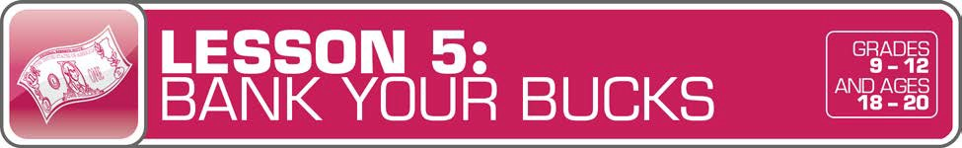

LESSON OVERVIEW

With so much financial information to digest when living on one’s own for the first time, it can be confusing for teens and young adults to know where to save their money, and the difference between account types. In this lesson, students will explore the different roles bank employees play in the financial process and investigate savings and checking accounts. Applying their knowledge, students define and debate which accounts and institutions are applicable in different scenarios.
TOPIC: Choosing a Banking Partner

SUBJECT CONNECTIONS: Technology

TIME REQUIRED: 80 minutes (excluding
Extended Exploration activities)

LEARNING OBJECTIVES:
Students will be able to…
- Analyze different financial institutions and conduct a comparative analysis of each institution
- Explain the key differences between checking and savings accounts
- Demonstrate how to control personal information
- Understand the benefits of using federally insured financial institutions

SUPPLIES:
- Projector (for teacher presentation slides)
- Access to the Internet (optional)

PREPARATION:
- Make copies of student handouts
- Set up projector with presentation slides
- Cut out sections of the Banking Basics Scripts for warm up activity
Answer Key 13
Glossary with key vocabulary 15
STUDENT HANDOUTS:
(found in Student Guide)
- Banking Basics
- Banking Basics Scripts
- Security
- Checking and Savings Accounts
- Bank Checklist

TEACHER PRESENTATION SLIDES:
- Banking Institutions
- Checking and Savings Accounts

ESSENTIAL QUESTIONS:
- Why keep money in a bank?
- How do I know which financial institution and account to keep my money in?

ASSESSMENT ACTIVITIES:
PRE-ASSESSMENT:
- Banking Basics handout
POST-ASSESSMENT:
- Security handout
- Checking and Savings Accounts
handout
- Bank Checklist handout
- Why Bank? activity

MONEY SMART PORTFOLIO:
- Checking and Savings Accounts
- Bank Checklist handout

INSTRUCTION STEPS

WARM UP
BANKING BASICS [20 MINUTES]
Begin by asking for six volunteers to play the roles of a customer service representative, bank teller, loan officer, branch manager, ATM, and banking website. Assign each volunteer a script from the Banking Basics Scripts handout.
Designate specific stations for each volunteer and explain to students that they will get to travel from station to station learning about different people and resources they will encounter when banking.
Distribute the Banking Basics handout and give students time to visit each station and record what they learn.
Come back together as a class and invite students to share what they discovered about each resource at the bank. Ask students to think about why there are so many roles in a bank and the primary function of a bank. Guide the discussion to engage students in thinking about the reasons for saving in a bank versus tucking money under your mattress. Explain that banks help keep money safe and secure, they are convenient, and they allow you to earn interest, and that saving money in banks can help support you in reaching future goals. Inform students that once they turn 18 years old, they can also open a bank account without a cosigner.

GUIDED EXPLORATION
TYPES OF INSTITUTIONS AND ACCOUNTS [15 MINUTES]
Display the Banking Institutions slide and review with the class the difference between banks, thrifts, and credit unions. Banks are state- or federally chartered for-profit financial institutions that offer commercial and consumer loans and other financial services. Thrifts are financial institutions that operate under federal and state laws and regulations, and they make loans, pay checks, accept deposits, and provide other financial services. Credit unions are state- or federally chartered not-for- profit financial cooperatives that provide financial services to their member-owners, who have met specific employment, residence, or other eligibility requirements. Both banks and credit unions receive from the state or federal government a charter that permits them to operate. They can then accept deposits and make loans and are periodically examined by a regulatory agency. The Federal Deposit Insurance Corporation (FDIC) protects your insured deposits in banks and savings associations. The National Credit Union Administration (NCUA) protects your insured deposits in federal credit unions, and the majority of state-chartered credit unions. The FDIC and NCUA are each independent agencies of the United States government.

MONEY SMART TIP!
While discussing the Banking Institutions slide, find pictures of local banks and credit unions in your area and share these with students.

Distribute the Security handout and ask volunteers to read the “How Is Your Money Protected?” section to the class. Next, give students five minutes to complete the “Challenge” portion of the handout and then discuss the correct answers as a whole class.

MONEY SMART TIP!
Use the Security handout to discuss the benefits of using federally insured financial institutions. Explain how a well-selected, well-managed deposit account can allow a person to more easily –and safely – save money. The use of financial institutions provides consumers with federal deposit insurance, protections from discriminatory lending practices, and other consumer protections that can be helpful, for example, if a consumer has to dispute a charge to their account. Explain that banks also offer a wide array of loans. For example, the vast majority of banks offer small-dollar loans at better rates and terms than what nonbanks provide. Some small loans offered by non-banks can be costly and hard to pay off because the loans need to be repaid in full in a short timeor be rolled over into a new loan with additional fees. And the costs for cashing checks at places other than banks can add up. Help students understand that using a bank account responsibly is a useful way to achieve their financial goals.

INDEPENDENT EXPLORATION
Note: These activities are more independent than the Guided Exploration activities and may be used as homework assignments, collaborative group work, or independent study.

- CHECKING AND SAVINGS ACCOUNTS [40 MINUTES]
Display the Checking and Savings Accounts slide and distribute the Checking and Savings Accounts handout. Review the differences between checking and savings accounts with students. Next, have students complete the “How to Write a Check” exercise on the handout.
Divide students into small groups and distribute the Bank Checklist handout. Have students work together to research three different banks and record their research findings in the chart.
Invite students to share their research with the class, and reiterate the differences between checking and savings accounts and how each account serves a purpose.

MONEY SMART TIP!
Expand the discussion to highlight privacy concerns in sharing personal information when setting up and maintaining checking and savings accounts.
Refer to Lesson 14, Protect Yourself, for more information.

WRAP UP
WHY BANK? [5 MINUTES]
Bring the lesson to a close by asking students to reflect on why keeping money in the bank is important. Ask: How is our money protected in a checking and savings account?

EXTENDED EXPLORATION
Note: Use the following ideas to extend financial literacy concepts throughout the school year within core content areas through English Language Arts, Math, Social Studies and Economics, and Technology activities, projects, and discussions. Duration of activities will vary.

ENGLISH LANGUAGE ARTS
  - Writing Prompts:
    - What is your relationship with banks or financial institutions? Do you currently have a bank account? What are your reasons for having or not having one?
    - What is one behavior or action you can change that will help you save more money?
  - Suggested Readings:
    - Bank or Credit Union? You Decide by Mint: This article offers an overview, history, and points of consideration in selecting a bank or credit union. https://www.mint.com/blog/how-to/bank-or-credit-union-09022010/
    - For Everyday Banking: Choosing the Best Account for You by the FDIC: Tips on how to select a bank that will best meet your needs. https://www.fdic.gov/consumers/consumer/news/cnfall12/yourbankaccount.html

MATHEMATICS
  - Activity/Project Ideas:
    - Give students problems based on savings and checking accounts and have them balance the accounts after withdrawals and deposits.
    - Have students calculate interest earned on different savings balances. For example: provide students with different principals, years to grow, and interest rates and have students use the Compound Interest Calculator from Investor.gov to compare and contrast how money grows. http://www.investor.gov/tools/calculators/compound- interest-calculator#.VDLOfildVNs

SOCIAL STUDIES AND ECONOMICS
  - Discussion Topics:
    - How have technology and automation changed the banking industry in the past 20 years? Are the changes positive or negative? Argue and support your position.
    - How will technology affect the use of cash in the future? Will bills and coins become items of the past? Why or why not?
  - Activity/Project Ideas:
    - Have students construct a research project on the history of the FDIC and its role in the economy.

TECHNOLOGY
  - Online Resources:
    - Feed the Pig, Episode 26: Choosing the Correct Bank for You (10 minutes): A podcast exploring how to select a bank that meets your needs. http://www.feedthepig.org/toolbox/podcasts#.U_d7TCiNZdQ
    - Managing Your Money by Consumer.gov: A comprehensive web resource on how to manage money, with topics including opening a bank account and how to use a debit card. http://www.consumer.gov/section/managing-your-money
    - What Is a Credit Union, by the National Credit Union Administration and MyCreditUnion.gov: This web page is developed by the independent federal agency that regulates, charters, and supervises federal credit unions. It provides consumers with information on credit unions. It also includes tools (such as an interactive game) to teach teens and young adults about money.
http://www.mycreditunion.gov/Pages/whats-a-credit-union.aspx
    - Banking Basics by the Federal Reserve Bank of Boston: A web resource that highlights what a bank is, account types, how deposits work, electronic banking, and more. http://www.bostonfed.org/education/pubs/banking2.pdf
  - Activity/Project Ideas:
    - Have students research how banking technology has changed since banks were first introduced to the public. Challenge students to make predictions based on current technological advancements for how banks will operate 10, 20, 50, 100 years from now. What will banks of the future look like? What type of financial services will people need?

ANSWER KEY

for Student Handouts

LESSON 5: BANK YOUR BUCKS
Student Handout: Banking Basics

 | What is my primary role at the bank? | How do I help customers?
Customer Service Representative | Provide general customer service | Help you open an account, refer to a person who can help, provide written information about bank products, explain bank services, and answer general questions
Bank Teller | Deposit your money in your accounts | Help cash or deposit your checks, answer banking questions, and refer you to the right person who can help you with other bank services
Loan Officer | Provide loans to customers | Help answer questions about loans, help fill out applications for loans offered at the bank, and provide written information explaining different loan products
Branch Manager | Supervise bank operations at a branch location | Help resolve any problems or provide help a customer might need
ATM | Provide fast access to your money | Offer convenience and full-time availability (24 hours a day, 7 days a week), help check account balance, quick and easy way to access money
Website | Provide online banking | Offer convenience and full-time availability (24 hours a day, 7 days a week), help monitor withdrawals and deposits, help pay bills, help check account balance

Student Handout: Security
How Is Your Money Protected?
Stars & Stripes Financial Institution is insured by the FDIC. It must follow federal and state laws. You could get a loan, get a credit card, or open a checking or savings account here. Which one is it?
Bank or Thrift Credit Union
Great Financial Institution requires account holders to be a faculty or staff member or student at Great University. The account holders are also the owners. Which one is it?
Bank or Thrift Credit Union

Student Handout: Checking and Savings Accounts
Checking Accounts: Use handout to assess student ability to correctly complete writing a check.

Student Handout: Bank Checklist. Answers will vary. Use handout to assess student ability to conduct research and evaluate and compare data.

.

GLOSSARY

401k: A plan offered through an employer that gives employees a choice of investment options, typically mutual funds, to save a portion of their salary for retirement.
403b: A plan offered by to employees of public schools, certain non-profits, and some members of the clergy to set aside money for retirement.

Annual Percentage Rate (APR): The cost of borrowing money on a yearly basis, expressed as a percentage rate. For example: a $100 loan repaid in its entirety after one year with a $10 finance charge has an APR of 10%.

Annual Percentage Yield (APY): A percentage rate reflecting the total amount of interest paid on a deposit account based on the interest rate and the frequency of compounding for a year. For example: a $1,000 investment that earns 6% per year pays $60 at year-end and has an APY of 6%.

Asset: An item with economic value, such as stock or real estate.

Auto Insurance: A contract between you and an insurance company in which you agree to pay a fee (premium) and in return, the insurance company agrees to pay for certain expenses associated with an accident or other covered losses on your vehicle. (See also Insurance.)
Automated Teller Machine (ATM): A machine, activated by a magnetically encoded card or other medium that can process a variety of banking transactions. These include accepting deposits and loan payments, providing withdrawals, and transferring funds between accounts.
Balance Sheet: A summary of a company's assets, liabilities, and shareholders' equity.

Bank: A financial institution and business that accepts deposits, makes loans, and handles other financial transactions.
Bank Teller: A bank employee who handles routine transactions, such as deposits or withdraws into a bank account.

Beneficiary: Someone who is designated to receive certain benefits after the death of another individual.

Bonds: A debt security, similar to an “IOU”. When you buy a bond, you are lending money to the issuer in exchange for the issuer’s promise to pay you a specified rate of interest and to repay the principal when it "matures," or comes due.
Branch Manager: A bank employee that supervises bank operations at a branch location.

Budget: A plan that outlines what money you expect to earn or receive (your income) and how you will save it or spend it (your expenses) for a given period of time; also called a spending plan.
Capacity: Refers to your ability to repay a loan and other debts.

Capital: Refers to the value of your assets and your net worth.

Career: The type of work a person pursues for the majority of their life that may involve formal education, special training, or be within a specific industry.

Cash Flow: The amount of money flowing in (income) and flowing out (expenses) of a personal budget.

Cash Flow Statement: A summary of the money that comes in (income) and out (expenses) of a household or business over a period of time.
Certificate of Deposit (CD): A special type of savings account offered by banks or credit unions that typically offers a higher rate of interest than a regular savings account. You generally must keep your funds in the CD for a specified period of time to avoid penalties. The end of that time period is called the “maturity date.”
Certified Public Accountant (CPA): An accountant who has passed an examination and met other requirements and has been granted a certificate by a state agency.

Character: In finance, this refers to how you have paid your bills or debts in the past.

Charitable Giving: Money that you give to a nonprofit organization, charity, or private foundation.

Checking Account: A deposit account at a financial institution that allows consumers to make deposits, pay bills, and make withdrawals. Money that is in a checking account is very liquid, meaning it can be easily accessed.

Claim: Request to an insurance company for payment for a covered loss under an insurance policy.

Closing Costs: The expenses incurred by sellers and buyers in transferring ownership in real property. These costs may include the origination fee, attorneys' fees, loan fees, title search and insurance, and recordation fees.

Collateral: An asset that secures a loan or other debt that a lender can take if you default (don’t repay) the money you borrow. For example: if you get a real estate mortgage, the bank's collateral is typically your house.

College Work-Study Program (Federal Work-Study): A program that enables qualifying students to work part time to receive money that helps finance the costs of post-secondary education.
Commercial Property Insurance: Coverage that a business or other entity purchases from an insurer to help cover losses to buildings and contents due to a covered cause of loss, such as a fire. (See also Insurance.)

Compound Interest: The interest paid on principal and previously earned interest.

Consumer Installment Loan: Money that a person borrows and agrees to pay back by making a set number of payments over a period of time.

Co-Pay: Also known as a copayment, a fixed amount (for example: $15) you pay for a covered health care service, usually when you get the service.

Corporation: A legal entity that is distinct from the individual(s) who compose the business yet has rights and abilities similar to those of a natural person.
Credit: The ability to borrow money and pay it back later.

Credit Card: A plastic card that can be used to obtain credit (such as to purchase goods and services).

Credit Card Accountability Responsibility and Disclosure Act: A law that prohibits certain practices that are unfair or abusive. The law also makes the rates and fees on credit cards more transparent so consumers can understand how much they are paying for their credit card and can compare different cards.

Credit Report: A record of your credit - and some bill repayment history - and the status of your credit accounts. This information includes how often you make your payments on time, how much credit you have, how much credit you have available, how much credit you are using, and whether a debt or bill collector is collecting money you owe.

Credit Score: A number, roughly between 300 and 800, that measures an individual's credit worthiness. The most well-known type of credit score is the FICO® score. This score represents the answer from a mathematical formula that assigns numerical values to various pieces of information in your credit report.

Credit Union: A not-for-profit financial institution owned by its members and represented by a volunteer board of directors who are elected by the membership. To become a member, you must meet the credit union’s field of membership requirements and open a share account.

Creditworthiness: A creditor's measure of a consumer's past and future ability and willingness to repay debts. (See also Credit Report and Credit Score.)
Crowdfunding: A process of raising money for a cause or purpose, often online, from multiple people.

Customer Service Representative: A person who provides general information, handles complaints or inquiries, and may help consumers open accounts.
Debit Card: A plastic card that can be used to deposit or withdraw cash from a checking or other bank deposit account, such as at automated teller machines or at retail locations that accept cards.

Debt-to-Assets: Measures the ratio of your monies owed (liabilities such as a car loan) to items that are of value (assets such as property). To calculate, you divide your total liabilities by your total assets. For example: if you own a home that is worth $200,000 (asset), but you have a mortgage of $50,000 left on the home (liability), your debt-to-asset ratio is 25% ($50,000 ÷ $200,000 = 0.25 or 25%).
Debt-to-Equity: A measure of solvency (the ability of a business to pay off its debt if the business were immediately sold) that is calculated by dividing total liabilities by stockholders' equity.

Debt-to-Income: A measure calculated by dividing your monthly debt payments by your gross monthly income. For example: if you pay $200 each month for a car loan and $1,000 each month for a home loan, your total debt payment each month is $1,200 ($200 + $1,000). If your monthly gross income is $4,000, then your debt-to- income ratio is 30% ($1,200 ÷ $4,000).
Deductible: The dollar amount or percentage of a loss that you have to pay before the insurance policy begins to pay.

Deduction: An amount that reduces the amount of income on which a person pays tax.

Direct Loan: A low-interest loan for students and parents to help pay for the cost of a student's education after high school.

Disability Insurance: Protects a person from loss of income due to a covered illness or injury. (See also
Insurance.)

Diversification: The approach of spreading your money among various investments with the hope that if one investment loses money, the others will make up for those losses; also referred to by the phrase "don't put all your eggs in one basket.

Entrepreneur: An individual who establishes and operates his or her own business.

Equal Credit Opportunity Act: A federal law that prohibits credit-related discrimination on the basis of gender, race, marital status, religion, national origin, age, or receipt of public assistance.

Equity: The difference between the value of a piece of property (such as a house) and any debts for it (such as the amount of a mortgage).
Estate: The property of a person who has died.

Estate Planning: Planning for what will happen with assets or property after death.

Estate Tax: A tax on your right to transfer property at your death.

Executor: Someone who is selected to administer an estate (for example, make sure that the instructions in the will are properly followed).

Expense: The cost of goods and services.

Federal Deposit Insurance Corporation (FDIC): Preserves and promotes public confidence in the U.S. financial system by insuring deposits in banks and thrift institutions for at least $250,000. An independent agency of the federal government, the FDIC was created in 1933 in response to the thousands of bank failures that occurred in the 1920s and early 1930s. Since the start of FDIC insurance on January 1, 1934, no depositor has lost a single cent of insured funds as a result of a failure.

Finance Charge: The total dollar amount paid for credit. For example: a $100 loan repaid with $9 interest plus a
$1 service fee has a finance charge of $10.

Financial Advisor: A person who provides financial information and advice.

Financial Aid: Award(s) to individuals to help pay for education expenses.

Financial Planning: Identifying a person’s financial goals, needs, and expected earning, saving, investing, insurance, and debt management activities.

Financial Ratios: Useful indicators of financial performance.

Financial Recordkeeping: The documentation of a person’s financial affairs, including income earned, taxes paid, and expenses.

Fiscal Policy: A broad term used to refer to the tax and spending policies of the federal government. Fiscal policy decisions are determined by Congress and the governing Administration.

Fixed Expense: An expense that does not change from month to month.

Fixed-Rate Loan: A loan that has an interest rate that does not change.

Free Application for Federal Student Aid (FAFSA): The free application used to apply for federal student aid, such as federal grants, loans, and work-study.

Goal: Something you wish to achieve or accomplish in a specific amount of time.

Grant: A form of financial aid, often based on financial need that does not need to be repaid (unless, for example, you withdraw from school and owe a refund).
Gross Income (Gross Pay): Earnings before deductions (as for taxes or expenses) are subtracted.

Health Insurance: A contract that requires your health insurer to pay some or all of your health care costs in exchange for a premium (money paid).
Home-Based Business Insurance: Protection against certain losses and other risks for those who engage in business activity at their home. (See also Insurance.)

Homeowner’s Insurance: An insurance policy that covers a homeowner’s house, other structures on their property, and personal contents against losses caused by such things as windstorms, fire, and theft. It generally also provides liability coverage (for example: this coverage would be applicable if you are found responsible for the injury of a friend who injures themselves while visiting you). (See also Insurance.)
Identity Theft: When someone steals another person’s identity to commit fraud, such as by using his or her name or Social Security number to get something. Identity theft is a crime.

Income: Money that you receive from jobs, allowances, gifts, interest, dividends, and other sources.

Income Tax: Taxes on income, both earned (salaries, wages, tips, commissions) and unearned (interest, dividends). Income taxes can be levied on both individuals (personal income taxes) and businesses (business and corporate income taxes).
Individual Retirement Account (IRA): A deposit or investment account that an individual opens and uses to save money for retirement and that has certain tax advantages

Inflation: A rise in the general level of prices of goods and services in an economy over a period of time; the opposite is deflation.

Insurance: A contractual relationship that exists when one party (the Insurer), for a fee (the premium) agrees to reimburse another party (the Insured or third party on behalf of the Insured) for a specific loss.
Insurance Agent: A person who sells insurance policies.

Interest: Money that a bank or other financial institution pays you for keeping money on deposit with them, or the amount of money you pay a bank as a fee when you borrow money. You can earn interest from a bank (such as when you keep money in a saving account) or pay interest (such as when you borrow money).

Inventory Turnover Ratio: A ratio showing how often a company's inventory is sold and replaced during a year or other period of time.
Invest: To put money at risk with the goal of making a profit (return) in the future.

Investment: Using money or time in a way that you expect will bring you a return or increase in value.

Investment Vehicle: The type or methods that a person (or business) can use to invest money.

Investors: People who expect a future financial return from using their money to finance investments.

Job: A specific duty, task, or activity someone completes using his or her time, skills, and energy to earn money.

Joint Tenancy: Equal ownership of property by two or more parties, each of whom has the right of survivorship (for example: when a person dies, their interest in the property is transferred to the other owners).

Lawyer: A person who practices law; also known as an attorney.

Lease: A contract transferring the use of property or occupancy of land, space, structures, or equipment in exchange for rent (generally money).

Lender: An organization or person that lends money with the expectation that it is repaid.

Liability: An amount owed to a person or organization for borrowed funds; responsibility to another for negligence that results in injury or damage.

Liability Insurance: Covers losses that an insured is legally liable, such as for another’s personal injury or for property damage. (See also Insurance.)

Life Insurance: A form of insurance that will pay money to a beneficiary if the policyholder dies. (See also
Insurance.)

Limited Liability Company (LLC): An entity formed under state law by filing articles of organization as an LLC. Unlike a partnership, none of the members of an LLC are personally liable for its debts.

Loan: Money borrowed that has to be repaid, generally with interest.

Loan Officer: A bank employee that (depending on the bank) evaluates, authorizes, or recommends approval of loan applications for people and businesses.

Long-Term Care: Services that include medical and non-medical care provided to people who are unable to perform basic activities of daily living, like dressing or bathing. Medicare and most health insurance plans don’t pay for long-term care.

Medicare: A health insurance program for people who are 65 or older, certain younger people with disabilities, and people with permanent kidney failure requiring dialysis or a transplant. This program is financed by deductions from wages and managed by the federal Social Security Administration.

Monetary Policy: What the Federal Reserve, the nation's central bank, does to influence the amount of money and credit in the U.S. economy. What happens to money and credit affects interest rates (the cost of credit) and the performance of the U.S. economy.

Money Market Deposit Account: A savings account that offers a higher rate of interest in exchange for larger than normal deposits.

Mortgage (Home Loan): A contract, signed by a borrower when a home loan is made, that gives the lender the right to take possession of the property if the borrower fails to pay off, or defaults on, the loan.
Mutual Funds: An investment tool that pools the money of many investors and invests it in stocks, bonds, and money market assets, or other securities.

Need: Something you must have to survive, such as clothes, shelter, or food.

Net Income (Take-Home Pay): The gross pay minus deductions (such as for taxes, health care premiums, and retirement savings).

Net Worth: The difference between what you own (assets) and what you owe (debts).

Online Banking: A service that enables an accountholder to obtain account information and manage certain banking transactions through the financial institution's web site on the Internet.
Partnership: Two or more persons who join to carry on a trade or business. Each person contributes money, property, labor or skill, and expects to share in the profits and losses of the business. Partners are liable for the partnership’s financial responsibilities.
Paycheck: A check that is used to pay an employee for his or her work.

Pell Grant: Awarded to undergraduate students who have demonstrated financial need.

Perkins Loan: Low-interest federal student loans for undergraduate and graduate students with exceptional financial need.

Personal Exemptions: Reduces the income subject to taxation by the exemption amount.

Pharming: Redirecting Internet requests to false Web sites to collect personal information, which is generally then used to commit fraud and identity theft.

Philanthropy: Giving money or time for the purpose of trying to make life better for others.

Phishing: When fraudsters impersonate a business or government agency to try to get you to give them personal information, such as through an email or text message. Can also be thought of as “fishing for confidential information”.

Pi: A Greek letter that reflects the ratio of the circumference of a circle to its diameter.

Predatory Lending: Certain practices that result in a borrower obtaining a loan that is harmful. These include, among other things, charging excessive fees and interest rates, lending without regard to borrowers’ ability to repay, refinancing borrowers’ loans repeatedly over a short period of time without any economic gain for the borrower, and committing outright fraud or deception (such as falsifying documents).

Premium: The amount of money that has to be paid for an insurance policy.

Profit: The money gained or left over after money spent (expense) is subtracted from money earned (income).

Profit-and-Loss Statement: A financial statement that summarizes the financial performance of a business during a specific period of time, including by outlining the firm’s income, expenses, and the resulting profit or loss.

Policy: Contract between the insured and the insurer.

Power of Attorney: A legal instrument authorizing someone to handle the financial or other business affairs of another person.

Principal: The amount of money originally invested or the money that is borrowed.

Property Insurance: Insurance to protect you against damage that may occur to your property. (See also
Insurance.)

“Rainy Day” Fund (Emergency Fund): Money set aside to pay for unexpected expenses.

Rate of Return: Profit or loss over a one year period, expressed as a percentage.

Recession: A period of reduced economic activity.

Rent: The amount of money needed to live in or use someone else’s property, such as a home, condo, or apartment.

Rent-to-Own: A lease contract that includes an option to buy the product.

Return on Assets: An amount calculated by dividing annual earnings by its total assets.

Return on Investment (ROI): The annual return on an investment, expressed as a percentage of the total amount invested.
Revenue: The total income produced by a given source.

Right of Survivorship: A successor’s ability to acquire the property of a decreased individual upon his or her death.
Risk: The possibility that something unplanned or unintended may happen (such as losing money). Uncertainty about outcomes that are not equally desirable. In finance, it refers to the degree of uncertainty about the rate of return and the potential harm that could arise when financial returns are not what the investor expected.
Risk Management: The process of calculating risk and choosing approaches to minimize or manage loss.

Roth IRA: An Individual Retirement Account that you deposit after tax dollars into for accumulation of retirement savings.
Rule of 72: A rough calculation of the time or interest rate needed to double the value of an investment determined by taking the number 72 and dividing it by the interest rate. For example: To figure how many years it will take to double a lump sum invested at an annual rate of 8%, divide 72 by 8, for a result of 9 years.
Salary: Compensation for work paid on a regular basis (bi-weekly/monthly) typically expressed as an annual amount.

Save: To set something, like money, aside to use in the future.

Savings Account: A bank account that you can use to set aside money, and that pays you interest.

Scholarship: Money awarded to students based on academic or other achievements to help pay for education expenses. Scholarships generally do not have to be repaid.
Secured Installment Loan: A loan for which you provide collateral to secure your promise to repay the money you borrow.

Self-Employment Tax: Money that someone who is considered self-employed must pay to the federal government to fund Medicare and Social Security.

Social Security: A federal government program that provides retirement, survivors, and disability benefits, funded by a tax on income.
Sole Proprietorship: A simple structure where there is only one person owning and operating the business.

Spending Plan: Another name for a budget.

Start-Up Capital: Money that is invested to help start a new business.

Stock: An investment that represents a share of ownership in a company.

Student Loans: A sum of money borrowed by an individual to help pay for college with the intent that it will be repaid at a future date, along with any agreed-upon interest.

Tax: Money that has to be paid to a government to provide public goods and services.

Tenancy in Common: Shared ownership of a property in which more than two people hold the title.

Tenancy in Entirety: Shared ownership of a property between a husband and wife, when one dies, the other still owns the property.

Text Message Spam: Similar to e-mail spam, but on your cell phone. Criminals often text offers of free gifts or low-cost credit offers to try to get you to click on a link so they can install malware on your phone or get you to give them information they can use to commit fraud.

Time Value of Money: The concept that a dollar today is not worth the same as a dollar in the future.

Traditional IRA: A retirement savings program to which yearly tax-deductible contributions up to a specified limit can be made. The amount contributed is not taxed until withdrawn. Withdrawal is not permitted without penalty until the individual reaches age 59 and a half.
Trust: A legal arrangement in which one person holds or manages assets or other property for the benefit of another.

Unsecured Installment Loan: A loan that is not secured by an asset (collateral) that a lender could take if you do not repay the loan.

Variable Annuities: A contract between you and an insurance company, under which you make a lump-sum payment or series of payments. In return, the insurer agrees to make periodic payments to you beginning immediately or at some future date.

Variable Expense: Money that a person spends or gives away that varies from month to month.

Variable-Rate Loan: A loan where the interest rate might change.

Want: Something that you would like to have but that you could live without, such as a TV or tickets to a baseball game.

Will: A legal document in which a person conveys information such as how they want their money and assets to be distributed after their death and who should be the guardian of their children.

for Grades 9-12
Student Guide

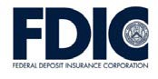
A fun way to help teens get smart about money.

TABLE OF CONTENTS
Lesson 5: Bank Your Bucks (Choosing a Banking Partner) 3
  - Student Handout 1: Banking Basics
  - Student Handout 2: Banking Basics Scripts
  - Student Handout 3: Security
  - Student Handout 4: Checking and Savings Accounts
  - Student Handout 5: Bank Checklist

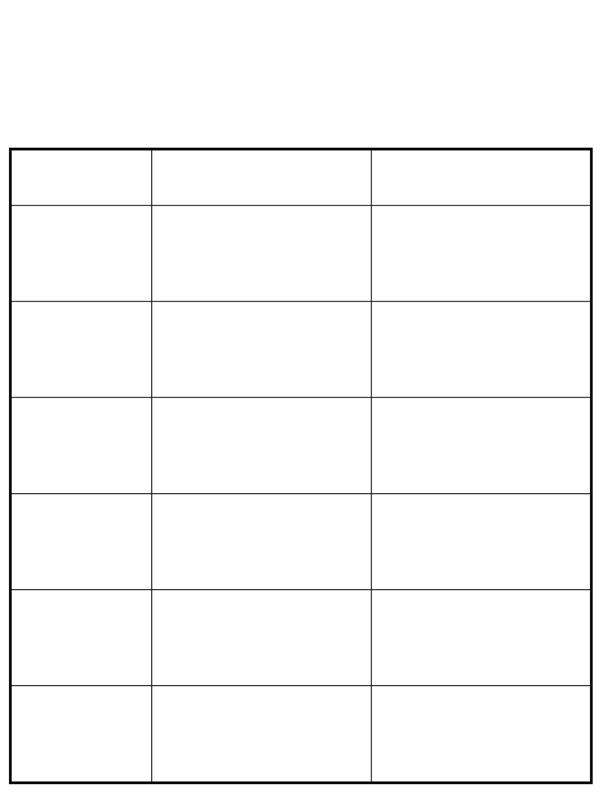

BANKING BASICS
Name: _
Travel around the room to each different banking station and record what you learn about the following people and banking tools.

What is my primary role
at the bank? How do I help customers?

Customer Service Representative

Bank Teller

Loan Officer

Branch Manager

ATM

Website

BANKING BASICS SCRIPTS

Hi, I am the Customer Service Representative. I can:
- Help you open your account
- Explain services we offer
- Answer general questions
- Refer you to a person who can help you
- Provide written information explaining the bank products
Hi, I am the bank teller. I will:
- Deposit and withdraw money from your account for you
- Cash your checks
- Answer questions about bank accounts
- Refer you to the person who can help you with other bank services
- Create a bank-certified check for you

Hi, I am the loan officer. If you need a loan, I can:
- Take applications for loans offered at the bank
- Answer questions about loans
- Provide written information explaining loan products
- Help you fill out a loan application
- Evaluate loan applications
Hi, I am the branch manager. I will:
- Supervise all the bank operations that take place at this branch
- Help fix the problems that other employees cannot solve

Hi, I am an Automated Teller Machine, or ATM for short. I will:
  - Get you fast access to your money
  - Be available 24 hours a day, 7 days a week
  - Help you check your account balance and make deposits
Hi, I am the bank website. I can:
  - Help you monitor your withdrawals and deposits, and even pay bills
  - Be available 24 hours a day, 7 days a week for online banking
  - Help you check your account balance
  - Help you complete wire transfers
  - Help you set up automatic payments

SECURITY
Name: _
How Is Your Money Protected?

The Federal Deposit Insurance Corporation (FDIC) insures deposits up to the maximum amount allowed by law. This means that the FDIC will return customers’ money up to
$250,000 per depositor, per insured bank based on the current Standard Maximum Deposit Insurance Amount (SMDIA) if a bank closes and cannot give its customers their money.
You can tell whether the FDIC insures a bank by the displayed FDIC logo. Most credit unions are insured by the National Credit Union Administration (NCUA). The deposit insurance rules are similar at NCUA-insured credit unions as they are at FDIC-insured banks.
The FDIC has an online tool called the Electronic Deposit Insurance Estimator (EDIE). You can calculate the insurance coverage of your accounts at each FDIC-insured institution online at www.myfdicinsurance.gov/.

Challenge
Read the following descriptions and place a  by the correct financial institution.
Stars & Stripes Financial Institution is insured by the FDIC. It must follow federal and state laws. You could get a loan, a credit card, or open a checking or savings account here. Which one is it?
 Bank or Thrift  Credit Union

Great Financial Institution requires account holders to be a faculty or staff member or student at Great University. The account holders are also the owners. Which one is it?
 Bank or Thrift  Credit Union

CHECKING AND SAVINGS ACCOUNTS

Name: _

Checking Accounts: A checking account allows you to pay bills and buy goods with the money you have deposited.
- When you write a check, use an ATM or debit card, or bank online, the financial institution takes the money from your account and pays it to the designated person or business.
- The financial institution makes a monthly record of the deposits and withdrawals made available to you either by mail or online. This is called a bank statement.
It is a good idea to compare the rules of the different accounts. For example: some banks might require you to have a certain balance to open an account, earn interest, or avoid fees. This is usually called a minimum balance.

Savings Accounts: A savings account is a safe place for you to save money. You generally will be paid interest on the money in your savings account, but you usually cannot write checks from this type of account.
- You can often open a savings account with a few dollars, but you might pay a monthly fee if the balance is below a certain amount.
- You can keep track of your account balance by reviewing the account statement.

Don’t Forget About Interest: One of the advantages of having a bank account is the interest you earn. Interest is a percentage of your balance that the bank pays you for keeping your money at that bank (if the account pays interest). Most savings accounts pay interest. It is less common for checking accounts to pay interest, but some may.

CHECKING AND SAVINGS ACCOUNTS (CONTINUED)

How to Write a Check:
- Know where the routing and bank account numbers are
- Write in the date
- Write the person or entity (for example: a business or organization name) that you are paying
- Write the numerical amount of the payment
- Spell out the amount of payment
- Sign your name, but don’t sign the back! The person receiving the check signs the check to endorse it for deposit

John Doe
55 Main Street
City, State 55555
2 December 1, 2014
Date
001

3 ABC Car Rental $ 160.50 4

5 One hundred sixty dollars and 50 100

BMaanink St.

Dollars

For car rental 6 John Doe MP 012345678 012345678987 0001
1

Now it’s your turn! Practice filling in the blank check below.

Date
$

John Doe
55 Main Street
City, State 55555
001

Dollars
Bank Main St.
For MP 012345678 012345678987 0001

MONEY SMART FOR GRADES 9–12 AND AGES 18–20: STUDENT GUIDE 7

BANK CHECKLIST
Name: _

Using an Internet search engine, locate and review the offerings from three different financial institutions and complete the chart below.

*If the financial institution is a credit union, be sure you are eligible to join.

Does the bank offer the services I need?
Convenient branches and ATMs? Bank hours?
Do employees speak my language? Is it insured by the FDIC/NCUA?
Does the bank have any special
programs for students?
Bank Name/ Account Type

Bank Information

Accounts
Bank Name/ Account Type
Bank Name/ Account Type
_

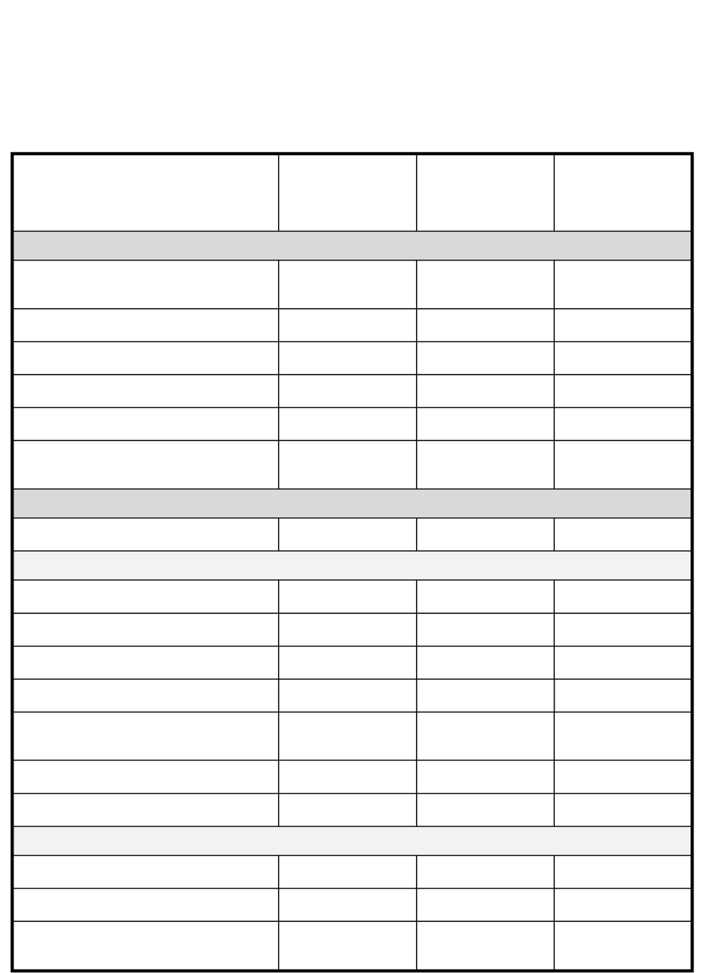
Requirements for opening account?

Checking Accounts Minimum opening balance? Minimum monthly balance? Fees?
Fee waivers available?

Number of withdrawals per month without a fee?
Earns interest? Deposit hold times? Overdraft Programs
Low-balance alerts offered? Overdraft fees?
Link to a savings account to cover overdrafts? If so, is there a fee?

BANK CHECKLIST (CONTINUED)

Bank Name/ Account Type
Bank Name/ Account Type
Bank Name/ Account Type
_

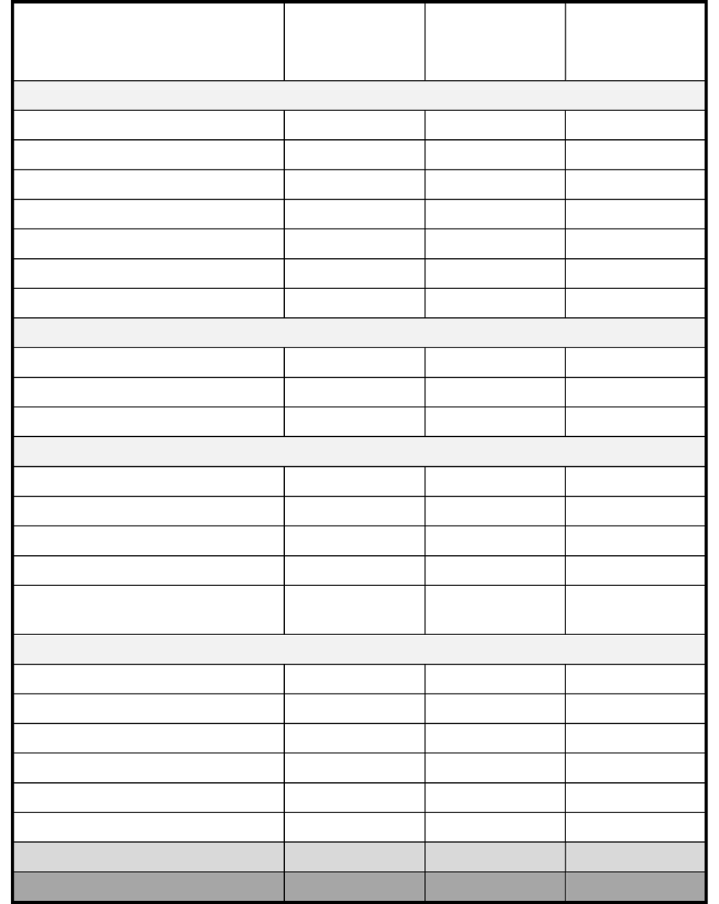
Savings Accounts Minimum opening balance? Minimum monthly balance?
Annual percentage yield (APY)? Fees?
Fee waivers available? Withdrawal limits per month? Services available?
ATM Cards

Fees?

Fee waivers available? Location/number of ATMs? Debit Cards
Fees?

Fee waivers available? Rebates or bonuses for use? Location/number of ATMs?
Debit card transactions requirements or limits?
Mobile/Online Banking

Is it available?

Transaction types and limits? Fees?
Fee waivers available? Online bill pay?
Other Information? Total Monthly Costs Total Annual Costs

