for Grades 9-12

Educator Guide

FDIC Disclaimer:
The books and online resources referenced in the Educator Guide and Parent/Caregiver Guide are examples/options that may be used to support the subject being taught and should not be considered as an endorsement by the Federal Deposit Insurance Corporation (FDIC). Reference to any specific commercial product, process, or service by trade name, trademark, manufacture, or otherwise does not constitute an endorsement, a recommendation, or a favoring by the FDIC or the United States government.
The FDIC Money Smart curriculum references books and provides links to other websites for convenience and informational purposes only. Users should be aware that when they select a link on the FDIC’s website to an external website, they are leaving the FDIC’s site. Linked sites are not under the control of the FDIC, and the FDIC is not responsible for the contents of any linked site or any link contained in a linked site, or any changes or updates to such sites. The FDIC is not responsible for any transmission received from a linked site. The inclusion of a link does not imply endorsement by the FDIC of the site, its content, advertisers, or sponsors. External sites may contain information that is copyrighted with restrictions on reuse. Permission to use copyrighted materials must be obtained from the original source and cannot be obtained from the FDIC.

TABLE OF CONTENTS
Welcome to Money Smart 4
Getting Started 5
Lesson 7: Capacity, Character, Collateral, Capital (Credit) 8
Answer Key 14
Glossary 15

Welcome to Money Smart, an exciting interactive exploration of the concepts of money. This standards-aligned, cross-curricular program is designed to promote personal financial education in grades 9 through 12 students and young adults aged 18 to 20. You can use Money Smart to add engaging and enriching activities to financial literacy and economics instruction. Extension activities support English Language Arts, Math, Social Studies and Economics, and Technology, while also helping your students build the foundation to become financially responsible adults.
In Money Smart you will find:
- Twenty-Two Lessons with hands-on, cross-curricular activities that engage ninth- through twelfth-grade students and young adults aged 18 to 20 in discussing and exploring key financial concepts
- Teacher Presentation Slides, which provide helpful visuals, as well as challenge exercises and reflective prompts to support the activities in each lesson
- A Student Guide with handouts, worksheets, and resources that let students explore the topics covered in each lesson and apply their new knowledge
- A Parent/Caregiver Guide with information about topics being covered in class, conversation starters, online and literary sources, along with conversation starters and family activities to try together

Developing positive financial habits equips students with 21st-century skills and tools that last a lifetime. We hope you and your students enjoy learning about money and its many uses.
We are eager to hear from you about how you use this curriculum. We would like to know what works well and what could be improved to make Money Smart even better. If you have any questions, we would like to help. Please contact us with your comments and questions via e-mail at communityaffairs@fdic.gov.

Money Smart provides a comprehensive, developmentally appropriate program for teens and young adults to build an understanding of key financial concepts.
There are many features that help make the Money Smart curriculum engaging, motivating, and easy to use. Each lesson includes learning objectives, essential questions, supplies needed, and preparation required, as well as the following features and components to support easy integration of Money Smart activities into your instructional day.

STANDARDS
Each lesson promotes real-world connections through student-centered learning experiences and aligns to the following education standards, including Common Core State Standards in mathematics and English Language Arts. The Education Standards Chart identifies which standards are met in each lesson.
- Financial Literacy Jump$tart Standards
- English Language Arts Common Core State Standards
- Mathematics Common Core State Standards
- National Standards in Economics by Council for Economic Education
- Partnership for 21st-Century Skills

GRADE-LEVEL MODIFICATIONS
Please note the modifications identified throughout the lessons to differentiate learning experiences for beginners and advanced learners. Modifications provide developmentally appropriate activity recommendations and extension opportunities for a wide range of learning levels.

PRESENTATION TIME
Each lesson plan includes an estimated time needed to teach the lesson. Actual time required will vary classroom to classroom. The estimation includes time spent on the Warm Up, Guided Exploration, Independent Exploration, and Wrap Up. Activities may also be taught as several short lessons over a period of days or weeks. Extended Exploration activities are included to extend financial literacy learning opportunities throughout the year and provide easy ways to integrate the topics into various content areas.

ASSESSMENTS
A variety of assessments will be integrated throughout each of the twenty-two lessons. Assessments are designed to build value, meaning, and context around a topic, while providing teachers with opportunities to evaluate prior student knowledge, and collect evidence of their new understandings of lesson concepts and skills. Pre- (formative) and post- (summative) assessments are noted on the first page of each lesson. Assessments include discussions, reflections, questions and answers, reading, writing, and problem-solving exercises. Student handouts are an especially useful form of written assessment.

LESSON STRUCTURE
Each lesson is designed to include the following:
- Warm Up introduces students to the topic and sparks inquiry.
- Guided Exploration integrates key financial literacy learning objectives with teacher support and guidance. Through whole-class discussions and activities, students discuss key topics and begin connecting the concepts to the context of their own lives.
- Money Smart Tips are provided throughout lessons to offer additional guidance, interesting and relevant financial facts, and additional ideas to help make Money Smart a success in your classroom.
- Independent Exploration activities are designed to engage students in the process of learning through individual discovery, research, and interpretation. These activities are more independent than the Guided Exploration activities and may also be used as homework assignments, for collaborative group work, or independent study.
- Wrap Up provides a reflection question or activity to review lesson concepts and allow students to demonstrate their understanding.
- Extended Exploration provides teachers with additional opportunities to extend financial literacy concepts throughout the school year within core content areas including English Language Arts and Math. Activities can be completed as a class, in small groups, or by students individually. Useful resources (such as books, web links, games, or videos) are also included to promote even more student engagement. The books and online resources suggested in this guide are just a few of the many available resources that explore these topics, and are not endorsed by the FDIC.
- Student Handouts (found in the Student Guide) and Teacher Presentation Slides provide dynamic instructional support. Student handouts create an opportunity for students to apply their knowledge and for teachers to assess their understanding. Teacher presentation slides offer visuals and interactive activities corresponding with lessons.
- The Answer Key, Glossary, and Standards Chart house all of the information needed to check for understanding, define key terms, and check which activities meet specific education standards. Vocabulary words are bolded in each lesson as they are introduced. It may be helpful to distribute copies of the entire glossary to students as a reference.

MONEY SMART AT HOME
The Money Smart curriculum includes a helpful Parent/Caregiver Guide that corresponds to the classroom materials. Families may also use it independently of the curriculum. It contains resources, activities, games, and conversation starters on financial literacy topics covered in each lesson. Use the following ideas to encourage parents to use the guide at home:
- Introduce parents to the Money Smart program and share the Parent/Caregiver Guide at the start of the school year.
- Discuss the Money Smart program during parent/teacher conferences, or in monthly parent newsletters home, and the importance of building healthy financial habits early on in life.

- Hold a Money Smart family night. Play games and have students share short skits about financial concepts they have learned.
- Send student handouts from each lesson home in homework folders for parents to review and sign.

MONEY SMART PORTFOLIO
To promote positive financial behaviors and demonstrate the compounding knowledge of financial literacy skills developed throughout the Money Smart curriculum program, introduce the Money Smart Portfolio into your classroom. The Money Smart Portfolio is a semester-long project that collects student handouts and activities from each lesson to be presented as a final portfolio.
The portfolio creation recognizes students’ financial growth throughout each phase of the learning process. The portfolio also enables students to walk away with a comprehensive resource that may be referred back to anytime a financial question arises in their futures. Using the Money Smart Portfolio as a semester-long project also gives students a long-term goal to work toward, while enabling an excellent opportunity for final assessment.
Money Smart Portfolio is designed for the following purposes:
- Assess student understanding from each phase of the program
- Create opportunities for final student self-reflection and personal assessment
- Reaffirm for students the intrinsic nature of financial skills and how one skill and strategy leads to another
- Build long-term vision for students to invest in the program from beginning to end

FINANCIAL LITERACY ALL YEAR LONG
Highlight financial literacy at your school all year long, especially in April, during National Financial Literacy Month and School Library Month.
- Create bulletin boards or posters with students about financial literacy themes learned in
Money Smart
- Create a class or school newsletter with students to distribute to the school community about money skills and financial concepts covered in class.
- Publish student handouts and activities from the Money Smart lessons by sharing them on a classroom blog, website, or through social media.
- Display student work in the classroom, library, and hallways to spread financial literacy throughout the school community.
- Connect with other teachers to integrate real-world applications of financial literacy across all disciplines and classrooms, from Math to English Language Arts and Technology courses.
The more that students are exposed to financial literacy, and the more opportunity they have to practice applying their new knowledge and understanding of concepts, at school and at home, the more prepared they will be to live Money Smart lives.

LESSON OVERVIEW
Young adults are faced with credit offers all the time, and knowing what to do when approached with an offer can mean a major difference in a teen’s financial future. This lesson walks students through the process of getting credit, analyzing good and bad credit, and how to manage and harm one’s credit. By the end of the lesson, students will demonstrate their understanding of how credit is earned and possess a greater understanding of the consequences of poorly managing one’s credit.

TOPIC: Credit

SUBJECT CONNECTIONS: English
Language Arts, Art

TIME REQUIRED: 70 minutes (excluding
Extended Exploration activities)

LEARNING OBJECTIVES:
Students will be able to…
- Define creditworthiness
- Evaluate positive and negative types of credit
- Explain credit factors and risks and how credit scores work
- Discuss how to maintain or increase credit score
- Explain how credit is damaged

SUPPLIES:
- Projector (for teacher presentation slides)
- Access to the Internet (optional)

PREPARATION:
- Make copies of student handouts
- Set up projector with presentation slides
Answer Key 14
Glossary with key vocabulary 15
STUDENT HANDOUTS:
(found in Student Guide)
- The Four Cs of Credit
- The Four Cs Challenge
- Manage or Damage?
- Creditworthiness Comic

TEACHER PRESENTATION SLIDES:
- Predatory Lending
- Types of Loans (3)
- The Four Cs of Credit
- Credit Report

ESSENTIAL QUESTIONS:
- What is credit?
- How can I be creditworthy?
- What are ways to manage my credit?

ASSESSMENT ACTIVITIES:
PRE-ASSESSMENT:
- What Is Credit? activity
POST-ASSESSMENT:
- The Four Cs Challenge handout
- Manage or Damage? handout
- Creditworthiness Comic handout

MONEY SMART PORTFOLIO:
- The Four Cs Challenge handout
- Manage or Damage? handout
- Creditworthiness Comic handout

INSTRUCTION STEPS

WARM UP
WHAT IS CREDIT? [15 MINUTES]
Open the lesson by displaying the Predatory Lending slide. Ask students to reflect on what the statements on the slide mean, and explain that credit offers are everywhere and that it is important to understand how credit works and not be lured in by predatory advertising (for example: advertising that is intended to exploit others for personal gain or profit). Remind students that, if an offer sounds too good to be true, then it likely is.
Engage the class in a brief discussion about what credit is and factors in deciding whether or not to use credit. Explain that credit is the ability to borrow money, and that, when you borrow money on credit, you are getting a loan. Use the glossary to review with students the definitions of credit and loans.
Ask students to share their ideas about when someone might use credit and borrow money. Help students understand that saving money and waiting to make a purchase is an alternative to credit. In some cases, though, credit offers the chance to invest in something that has the potential to provide a return greater than the cost of credit, such as a student loan or purchase of a home, in order to increase long-term earning potential. Credit can also help people get through emergencies and unexpected job loss. Explain that credit is inherently neither good nor bad, but it can be either, depending on how it is used.

GUIDED EXPLORATION
HOW CREDIT WORKS [25 MINUTES]
Ask students to think about an instance when they might need to borrow money in the future (for example: when it is something they need but do not have the cash to pay for, such as a home or vehicle). Explain that there are different types of loans depending on an individual’s credit needs. These include credit cards, consumer installment loans, school loans, and home loans or mortgages.

MONEY SMART TIP!
Refer to Lesson 8, The Almighty Dollar?, for more information about credit cards.

Display the three Types of Loans slides and walk students through each type of loan. Help students understand that credit cards give you the ongoing ability to borrow money for household, family, and other personal expenses; however, if you’re not careful in spending, you can get into big trouble and become burdened with debt.

Bring rent-to-own services into the discussion and have students compare and contrast rent-to-own services versus paying for something with cash or credit card, or applying for an installment loan. Show students that, whereas the rent-to-own payments may seem less expensive, you will actually
end up paying much more for something than if you paid with cash.

Begin introducing the concept of creditworthiness by helping students understand that, in order to borrow money, you have to show that you are able to responsibly pay back the money. Lenders take a risk when loaning you money, and not paying loans on time and in full can influence whether or not you are able to borrow money again in the future.

MONEY SMART TIP!
Review with students the Equal Credit Opportunity Act (ECOA) (http://www.consumer.ftc.gov/articles/0347-your-equal-credit-opportunity-rights) and discuss how the act ensures that all creditworthy applicants
are given an equal chance to obtain credit.

Display the Four Cs of Credit slide and explain to students that, when you apply for credit, the lender will review the Four Cs to decide whether you are a good credit risk and will be able to successfully pay back the loan. Distribute The Four Cs of Credit and The Four Cs Challenge handouts and ask for volunteers to read the details for each of the Four Cs to the class. Next, give students time to complete The Four Cs Challenge individually, and then regroup to discuss student answers.
Grade-Level Modifications:
Beginner: Complete The Four Cs Challenge handout together as a whole class.
Advanced: Give students the opportunity to practice filling out an application for a credit card, student loan, car, or home.

INDEPENDENT EXPLORATION
Note: These activities are more independent than the Guided Exploration activities and may be used as homework assignments, collaborative group work, or independent study.

MANAGE AND DAMAGE CREDIT [20 MINUTES]
To help assess the Four Cs, explain to students that lenders will review your credit report. Display the Credit Report slide to show students an example of what a credit report looks like. Next, have students review The Four Cs Challenge handout, and explain that a credit report is a record of your financial behaviors, and it includes:
- Who you are
- How much debt you have
- Whether you have made payments on time
- Whether there is negative information about you in public records

Share with students the three major credit-reporting agencies: Equifax (www.equifax.com), Experian (www.experian.com), and TransUnion (www.transunion.com).

Next, explain that a credit report is used to calculate a credit score. A great majority of lenders use the FICO credit score, which is a number that ranges from 300 to 850; the higher your score, the greater your creditworthiness and the less risky you are to a lender. A credit score is a quick and easy way for a lender to assess your creditworthiness. A credit score is used to predict how likely an individual is to repay a new loan based on information in his or her credit report. The factors that determine your credit score include payment history (35%), outstanding debt (30%), credit history (15%), pursuit of new credit or credit inquiries (10%), and types of credit in use (10%). Credit is granted based partially on your credit score. Lenders also check your credit score when you apply for a credit card or before you can rent a new apartment. Each time you demonstrate a financial behavior, such as paying bills (whether late or on time) or opening up a new line of credit, your credit score is continually updated to reflect your ability to successfully manage finances.

MONEY SMART TIP!
Share with students the resource website http://AnnualCreditReport.com and explain that federal law makes it so everyone can have access to his or her
free credit report once every 12 months from each of the credit bureaus.

Distribute the Manage or Damage? handout and divide the class into pairs. Have pairs discuss each scenario and determine whether the actions are managing or damaging credit. Invite volunteers to share their assessments, and discuss why actions can be helpful or harmful in determining one’s creditworthiness.

MONEY SMART TIP!
Have students read an article about how social media can influence lenders’ perceptions of you, such as Could Your Facebook Friends Affect Your Creditworthiness? (http://pittsburgh.cbslocal.com/2013/09/04/could-your-facebook- friends-affect-your-creditworthiness/). Use the article as a discussion tool to address the ramifications of sharing personal information online. Refer to
Lesson 20, Protect Yourself, for more information on consumer protection.

WRAP UP
HOW TO BE CREDITWORTHY [10 MINUTES]
Close the lesson by having students complete the Creditworthiness Comic handout.

In addition to using the Creditworthiness Comic handout in the Money Smart Portfolio, have students publish their creditworthy comics in the school newspaper or classroom blog, or compile them into one packet that can be shared with families and peers. For further extension, have students write a short story or narrative to accompany their comic.

EXTENDED EXPLORATION
Note: Use the following ideas to extend financial literacy concepts throughout the school year within core content areas through English Language Arts, Math, Social Studies and Economics, and Technology activities, projects, and discussions. Duration of activities will vary.

ENGLISH LANGUAGE ARTS
- Writing Prompts:
  - How do you know which credit offers are legitimate? How could you tell if an offer was deceptive?
  - What are some consequences that might arise if one is living only on credit?
  - What are the consequences of mismanaging credit?
- Suggested Readings:
  - Steps to Get and Keep a Good Credit Score by Consumer Finance.gov: A brochure with steps to take to maintain a good credit score by paying attention to your credit report. http://files.consumerfinance.gov/f/2011/07/CFPB_20110719_CreditScoresFlyer.pdf
  - Could Your Facebook Friends Affect Your Creditworthiness? by Pittsburgh CBS Local News: An article exploring how sharing information on social networks may impact your creditworthiness. http://pittsburgh.cbslocal.com/2013/09/04/could-your-facebook- friends-affect-your-creditworthiness/

MATHEMATICS
- Activity/Project Ideas:
  - Challenge students to calculate interest on ongoing credit card balances to demonstrate the true cost of credit. For example: have students play the “I Paid How Much?” quiz from TheMint.org, which presents different finance charges for students to explore. http://www.themint.org/teens/i-paid-how-much.html

SOCIAL STUDIES AND ECONOMICS
- Discussion Topics:
  - Debate and discuss the ways consumer credit card debt impacts the economy. For example: explore the dichotomy between fueling the economy through credit consumption versus how that same consumption leaves consumers with massive amounts of debt. Is buying on credit hurting or helping the economy? Is it hurting or helping the consumer?

o Invite students to bring the discussion of credit home and to ask parents and family members if they use credit cards or borrow money for large purchases such as a home or car.
- Activity/Project Ideas:
  - Encourage students to research laws that are in place to help protect consumers from predatory lenders. Have students share what they learn with the class. For example: have students visit Consumer Complaints and Protection at USA.gov (http://www.usa.gov/topics/consumer.shtml) and the Federal Trade Commission’s Bureau of Consumer Protection at FTC.gov. http://www.ftc.gov/about-ftc/bureaus- offices/bureau-consumer-protection
  - Review and discuss historical mortgage lending practices and how home loans contributed to the financial crisis of 2008. Show students all or part of the hour-long PBS video, Inside the Meltdown, which provides an overview of the crisis (http://www.pbs.org/wgbh/pages/frontline/meltdown/view/), or review Chairman Ben Bernanke’s speech at the Federal Reserve System Conference on Housing and Mortgage Markets on December 4, 2008. http://www.federalreserve.gov/newsevents/speech/bernanke20081204a.htm

TECHNOLOGY
- Online Resources:
  - The following credit-reporting agencies allow you to access your credit report: Equifax (www.equifax.com), Experian (www.experian.com), and TransUnion (www.transunion.com).
  - Spending Challenge by The Mint: A question-and-answer challenge that simulates the decision-making process when using credit. http://www.themint.org/teens/take-the- spending-challenge.html
  - Annual Credit Report: A website allowing you to obtain a free credit report every 12 months. https://www.annualcreditreport.com/index.action
  - Credit and Loans by the Federal Trade Commission: A web resource listing tips for how to assess credit and loan offers, including information on credit reports and credit scores. http://www.consumer.ftc.gov/topics/credit-and-loans
  - The Secret History of the Credit Card by PBS (60 minutes): A video detailing the history of credit cards, as well as an overview of the marketing tactics used to engage consumers in using credit cards. http://video.pbs.org/video/1340904268/

ANSWER KEY

for Student Handouts

LESSON 7: CAPACITY, CHARACTER, COLLATERAL, CAPITAL
Student Handout: The Four Cs Challenge
Review each section and match the required information with the appropriate C: Capital, Collateral, Character, or Capacity. There may be more than one correct answer.
- Employment Information: Capacity
- Monthly Income and Combined Housing Expense Information: Capacity
- Declarations: Character
- Assets (for example: checking and savings account, investment products, and car) and Liabilities (for example: automobile or other loans, charge accounts, and other forms of debt): Capital and Collateral

Student Handout: Manage or Damage?
  - Eli’s Scenario: MANAGE. Eli pays attention to what he uses his credit card for and pays the bill in full at the end of every month.
  - Imani’s Scenario: DAMAGE. Imani did not think long term when she made a commitment to a two-year contract, and the result is that she is unable to meet her repayment responsibilities.
  - Ethan’s Scenario: DAMAGE. Ethan failed to realize that, just because credit was available to him, he didn’t need to use it all. He overextended himself and is considering going even deeper in debt to pay off his existing debt.

Student Handout: Creditworthiness Comic. Answers will vary. Use handout to assess student ability to demonstrate what it means to be creditworthy.

GLOSSARY

401k: A plan offered through an employer that gives employees a choice of investment options, typically mutual funds, to save a portion of their salary for retirement.
403b: A plan offered by to employees of public schools, certain non-profits, and some members of the clergy to set aside money for retirement.
Annual Percentage Rate (APR): The cost of borrowing money on a yearly basis, expressed as a percentage rate. For example: a $100 loan repaid in its entirety after one year with a $10 finance charge has an APR of 10%.
Annual Percentage Yield (APY): A percentage rate reflecting the total amount of interest paid on a deposit account based on the interest rate and the frequency of compounding for a year. For example: a $1,000 investment that earns 6% per year pays $60 at year-end and has an APY of 6%.
Asset: An item with economic value, such as stock or real estate.

Auto Insurance: A contract between you and an insurance company in which you agree to pay a fee (premium) and in return, the insurance company agrees to pay for certain expenses associated with an accident or other covered losses on your vehicle. (See also Insurance.)
Automated Teller Machine (ATM): A machine, activated by a magnetically encoded card or other medium that can process a variety of banking transactions. These include accepting deposits and loan payments, providing withdrawals, and transferring funds between accounts.
Balance Sheet: A summary of a company's assets, liabilities, and shareholders' equity.

Bank: A financial institution and business that accepts deposits, makes loans, and handles other financial transactions.
Bank Teller: A bank employee who handles routine transactions, such as deposits or withdraws into a bank account.
Beneficiary: Someone who is designated to receive certain benefits after the death of another individual.

Bonds: A debt security, similar to an “IOU”. When you buy a bond, you are lending money to the issuer in exchange for the issuer’s promise to pay you a specified rate of interest and to repay the principal when it "matures," or comes due.
Branch Manager: A bank employee that supervises bank operations at a branch location.

Budget: A plan that outlines what money you expect to earn or receive (your income) and how you will save it or spend it (your expenses) for a given period of time; also called a spending plan.
Capacity: Refers to your ability to repay a loan and other debts.

Capital: Refers to the value of your assets and your net worth.

Career: The type of work a person pursues for the majority of their life that may involve formal education, special training, or be within a specific industry.

Cash Flow: The amount of money flowing in (income) and flowing out (expenses) of a personal budget.

Cash Flow Statement: A summary of the money that comes in (income) and out (expenses) of a household or business over a period of time.
Certificate of Deposit (CD): A special type of savings account offered by banks or credit unions that typically offers a higher rate of interest than a regular savings account. You generally must keep your funds in the CD for a specified period of time to avoid penalties. The end of that time period is called the “maturity date.”
Certified Public Accountant (CPA): An accountant who has passed an examination and met other requirements and has been granted a certificate by a state agency.
Character: In finance, this refers to how you have paid your bills or debts in the past.

Charitable Giving: Money that you give to a nonprofit organization, charity, or private foundation.

Checking Account: A deposit account at a financial institution that allows consumers to make deposits, pay bills, and make withdrawals. Money that is in a checking account is very liquid, meaning it can be easily accessed.
Claim: Request to an insurance company for payment for a covered loss under an insurance policy.

Closing Costs: The expenses incurred by sellers and buyers in transferring ownership in real property. These costs may include the origination fee, attorneys' fees, loan fees, title search and insurance, and recordation fees.
Collateral: An asset that secures a loan or other debt that a lender can take if you default (don’t repay) the money you borrow. For example: if you get a real estate mortgage, the bank's collateral is typically your house.
College Work-Study Program (Federal Work-Study): A program that enables qualifying students to work part time to receive money that helps finance the costs of post-secondary education.
Commercial Property Insurance: Coverage that a business or other entity purchases from an insurer to help cover losses to buildings and contents due to a covered cause of loss, such as a fire. (See also Insurance.)

Compound Interest: The interest paid on principal and previously earned interest.

Consumer Installment Loan: Money that a person borrows and agrees to pay back by making a set number of payments over a period of time.
Co-Pay: Also known as a copayment, a fixed amount (for example: $15) you pay for a covered health care service, usually when you get the service.
Corporation: A legal entity that is distinct from the individual(s) who compose the business yet has rights and abilities similar to those of a natural person.
Credit: The ability to borrow money and pay it back later.

Credit Card: A plastic card that can be used to obtain credit (such as to purchase goods and services).

Credit Card Accountability Responsibility and Disclosure Act: A law that prohibits certain practices that are unfair or abusive. The law also makes the rates and fees on credit cards more transparent so consumers can understand how much they are paying for their credit card and can compare different cards.

Credit Report: A record of your credit - and some bill repayment history - and the status of your credit accounts. This information includes how often you make your payments on time, how much credit you have, how much credit you have available, how much credit you are using, and whether a debt or bill collector is collecting money you owe.

Credit Score: A number, roughly between 300 and 800, that measures an individual's credit worthiness. The most well-known type of credit score is the FICO® score. This score represents the answer from a mathematical formula that assigns numerical values to various pieces of information in your credit report.

Credit Union: A not-for-profit financial institution owned by its members and represented by a volunteer board of directors who are elected by the membership. To become a member, you must meet the credit union’s field of membership requirements and open a share account.

Creditworthiness: A creditor's measure of a consumer's past and future ability and willingness to repay debts. (See also Credit Report and Credit Score.)

Crowdfunding: A process of raising money for a cause or purpose, often online, from multiple people.

Customer Service Representative: A person who provides general information, handles complaints or inquiries, and may help consumers open accounts.
Debit Card: A plastic card that can be used to deposit or withdraw cash from a checking or other bank deposit account, such as at automated teller machines or at retail locations that accept cards.

Debt-to-Assets: Measures the ratio of your monies owed (liabilities such as a car loan) to items that are of value (assets such as property). To calculate, you divide your total liabilities by your total assets. For example: if you own a home that is worth $200,000 (asset), but you have a mortgage of $50,000 left on the home (liability), your debt-to-asset ratio is 25% ($50,000 ÷ $200,000 = 0.25 or 25%).
Debt-to-Equity: A measure of solvency (the ability of a business to pay off its debt if the business were immediately sold) that is calculated by dividing total liabilities by stockholders' equity.
Debt-to-Income: A measure calculated by dividing your monthly debt payments by your gross monthly income. For example: if you pay $200 each month for a car loan and $1,000 each month for a home loan, your total debt payment each month is $1,200 ($200 + $1,000). If your monthly gross income is $4,000, then your debt-to- income ratio is 30% ($1,200 ÷ $4,000).
Deductible: The dollar amount or percentage of a loss that you have to pay before the insurance policy begins to pay.

Deduction: An amount that reduces the amount of income on which a person pays tax.

Direct Loan: A low-interest loan for students and parents to help pay for the cost of a student's education after high school.
Disability Insurance: Protects a person from loss of income due to a covered illness or injury. (See also
Insurance.)

Diversification: The approach of spreading your money among various investments with the hope that if one investment loses money, the others will make up for those losses; also referred to by the phrase "don't put all your eggs in one basket.

Entrepreneur: An individual who establishes and operates his or her own business.

Equal Credit Opportunity Act: A federal law that prohibits credit-related discrimination on the basis of gender, race, marital status, religion, national origin, age, or receipt of public assistance.
Equity: The difference between the value of a piece of property (such as a house) and any debts for it (such as the amount of a mortgage).
Estate: The property of a person who has died.

Estate Planning: Planning for what will happen with assets or property after death.

Estate Tax: A tax on your right to transfer property at your death.

Executor: Someone who is selected to administer an estate (for example, make sure that the instructions in the will are properly followed).
Expense: The cost of goods and services.

Federal Deposit Insurance Corporation (FDIC): Preserves and promotes public confidence in the U.S. financial system by insuring deposits in banks and thrift institutions for at least $250,000. An independent agency of the federal government, the FDIC was created in 1933 in response to the thousands of bank failures that occurred in the 1920s and early 1930s. Since the start of FDIC insurance on January 1, 1934, no depositor has lost a single cent of insured funds as a result of a failure.

Finance Charge: The total dollar amount paid for credit. For example: a $100 loan repaid with $9 interest plus a
$1 service fee has a finance charge of $10.

Financial Advisor: A person who provides financial information and advice.

Financial Aid: Award(s) to individuals to help pay for education expenses.

Financial Planning: Identifying a person’s financial goals, needs, and expected earning, saving, investing, insurance, and debt management activities.
Financial Ratios: Useful indicators of financial performance.

Financial Recordkeeping: The documentation of a person’s financial affairs, including income earned, taxes paid, and expenses.

Fiscal Policy: A broad term used to refer to the tax and spending policies of the federal government. Fiscal policy decisions are determined by Congress and the governing Administration.

Fixed Expense: An expense that does not change from month to month.

Fixed-Rate Loan: A loan that has an interest rate that does not change.

Free Application for Federal Student Aid (FAFSA): The free application used to apply for federal student aid, such as federal grants, loans, and work-study.
Goal: Something you wish to achieve or accomplish in a specific amount of time.

Grant: A form of financial aid, often based on financial need that does not need to be repaid (unless, for example, you withdraw from school and owe a refund).
Gross Income (Gross Pay): Earnings before deductions (as for taxes or expenses) are subtracted.

Health Insurance: A contract that requires your health insurer to pay some or all of your health care costs in exchange for a premium (money paid).
Home-Based Business Insurance: Protection against certain losses and other risks for those who engage in business activity at their home. (See also Insurance.)

Homeowner’s Insurance: An insurance policy that covers a homeowner’s house, other structures on their property, and personal contents against losses caused by such things as windstorms, fire, and theft. It generally also provides liability coverage (for example: this coverage would be applicable if you are found responsible for the injury of a friend who injures themselves while visiting you). (See also Insurance.)

Identity Theft: When someone steals another person’s identity to commit fraud, such as by using his or her name or Social Security number to get something. Identity theft is a crime.
Income: Money that you receive from jobs, allowances, gifts, interest, dividends, and other sources.

Income Tax: Taxes on income, both earned (salaries, wages, tips, commissions) and unearned (interest, dividends). Income taxes can be levied on both individuals (personal income taxes) and businesses (business and corporate income taxes).
Individual Retirement Account (IRA): A deposit or investment account that an individual opens and uses to save money for retirement and that has certain tax advantages
Inflation: A rise in the general level of prices of goods and services in an economy over a period of time; the opposite is deflation.
Insurance: A contractual relationship that exists when one party (the Insurer), for a fee (the premium) agrees to reimburse another party (the Insured or third party on behalf of the Insured) for a specific loss.
Insurance Agent: A person who sells insurance policies.

Interest: Money that a bank or other financial institution pays you for keeping money on deposit with them, or the amount of money you pay a bank as a fee when you borrow money. You can earn interest from a bank (such as when you keep money in a saving account) or pay interest (such as when you borrow money).
Inventory Turnover Ratio: A ratio showing how often a company's inventory is sold and replaced during a year or other period of time.
Invest: To put money at risk with the goal of making a profit (return) in the future.

Investment: Using money or time in a way that you expect will bring you a return or increase in value.

Investment Vehicle: The type or methods that a person (or business) can use to invest money.

Investors: People who expect a future financial return from using their money to finance investments.

Job: A specific duty, task, or activity someone completes using his or her time, skills, and energy to earn money.

Joint Tenancy: Equal ownership of property by two or more parties, each of whom has the right of survivorship (for example: when a person dies, their interest in the property is transferred to the other owners).
Lawyer: A person who practices law; also known as an attorney.

Lease: A contract transferring the use of property or occupancy of land, space, structures, or equipment in exchange for rent (generally money).
Lender: An organization or person that lends money with the expectation that it is repaid.

Liability: An amount owed to a person or organization for borrowed funds; responsibility to another for negligence that results in injury or damage.
Liability Insurance: Covers losses that an insured is legally liable, such as for another’s personal injury or for property damage. (See also Insurance.)

Life Insurance: A form of insurance that will pay money to a beneficiary if the policyholder dies. (See also
Insurance.)

Limited Liability Company (LLC): An entity formed under state law by filing articles of organization as an LLC. Unlike a partnership, none of the members of an LLC are personally liable for its debts.
Loan: Money borrowed that has to be repaid, generally with interest.

Loan Officer: A bank employee that (depending on the bank) evaluates, authorizes, or recommends approval of loan applications for people and businesses.
Long-Term Care: Services that include medical and non-medical care provided to people who are unable to perform basic activities of daily living, like dressing or bathing. Medicare and most health insurance plans don’t pay for long-term care.
Medicare: A health insurance program for people who are 65 or older, certain younger people with disabilities, and people with permanent kidney failure requiring dialysis or a transplant. This program is financed by deductions from wages and managed by the federal Social Security Administration.

Monetary Policy: What the Federal Reserve, the nation's central bank, does to influence the amount of money and credit in the U.S. economy. What happens to money and credit affects interest rates (the cost of credit) and the performance of the U.S. economy.
Money Market Deposit Account: A savings account that offers a higher rate of interest in exchange for larger than normal deposits.
Mortgage (Home Loan): A contract, signed by a borrower when a home loan is made, that gives the lender the right to take possession of the property if the borrower fails to pay off, or defaults on, the loan.
Mutual Funds: An investment tool that pools the money of many investors and invests it in stocks, bonds, and money market assets, or other securities.
Need: Something you must have to survive, such as clothes, shelter, or food.

Net Income (Take-Home Pay): The gross pay minus deductions (such as for taxes, health care premiums, and retirement savings).

Net Worth: The difference between what you own (assets) and what you owe (debts).

Online Banking: A service that enables an accountholder to obtain account information and manage certain banking transactions through the financial institution's web site on the Internet.
Partnership: Two or more persons who join to carry on a trade or business. Each person contributes money, property, labor or skill, and expects to share in the profits and losses of the business. Partners are liable for the partnership’s financial responsibilities.
Paycheck: A check that is used to pay an employee for his or her work.

Pell Grant: Awarded to undergraduate students who have demonstrated financial need.

Perkins Loan: Low-interest federal student loans for undergraduate and graduate students with exceptional financial need.
Personal Exemptions: Reduces the income subject to taxation by the exemption amount.

Pharming: Redirecting Internet requests to false Web sites to collect personal information, which is generally then used to commit fraud and identity theft.

Philanthropy: Giving money or time for the purpose of trying to make life better for others.

Phishing: When fraudsters impersonate a business or government agency to try to get you to give them personal information, such as through an email or text message. Can also be thought of as “fishing for confidential information”.
Pi: A Greek letter that reflects the ratio of the circumference of a circle to its diameter.

Predatory Lending: Certain practices that result in a borrower obtaining a loan that is harmful. These include, among other things, charging excessive fees and interest rates, lending without regard to borrowers’ ability to repay, refinancing borrowers’ loans repeatedly over a short period of time without any economic gain for the borrower, and committing outright fraud or deception (such as falsifying documents).
Premium: The amount of money that has to be paid for an insurance policy.

Profit: The money gained or left over after money spent (expense) is subtracted from money earned (income).

Profit-and-Loss Statement: A financial statement that summarizes the financial performance of a business during a specific period of time, including by outlining the firm’s income, expenses, and the resulting profit or loss.

Policy: Contract between the insured and the insurer.

Power of Attorney: A legal instrument authorizing someone to handle the financial or other business affairs of another person.
Principal: The amount of money originally invested or the money that is borrowed.

Property Insurance: Insurance to protect you against damage that may occur to your property. (See also
Insurance.)

“Rainy Day” Fund (Emergency Fund): Money set aside to pay for unexpected expenses.

Rate of Return: Profit or loss over a one year period, expressed as a percentage.

Recession: A period of reduced economic activity.

Rent: The amount of money needed to live in or use someone else’s property, such as a home, condo, or apartment.
Rent-to-Own: A lease contract that includes an option to buy the product.

Return on Assets: An amount calculated by dividing annual earnings by its total assets.

Return on Investment (ROI): The annual return on an investment, expressed as a percentage of the total amount invested.
Revenue: The total income produced by a given source.

Right of Survivorship: A successor’s ability to acquire the property of a decreased individual upon his or her death.
Risk: The possibility that something unplanned or unintended may happen (such as losing money). Uncertainty about outcomes that are not equally desirable. In finance, it refers to the degree of uncertainty about the rate of return and the potential harm that could arise when financial returns are not what the investor expected.
Risk Management: The process of calculating risk and choosing approaches to minimize or manage loss.

Roth IRA: An Individual Retirement Account that you deposit after tax dollars into for accumulation of retirement savings.
Rule of 72: A rough calculation of the time or interest rate needed to double the value of an investment determined by taking the number 72 and dividing it by the interest rate. For example: To figure how many years it will take to double a lump sum invested at an annual rate of 8%, divide 72 by 8, for a result of 9 years.
Salary: Compensation for work paid on a regular basis (bi-weekly/monthly) typically expressed as an annual amount.

Save: To set something, like money, aside to use in the future.

Savings Account: A bank account that you can use to set aside money, and that pays you interest.

Scholarship: Money awarded to students based on academic or other achievements to help pay for education expenses. Scholarships generally do not have to be repaid.
Secured Installment Loan: A loan for which you provide collateral to secure your promise to repay the money you borrow.
Self-Employment Tax: Money that someone who is considered self-employed must pay to the federal government to fund Medicare and Social Security.
Social Security: A federal government program that provides retirement, survivors, and disability benefits, funded by a tax on income.
Sole Proprietorship: A simple structure where there is only one person owning and operating the business.

Spending Plan: Another name for a budget.

Start-Up Capital: Money that is invested to help start a new business.

Stock: An investment that represents a share of ownership in a company.

Student Loans: A sum of money borrowed by an individual to help pay for college with the intent that it will be repaid at a future date, along with any agreed-upon interest.
Tax: Money that has to be paid to a government to provide public goods and services.

Tenancy in Common: Shared ownership of a property in which more than two people hold the title.

Tenancy in Entirety: Shared ownership of a property between a husband and wife, when one dies, the other still owns the property.
Text Message Spam: Similar to e-mail spam, but on your cell phone. Criminals often text offers of free gifts or low-cost credit offers to try to get you to click on a link so they can install malware on your phone or get you to give them information they can use to commit fraud.
Time Value of Money: The concept that a dollar today is not worth the same as a dollar in the future.

Traditional IRA: A retirement savings program to which yearly tax-deductible contributions up to a specified limit can be made. The amount contributed is not taxed until withdrawn. Withdrawal is not permitted without penalty until the individual reaches age 59 and a half.
Trust: A legal arrangement in which one person holds or manages assets or other property for the benefit of another.
Unsecured Installment Loan: A loan that is not secured by an asset (collateral) that a lender could take if you do not repay the loan.
Variable Annuities: A contract between you and an insurance company, under which you make a lump-sum payment or series of payments. In return, the insurer agrees to make periodic payments to you beginning immediately or at some future date.
Variable Expense: Money that a person spends or gives away that varies from month to month.

Variable-Rate Loan: A loan where the interest rate might change.

Want: Something that you would like to have but that you could live without, such as a TV or tickets to a baseball game.
Will: A legal document in which a person conveys information such as how they want their money and assets to be distributed after their death and who should be the guardian of their children.

for Grades 9-12
Student Guide

A fun way to help teens get smart about money.

TABLE OF CONTENTS
Lesson 7: Capacity, Character, Collateral, Capital (Credit) 3
  - Student Handout 1: The Four Cs of Credit
  - Student Handout 2: The Four Cs Challenge
  - Student Handout 3: Manage or Damage?
  - Student Handout 4: Creditworthiness Comic

MONEY SMART FOR GRADES 9–12 AND AGES 18–20: STUDENT GUIDE
2

THE FOUR Cs OF CREDIT

CAPACITY

Capacity refers to your present and future ability to meet your payments. A lender wants to see that you have a job and you have held the same job or the same type of job for at least a year.

Lenders may ask:

Do you have a job?

How much money do you make each month?

What are your monthly expenses?
CAPITAL

Capital refers to the value of your assets and your net worth. Lenders want to determine the value of your assets (things you own that have financial value). Lenders will also compare the value of your assets and the amount of debt you have. This is called net worth. A positive net worth demonstrates your ability to manage your money.

Lenders may ask:

How much money do you have in your checking and savings accounts?

Do you have investments

(for example: stocks, bonds) or other assets (for example: a car)?

CHARACTER

Character refers to how you have paid your bills or debts in the past.

Lenders may ask:

Have you had credit in the past?

How many credit accounts do you have?

Have you ever filed for bankruptcy, had property repossessed, or made late payments?

COLLATERAL

Collateral refers to property or assets you can offer to secure the loan.

Collateral is security you provide the lender. Giving the lender collateral means that you pledge an asset that you own (for example: a car) to the lender with the agreement that it will be the repayment source in case you cannot repay the loan.

Lenders may ask:

Do you have assets to secure the loan beyond your capacity to pay it off?

MONEY SMART FOR GRADES 9–12 AND AGES 18–20: STUDENT GUIDE 3

THE FOUR Cs OF CREDIT (continued)
CREDIT SCORE
A credit score is used to predict how likely an individual is to repay a new loan based on information in his or her credit report. Your credit score is a number that is developed by a computer model based on the information in your credit report. It is intended to predict, for example, how likely you are to repay your debts. Keep in mind that credit scores may vary depending on which scoring services prepared them and which of the many different credit scoring models is being used. As an example, the factors that determine your credit score in one commonly used model include:
OUTSTANDING DEBT
(Do you currently owe money on any of your accounts?) 30%
CREDIT HISTORY
(how long have you been using credit accounts?) 15%
TYPES OF CREDIT IN USE
(What type of credit do you have? For example, mortgage loans, credit cards, Installment loans?) 10%
PURSUIT OF NEW CREDIT
OR CREDIT INQUIRIES
(What credit accounts have you opened lately?)
10%
PAYMENT HISTORY
(Have you paid your bills on time?) 35%

For more information on credit scores and how they are calculated, visit the Consumer Financial Protection Bureau's website at http://www.consumerfinance.gov/askcfpb/315/what-is-my-credit-score.html.

THE FOUR Cs CHALLENGE

Name:

Lenders often determine an applicant’s Four Cs during the loan application process. The following information is taken from the Uniform Residential Loan Application, which is the standard form used for mortgage loan applications. The questions are similar to applications for other types of loans.
Review each section and match the required information with the appropriate C: Capital, Collateral, Character, or Capacity. There may be more than one correct answer.

1) Employment Information: _

Name & Address of Employer | - Self Employed | Dates (from – to)  Monthly Income
 |  | $
Position/Title/Type of Business |  | Business Phone (incl. area code)
 | - Self Employed
Name & Address of Employer |  | Dates (from – to)
 |  | Monthly Income
 |  | $
Position/Title/Type of Business |  | Business Phone (incl. area code)

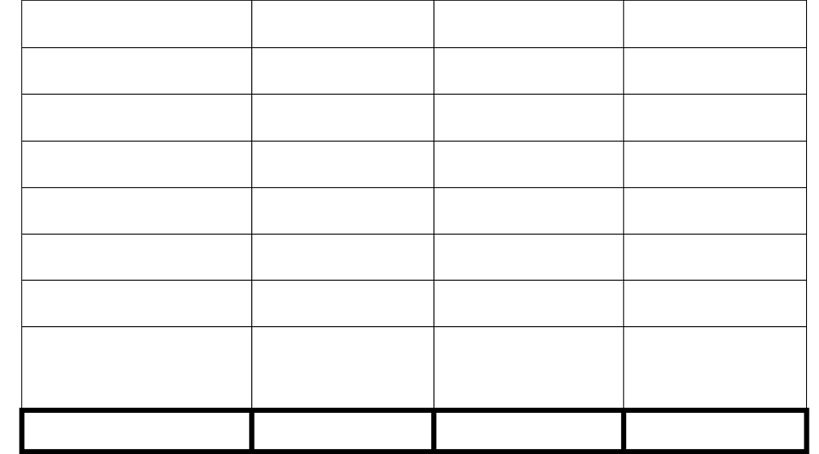
THE FOUR Cs CHALLENGE (continued)
2) Monthly Income and Combined Housing Expense Information: _
Gross Monthly Income
Borrower
Co-Borrower
Total
Base Empl. Income*
$
$
$
Overtime

Bonuses Commissions Dividends/Interest Net Rental Income
Other) before completing, see the notice in “describe other income,” below”

Total $
$
$
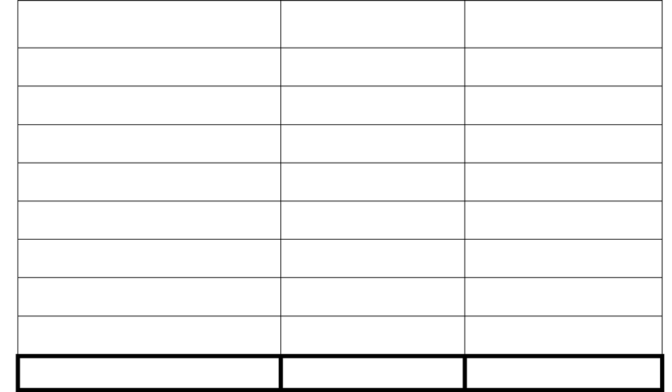
Combined Monthly Housing
Expense
Present
Proposed
Rent
$
First Mortgage(P&I)
$
Other Financing (P&I)

Hazard Insurance Real Estate Taxes Mortgage Insurance
Homeowner Assn. Dues Other
Total
$
$

DECLARATIONS
If you answer “Yes” to any questions a through i, please use continuation sheet for explanation.
Borrower
Co-Borrower
- Are there any outstanding judgments against you?

- Have you been declared bankrupt within the past 7 years?

- Have you had property foreclosed upon or given title or deed in lieu thereof in the last 7 years?
- Are you a party to a lawsuit?

- Have you directly or indirectly been obligated on any loan which resulted in foreclosure, transfer of title in lieu of foreclosure, or judgment?
(This would include such loans as home mortgage loans, SBA loans, home improvement loans, educational loans, manufactured (mobile) home loans, any mortgage, financial obligation, bond, or loan guarantee. If “Yes,” provide details, including date, name, and address of Lender, FHA or VA
case number, if any, and reasons for the action.)

Yes  ❑ | No  ❑ | Yes  ❑ | No  ❑
❑ | ❑ | ❑ | ❑
❑ | ❑ | ❑ | ❑
❑ | ❑ | ❑ | ❑
❑ | ❑ | ❑ | ❑

4) Assets (for example: checking and savings account, investment products, and car) and Liabilities (for example: automobile or other loans, charge accounts, and other forms of debt):

ASSETS
Cash or
Market Value
Description
Cash deposit toward purchase held by:
$
Liabilities and Pledged Assets. List the creditor’s name, address, and
account number for all outstanding debts, including automobile loans, revolving charge accounts, real estate loans, alimony, child support, stock pledges, etc. Use continuation sheet, if necessary. Indicate by (*) those liabilities, which will be satisfied upon sale of real estate owned or upon refinancing of the subject property.
List checking and savings accounts below LIABILITIES
Name and address of Bank, S&L, or Credit Union
Name and address of Company
Monthly Payment & Unpaid
Months Left to Pay Balance
$ Payment/Months $
Acct. no.
$
Name and address of Bank, S&L, or Credit Union
Acct. no.
Name and address of Company
$ Payment/Months
$
Acct. no.
$
Acct. no.

MANAGE OR DAMAGE?

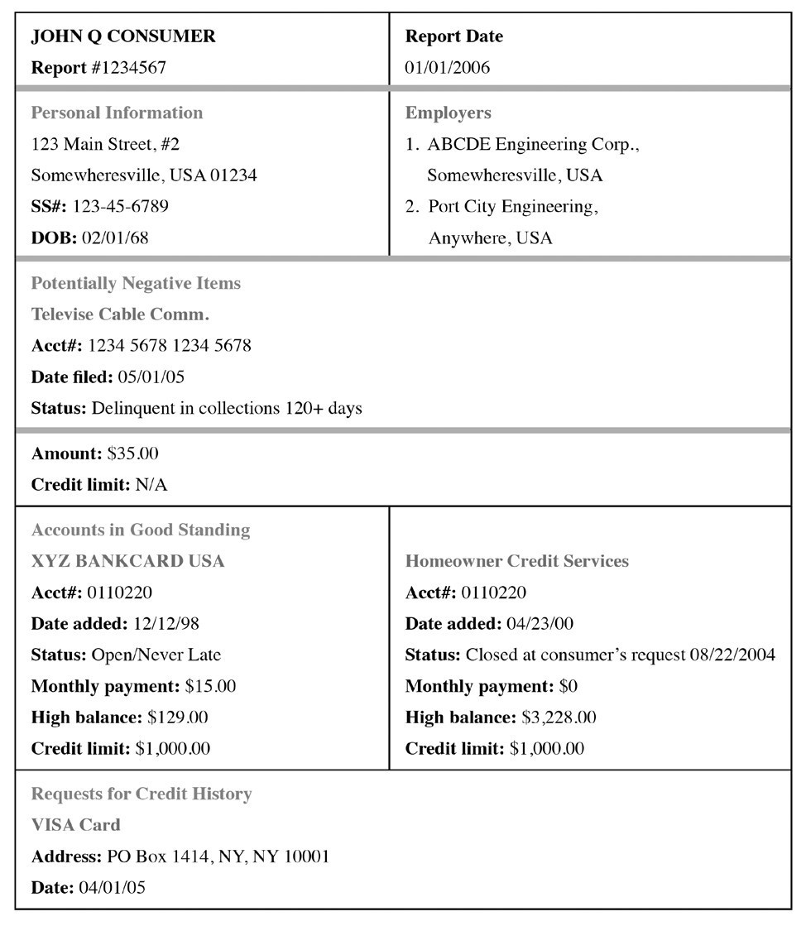Sample credit report:

MANAGE OR DAMAGE? (continued)

Name: _
Read the scenarios below and decide if each person’s actions are managing or damaging credit. Select the correct answer and explain your reasons.
“I’ve had a credit card for about a year now and I use it mostly to buy bigger items. Like last week I bought a new microwave for my apartment and put it on my credit card. I get a bill at the end of every month and then I’ll go online and pay it in full. I don’t want to have to worry about the credit card adding up to more than I have so I just think it’s easier to pay it off every month.”
–Eli, 22 years old

MANAGE DAMAGE

Why? _

“I bought a cell phone because I work late at the movie theater on the weekends. At first, I made all of my payments on time. But I ended up having to quit my job because I was having trouble in school and needed more time to study and get my homework done. I haven’t been able to pay my phone bill on time for the last three months. I signed a two-year contract for my phone because the phone company gave me a discount if I did, but now I don’t know if I can make it the full two years.”
–Imani, 18 years old

MANAGE DAMAGE

Why? _

“When I started college last year, I couldn’t believe how many credit card applications were offered to me. I thought, hey, why not? I’m going to need money for books and food and probably a football game or two, so I went ahead and applied for them all…and got approved! I was pumped. Now, all my cards are maxed out and I can’t use them anymore because I’ve hit my credit limit. I let a few of the payments slip last month because I didn’t have the money, but I’m thinking if I can get a new card then I can get more money to pay off my other ones.”
–Ethan, 19 years old

MANAGE DAMAGE

Why? _

CREDITWORTHINESS COMIC

Name: _
Think of an instance, action, or behavior that represents being creditworthy, such as successfully paying off a car loan or making monthly payments on time, and illustrate a story about your creditworthy idea in the comic strip below.

Box l: Use this space to illustrate the beginning of your story, such as who is demonstrating the creditworthy act (your main character) and where the story takes place (at home, at a bank, at a store).

Box 2: Use this box to illustrate the middle of your story, or where all the action takes place.

Box 3: Draw the end, or resolution, of your story here and how your main character displayed creditworthiness.

