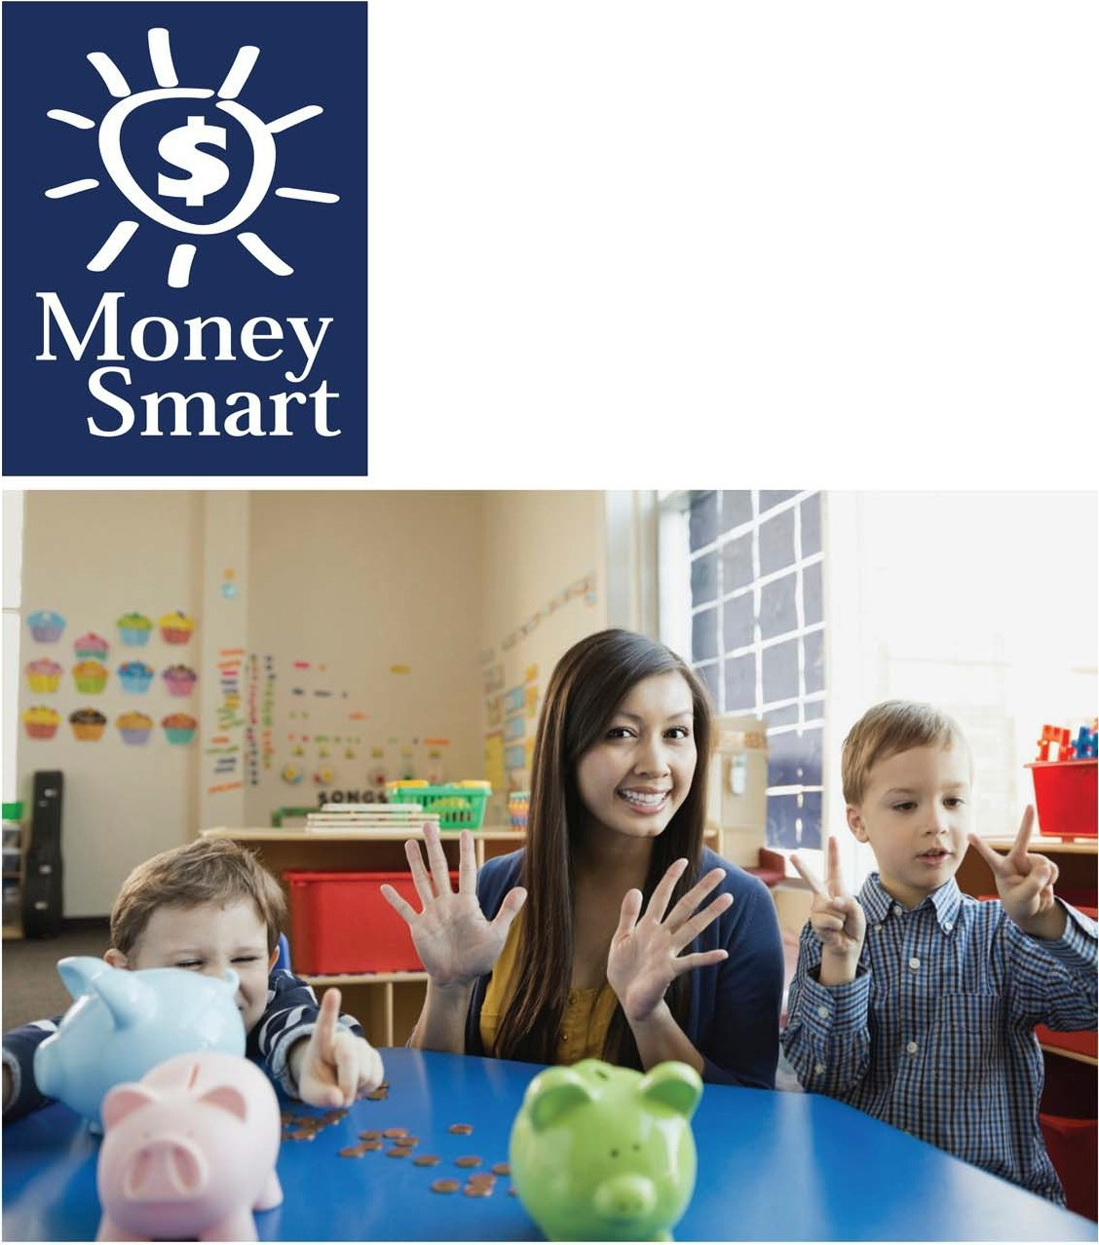
for Grades Pre-K-2

Educator Guide

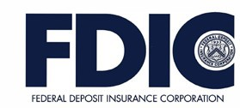

Caution:

Coins are a leading cause of choking-related injury and death for young children, particularly for those aged 3 and under.
FDIC Disclaimer:

The books and online resources referenced in the Educator Guide and Parent/Caregiver Guide are examples/options that may be used to support the subject being taught and should not be considered as an endorsement by the Federal Deposit Insurance Corporation (FDIC). Reference to any specific commercial product, process, or service by trade name, trademark, manufacture, or otherwise does not constitute an endorsement, a recommendation, or a favoring by the FDIC or the United States government.
The FDIC Money Smart curriculum references books and provides links to other websites for convenience and informational purposes only. Users should be aware that when they select a link on the FDIC's website to an external website, they are leaving the FDIC's site. Linked sites are not under the control of the FDIC, and the FDIC is not responsible for the contents of any linked site or any link contained in a linked site, or any changes or updates to such sites. The FDIC is not responsible for any transmission received from a linked site. The inclusion of a link does not imply endorsement by the FDIC of the site, its content, advertisers or sponsors. External sites may contain information that is copyrighted with restrictions on reuse. Permission to use copyrighted materials must be obtained from the original source and cannot be obtained from the FDIC.

TABLE OF CONTENTS
Lesson 5: Super Savers (Saving and Spending) 10
- Student Handout 1: Spending Choices 15
- Student Handout 2: Savings Tips 16
Answer Key 17
Glossary……………………………………………………………………………….….……….19

WELCOME TO MONEY SMART

Welcome to Money Smart, an exciting interactive exploration of the concepts of money. This standards-aligned, cross-curricular program is designed to promote financial understanding in children ages 4 through 8. You can use Money Smart to add engaging and enriching activities to Math, English Language Arts, and Social Studies lessons while also helping your students build the foundation to become financially responsible adults.

In Money Smart you will find:
- Six Lessons with hands-on, cross-curricular activities that engage preschool through second- grade students in discussing and exploring key financial concepts
- Teacher Presentation Slides, which provide helpful visuals, as well as fill-in charts to support the activities in each lesson
- Student Handouts that let students explore the topics covered in each lesson and apply their new knowledge
- A Parent/Caregiver Guide with information about topics and terms being covered in class, conversation starters, online and literary resources, along with activities to try at home and around town

Developing positive financial habits equips students with 21st-century skills and tools that last a lifetime. We hope you and your students enjoy learning about money and its many uses.

We are eager to hear from you about how you use this curriculum. We would like to know what works well and what could be improved to make Money Smart even better. If you have any questions, we would like to help. Please contact us with your comments and questions via e-mail at communityaffairs@fdic.gov.

GETTING STARTED
Money Smart provides a comprehensive, developmentally appropriate program for young students to build an understanding of key financial concepts.
There are many features that help make the Money Smart curriculum engaging, motivating, and easy to use. Each lesson includes learning objectives, essential questions, supplies needed, and preparation required, as well as the following features and components to support easy integration of Money Smart activities into your instructional day.

STANDARDS
Each lesson promotes real-world connections through student-centered learning experiences and aligns to the following education standards and learning outcomes, including Common Core State Standards in mathematics and English Language Arts. The Education Standards Chart identifies which standards are met in each lesson.
- Financial Literacy Jump$tart Standards
- English Language Arts Common Core Standards
- Mathematics Common Core Standards
- National Early Childhood Learning Outcomes (NAEYC, NAECS/SDE, USDOE)
- Partnership for 21st-Century Skills

GRADE LEVEL MODIFICATIONS
Please note the grade level modifications identified throughout lessons to differentiate learning experiences for Pre-K–K and first- through second-grade students. Modifications provide developmentally appropriate activity recommendations and extension opportunities.

PRESENTATION TIME
Each lesson plan includes an estimated time required to teach the lesson. Actual time required will vary from classroom to classroom. The estimation includes instructional time spent on the Warm Up, Guided Exploration, and Wrap Up. Activities may also be taught as several short lessons over a period of days or weeks. Extended Exploration activities are included to extend financial literacy learning opportunities throughout the year and provide easy ways to integrate the topics into various content areas.

ASSESSMENTS
A variety of assessments are integrated throughout each of the six lessons. Assessments are designed to build value, meaning, and context around a topic, while providing teachers with opportunities to evaluate prior student knowledge, and collect evidence of new understandings of lesson concepts and skills. Pre- (formative) and post- (summative) assessments are noted on the first page of each lesson. Assessments include discussions, reflections, questions and answers, reading, writing, and problem-solving exercises. Student handouts are an especially useful form of written assessment.

MONEY SMART FOR GRADES PRE-K–2: EDUCATOR GUIDE 5

LESSON STRUCTURE
Each lesson is designed to include the following:
- Warm Up introduces students to the topic and sparks inquiry.
- Guided Exploration integrates cross-curricular and developmentally appropriate learning activities and assessments while focusing on the key financial literacy learning objectives of the lesson.
- Wrap Up provides a reflection question or activity to review lesson concepts and allow students to demonstrate their understanding.
- Money Smart Tips are provided throughout lessons to offer additional guidance, interesting and relevant financial facts, and additional ideas to help make Money Smart a success in your classroom.
- Extended Exploration activities provide teachers with additional opportunities to extend financial literacy concepts throughout the school year within core and creative content areas including English Language Arts, Math, Social Studies, Technology, and Art. All activities support dynamic classroom groupings throughout the day and can be completed independently, in groups, during “center time,” or in station rotations. Useful resources (such as books, web links, games, or videos) are also included to promote even more student engagement. The books and online resources suggested in this guide are just a few of the many available resources that explore these topics, and are not endorsed by FDIC.
- Student Handouts and Teacher Presentation Slides provide dynamic instructional support. Student handouts create an opportunity for students to apply their knowledge and for teachers to assess their understanding. Teacher presentation slides offer visuals and interactive activities corresponding with each lesson, and can be projected for whole-group activities, or copied for small-group use.
- The Answer Key, Glossary, and the Standards Chart house all of the information needed to check for understanding, define key terms, and check which activities meet specific national education standards. Vocabulary words are bolded in each lesson as they are introduced. The vocabulary words can be used to create flash cards or a classroom Word Bank list. Students can also make their own Word Banks and refer to the lists as needed.

MONEY SMART AT HOME
The Money Smart curriculum includes a helpful Parent/Caregiver Guide that corresponds to the classroom resources. Families of young children may also use it independently of the curriculum. It contains resources, activities, games, and conversation starters on financial literacy topics covered in each lesson. Use the following ideas to encourage parents to use the guide at home:
- Introduce parents to the Money Smart program and share the Parent/Caregiver Guide at the start of the school year.
- Discuss the Money Smart program during parent/teacher conferences, or in monthly parent newsletters home, and emphasize the importance of building healthy financial habits from an early age.

- Hold a Money Smart family night. Play games and have students present short skits about financial concepts they have learned.
- Send student handouts from each lesson home in each child’s homework folder for parents to review and sign.

SMART BUCKS
Additional incentives can be used to promote positive financial behaviors and study habits throughout the Money Smart curriculum and school year. Introduce Smart Bucks to recognize students’ positive financial and classroom behaviors.
Smart Bucks can be earned for the following behaviors:
- Accomplishment of a goal(s)
- Completion of homework
- Exceptional classroom conduct
- Classroom monitoring and keeping the classroom clean and neat
- Participating in discussions or responding to questions
- Excellent group collaboration or individual work
- Completing daily work
- Respectful behavior
As students accumulate Smart Bucks, they may “cash” them in, or “spend” them on prizes, toys, or special activities (extra computer time, free reading time, or game board time, for example) at the end of the week, month, or whenever you normally provide rewards.
Smart Bucks may be tracked using a chart (displaying desired behaviors and goals), stored in a classroom “treasury” box, or in a cash register (if a class “store” is set up), and handed out to students using play money. Provide price tags or stickers on items or activities to be “sold”. The presentation for cashing in Smart Bucks can be as simple or elaborate as you choose.
Aside from being a fun way to reward positive behaviors, Smart Bucks can help foster an application of the financial literacy concepts covered in Money Smart lessons.
With Smart Bucks, students can learn:
- How to identify bills (particularly how much money a given bill is worth)
- Various ways to make certain dollar amounts (for example, two 5s equal a 10-dollar bill, and so on)
- How to practice their counting skills in order to total up a combination of bills earned (you may suggest that students must be able to count their own money to cash in for a prize as an additional incentive)
- The concept of making change
- The value of saving as they choose to save instead of spend, or set a goal to save for a more desired choice

Use Smart Bucks during Money Smart lessons or continue throughout the year.

FINANCIAL LITERACY ALL YEAR LONG
Highlight financial literacy at your school all year long, especially in April, during National Financial Literacy and School Library Month.
- Create bulletin boards or posters with students about financial literacy themes learned in

Money Smart.
- Play games that focus on numeracy skills and financial concepts (such as Monopoly).
- Send home newsletters each week to parents about money skills and financial concepts covered in class.
- Feature children’s literature selections that cover financial literacy concepts in the library or during classroom reading time.

The more students are exposed to financial literacy, and the more opportunity they have to practice applying their new knowledge and understanding of concepts, at school and at home, the more prepared they will be to live Money Smart lives.

LESSONS AT-A-GLANCE

Lesson Title Topic Learning Objectives
Time Required

5 Super Savers
Saving and Spending
- Identify and evaluate saving and spending
- Recognize a bank as a safe place to save
- Create a savings jar or piggy bank
55 min

Answer Key 17
Glossary with key vocabulary 18

LESSON OVERVIEW

Students set out to become super savers in this lesson by creating their own savings banks after exploring engaging storybooks and evaluating the choices characters make around saving and spending. Dig deeper into the exploration of choice and saving throughout the year with a variety of cross-curricular independent and small group activities.
TOPIC: Saving and Spending

TIME REQUIRED: 55 minutes
(excluding Extended Exploration activities)

LEARNING OBJECTIVES:
Students will be able to.
- Identify and evaluate saving and spending
- Recognize a bank as a safe place to save
- Create a savings jar or piggy bank

SUPPLIES:
- Chart paper, pencils, crayons, markers, blank paper, glue sticks
- Empty containers (to decorate as savings banks)
- Art supplies such as stickers or other decorating materials
- Projector (for teacher presentation slides)
- Access to the Internet (optional)
- Suggested books (optional):
  - Alexander Who Used to Be Rich Last Sunday by Judith Viorst
  - Just a Piggy Bank by Gina and Mercer Meyer
  - My Rows and Piles of Coins by Tololwa
M. Mollel
  - Isabel’s Car Wash by Sheila Bair

PREPARATION:
- Make copies of handouts
- Set up projector with presentation slides

STUDENT HANDOUTS:

Spending Choices
- Savings Tips

TEACHER PRESENTATIONSLIDES:

Ways to Use Money
- Story Problems: Super Savers

ESSENTIAL QUESTIONS:
- What is spending?
- What is saving?
- Why should I save?
- How can I save my money?
- Why should I plan my spending?
- How can I plan my spending?

ASSESSMENT ACTIVITIES:
PRE-ASSESSMENT:
- The Uses of Money activity
POST-ASSESSMENT:
- Spending Choices handout
- Race to the Bank handout
- Savings Tips handout

Story Problems: Super Savers slide
- Class Reflection activity

INSTRUCTION STEPS

WARM UP
Teacher Tips:
- Look for grade level modifications throughout this lesson for ways to adapt activities for your students.
- The saving and spending of classroom rewards, such as Smart Bucks (see page 7 for more ideas), offer young students practical experience with these important financial concepts.
- Make time to explore the literature and technology resources mentioned in the guided and extended exploration sections of this lesson.
THE USES OF MONEY [10 MINUTES]
Begin by asking students how many of them have spent, or watched someone spend, money this week. After giving students the opportunity to respond, share the Ways to Use Money slide and discuss the examples shown.
Ask students: Where are some of the places we spend money? Where can we save money?
Record or draw student answers on chart paper.

MONEY SMART TIP!

Students may share examples of seeing money spent through the use of plastic debit cards. This is an opportunity to talk about how using debit/ATM cards takes money from the person’s bank account. Spending coins in video games can also be used as an example.
Even though we are not physically holding the coins, when we buy something in a game, our total number of coins goes down.

GUIDED EXPLORATION
SAVING VERSUS SPENDING [20 MINUTES]
Reflecting on the student responses from the Ways to Use Money slide discussion, share with students that we have many choices when it comes to choosing to spend or save our money. Pass out the Spending Choices student handout.
Ask students to imagine they have three quarters to spend. How much is each quarter worth? How much do they have in total? What would they do with their coins? Would they buy gum? Save their money? Buy a pencil? Students can think back to Lesson 3 as they choose three ways to use their money.

Grade Level Modifications:
Pre-K–K: Model how the images at the bottom of the Spending Choices handout can be cut out and pasted in sequence on the chart. Students can practice using sequential words—first, second, third, and fourth—to describe their prioritization of items. Young students may not be able to add amounts but consider other elements of choices when prioritizing spending; they may also use stickers or magazine images to express and discuss spending choices. The completed handout may be used by students to share a social story at circle time or in a small group activity.
Grades 1–2: Have students work with a partner to discuss their choices, and place their selections on the Spending Choices student handout inpriority order. Students can also add up the items for the total spent. How much money do they have left over?

Optional: Read a story about saving and spending with the class, such as Alexander Who Used to Be Rich Last Sunday by Judith Viorst. While reading the story, the class can stop to predict how the character will spend or save money, as well as what the character might be feeling about his choices.
Possible discussion questions are: What is spending? What did the character spend money on? What is saving? Why should the character have saved his money? How did the character feel about his choices (spending and saving)? If the character had saved his money, would he have been able to make different choices later? (For example: buying a larger item or having money available if he decided he wanted something different.)

FINDING PLACES TO SAVE [20 MINUTES]
Ask students where we can keep our money, protect our money safely, or save it. (Possible answers are piggy bank or bank.)
Explore why we keep money in the bank. Ask students: Why do you (or should you) keep your money in the bank? Some reasons may include:
- Safety. Ask: What happens if someone steals your piggy bank or you lose it? You would be out of money. But money in a bank is safe from theft, loss, and fire. You also do not have to worry if the bank ever closes (goes out of business).

MONEY SMART TIP!

The Federal Deposit Insurance Corporation, or FDIC for short, is a part of the federal government. The FDIC’s biggest job is insuring the savings of millions of Americans in all the FDIC-insured banks across the country. Since the FDIC was established in 1933, no depositor has lost a penny of FDIC-insured funds.

- Ease. When your money is in a bank, you can get money quickly and easily. Ask: What happens if you have an emergency and you need to buy medicine, but you left all of your money at home?
Tell students they need to get their piggy bank that’s full of money to the bank. Next, ask students to think about ways they could save money. After giving students a chance to respond, share that they will have the opportunity to make a personal savings bank for their money and take home a Savings Tips student handout to share ideas with their families for ways they can save.

Grade Level Modifications:

Pre-K–K: Give each student a container to decorate as his or her savings bank. (Plastic peanut butter and jelly jars, coffee canisters, or even tissue boxes can be used.) Containers may be decorated with stickers, markers, construction paper, or tissue paper.
Grades 1–2: Give each student a container to decorate as his or her savings bank. After students have finished decorating their banks, they can write down a reason they have for saving and put it in their bank.

MONEY SMART TIP!

When discussing ways to save money, include both the simple—like putting coins into a piggy bank—and the complex—like shopping for the best deal.

WRAP UP
CLASS REFLECTION [5 MINUTES]
Ask students: What is spending and saving? How can you spend or save your money? Invite them to share their responses. Check for understanding and possibly introduce extended exploration centers for exploring topic further.

EXTENDED EXPLORATION
Note: Use the following activities to extend the lesson topic throughout the year. Activities can be completed as a class, in small groups, or during center time. Duration of activities will vary.

LITERACY CENTER

Possible Book Club or Classroom Library Selections:
Note: Read books with your class that focus on the lesson’s financial literacy topic. Below are suggestions, but you may find other selections in your library that can be used to generate a similar discussion. For pre-literate students, read books aloud.
    - Just a Piggy Bank by Gina and Mercer Meyer: Little Critter is given a piggy bank by his grandfather and learns all about the importance of saving money.
- Discussion Questions: Do you have a piggy bank at home? What do you put in your bank? All of your money? Some of your money? What was the most money you’ve saved?
    - My Rows and Piles of Coins by Tololwa M. Mollel: A boy saves all of his coins to buy something very important. He works and saves to buy the bicycle he needs to help his family cart items to and from the local market.
- Discussion Questions: Have you ever saved your money for anything? What was it? Have you ever seen your mom and dad put money away in their savings?
What is one way saving money could be helpful or important?

    - Isabel’s Car Wash by Sheila Bair: Isabel wants a doll but doesn’t have enough money to buy it. She starts a car wash business with money invested from her friends with hopes to make enough money to buy the doll and pay her friends back.
- Discussion Questions: What is Isabel’s problem? What are some ways she can earn money? How did Isabel come up with the idea to start a car wash? How did she get money to start her business? How much money did Isabel make from her car wash? How much money did her friends earn? What business idea could we start as a class?

Speaking, Listening, and Writing Prompts:
Explore the following prompts through a themed show-and-tell, circle time discussions, partner pair-share discussions, or writing.

Grade Level Modifications:
Pre-K–K: Provide students with a visual or real-world object to support exploration of the prompt. Pre-literate students may discuss pictures and objects while having their stories recorded through modeled or guided writing as a small group or with the class.
- What is something you would like to save money for?
Grades 1–2: Students may explore the following writing prompt by journaling or as independent writing assignments.
- What are some ways you can save money?

MATH CENTER
  - Math Station: Using the materials below, students can explore the following math station activities independently or as part of a small group. These could be used during classroom centers or as a choice for students who finish assignments early.

Grade Level Modifications:
Pre-K–K: Materials: Piggy bank, coins. Instructions: Give students the opportunity to practice “saving” and “spending” coins from a class piggy bank. Students can count the coins as they place them into the bank.
Grades 1–2: Materials: Piggy bank, coins, mixed math fact cards. Instructions: Have students solve the problem on the math card and then place the appropriate value of coins into the piggy bank. Challenge the class to solve enough math fact cards to get all the coins in the bank.
  - Story Problems: Display the Story Problems: Super Savers slide. Problems can be printed or projected, then explored and solved as a whole class, a small collaborative group, or individually. The first problem listed, Challenge 1, is more appropriate for young students. Challenge 2 will provide more difficulty.

Grade Level Modifications:
Pre-K–K: Solve step-by-step problems developing students’ critical thinking and deductive reasoning during circle time or as a small group. Each challenge involves using or creating a visual with students and discussing small steps to solve a problem.
Grades 1–2: Using the provided challenges as inspiration, create personal story problems and exchange them with classmates to solve.

TECHNOLOGY CENTER

Games and Online Activities:
    - Piggy Bank Game: Little ones will click the piggy bank to make coins drop in. When the bank is full, it breaks open and a new item is made available. http://duckiedeck.com/play/piggy-banks
Play with the whole class and talk about what is happening as the piggy bank gets fuller and fuller. The whole group may use the piggy banks they made to add plastic coins and count along with the game.
    - PBS Cyber Chase Money Videos: Students practice mental math skills while exploring saving and spending with these short animated videos. http://pbskids.org/cyberchase/find-it/money/videos/

SPENDING CHOICES

Name:
Imagine you have three quarters. How much money do you have? Look at the items you can buy. Color, then cut and paste the items you are going to buy. What did you choose, and why? How much money do you have left? How much have you saved?

1. | 2. | 3. | 4.

3 Pieces of Gum 15¢ | Snake Rental 25¢ | Apple 11¢ | Yard Sale 20¢

SAVINGS TIPS

Name: Saving money is important. What are some things you can do
to start saving money? Look at, then color the money-saving activities below.

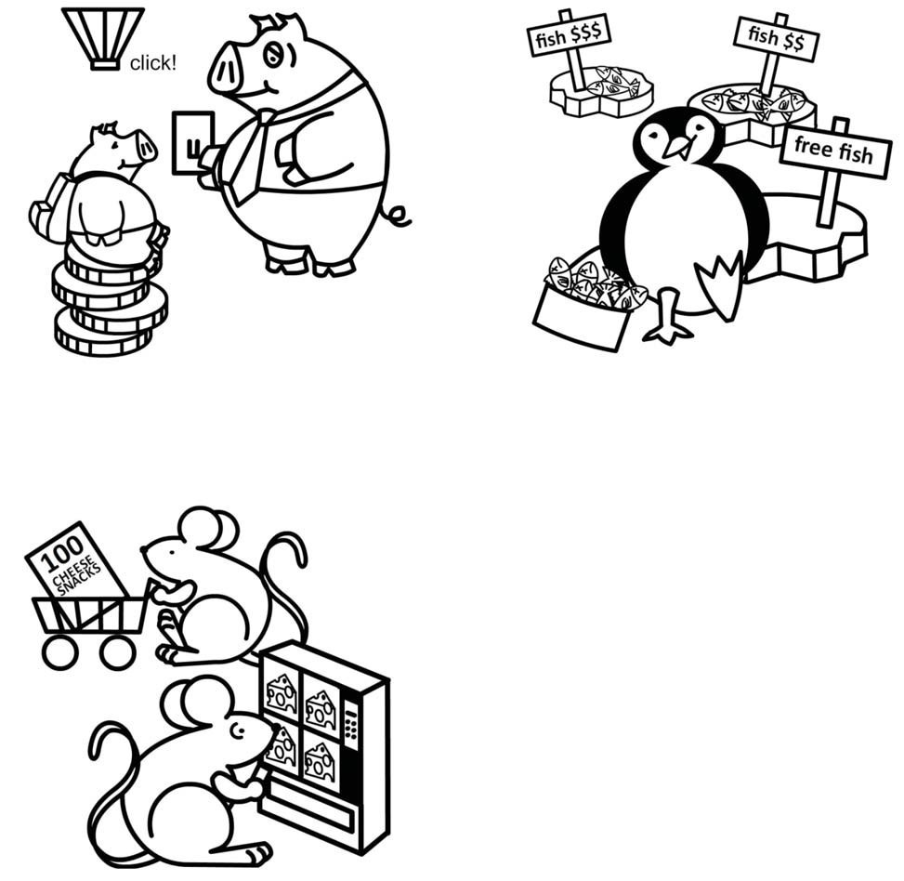
Turn off the lights if you are
not in the room.
Shop around for the best deal.
Buy snacks on sale at the
grocery store instead of buying them from a vending machine.
Can you think of another way to
save money? Draw your own money-saving activity below.

SPENDING CHOICES
Name: Imagine you have three quarters. How much money do you have?
Look at the items you can buy. Color then cut and paste the items you are going to buy. What did you choose and why? How much money do you have left? How much have you saved?

Student answers will vary. Use handout to assess student ability to evaluate wants from needs and understanding of spending versus saving.
1. | 2. | 3. | 4.

3 Pieces of Gum 15¢ | Snake Rental 25¢ | Apple 11¢ | Yard Sale 20¢

Candy = Want Pet = Want Food = Need Toy = Want

SAVINGS TIPS

Name:
Saving money is important. What are some things you can do to start saving money? Look at, then color the money-saving activities below.

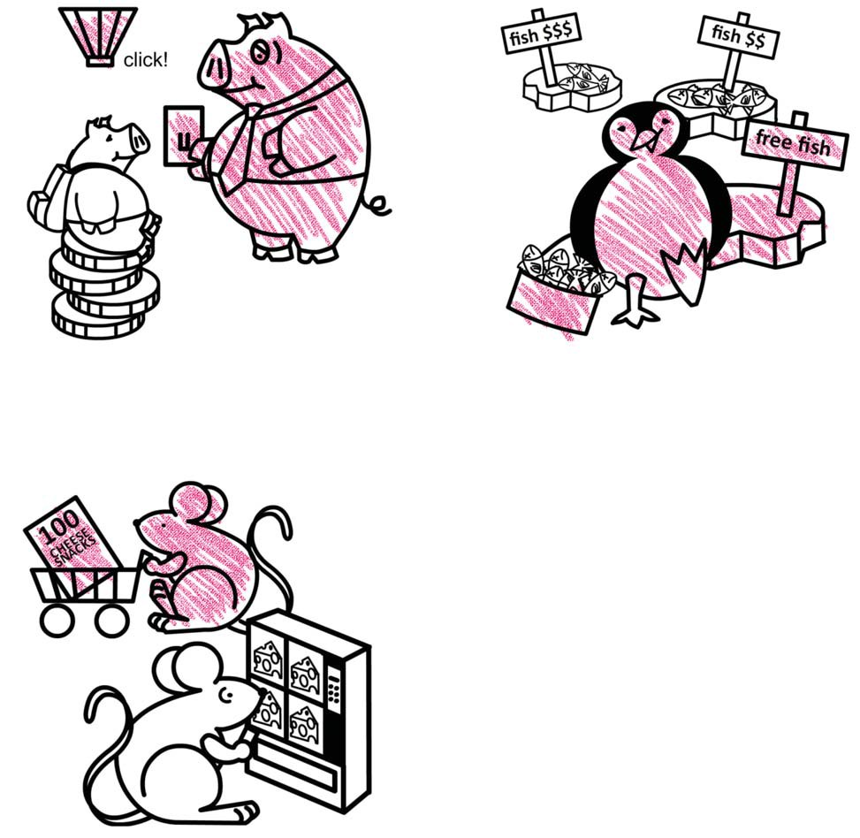
Turn off the lights if you are
not in the room.
Shop around for the best deal.
Buy snacks on sale at the
grocery store instead of buying them from a vending machine.
Can you think of another way to
save money? Draw your own money-saving activity below.

GLOSSARY

Bank: A financial institution and business that accepts deposits and makes loans.

Borrow: To receive something on loan with the understanding that you will return it.

Currency: A form of money that is generally accepted to measure value (banknotes, bills, coins, and so on).

Earn: To receive money in exchange for goods or services

Federal Deposit Insurance Corporation (FDIC): Preserves and promotes public confidence in the U.S. financial system by insuring deposits in banks and thrift institutions for at least $250,000. An independent agency of the federal government, the FDIC was created in1933.

Goal: Something, such as an outcome, you wish to achieve or accomplish in a specific amount of time.

Income: Money that you receive from jobs, gifts, allowances, interest, dividends, and other sources.

Job: A specific duty, task, or activity someone completes using his or her time, skills, and energy to earn money.

Lend: The act of giving something to someone with the understanding that they will give it back to you.

Money: Money is an object you can use to purchase goods and services. Money looks different in different places around the world.

Need: Something you must have to survive, such as clothes, shelter, or food.

Save: Setting something, like money, aside to use in the future.

Spend: The act of using money to buy goods or services.

Want: Something that you would like to have but that you could live without.

