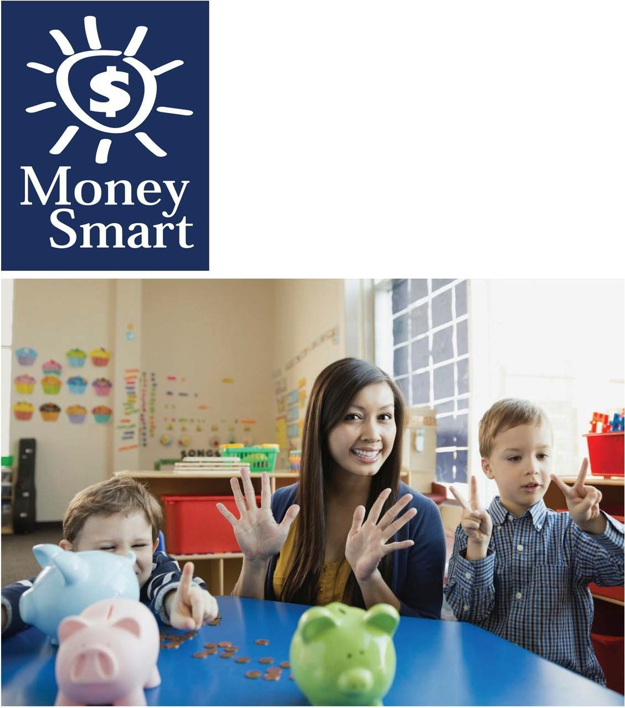
for Grades Pre-K-2

Educator Guide

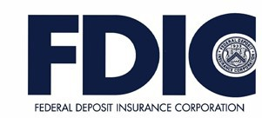

Caution:

Coins are a leading cause of choking-related injury and death for young children, particularly for those aged 3 and under.

FDIC Disclaimer:

The books and online resources referenced in the Educator Guide and Parent/Caregiver Guide are examples/options that may be used to support the subject being taught and should not be considered as an endorsement by the Federal Deposit Insurance Corporation (FDIC). Reference to any specific commercial product, process, or service by trade name, trademark, manufacture, or otherwise does not constitute an endorsement, a recommendation, or a favoring by the FDIC or the United States government.
The FDIC Money Smart curriculum references books and provides links to other websites for convenience and informational purposes only. Users should be aware that when they select a link on the FDIC's website to an external website, they are leaving the FDIC's site. Linked sites are not under the control of the FDIC, and the FDIC is not responsible for the contents of any linked site or any link contained in a linked site, or any changes or updates to such sites. The FDIC is not responsible for any transmission received from a linked site. The inclusion of a link does not imply endorsement by the FDIC of the site, its content, advertisers or sponsors. External sites may contain information that is copyrighted with restrictions on reuse. Permission to use copyrighted materials must be obtained from the original source and cannot be obtained from the FDIC.

TABLE OF CONTENTS
Welcome To Money Smart 4
Getting Started 5
Lessons At-a-Glance 9
Lesson 6: Borrowing Bills (Borrowing and Lending) 10
- Student Handout 1: Ways to Borrow and Share 15
- Student Handout 2: Borrowing Bookmarks 16
Answer Key 17
Glossary 18

WELCOME TO MONEY SMART

Welcome to Money Smart, an exciting interactive exploration of the concepts of money. This standards-aligned, cross-curricular program is designed to promote financial understanding in children ages 4 through 8. You can use Money Smart to add engaging and enriching activities to Math, English Language Arts, and Social Studies lessons while also helping your students build the foundation to become financially responsible adults.

In Money Smart you will find:
- Six Lessons with hands-on, cross-curricular activities that engage preschool through second- grade students in discussing and exploring key financial concepts
- Teacher Presentation Slides, which provide helpful visuals, as well as fill-in charts to support the activities in each lesson
- Student Handouts that let students explore the topics covered in each lesson and apply their new knowledge
- A Parent/Caregiver Guide with information about topics and terms being covered in class, conversation starters, online and literary resources, along with activities to try at home and around town

Developing positive financial habits equips students with 21st-century skills and tools that last a lifetime. We hope you and your students enjoy learning about money and its many uses.

We are eager to hear from you about how you use this curriculum. We would like to know what works well and what could be improved to make Money Smart even better. If you have any questions, we would like to help. Please contact us with your comments and questions via e-mail at communityaffairs@fdic.gov.

GETTING STARTED
Money Smart provides a comprehensive, developmentally appropriate program for young students to build an understanding of key financial concepts.
There are many features that help make the Money Smart curriculum engaging, motivating, and easy to use. Each lesson includes learning objectives, essential questions, supplies needed, and preparation required, as well as the following features and components to support easy integration of Money Smart activities into your instructional day.

STANDARDS
Each lesson promotes real-world connections through student-centered learning experiences and aligns to the following education standards and learning outcomes, including Common Core State Standards in mathematics and English Language Arts. The Education Standards Chart identifies which standards are met in each lesson.
- Financial Literacy Jump$tart Standards
- English Language Arts Common Core Standards
- Mathematics Common Core Standards
- National Early Childhood Learning Outcomes (NAEYC, NAECS/SDE, USDOE)
- Partnership for 21st-Century Skills

GRADE LEVEL MODIFICATIONS
Please note the grade level modifications identified throughout lessons to differentiate learning experiences for Pre-K–K and first- through second-grade students. Modifications provide developmentally appropriate activity recommendations and extension opportunities.

PRESENTATION TIME
Each lesson plan includes an estimated time required to teach the lesson. Actual time required will vary from classroom to classroom. The estimation includes instructional time spent on the Warm Up, Guided Exploration, and Wrap Up. Activities may also be taught as several short lessons over a period of days or weeks. Extended Exploration activities are included to extend financial literacy learning opportunities throughout the year and provide easy ways to integrate the topics into various content areas.

ASSESSMENTS
A variety of assessments are integrated throughout each of the six lessons. Assessments are designed to build value, meaning, and context around a topic, while providing teachers with opportunities to evaluate prior student knowledge, and collect evidence of new understandings of lesson concepts and skills. Pre- (formative) and post- (summative) assessments are noted on the first page of each lesson. Assessments include discussions, reflections, questions and answers, reading, writing, and problem-solving exercises. Student handouts are an especially useful form of written assessment.

MONEY SMART FOR GRADES PRE-K–2: EDUCATOR GUIDE 5

LESSON STRUCTURE
Each lesson is designed to include the following:
- Warm Up introduces students to the topic and sparks inquiry.
- Guided Exploration integrates cross-curricular and developmentally appropriate learning activities and assessments while focusing on the key financial literacy learning objectives of the lesson.
- Wrap Up provides a reflection question or activity to review lesson concepts and allow students to demonstrate their understanding.
- Money Smart Tips are provided throughout lessons to offer additional guidance, interesting and relevant financial facts, and additional ideas to help make Money Smart a success in your classroom.
- Extended Exploration activities provide teachers with additional opportunities to extend financial literacy concepts throughout the school year within core and creative content areas including English Language Arts, Math, Social Studies, Technology, and Art. All activities support dynamic classroom groupings throughout the day and can be completed independently, in groups, during “center time,” or in station rotations. Useful resources (such as books, web links, games, or videos) are also included to promote even more student engagement. The books and online resources suggested in this guide are just a few of the many available resources that explore these topics, and are not endorsed by FDIC.
- Student Handouts and Teacher Presentation Slides provide dynamic instructional support. Student handouts create an opportunity for students to apply their knowledge and for teachers to assess their understanding. Teacher presentation slides offer visuals and interactive activities corresponding with each lesson, and can be projected for whole-group activities, or copied for small-group use.
- The Answer Key, Glossary, and the Standards Chart house all of the information needed to check for understanding, define key terms, and check which activities meet specific national education standards. Vocabulary words are bolded in each lesson as they are introduced. The vocabulary words can be used to create flash cards or a classroom Word Bank list. Students can also make their own Word Banks and refer to the lists as needed.

MONEY SMART AT HOME
The Money Smart curriculum includes a helpful Parent/Caregiver Guide that corresponds to the classroom resources. Families of young children may also use it independently of the curriculum. It contains resources, activities, games, and conversation starters on financial literacy topics covered in each lesson. Use the following ideas to encourage parents to use the guide at home:
- Introduce parents to the Money Smart program and share the Parent/Caregiver Guide at the start of the school year.
- Discuss the Money Smart program during parent/teacher conferences, or in monthly parent newsletters home, and emphasize the importance of building healthy financial habits from an early age.

- Hold a Money Smart family night. Play games and have students present short skits about financial concepts they have learned.
- Send student handouts from each lesson home in each child’s homework folder for parents to review and sign.

SMART BUCKS
Additional incentives can be used to promote positive financial behaviors and study habits throughout the Money Smart curriculum and school year. Introduce Smart Bucks to recognize students’ positive financial and classroom behaviors.
Smart Bucks can be earned for the following behaviors:
- Accomplishment of a goal(s)
- Completion of homework
- Exceptional classroom conduct
- Classroom monitoring and keeping the classroom clean and neat
- Participating in discussions or responding to questions
- Excellent group collaboration or individual work
- Completing daily work
- Respectful behavior
As students accumulate Smart Bucks, they may “cash” them in, or “spend” them on prizes, toys, or special activities (extra computer time, free reading time, or game board time, for example) at the end of the week, month, or whenever you normally provide rewards.
Smart Bucks may be tracked using a chart (displaying desired behaviors and goals), stored in a classroom “treasury” box, or in a cash register (if a class “store” is set up), and handed out to students using play money. Provide price tags or stickers on items or activities to be “sold”. The presentation for cashing in Smart Bucks can be as simple or elaborate as you choose.
Aside from being a fun way to reward positive behaviors, Smart Bucks can help foster an application of the financial literacy concepts covered in Money Smart lessons.
With Smart Bucks, students can learn:
- How to identify bills (particularly how much money a given bill is worth)
- Various ways to make certain dollar amounts (for example, two 5s equal a 10-dollar bill, and so on)
- How to practice their counting skills in order to total up a combination of bills earned (you may suggest that students must be able to count their own money to cash in for a prize as an additional incentive)
- The concept of making change
- The value of saving as they choose to save instead of spend, or set a goal to save for a more desired choice

Use Smart Bucks during Money Smart lessons or continue throughout the year.

FINANCIAL LITERACY ALL YEAR LONG
Highlight financial literacy at your school all year long, especially in April, during National Financial Literacy and School Library Month.
- Create bulletin boards or posters with students about financial literacy themes learned in
Money Smart.
- Play games that focus on numeracy skills and financial concepts (such as Monopoly).
- Send home newsletters each week to parents about money skills and financial concepts covered in class.
- Feature children’s literature selections that cover financial literacy concepts in the library or during classroom reading time.

The more students are exposed to financial literacy, and the more opportunity they have to practice applying their new knowledge and understanding of concepts, at school and at home, the more prepared they will be to live Money Smart lives.

LESSONS AT-A-GLANCE
Lesson Title
Topic
Learning Objectives
Time Required
6
Borrowing
Bills
Borrowing and
Lending
- Describe borrowing and lending
with real-life examples
- Discuss and illustrate ways to borrow responsibly
45 min

Answer Key 17
Glossary with key vocabulary 18

LESSON OVERVIEW

Students explore the benefits and challenges of borrowing by examining how we check out, use, and return books from the library. Students will then examine ways to borrow items responsibly and create their own bookmarks with borrowing tips. Exploring strategies for sharing and responsible use of materials supports students in forming habits for success at school and home. Extend the discussion of sharing (lending) and responsibility (borrowing) throughout the year with a variety of cross- curricular independent and small group activities, including children’s literature, math stations, social studies activities, and more.
TOPIC: Borrowing and Lending

TIME REQUIRED: 45 minutes
(excluding Extended Exploration activities)

LEARNING OBJECTIVES:
Students will be able to.
- Describe borrowing and lending with real- life examples
- Discuss and illustrate ways to borrow responsibly

SUPPLIES:
- Chart paper, pencils, crayons, scissors
- Projector (for teacher presentation slides)
- Access to the Internet (optional)
- Suggested books (optional):
  - Sharing a Shell by Julia Donaldson
  - Benny’s Pennies by Pat Brisson

PREPARATION:
- Make copies of student handouts
- Set up projector with presentationslides

STUDENT HANDOUTS:
- Ways to Borrow and Share
- Borrowing Bookmarks

TEACHER PRESENTATION SLIDES:
- Borrowing Books Responsibly
- Story Problems: Borrowing Bills

ESSENTIAL QUESTIONS:
- What is borrowing?
- What is lending?
- How is lending different from giving?
- How can I be responsible when borrowing?

ASSESSMENT ACTIVITIES:
PRE-ASSESSMENT:
- Introducing Borrowing and Lending
activity
POST-ASSESSMENT:
- Ways to Borrow and Share handout
- Borrowing Bookmarks handout
- Story Problems: Borrowing Bills slide
- Class Reflection activity

INSTRUCTION STEPS

WARM UP
Teacher Tips:
- Look for grade level modifications throughout this lesson for ways to adapt activities for your students.
- Focus on connecting the concepts of borrowing and lending to daily classroom- based expectations. This will provide young students with personal context to build on their foundational understanding of this financial concept.
- Make time to explore the literature and technology resources mentioned in the guided and extended.

INTRODUCING BORROWING AND LENDING
[5 MINUTES]
Begin by asking students whether they can think of a time when they, or someone they knew, borrowed something from someone else. Ask students whether it was nice to be able to use something they didn’t have before. Explain that lending something to a friend or sibling is a nice way to share items. Ask students: How is lending different from giving? Explain that, when you lend someone something, it needs to be returned.

MONEY SMART TIP!

Discussing sharing in connection with responsible borrowing can support students in developing strategies for problem solving with peers.

GUIDED EXPLORATION
WHAT IS BORROWING? [20 MINUTES]
Share two or three children’s book titles where the theme or topic explored includes characters borrowing or lending items. (See suggestions for books in the Extended Exploration activities.)
After sharing information about the books that will be available in class during independent activity time or through the class library, ask students: Where can we borrow books? (The library) Next, ask students: How should we treat books that we borrow? What if we don’t take care of the books we borrow? Are there consequences for not taking care of books we borrow? What should we do when we are done using the books?
Share the Borrowing Books Responsibly slide. Read the list as a class. Circle the scenarios that are good examples of borrowing responsibly. (Possible circled answers are: Take good care of the books, return them when agreed, or Use books like I would want someone to take care of my books.) Cross out the actions that do not reflect responsible borrowing.
After going through the whole list, cross out the word “books” in the title, and then discuss how, when we borrow anything from friends or family, including toys or money, we should consider these strategies. Looking back at the list, write in the word “money” where books appeared, and review the circled strategies for borrowing responsibly. Remind students that, whatever we borrow, we need to return.

MONEY SMART TIP!

Expanding on what it means to be responsible by revisiting classroom rules and procedures supports students in taking an active role in building a caring learning community.

Share the Ways to Borrow and Share handout with students and have them color in the examples of responsible borrowing. Students may also share strategies for responsibly caring for classroom materials. Students can complete the handout to show their understanding of basic borrowing, or the handout can be completed as a class to extend the discussion of ways to borrow responsibly.

BORROWING RESPONSIBLY [15 MINUTES]
Give each student a Borrowing Bookmarks handout. Read the tips for being a responsible borrower on the bookmark as a whole class, and then give students the opportunity to decorate and cut out one bookmark for themselves and one to share. As students decorate their bookmarks, they may discuss other ways they can show sharing, caring, and responsibility in their community.

WRAP UP
CLASS REFLECTION [5 MINUTES]
Ask students: What is important to remember when borrowing from or lending something to a friend? Invite them to share their responses. Check for understanding and possibly introduce extended exploration centers for exploring the topic further.

EXTENDED EXPLORATION
Note: Use the following activities to extend the lesson topic throughout the year. Activities can be completed as a class, in small groups, or during center time. Duration of activities will vary.

LITERACY CENTER

Possible Book Club or Classroom Library Selections:
Note: Read books with your class that focus on the lesson’s financial literacy topic. Below are suggestions, but you may find other selections in your library that can be used to generate a similar discussion. For pre-literate students, read books aloud.
  - One Hen: How One Small Hen Made a Big Difference by Katie Smith: In a remote African village, a family finds out how a small loan and one hen can change their lives. The book includes a section on the microloan system that young learners will be able to understand.
- Discussion Questions: How did one hen make a difference? What did the main character do after he was successful? Have you ever heard a grown-up talk about borrowing money? What did he or she borrow it for?
  - Sharing a Shell by Julia Donaldson: A hermit crab finds the value of friendship and sharing when his new shell comes with unwanted company.
- Discussion Questions: Why did the hermit crab want the shell all to himself? How did the sea creatures work together? How did sharing the shell help the hermit crab and other sea creatures?

  - Benny’s Pennies by Pat Brisson: Benny shares his five shiny pennies by buying special gifts for his family and pets.
- Discussion Questions: What did Benny buy with his five pennies? Who did he give gifts to? How did he feel after spending his money?

Speaking, Listening, and Writing Prompts:
Explore the following prompts through a themed show-and-tell, circle time discussions, partner pair-share discussions, or writing.

Grade Level Modifications:

Pre-K–K: Provide students with a visual or real-world object to support exploration of the prompt. Pre-literate students may discuss pictures and objects while having their stories recorded through modeled or guided writing as a small group or with the class.
- What is something you would like to borrow?

Grades 1–2: Students may explore the following writing prompt by journaling or as independent writing assignments.
- Share a time when you borrowed something from a friend or family member.

MATH CENTER
- Math Station: Using the materials below, students can explore the following math station activities independently or as part of a small group. These could be used during classroom centers or as a choice for students who finish assignments early.

Grade Level Modifications:

Pre-K–K: Borrowing Shapes. Materials: Play dough, straws, and shape templates. Instructions: Form groups of three to four students. Provide each group with either straws or play dough. Provide each child with a shape template. Groups will need to
work with each other to lend and borrow play dough and straws in order to complete their shapes. The straws can be joined using play dough, or simply placed on the shape templates. Emphasize the importance of borrowing and lending materials so that everyone can complete the assignment. Have students share what they needed to borrow and lend.
Grades 1–2: Banker Game. Materials: Play money, dice, multi-base ten blocks, and unit blocks. Instructions: This game may be played in small groups, with one child as the banker. Each group has a die. Use multi-base tens and unit blocks to start, or toy money, dimes, and pennies. Explain that each child will borrow money, or get a loan, from the bank. The objective of the game is to pay the loan back to the bank. Each player will start with a 50-cent loan from the banker, in dimes. Children will take turns throwing the die in order to figure out how much he or she returns to the bank. If a player throws a three, for example, he or she can get rid of three cents. But to do this, he or she has to exchange a dime at the bank. The banker will give seven pennies in change back to the player. The player who gets rid of all her money first is the winner. The game gives students a better grasp of borrowing, lending, and regrouping in subtraction.
- Story Problems: Display the Story Problems: Borrowing Bills slide. Problems can be printed or projected, then explored and solved as a whole class, a small collaborative group, or

individually. The first problem listed, Challenge 1, is more appropriate for young students. Challenge 2 will provide more difficulty.

Grade Level Modifications:

Pre-K–K: Solve step-by-step problems developing students’ critical thinking and deductive reasoning during circle time or as a small group. Each challenge involves using or creating a visual with students and discussing small steps to solve a problem.
Grades 1–2: Using the provided challenges as inspiration, create personal story problems and exchange them with classmates to solve.

TECHNOLOGY CENTER

Games and Online Activities:
  - Learning Coins: Little ones will get to familiarize themselves with coin names and denominations with this fun game. http://www.abcya.com/learning_coins.htm This link can be set up as a practice station or can be used with the whole class.
  - Hands on Banking: Explore saving, spending, and borrowing money by jetting around the financial universe with a friendly alien guide. http://www.handsonbanking.org/htdocs/en/k/

SOCIAL STUDIES CENTER
- Discuss borrowing and sharing as part of creating a classroom community of respect and caring.
- Read one of the literature selections or another title about borrowing. Discuss the benefits of borrowing and sharing within a community.

ARTS & DRAMATIC PLAY CENTER
- Dramatic Play: Explore borrowing and sharing items and money through a variety of class dramatic play areas, including bank or library.
- Sensory Activities: Provide students with plastic cups and a variety of coins. They can play a card-less version of “Go Fish.” Each student places seven coins in his or her cup. The rest of the coins go into a cup in the middle. Students take turns asking peers whether they have a specific coin in their cup. If the student gets the coin he or she asks for, the coins are set aside as a pair and the student goes again. If he or she does not get the requested coin, he or she “goes fish” in the middle cup for a new coin.

WAYS TO BORROW AND SHARE

Name:

Color in the examples of how we should treat things that we borrow or share.

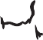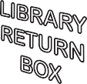

BORROWING BOOKMARKS

Name:

Color and cut out along the dotted lines. Share one bookmark with a friend.
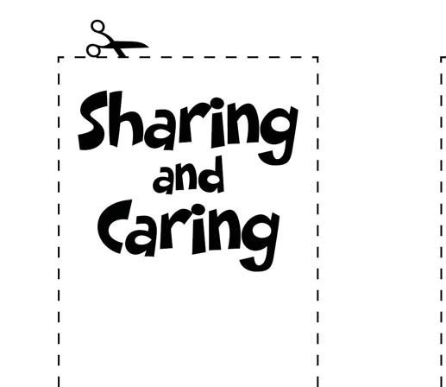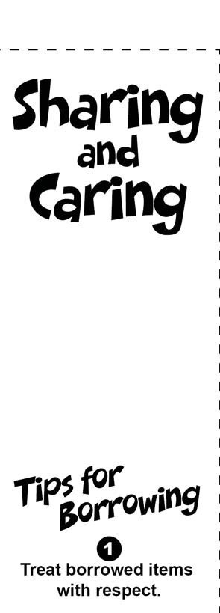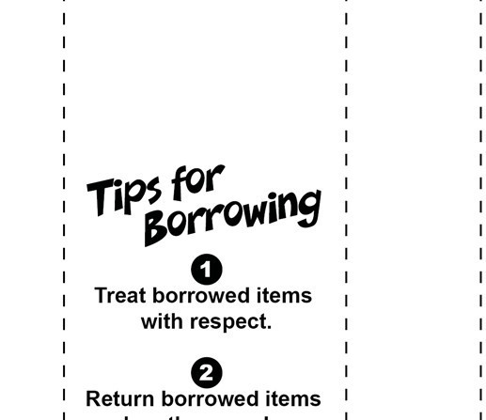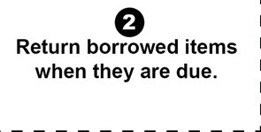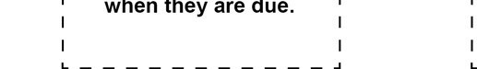

WAYS TO BORROW AND SHARE

Name:

Color in the examples of how we should treat things that we borrow or share.

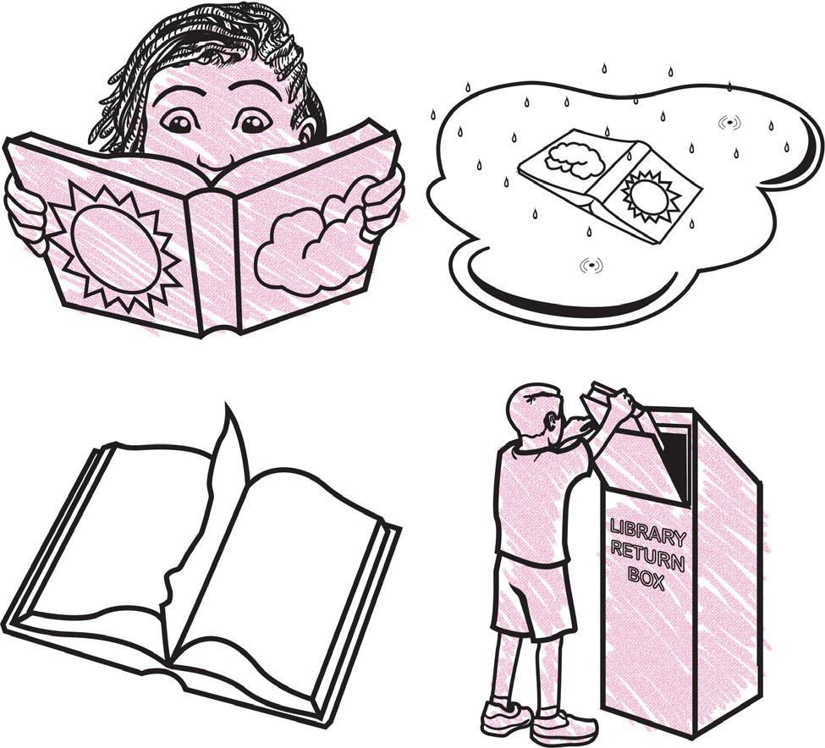

GLOSSARY

Bank: A financial institution and business that accepts deposits and makes loans.

Borrow: To receive something on loan with the understanding that you will return it.

Currency: A form of money that is generally accepted to measure value (banknotes, bills, coins, and so on).

Earn: To receive money in exchange for goods or services

Federal Deposit Insurance Corporation (FDIC): Preserves and promotes public confidence in the U.S. financial system by insuring deposits in banks and thrift institutions for at least $250,000. An independent agency of the federal government, the FDIC was created in 1933.

Goal: Something, such as an outcome, you wish to achieve or accomplish in a specific amount of time.

Income: Money that you receive from jobs, gifts, allowances, interest, dividends, and other sources.

Job: A specific duty, task, or activity someone completes using his or her time, skills, and energy to earn money.

Lend: The act of giving something to someone with the understanding that they will give it back to you.

Money: Money is an object you can use to purchase goods and services. Money looks different in different places around the world.

Need: Something you must have to survive, such as clothes, shelter, or food.

Save: Setting something, like money, aside to use in the future.

Spend: The act of using money to buy goods or services.

Want: Something that you would like to have but that you could live without.

