for Grades Pre-K-2

Educator Guide

Caution:

Coins are a leading cause of choking-related injury and death for young children, particularly for those aged 3 and under.

FDIC Disclaimer:

The books and online resources referenced in the Educator Guide and Parent/Caregiver Guide are examples/options that may be used to support the subject being taught and should not be considered as an endorsement by the Federal Deposit Insurance Corporation (FDIC). Reference to any specific commercial product, process, or service by trade name, trademark, manufacture, or otherwise does not constitute an endorsement, a recommendation, or a favoring by the FDIC or the United States government.
The FDIC Money Smart curriculum references books and provides links to other websites for convenience and informational purposes only. Users should be aware that when they select a link on the FDIC's website to an external website, they are leaving the FDIC's site. Linked sites are not under the control of the FDIC, and the FDIC is not responsible for the contents of any linked site or any link contained in a linked site, or any changes or updates to such sites. The FDIC is not responsible for any transmission received from a linked site. The inclusion of a link does not imply endorsement by the FDIC of the site, its content, advertisers or sponsors. External sites may contain information that is copyrighted with restrictions on reuse. Permission to use copyrighted materials must be obtained from the original source and cannot be obtained from the FDIC.

TABLE OF CONTENTS
Welcome To Money Smart 4
Getting Started 5
Lessons At-a-Glance 9
Lesson 3: Weighing Needs and Wants (Needs and Wants) 10
- Student Handout 1: Needs and Wants 15
- Student Handout 2: My Needs and Wants Mini-Book 16
Glossary 18

WELCOME TO MONEY SMART

Welcome to Money Smart, an exciting interactive exploration of the concepts of money. This standards-aligned, cross-curricular program is designed to promote financial understanding in children ages 4 through 8. You can use Money Smart to add engaging and enriching activities to Math, English Language Arts, and Social Studies lessons while also helping your students build the foundation to become financially responsible adults.

In Money Smart you will find:
- Six Lessons with hands-on, cross-curricular activities that engage preschool through second- grade students in discussing and exploring key financial concepts
- Teacher Presentation Slides, which provide helpful visuals, as well as fill-in charts to support the activities in each lesson
- Student Handouts that let students explore the topics covered in each lesson and apply their new knowledge
- A Parent/Caregiver Guide with information about topics and terms being covered in class, conversation starters, online and literary resources, along with activities to try at home and around town

Developing positive financial habits equips students with 21st-century skills and tools that last a lifetime. We hope you and your students enjoy learning about money and its many uses.

We are eager to hear from you about how you use this curriculum. We would like to know what works well and what could be improved to make Money Smart even better. If you have any questions, we would like to help. Please contact us with your comments and questions via e-mail at communityaffairs@fdic.gov.

GETTING STARTED
Money Smart provides a comprehensive, developmentally appropriate program for young students to build an understanding of key financialconcepts.
There are many features that help make the Money Smart curriculum engaging, motivating, and easy to use. Each lesson includes learning objectives, essential questions, supplies needed, and preparation required, as well as the following features and components to support easy integration of Money Smart activities into your instructional day.

STANDARDS
Each lesson promotes real-world connections through student-centered learning experiences and aligns to the following education standards and learning outcomes, including Common Core State Standards in mathematics and English Language Arts. The Education Standards Chart identifies which standards are met in each lesson.
- Financial Literacy Jump$tart Standards
- English Language Arts Common Core Standards
- Mathematics Common CoreStandards
- National Early Childhood Learning Outcomes (NAEYC, NAECS/SDE, USDOE)
- Partnership for 21st-Century Skills

GRADE LEVEL MODIFICATIONS
Please note the grade level modifications identified throughout lessons to differentiate learning experiences for Pre-K–K and first- through second-grade students. Modifications provide developmentally appropriate activity recommendations and extension opportunities.

PRESENTATION TIME
Each lesson plan includes an estimated time required to teach the lesson. Actual time required will vary from classroom to classroom. The estimation includes instructional time spent on the Warm Up, Guided Exploration, and Wrap Up. Activities may also be taught as several short lessons over a period of days or weeks. Extended Exploration activities are included to extend financial literacy learning opportunities throughout the year and provide easy ways to integrate the topics into various content areas.

ASSESSMENTS
A variety of assessments are integrated throughout each of the six lessons. Assessments are designed to build value, meaning, and context around a topic, while providing teachers with opportunities to evaluate prior student knowledge, and collect evidence of new understandings of lesson concepts and skills. Pre- (formative) and post- (summative) assessments are noted on the first page of each lesson. Assessments include discussions, reflections, questions and answers, reading, writing, and problem-solving exercises. Student handouts are an especially useful form of written assessment.

MONEY SMART FOR GRADES PRE-K–2: EDUCATOR GUIDE 5

LESSON STRUCTURE
Each lesson is designed to include the following:
- Warm Up introduces students to the topic and sparks inquiry.
- Guided Exploration integrates cross-curricular and developmentally appropriate learning activities and assessments while focusing on the key financial literacy learning objectives of the lesson.
- Wrap Up provides a reflection question or activity to review lesson concepts and allow students to demonstrate their understanding.
- Money Smart Tips are provided throughout lessons to offer additional guidance, interesting and relevant financial facts, and additional ideas to help make Money Smart a success in your classroom.
- Extended Exploration activities provide teachers with additional opportunities to extend financial literacy concepts throughout the school year within core and creative content areas including English Language Arts, Math, Social Studies, Technology, and Art. All activities support dynamic classroom groupings throughout the day and can be completed independently, in groups, during “center time,” or in station rotations. Useful resources (such as books, web links, games, or videos) are also included to promote even more student engagement. The books and online resources suggested in this guide are just a few of the many available resources that explore these topics, and are not endorsed by FDIC.
- Student Handouts and Teacher Presentation Slides provide dynamic instructional support. Student handouts create an opportunity for students to apply their knowledge and for teachers to assess their understanding. Teacher presentation slides offer visuals and interactive activities corresponding with each lesson, and can be projected for whole-group activities, or copied for small-group use.
- The Answer Key, Glossary, and the Standards Chart house all of the information needed to check for understanding, define key terms, and check which activities meet specific national education standards. Vocabulary words are bolded in each lesson as they are introduced. The vocabulary words can be used to create flash cards or a classroom Word Bank list. Students can also make their own Word Banks and refer to the lists as needed.

MONEY SMART AT HOME
The Money Smart curriculum includes a helpful Parent/Caregiver Guide that corresponds to the classroom resources. Families of young children may also use it independently of the curriculum. It contains resources, activities, games, and conversation starters on financial literacy topics covered in each lesson. Use the following ideas to encourage parents to use the guide at home:
- Introduce parents to the Money Smart program and share the Parent/Caregiver Guide at the start of the school year.
- Discuss the Money Smart program during parent/teacher conferences, or in monthly parent newsletters home, and emphasize the importance of building healthy financial habits from an early age.

- Hold a Money Smart family night. Play games and have students present short skits about financial concepts they havelearned.
- Send student handouts from each lesson home in each child’s homework folder for parents to review and sign.

SMART BUCKS
Additional incentives can be used to promote positive financial behaviors and study habits throughout the Money Smart curriculum and school year. Introduce Smart Bucks to recognize students’ positive financial and classroom behaviors.
Smart Bucks can be earned for the following behaviors:
- Accomplishment of a goal(s)
- Completion of homework
- Exceptional classroom conduct
- Classroom monitoring and keeping the classroom clean and neat
- Participating in discussions or responding to questions
- Excellent group collaboration or individual work
- Completing daily work
- Respectful behavior
As students accumulate Smart Bucks, they may “cash” them in, or “spend” them on prizes, toys, or special activities (extra computer time, free reading time, or game board time, for example) at the end of the week, month, or whenever you normally provide rewards.
Smart Bucks may be tracked using a chart (displaying desired behaviors and goals), stored in a classroom “treasury” box, or in a cash register (if a class “store” is set up), and handed out to students using play money. Provide price tags or stickers on items or activities to be “sold”. The presentation for cashing in Smart Bucks can be as simple or elaborate as you choose.
Aside from being a fun way to reward positive behaviors, Smart Bucks can help foster an application of the financial literacy concepts covered in Money Smart lessons.
With Smart Bucks, students can learn:
- How to identify bills (particularly how much money a given bill is worth)
- Various ways to make certain dollar amounts (for example, two 5s equal a 10-dollar bill, and so on)
- How to practice their counting skills in order to total up a combination of bills earned (you may suggest that students must be able to count their own money to cash in for a prize as an additional incentive)
- The concept of making change
- The value of saving as they choose to save instead of spend, or set a goal to save for a more desired choice

Use Smart Bucks during Money Smart lessons or continue throughout the year.

FINANCIAL LITERACY ALL YEAR LONG
Highlight financial literacy at your school all year long, especially in April, during National Financial Literacy and School Library Month.
- Create bulletin boards or posters with students about financial literacy themes learned in

Money Smart.
- Play games that focus on numeracy skills and financial concepts (such as Monopoly).
- Send home newsletters each week to parents about money skills and financial concepts covered in class.
- Feature children’s literature selections that cover financial literacy concepts in the library or during classroom reading time.

The more students are exposed to financial literacy, and the more opportunity they have to practice applying their new knowledge and understanding of concepts, at school and at home, the more prepared they will be to live Money Smart lives.

LESSONS AT-A-GLANCE
Lesson Title
Topic
Learning Objectives
Time Required
3 Weighing
Needs and Wants
- Define needs andwants
- Differentiate between needs and wants
- Compare and prioritize needs and wants
45 min

Glossary with key vocabulary 18

LESSON OVERVIEW

Dig into the difference between needs and wants in this lesson with engaging storybooks and math activities. Students will think critically to differentiate between and prioritize needs and wants as they sort, craft mini-books, and collaborate on class games. A variety of independent and small group activities are provided to extend students’ exploration of needs and wants throughout the school year.
TOPIC: Needs and Wants

TIME REQUIRED: 45 minutes
(excluding Extended Exploration activities)

LEARNING OBJECTIVES:
Students will be able to.
- Define needs and wants
- Differentiate between needs and wants
- Compare and prioritize needs and wants

SUPPLIES:
- Chart paper, markers, pencils, crayons
- Projector (for teacher presentation slides)
- Access to the Internet (optional)
- Suggested books (optional):
  - Lily Learns About Wants and Needs by Lisa Bullard (Pre-K–2)
  - If You Give a Mouse a Cookie by Laura Numeroff (grades 1–2)
  - Bunny Money by Rosemary Wells (Pre- K–2)
  - Sam and the Lucky Money by Karen Chinn
  - Almost Zero by Nikki Grimes

PREPARATION:
- Make copies of handouts
- Set up projector with presentation slides

STUDENT HANDOUTS:

Needs and Wants
- My Needs and Wants Mini-Book

TEACHER PRESENTATION SLIDES:

Definitions: Needs and Wants
- Chart: Needs and Wants
- Story Problems: Weighing Needs and Wants

ESSENTIAL QUESTIONS:
- What are needs and wants?
- How do I choose between my needs and wants?

ASSESSMENT ACTIVITIES:
PRE-ASSESSMENT:
- What Are Needs and Wants? activity
POST-ASSESSMENT:
- Needs and Wants handout

My Needs and Wants Mini-Book handout
- Story Problems: Weighing Needs and Wants slide
- Class Reflection activity

INSTRUCTION STEP
Teacher Tips:
- Look for
modifications
grade level
throughout this
lesson for ways to adapt activities
for your students.
- Focus on the concept of needs and wants. Connect this concept to daily classroom activities. Give students time to practice prioritizing needs and wants.
- Make time to explore the literature and technology resources mentioned in the guided and extended exploration sections

WARM UP

WHAT ARE NEEDS AND WANTS?
[10 MINUTES]
Begin by sharing the Definitions: Needs and Wants and Chart: Needs and Wants slides. Read the definition of a need and want and look at the example items in each category. Use the slides to create a class chart or, alternatively, create a T-Chart on poster or chart paper.
As a class, title one side “Things we need for our classroom” (for example: pencils, paper, desks), and title the other side “Things we want for our classroom” (for example: markers, stickers, toys).
Share with students that a need is something we must have to successfully complete our school day. A want is
something that would be nice to have. Ask students to look around the room and see if they can spy one item that would fit into each category. Record students’ responses on the chart.

MONEY SMART TIP!

After discussing classroom needs and wants, it can be helpful to discuss with students strategies for making sure everyone has the supplies he or she needs and that classroom materials are well cared for.

GUIDED EXPLORATION
THE DIFFERENCE BETWEEN NEEDS AND WANTS [20 MINUTES]
Facilitate a deeper discussion about needs and wants through the exploration of picture books. Begin by introducing a related story. Two possible selections include: Lily Learns About Wants and Needs by Lisa Bullard (Pre-K–2) and If You Give a Mouse a Cookie by Laura Numeroff (Grades 1–2). After introducing the book selection, ask students to guess or predict what the main characters may need in the story and what they want.
Ask students whether it is always possible to get what we want. Share that sometimes we may need to choose between our needs and wants, or even choose between two things we want. Discuss as a group what choices the characters in the story made. As a whole class, reflect on three items the main character in the story wanted. Ask students: How would you decide between the choices if you were the main character? Which would be your first, second, or third choice? What affected your choices and prioritization?
After discussing the story, have students practice sorting needs by completing the Needs and Wants
handout.

Grade Level Modifications:

Pre-K–K: Students may match each item to needs or wants as a whole group and then color the activity sheet.
Grades 1–2: Students may extend the activity sheet by numbering the three wants pictured to assign their personal rank.

PRIORITIZING NEEDS AND WANTS [10 MINUTES]
Ask students to imagine someone who is going shopping for school supplies. Ask: What items might she need to buy? What things might she want but not need for school? Discuss how a student might make choices on the shopping trip.
Introduce the My Needs and Wants Mini-Book handout. Read the mini-book pages aloud and model how to complete each page and assemble the book.

Grade Level Modifications:

Pre-K–K: Assist children by cutting out the pages of their books beforehand and then assembling their books for them. They may draw or paste pictures on pages instead of writing. Students may complete the My Needs and Wants Mini-Book by using stickers or magazine images or drawing pictures of items they need and want instead of writing the words. The mini-book can also be completed as a whole class at circle time, modeling reading the pages, coloring needs, and circling wants, and creating a list of class wants and needs. Individual copies can then be sent home for families to create.
Grades 1–2: Students may add an estimated cost for the items they choose as needs and wants.

WRAP UP
CLASS REFLECTION [5 MINUTES]
Ask students: What are needs and wants? How do you choose between things you need and want? Invite them to share their responses. Check for understanding and possibly introduce free exploration centers for exploring the topic further.

EXTENDED EXPLORATION
Note: Use the following activities to extend the lesson topic throughout the year. Activities can be completed as a class, in small groups, or during center time. Duration of activities will vary.

LITERACY CENTER

Possible Book Club or Classroom Library Selections:
Note: Read books with your class that focus on the lesson’s financial literacy topic. Below are suggestions, but you may find other selections in your library that can be used to generate a similar discussion. For pre-literate students, read books aloud.

  - Pre-K–K: Bunny Money by Rosemary Wells: Max and Ruby are on a mission to find the best birthday present for their grandma. But, when emergencies arise, they have to spend their carefully saved money.
- Discussion Questions: Do Max and Ruby need to buy their grandma a birthday present? List some of the items Max and Ruby needed to buy and some things they wanted to buy. If you didn’t have any money to buy a present, what could you do instead?
  - Sam and the Lucky Money by Karen Chinn: Sam is now old enough to spend his lucky Chinese New Year money any way he wants, but Sam doesn’t have enough money. Sam learns lessons in making choices and spending money, and discovers that there are some things money can’t buy.
- Discussion Questions: What would you buy if you were given an envelope full of money? Have you ever had a money gift and had to choose how to spend it? What would you most want to buy? What is one thing you think you would need to buy?
  - Almost Zero by Nikki Grimes: Dyamonde is a little girl who really wants a pair of red high-top sneakers, but they are so expensive! Dyamonde’s mom teaches her all about wants, needs, and making wise money choices.
- Discussion Questions: Have you ever wanted something as much as Dyamonde wants her red shoes? How do you choose between a want and a need?

Speaking, Listening, and Writing Prompts:
Explore the following prompts through a themed show-and-tell, circle time discussions, partner pair-share discussions, or writing.

Grade Level Modifications:

Pre-K–K: Provide students with a visual or real world object to support exploration of the prompt. Pre-literate students may discuss pictures and objects while having their stories recorded through modeled or guided writing as a small group or with the class.
- What is something you need for your classroom or room at home?
- What is something you want for your classroom or room at home?

Grades 1–2: Students may explore the following writing prompts by journaling or as independent writing assignments.
- What are three things you want and three things you need?
- If you can only get one of the items you want, how will you decide which to choose?

MATH CENTER
- Math Station: Using the materials below, students can explore the following math station activities independently or as part of a small group. These could be used during classroom centers or as a choice for students who finish assignments early.

Grade Level Modifications:

Pre-K–K: Materials: Two large bags (one labeled “Needs,” one labeled “Wants”), a large box of items or images to represent needs and wants, words, or sentence frames.
Instructions: Have students sort objects into two piles: one for needs and one for wants. Place the bags and items for sorting out. The children will rummage through the box and

place needs in the “Needs” bag and wants in the “Wants” bag. To develop early writing skills, the students may trace or copy the name of a need and a want, or a simple sentence, and turn it in to show they have completed the task.
Grades 1–2: Materials: Poster board or large paper, glue, markers, scissors, and magazines. Instructions: Have students draw a line down the middle of their papers. On one side have them write “Needs” and on the other have them write “Wants.” Children will cut out and glue pictures of needs and wants on their posters.
At the bottom of their poster, have students create a number sentence Needs +
Wants = Total.
- Story Problems: Display the Story Problems: Weighing Needs and Wants slide. Problems can be printed or projected then explored and solved as a whole class, a small collaborative group, or individually. The first problem listed, Challenge 1, is more appropriate for young students. Challenge 2 will provide more difficulty.

Grade Level Modifications:
Pre-K–K: Solve step-by-step problems developing students’ critical thinking and deductive reasoning during circle time or as a small group. Each challenge involves using or creating a visual with students and discussing small steps to solve a problem.
Grades 1–2: Using the provided challenges as inspiration create personal story problems and exchange them with classmates to solve.

TECHNOLOGY CENTER

Games and Online Activities:
  - 3-2-1 Snack! Everyone needs to eat. Help cat get his snacks by finding the right amount of food and counting some crazy chickens. The game can be used to reinforce the concept of needs as well as basic counting and number skills. Set up the game and have learners rotate through the station in teams of two.

http://pbskids.org/peg/games/3-2-1-snack
  - Econ Ed Link: The Perfect Pet: Decide between needs and wants for a virtual pet.

http://www.econedlink.org/interactives/index.php?iid=247&type=educator

SOCIAL STUDIES CENTER
- A class store can be created to sell items at the school, or can be organized for students within the class to shop with class tokens, tickets, or other classroom currency.
- When preparing to celebrate holidays and birthdays, students can discuss needs and wants while exploring thoughts in the decision-making process.

ARTS & DRAMATIC PLAY CENTER
- Dramatic Play: Students can explore needs and wants through a range of dramatic play themes such as a grocery store or shopping center.
- Art Project: Provide grocery store advertisements for students to circle needs and highlight wants.

NEEDS AND WANTS

Name:

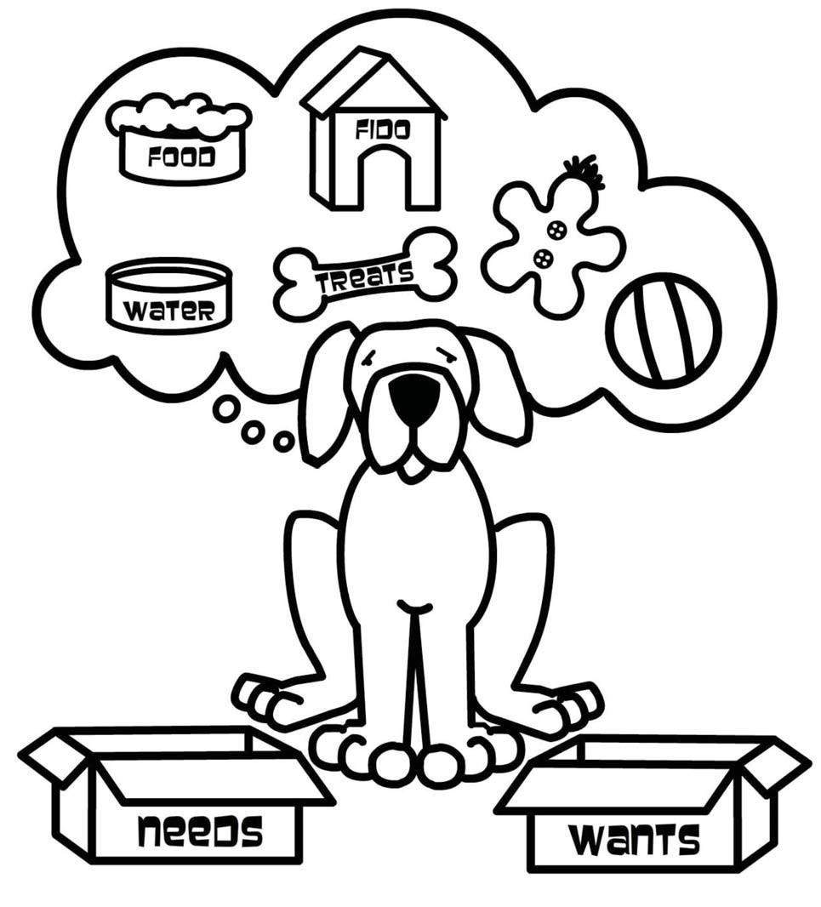
Fido has a list of things he needs and wants. Help him choose what a need is and what a want is. Draw a line from each item to the correct box.

MY NEEDS AND WANTS MINI-BOOK

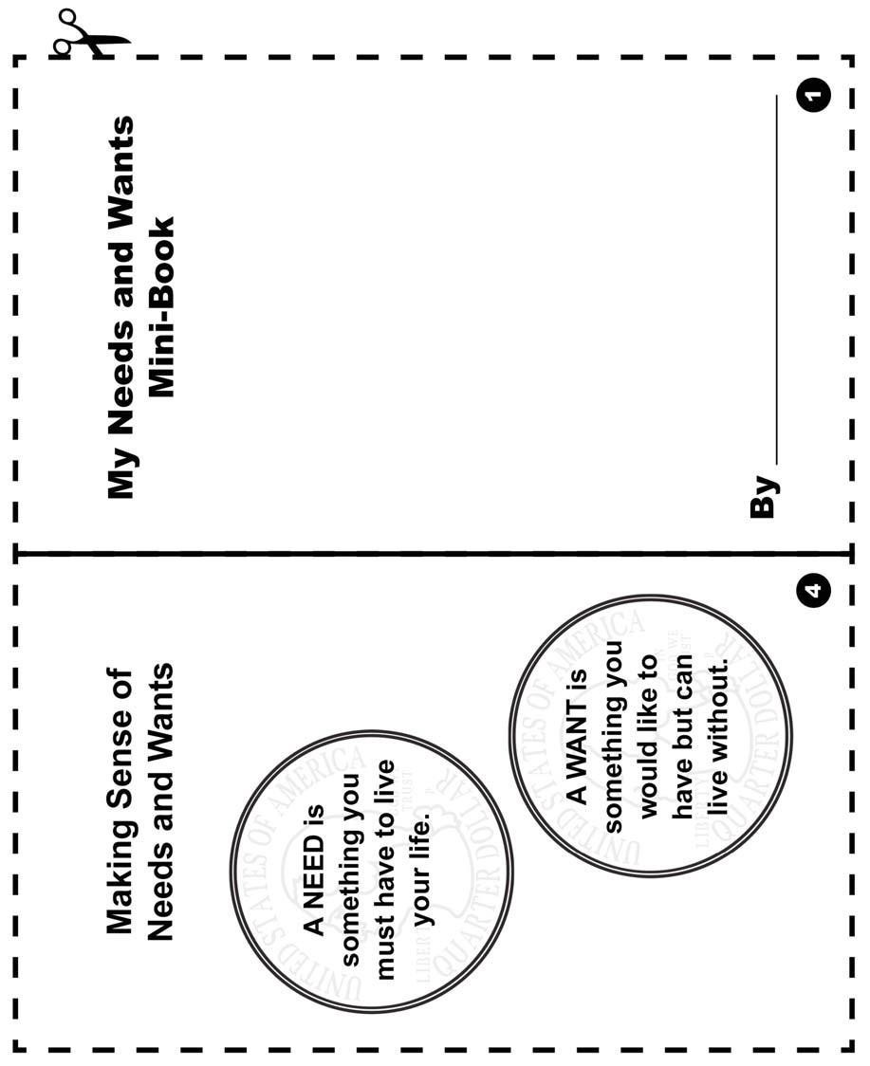
Color and cut out the pages along the dotted lines, then fold them to make your mini-book. Write or draw pictures of your answers on each page.

MY NEEDS AND WANTS MINI-BOOK (continued)

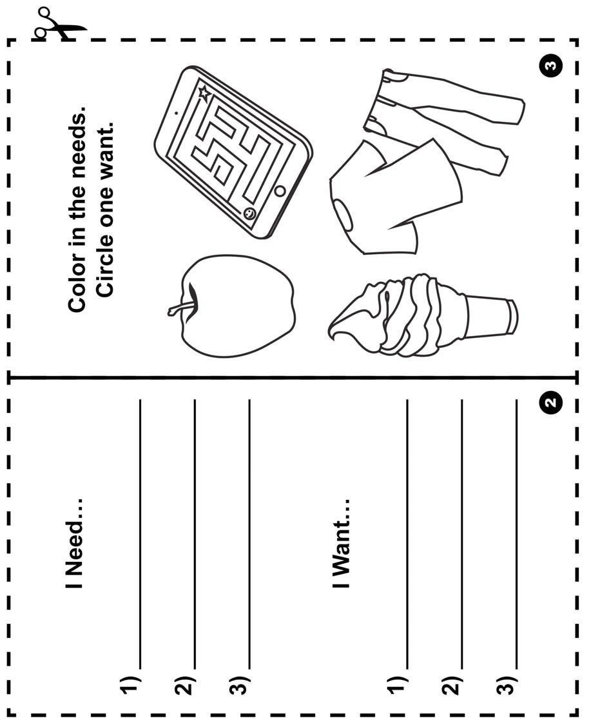

GLOSSARY

Bank: A financial institution and business that accepts deposits and makes loans.

Borrow: To receive something on loan with the understanding that you will return it.

Currency: A form of money that is generally accepted to measure value (banknotes, bills, coins, and so on).

Earn: To receive money in exchange for goods or services

Federal Deposit Insurance Corporation (FDIC): Preserves and promotes public confidence in the U.S. financial system by insuring deposits in banks and thrift institutions for at least $250,000. An independent agency of the federal government, the FDIC was created in 1933.

Goal: Something, such as an outcome, you wish to achieve or accomplish in a specific amount of time.

Income: Money that you receive from jobs, gifts, allowances, interest, dividends, and other sources.

Job: A specific duty, task, or activity someone completes using his or her time, skills, and energy to earn money.

Lend: The act of giving something to someone with the understanding that they will give it back to you.

Money: Money is an object you can use to purchase goods and services. Money looks different in different places around the world.

Need: Something you must have to survive, such as clothes, shelter, or food.

Save: Setting something, like money, aside to use in the future.

Spend: The act of using money to buy goods or services.

Want: Something that you would like to have but that you could live without.

