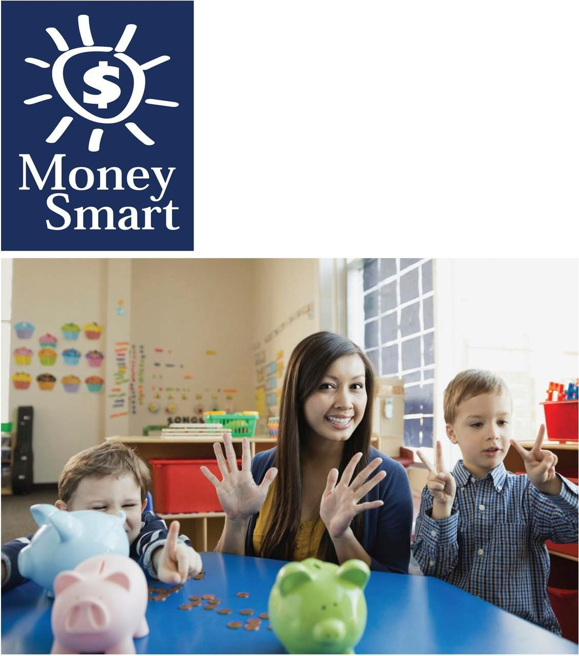**for Grades Pre-K-2**

**Educator Guide**





**Caution:**

**Coins are a leading cause of choking-related injury and death for young children, particularly for those aged 3 and under.**



**FDIC Disclaimer:**

The books and online resources referenced in the Educator Guide and Parent/Caregiver Guide are examples/options that may be used to support the subject being taught and should not be considered as an endorsement by the Federal Deposit Insurance Corporation (FDIC). Reference to any specific commercial product, process, or service by trade name, trademark, manufacture, or otherwise does not constitute an endorsement, a recommendation, or a favoring by the FDIC or the United States government.

The FDIC ***Money Smart*** curriculum references books and provides links to other websites for convenience and informational purposes only. Users should be aware that when they select a link on the FDIC's website to an external website, they are leaving the FDIC's site. Linked sites are not under the control of the FDIC, and the FDIC is not responsible for the contents of any linked site or any link contained in a linked site, or any changes or updates to such sites. The FDIC is not responsible for any transmission received from a linked site. The inclusion of a link does not imply endorsement by the FDIC of the site, its content, advertisers or sponsors. External sites may contain information that is copyrighted with restrictions on reuse. Permission to use copyrighted materials must be obtained from the original source and cannot be obtained from the FDIC.



**TABLE OF CONTENTS**

Welcome To Money Smart 4

Getting Started 5

Lessons At-a-Glance 9

Lesson 2: Learn to Earn (Earning Money) 10

* Student Handout 1: What I Want to be When I Grow Up 15
* Student Handout 2: Jobs and Action Words 16

Glossary 17

## WELCOME TO MONEY SMART

Welcome to ***Money Smart***, an exciting interactive exploration of the concepts of money. This standards-aligned, cross-curricular program is designed to promote financial understanding in children ages 4 through 8. You can use ***Money Smart*** to add engaging and enriching activities to Math, English Language Arts, and Social Studies lessons while also helping your students build the foundation to become financially responsible adults.

In ***Money Smart*** you will find:

* **Six Lessons** with hands-on, cross-curricular activities that engage preschool through second- grade students in discussing and exploring key financial concepts
* **Teacher Presentation Slides,** which provide helpful visuals, as well as fill-in charts tosupport the activities in each lesson
* **Student Handouts** that let students explore the topics covered in each lesson and applytheir new knowledge
* **A Parent/Caregiver Guide** with information about topics and terms being covered in class, conversation starters, online and literary resources, along with activities to try at home and around town

Developing positive financial habits equips students with 21st-century skills and tools that last a lifetime. We hope you and your students enjoy learning about money and its many uses.

We are eager to hear from you about how you use this curriculum. We would like to know what works well and what could be improved to make ***Money Smart*** even better. If you have any questions, we would like to help. Please contact us with your comments and questions via e-mail at [**communityaffairs@fdic.gov**.](mailto:communityaffairs@fdic.gov)

## GETTING STARTED

***Money Smart*** provides a comprehensive, developmentally appropriate program for young students to build an understanding of key financialconcepts.

There are many features that help make the ***Money Smart*** curriculum engaging, motivating, and easy to use. Each lesson includes learning objectives, essential questions, supplies needed, and preparation required, as well as the following features and components to support easy integration of ***Money Smart*** activities into your instructional day.

**STANDARDS**

Each lesson promotes real-world connections through student-centered learning experiences and aligns to the following education standards and learning outcomes, including Common Core State Standards in mathematics and English Language Arts. The **Education Standards Chart** identifies which standards are met in each lesson.

* Financial Literacy Jump$tart Standards
* English Language Arts Common Core Standards
* Mathematics Common CoreStandards
* National Early Childhood Learning Outcomes (NAEYC, NAECS/SDE, USDOE)
* Partnership for 21st-Century Skills

**GRADE LEVEL MODIFICATIONS**

Please note the grade level modifications identified throughout lessons to differentiate learning experiences for Pre-K–K and first- through second-grade students. Modifications provide developmentally appropriate activity recommendations and extension opportunities.

**PRESENTATION TIME**

Each lesson plan includes an estimated time required to teach the lesson. Actual time required will vary from classroom to classroom. The estimation includes instructional time spent on the **Warm Up, Guided Exploration,** and **Wrap Up**. Activities may also be taught as several short lessons over a period of days or weeks. **Extended Exploration** activities are included to extend financial literacy learning opportunities throughout the year and provide easy ways to integrate the topics into various content areas.

**ASSESSMENTS**

A variety of assessments are integrated throughout each of the six lessons. Assessments are designed to build value, meaning, and context around a topic, while providing teachers with opportunities to evaluate prior student knowledge, and collect evidence of new understandings of lesson concepts and skills. Pre- (formative) and post- (summative) assessments are noted on the first page of each lesson. Assessments include discussions, reflections, questions and answers, reading, writing, and problem-solving exercises. Student handouts are an especially useful form of written assessment.

**MONEY SMART FOR GRADES PRE-K–2: EDUCATOR GUIDE 5**



**LESSON STRUCTURE**

Each lesson is designed to include the following:

* **Warm Up** introduces students to the topic and sparks inquiry.
* **Guided Exploration** integrates cross-curricular and developmentally appropriate learning activities and assessments while focusing on the key financial literacy learning objectives of the lesson.
* **Wrap Up** provides a reflection question or activity to review lesson concepts and allow students to demonstrate their understanding.
* **Money Smart Tips** are provided throughout lessons to offer additional guidance, interesting and relevant financial facts, and additional ideas to help make ***Money Smart*** a success in your classroom.
* **Extended Exploration** activities provide teachers with additional opportunities to extend financial literacy concepts throughout the school year within core and creative content areas including English Language Arts, Math, Social Studies, Technology, and Art. All activities support dynamic classroom groupings throughout the day and can be completed independently, in groups, during “center time,” or in station rotations. Useful resources (such as books, web links, games, or videos) are also included to promote even more student engagement. The books and online resources suggested in this guide are just a few of the many available resources that explore these topics, and are not endorsed by FDIC.
* **Student Handouts** and **Teacher Presentation Slides** provide dynamic instructional support. Student handouts create an opportunity for students to apply their knowledge and for teachers to assess their understanding. Teacher presentation slides offer visuals and interactive activities corresponding with each lesson, and can be projected for whole-group activities, or copied for small-group use.
* The **Answer Key**, **Glossary**, and the **Standards Chart** house all of the information needed to check for understanding, define key terms, and check which activities meet specific national education standards. Vocabulary words are **bolded** in each lesson as they are introduced. The vocabulary words can be used to create flash cards or a classroom Word Bank list. Students can also make their own Word Banks and refer to the lists as needed.

**MONEY SMART AT HOME**

The ***Money Smart*** curriculum includes a helpful **Parent/Caregiver Guide** that corresponds to the classroom resources. Families of young children may also use it independently of the curriculum. It contains resources, activities, games, and conversation starters on financial literacy topics covered in each lesson. Use the following ideas to encourage parents to use the guide at home:

* Introduce parents to the ***Money Smart*** program and share the **Parent/Caregiver Guide** at the start of the school year.
* Discuss the ***Money Smart*** program during parent/teacher conferences, or in monthly parent newsletters home, and emphasize the importance of building healthy financial habits from an early age.
* Hold a ***Money Smart*** family night. Play games and have students present short skits about financial concepts they havelearned.
* Send student handouts from each lesson home in each child’s homework folder for parents to review and sign.

###### SMART BUCKS

Additional incentives can be used to promote positive financial behaviors and study habits throughout the ***Money Smart*** curriculum and school year. Introduce **Smart Bucks** to recognize students’ positive financial and classroom behaviors.

**Smart Bucks** can be earned for the following behaviors:

* Accomplishment of a goal(s)
* Completion of homework
* Exceptional classroom conduct
* Classroom monitoring and keeping the classroom clean and neat
* Participating in discussions or responding toquestions
* Excellent group collaboration or individual work
* Completing daily work
* Respectful behavior

As students accumulate **Smart Bucks**, they may “cash” them in, or “spend” them on prizes, toys, or special activities (extra computer time, free reading time, or game board time, for example) at the end of the week, month, or whenever you normally provide rewards.

**Smart Bucks** may be tracked using a chart (displaying desired behaviors and goals), stored in a classroom “treasury” box, or in a cash register (if a class “store” is set up), and handed out to students using play money. Provide price tags or stickers on items or activities to be “sold”. The presentation for cashing in **Smart Bucks** can be as simple or elaborate as you choose.

Aside from being a fun way to reward positive behaviors, **Smart Bucks** can help foster an application of the financial literacy concepts covered in ***Money Smart*** lessons.

With **Smart Bucks,** students can learn:

* How to identify bills (particularly how much money a given bill is worth)
* Various ways to make certain dollar amounts (for example, two 5s equal a 10-dollarbill, and so on)
* How to practice their counting skills in order to total up a combination of bills earned (you may suggest that students must be able to count their own money to cash in for a prize as an additional incentive)
* The concept of making change
* The value of saving as they choose to save instead of spend, or set a goal to save for a more desired choice

Use **Smart Bucks** during ***Money Smart*** lessons or continue throughout the year.



###### FINANCIAL LITERACY ALL YEAR LONG

Highlight financial literacy at your school all year long, especially in April, during National Financial Literacy and School Library Month.

* Create bulletin boards or posters with students about financial literacy themes learned in

Money Smart.

* Play games that focus on numeracy skills and financial concepts (such as Monopoly).
* Send home newsletters each week to parents about money skills and financial concepts covered in class.
* Feature children’s literature selections that cover financial literacy concepts in the library or during classroom reading time.

The more students are exposed to financial literacy, and the more opportunity they have to practice applying their new knowledge and understanding of concepts, at school and at home, the more prepared they will be to live ***Money Smart*** lives.



**LESSONS AT-A-GLANCE**

**Lesson Title**

**Topic**

**Learning Objectives**

**Time Required**

**2**

**Learn to**

**Earn**

**Earning**

**Money**

* Identify and explore different jobs
* Examine sources of income (such as selling lemonade or receiving birthday money)
* Discover and explain that money is made (earned) by working

45 min

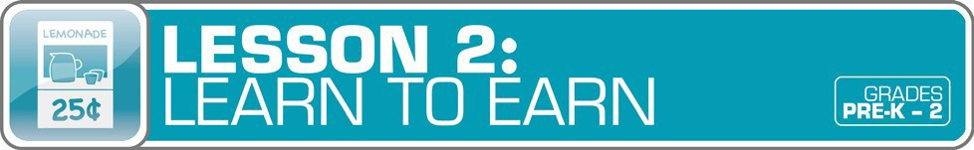

Glossary with key vocabulary 17

**LESSON OVERVIEW**

As students discover the purpose of money, they will begin to wonder how money is **earned**. Help students explore real-world concepts in this lesson by examining different **jobs** and sources of **income**. Making connections between jobs students are familiar with, such as those held by family members, learners begin to associate how income is earned. A variety of independent and small group activities are provided throughout the lesson to extend students’ exploration of earning money.

**TOPIC:** Earning Money

**TIME REQUIRED:** 45 minutes

*(excluding* **Extended Exploration** *activities)*

**LEARNING OBJECTIVES:**

*Students will be able to.*

* Identify and explore different jobs
* Examine sources of income (such as selling lemonade or receiving birthday money)
* Discover and explain that money is made (earned) by working

**SUPPLIES:**

* Chart paper, markers, pencils
* Projector (for teacher presentation slides)
* Access to the Internet **(optional)**
* Suggested books **(optional)**:
  + *The Go-Around Dollar* by Barbara Adams
  + *Clothesline Clues to Jobs People Do* by Kathryn Heling
  + *What Do People Do All Day?* By Richard Scarry

**PREPARATION:**

* Make copies of handouts
* Set up projector with presentation slides

**STUDENT HANDOUTS:**

* What I Want to Be When I Grow Up
* ***Jobs and Action Words***

**TEACHER PRESENTATION SLIDES:**

* Graph: Our Favorite Classroom Jobs
* ***The Cycle of Money***
* ***Story Problems: Learn to Earn***

**ESSENTIAL QUESTIONS:**

* *How do I get money?*
* *What is a job?*
* *How can I make money?*

**ASSESSMENT ACTIVITIES:**

**PRE-ASSESSMENT:**

* **Jobs in the Classroom** activity
* **Exploring Different Jobs** activity

**POST-ASSESSMENT:**

* What I Want to Be When I Grow Up

handout

* ***Jobs and Action Words*** handout
* Story Problems: Learn to Earn slide
* **Class Reflection** activity

### INSTRUCTION STEPS

#### WARM UP

**Teacher Tips:**

* Look for grade level modifications throughout this lesson for ways to adapt activities for your students.
* Spend time focusing on the concept of how income is earned and the money cycle.
* Adapt any writing activities to listening and speaking activities.
* Make time to explore the literature and technology resources mentioned in the guided and extended exploration sections of this

###### JOBS IN THE CLASSROOM

[5 MINUTES]

Begin by discussing classroom jobs and responsibilities. Students can each identify which **jobs** they like best, and why. As an extension activity, the class may use the ***Graph: Our Favorite Classroom Jobs*** slide to create a chart (tally chart, or bar graph, for example) recording favorite classroom jobs.

#### GUIDED EXPLORATION

**EXPLORING DIFFERENT JOBS [**15 MINUTES]

Ask students to share what jobs they might like to have when they grow up. What jobs do their family members hold? Brainstorm a list of possible jobs as a class, and record all ideas on chart paper.

Share with students that they will be able to use the ideas brainstormed as they create a page for a class book titled ***What I Want to Be When I Grow Up***. Give each student a copy of the ***What I Want to Be When I Grow Up*** handout to create his or her personal page of the class book.

Grade Level Modifications:

**Pre-K–K:** Students may draw a picture of their desired job and dictate the sentence bysharing “I want to be a .”

**Grades 1–2:** Students may draw their desired job and extend writing to include additional sentence(s) sharing why they are interested in the job, what someone with that job does, and so on.

**ANALYZING SOURCES OF INCOME [**5 MINUTES]

Facilitate a brief class discussion about making money. Possible discussion questions include: *Can kids make money? What are some way kids could make money?* For example: lemonade stand, garage sale, bake sale, or by doing chores.

**HOW MONEY IS EARNED [**15 MINUTES]

As a class, play “Where My Money Goes.” Have students come together in a circle. Each person will “earn” $5, which will move around the circle passed from one person to the next. Begin by sharing that there are many jobs in a community and that, today, the class will imagine how money could be earned and spent. Each student will repeat how he or she earned money and then share how it was spent, passing it to the next person.

For example: *“I earned this $5 selling popcorn, and then I spent it at (student’s name) sticker shop.”* (Hands $5 to next student.) Next student: *“I earned this $5 selling sticker and spent it at (student’s name) buying .”* Share ***The Cycle of Money*** slide. Go over each step in the cycle. Then discuss what this looked like in the game played inclass.

**MONEY SMART TIP!**

Discussing the cycle of money gives students the chance to reflect on how money is used, while also beginning to lay a foundation for understanding economic concepts in thefuture.

**Optional:** Read the story *The Go-Around Dollar* by Barbara Adams.

Grade Level Modifications:

**Pre-K–K:** Read only the fictional sections. The fact sections can be explored with young students by studying the pictures and discussing fun facts in more simplistic terms.

**Grades 1–2:** Have the class think back to the exploration of the history of money from Lesson

* 1. What facts do students know about where money comesfrom?

#### WRAP UP

**CLASS REFLECTION** [5 MINUTES]

Ask students: *How can you earn money? What jobs interest you and why?* Invite them to share their responses. Check for understanding and possibly introduce extended exploration centers for exploring the topic further.

#### EXTENDED EXPLORATION

**Note:** Use the following activities to extend the lesson topic throughout the year. Activities can be completed as a class, in small groups, or during center time. Duration of activities will vary.

###### LITERACY CENTER

* Possible Book Club or Classroom Library Selections:

**Note:** Read books with your class that focus on the lesson’s financial literacy topic. Below are suggestions, but you may find other selections in your library that can be used to generate a similar discussion. For pre-literate students, read books aloud.

* *Clothesline Clues to Jobs People Do* by Kathryn Heling: Students can guess what joba person might have by exploring the clothes hanging up to dry in this book.

 Discussion Questions: *What would your clothesline look like for the jobyou want to have when you grow up?*

* *What Do People Do All Day?* by Richard Scarry: Students discover all the community members hard at work in Busy town and learn about different jobs that people can have.

 Discussion Questions: *Can you find a job you would like to have in oneof the illustrations?*

* Speaking, Listening, and Writing Prompts:

Explore the following prompts through a themed show-and-tell, circle time discussions, partner pair-share discussions, or writing.

Grade Level Modifications:

**Pre-K–K:** Provide students with a visual or real-world object to support exploration of the prompt. Pre-literate students may discuss pictures and objects while having their stories recorded through modeled or guided writing as a small group or with the class.

* *What is your favorite classroom job, and why?*

**Grades 1–2:** Students may explore the following writing prompts by journaling or as independent writing assignments.

* *What jobs do you like, and why?*

###### MATH CENTER

* **Math Station:** Using the materials below, students can explore the following math station activities independently or as part of a small group. These could be used during classroom centers or as a choice for students who finish assignmentsearly.

Grade Level Modifications:

**Pre-K–K: Materials:** Stickers of different careers, piece of white paper. **Instructions:** Have students fold paper in half twice to create four quadrants. In each box have students write a number 1 through 4. Next, have students use career stickers to match the numbers they have written.

**Grades 1–2: Materials:** Images of different careers. **Instructions:** Have students brainstorm one way each career person would make money (what job they do) and one way they could use money.

* **Story Problems:** Display the ***Story Problems: Learn to Earn*** slides. Problems can be printed or projected, then explored and solved as a whole class, a small collaborative group, or individually. The first problem listed, Challenge 1, is more appropriate for young students. Challenge 2 will provide more difficulty.

Grade Level Modifications:

**Pre-K–K:** Solve step-by-step problems developing students’ critical thinking and deductive reasoning during circle time or as a small group. Each challenge involves using or creating a visual with students and discussing small steps to solve a problem.

**Grades 1–2:** Using the provided challenges as inspiration, create personal story problems and exchange them with classmates to solve.

###### TECHNOLOGY CENTER

* Games and Online Activities:
* **Paws in Job land:** Explore careers with Paws thePuppy.

<http://paws.bridges.com/cfncl.htm>

* **Sesame Street “The Job Song”:** Check different types of jobs with musical puppets.

<http://vimeo.com/49648565>

**SOCIAL STUDIES CENTER**

* During back-to-school and routine setting, discuss classroom jobs, including eachjob’s responsibilities and how jobs are assigned.
* For Labor Day, have students complete the **Jobs and Action Words** handout by matching jobs with the correct action verb related to the job. Forexample: Chef Cook.

###### ARTS & DRAMATIC PLAY CENTER

* **Dramatic Play:** Students can explore different careers through a range of dramatic play themes including, but not limited to, community jobs dress-up, veterinarian clinic, school bake sale, lemonade stand, or garage sale.
* **Sensory Activities:** Create communities with career dolls and figures, building blocks, and toy buildings. Older students can craft a 3-D map of a community by laying down a sheet of graph paper and using Un fix cubes to build community buildings. They can write labels on the graph paper for each of their buildings.
* **Art Project:** Create captions for different job pictures using magazines, photos, or other images of different careers.

# WHAT I WANT TO BE WHEN I GROW UP

##### Name:

**Complete the sentence and draw a picture of what you would like to be when you grow up.**

**I want to be a**

.

# JOBS AND ACTION WORDS

##### Name: Match each job with the correct actionword.



**Chef**



**Artist**

**Construction**

**Worker**



Nurse Scientist Police Officer

**CARE COOK RESEARCH PROTECT PAINT BUILD**

## GLOSSARY

**Bank:** A financial institution and business that accepts deposits and makes loans.

**Borrow:** To receive something on loan with the understanding that you will return it.

**Currency:** A form of money that is generally accepted to measure value (banknotes, bills, coins, and so on).

**Earn:** To receive money in exchange for goods or services

**Federal Deposit Insurance Corporation (FDIC):** Preserves and promotes public confidence in the U.S. financial system by insuring deposits in banks and thrift institutions for at least $250,000. An independent agency of the federal government, the FDIC was created in 1933.

**Goal:** Something, such as an outcome, you wish to achieve or accomplish in a specific amount of time.

**Income:** Money that you receive from jobs, gifts, allowances, interest, dividends, and other sources.

**Job:** A specific duty, task, or activity someone completes using his or her time, skills, and energy to earn money.

**Lend:** The act of giving something to someone with the understanding that they will give it back to you.

**Money:** Money is an object you can use to purchase goods and services. Money looks different in different places around the world.

**Need:** Something you must have to survive, such as clothes, shelter, or food.

**Save:** Setting something, like money, aside to use in the future.

**Spend:** The act of using money to buy goods or services.

**Want:** Something that you would like to have but that you could live without.

**MONEY SMART FOR GRADES PRE-K–2: EDUCATOR GUIDE**

17